**One-class SVM using Binary, Frequency, TF-IDF and Hadamard Representations,   
with Different Vector Dimensions, and Measures (F1-measure, Recall, Precision)**

**Figure 1 – Table of One-class SVM using Vector Size of 15 on Various Representations**

|  |  |  |  |  |  |  |
| --- | --- | --- | --- | --- | --- | --- |
| $$Keywords Vector Size \left(m\right)=15$$ | | | | | | |
| ***Kernel***  ***Representation*** | $$Linear$$ | | | $$Radial (RBF)$$ | | |
| $$F_{1}$$ | $$R$$ | $$P$$ | $$F_{1}$$ | $$R$$ | $$P$$ |
| Binary | 0.638 | 0.744 | 0.558 | 0.773 | 0.902 | 0.676 |
| Frequency | 0.550 | 0.641 | 0.481 | 0.737 | 0.860 | 0.645 |
| TF-IDF | 0.673 | 0.785 | 0.589 | 0.703 | 0.820 | 0.615 |
| Hadamard | 0.564 | 0.658 | 0.493 | 0.725 | 0.846 | 0.634 |
| $$* Value of each cell is the average of 100 samples of identical nature$$ | | | | | | |

**Figure 2 – Table of One-class SVM using Vector Size of 30 on Various Representations**

|  |  |  |  |  |  |  |
| --- | --- | --- | --- | --- | --- | --- |
| $$Keywords Vector Size \left(m\right)=30$$ | | | | | | |
| ***Kernel***  ***Representation*** | $$Linear$$ | | | $$Radial (RBF)$$ | | |
| $$F_{1}$$ | $$R$$ | $$P$$ | $$F_{1}$$ | $$R$$ | $$P$$ |
| Binary | 0.505 | 0.589 | 0.442 | 0.785 | 0.916 | 0.687 |
| Frequency | 0.580 | 0.677 | 0.507 | 0.628 | 0.732 | 0.549 |
| TF-IDF | 0.673 | 0.785 | 0.589 | 0.725 | 0.845 | 0.634 |
| Hadamard | 0.554 | 0.646 | 0.484 | 0.717 | 0.837 | 0.628 |
| $$* Value of each cell is the average of 100 samples of identical nature$$ | | | | | | |

**Figure 3 – Binary Representation in Linear and Radial (RBF) Kernels**

* WHITE – Training Data * YELLOW – POSITIVE DATA * RED – NEGATIVE DATA

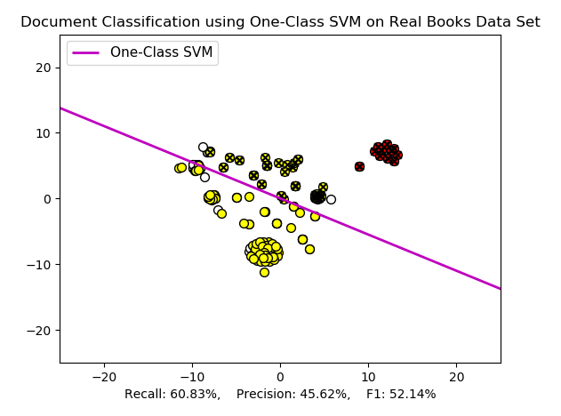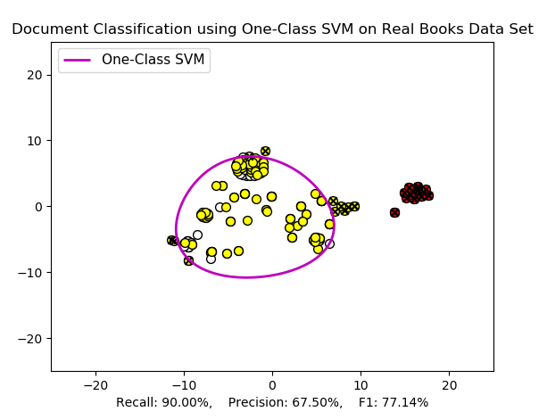

**Figure 4 – Frequency Representation in Linear and Radial (RBF) Kernels**

* WHITE – Training Data * YELLOW – POSITIVE DATA * RED – NEGATIVE DATA

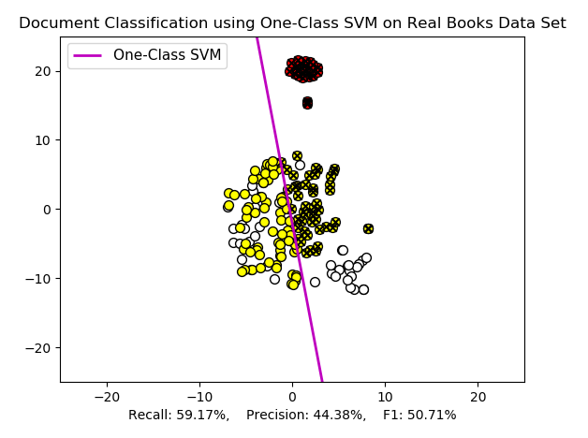 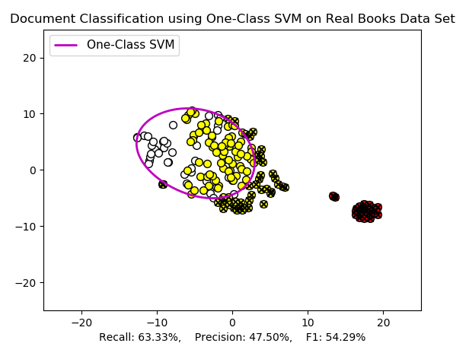**Figure 5 – TF-IDF Representation in Linear and Radial (RBF) Kernels**

* WHITE – Training Data * YELLOW – POSITIVE DATA * RED – NEGATIVE DATA

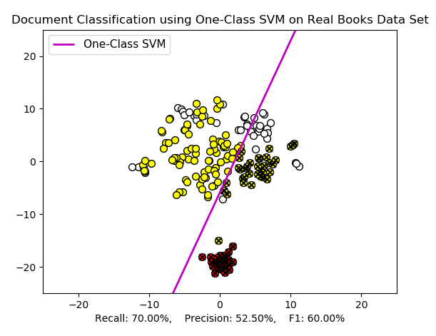 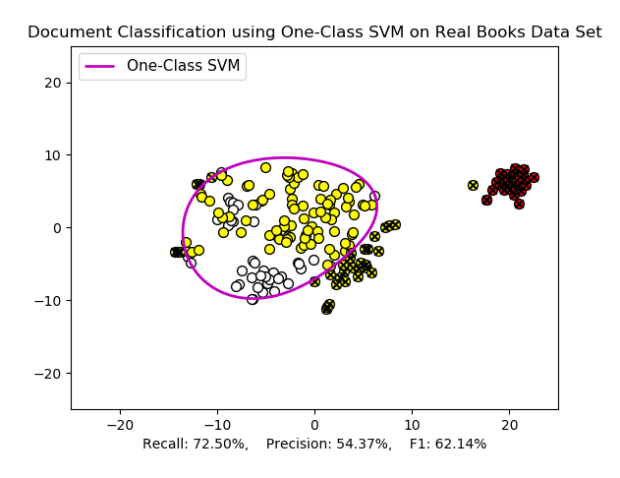

**Figure 6 – Hadamard Representation in Linear and Radial (RBF) Kernels**

* WHITE – Training Data * YELLOW – POSITIVE DATA * RED – NEGATIVE DATA

