I utilized both Copilot and Github Copilot in the following ways. To avoid confusion I will be writing Copilot for the Microsoft Copilot and Github Copilot for code and file editing. I used Copilot to plan out adding a new feature, add Category. I saved copies of the ui, db, and objects files into txt docs so Copilot could read them. I requested for it to provide a vscode Github Copilot chat prompt for creating the new feature.
Refactoring was similar to the above process except I asked for recommendations for refactoring and chose to add command dispatcher, extract input/validation helpers, extract service layer, generalize repeated UI patterns, and improved UI formatting. Revising the scope of the prompt and then asking for elaboration or to change aspects of the scope created the needed prompt for code editing. I also didn’t want the entirety of the code rewritten so I made sure that was included into the prompt at the end.

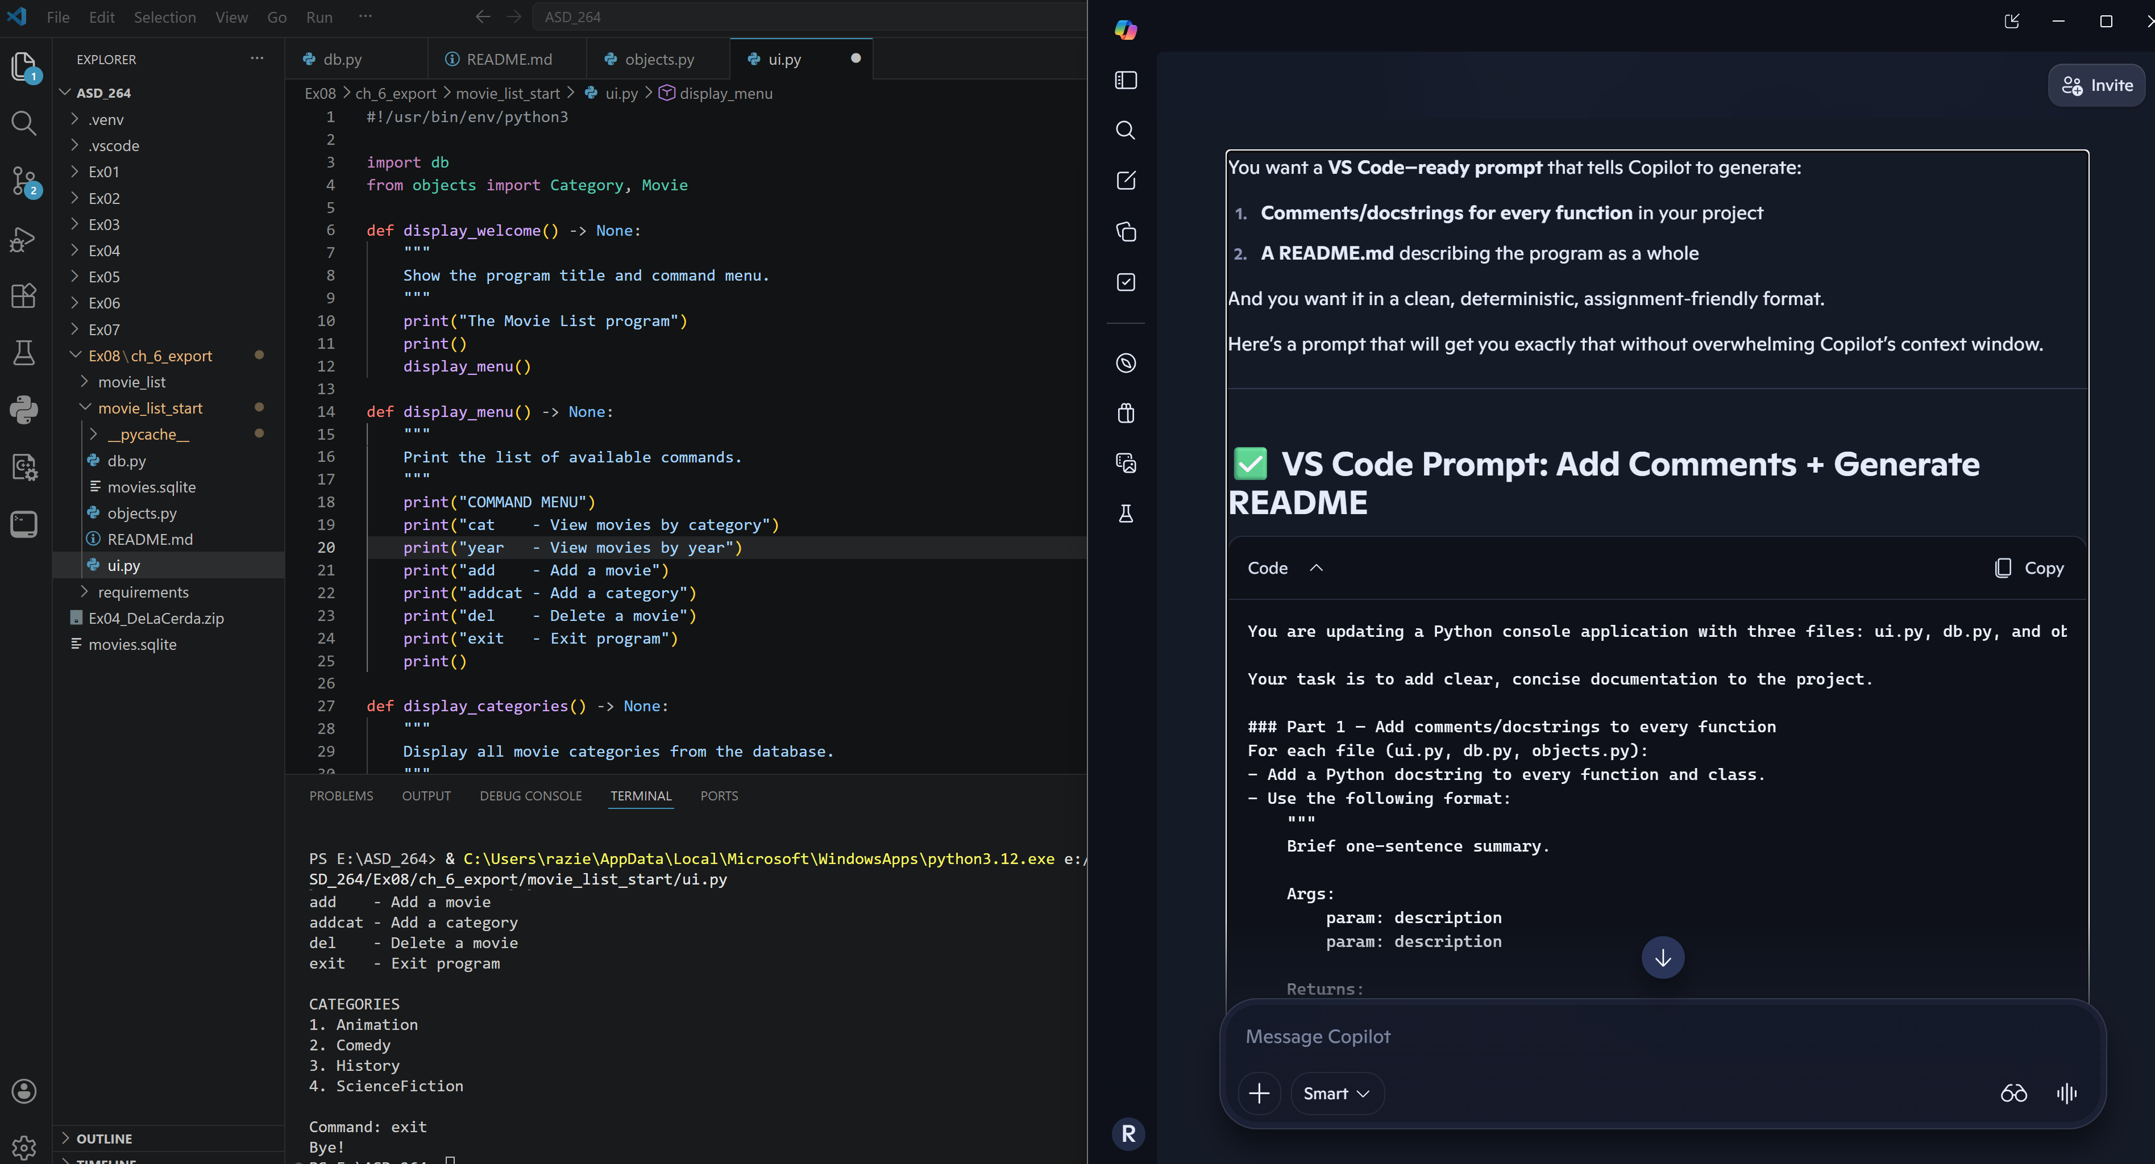

The prompt:
You are updating a Python console application with three files: ui.py, db.py, and objects.py.

Your task is to add clear, concise documentation to the project.

### Part 1 — Add comments/docstrings to every function
For each file (ui.py, db.py, objects.py):
- Add a Python docstring to every function and class.
- Use the following format:
"""
Brief one-sentence summary.

Args:
param: description
param: description

Returns:
Description of return value.
"""
- Keep descriptions short, accurate, and beginner-friendly.
- Do NOT change any logic or refactor code.
- Only add documentation.

### Part 2 — Generate a README.md for the project
Create a README.md that includes:
- Project title
- Short description of what the program does
- How to run it
- Description of each command (cat, year, add, addcat, del, exit)
- Description of the database structure (Category, Movie)
- Example usage
- Notes for future improvements

### Output Format
Provide ONLY:
1. The added/updated docstrings for each function and class (do not rewrite entire files).
2. The full README.md content.

Do not modify any code outside of adding documentation.

