I utilized both Copilot and Github Copilot in the following ways. To avoid confusion I will be writing Copilot for the Microsoft Copilot and Github Copilot for code and file editing. I used Copilot to plan out adding a new feature, add Category. I saved copies of the ui, db, and objects files into txt docs so Copilot could read them. I requested for it to provide a vscode Github Copilot chat prompt for creating the new feature.
Refactoring was similar to the above process except I asked for recommendations for refactoring and chose to add command dispatcher, extract input/validation helpers, extract service layer, generalize repeated UI patterns, and improved UI formatting. Revising the scope of the prompt and then asking for elaboration or to change aspects of the scope created the needed prompt for code editing. I also didn’t want the entirety of the code rewritten so I made sure that was included into the prompt at the end.

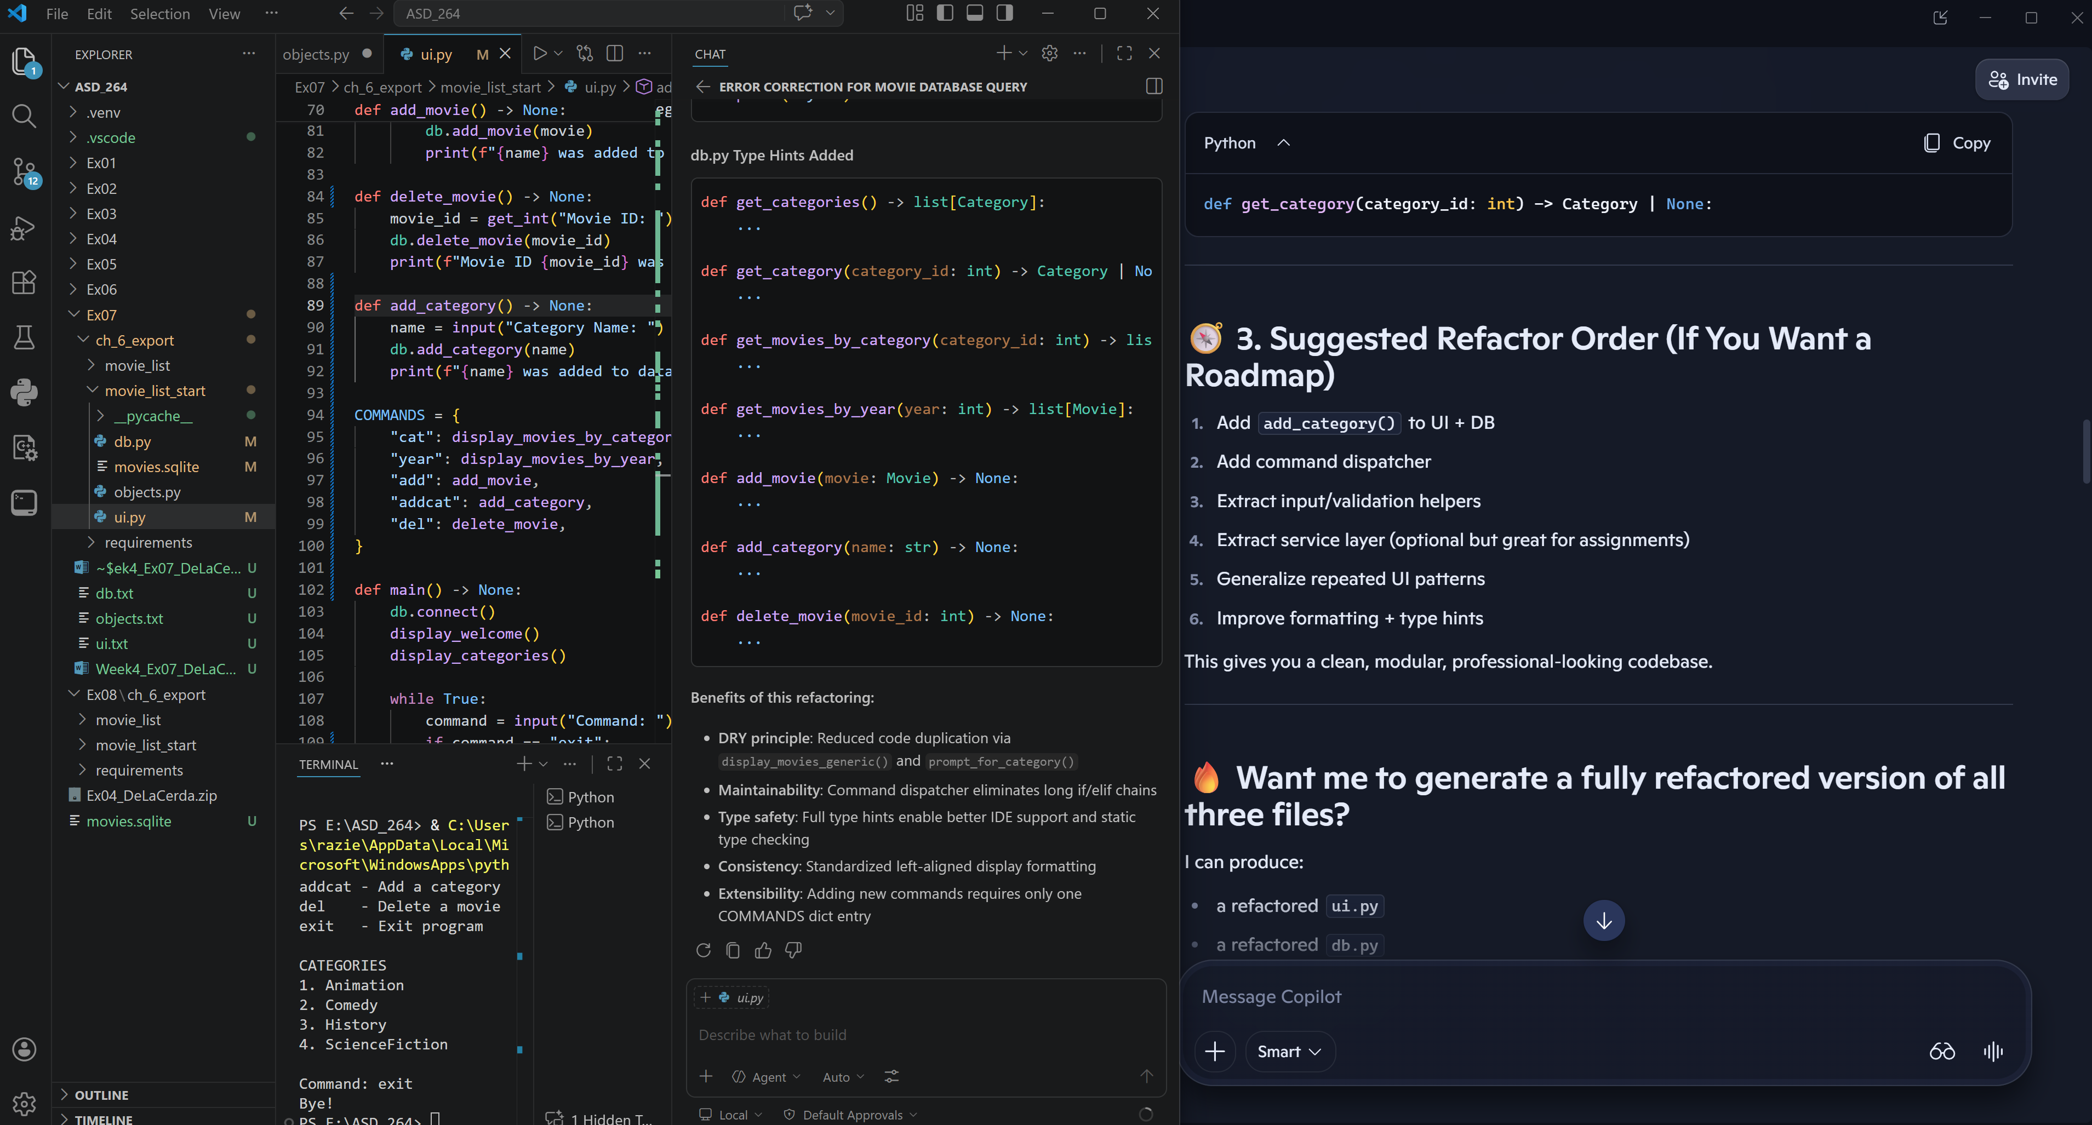

The prompt:
You are refactoring a Python console application with three files: ui.py, db.py, and objects.py.
The code already includes a new add_category() function. Now apply the following refactoring steps
(Recommendations 2 through 6 from the earlier analysis).

### Refactoring Requirements

## 2. Extract input/validation helpers
Create reusable helper functions in ui.py:
- prompt_for_category()
- prompt_for_movie_id() (optional but recommended)
These should encapsulate:
- prompting for an ID
- validating existence via db.get_category() or db.get_movie()
- printing error messages
- returning None on failure

Update add_movie(), display_movies_by_category(), and delete_movie() to use these helpers.

## 3. Replace the long if/elif command chain with a command dispatcher
In ui.py:
- Create a COMMANDS dict mapping command strings to functions.
- Replace the if/elif chain in main() with a lookup in COMMANDS.
- Add the new "addcat" command for adding a category.
- Keep "exit" handled separately.

## 4. Generalize repeated UI patterns
Create a helper function in ui.py:
display_movies_generic(fetch_fn, title_term)
This should:
- call fetch_fn()
- print a blank line
- call display_movies()

Refactor display_movies_by_category() and display_movies_by_year() to use this helper.

## 5. Improve display formatting
In display_movies():
- Replace manual spacing with consistent f-string alignment:
f"{'ID':<4}{'Name':<38}{'Year':<6}{'Mins':<6}{'Category':<10}"

Ensure all row formatting uses the same alignment style.

## 6. Add type hints
Add type hints to all new and modified functions in ui.py and db.py.
Examples:
- def prompt_for_category() -> Category | None:
- def add_category(name: str) -> None:
- def display_movies(movies: list[Movie], title_term: str) -> None:

### Output Format
Provide ONLY:
- New helper functions
- Updated functions that changed
- Updated COMMANDS dict
- Updated main() loop
- Updated display formatting block

Do NOT rewrite entire files. Only show modified or newly added sections.
Maintain the existing coding style and indentation.

