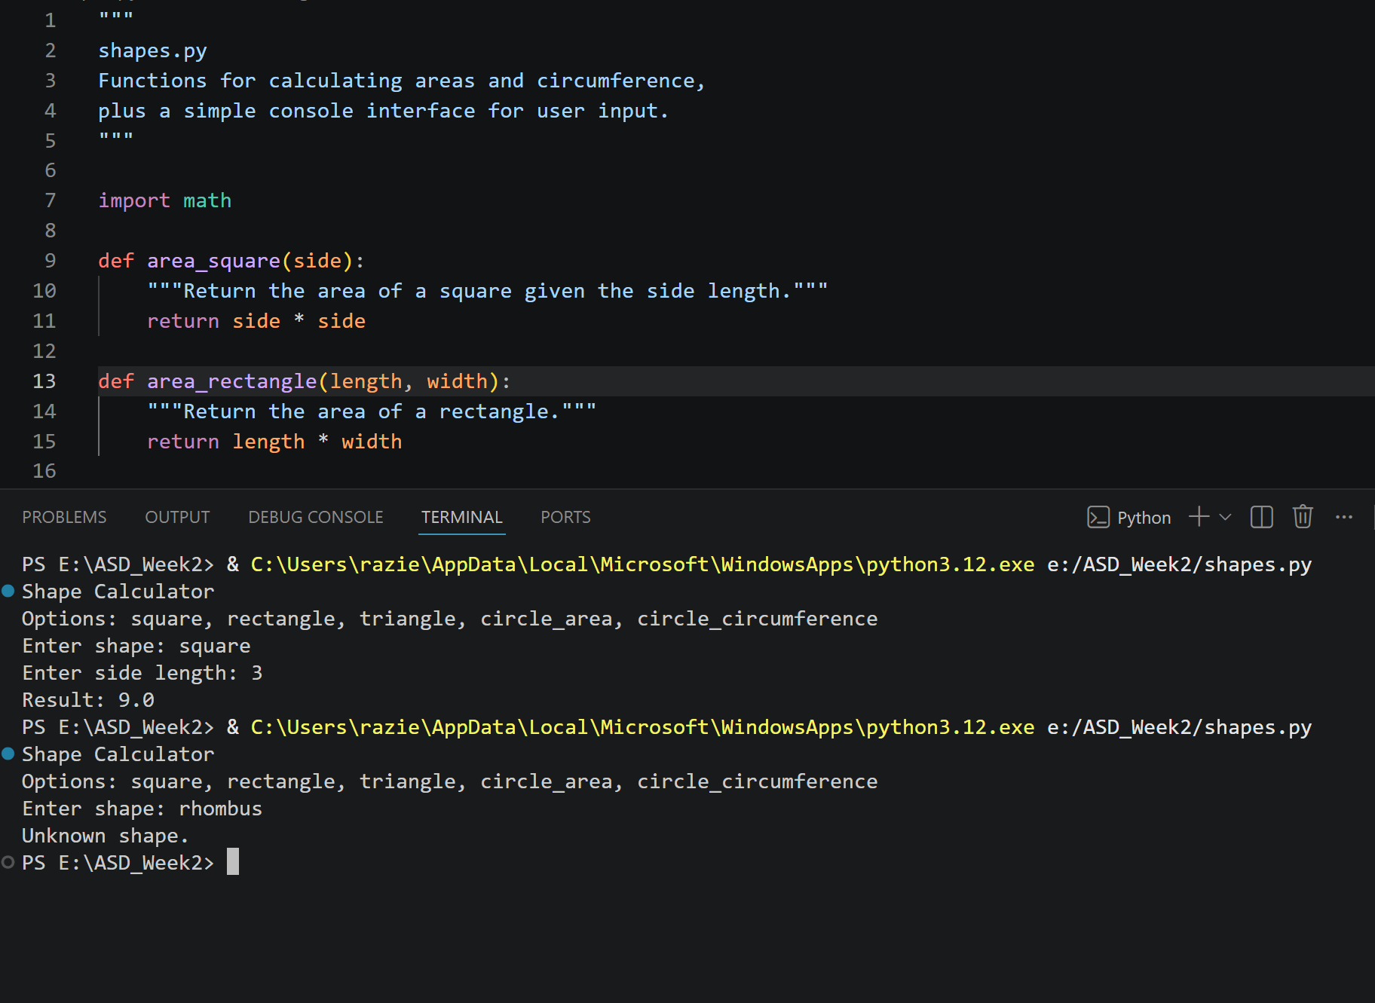
"""
shapes.py
Functions for calculating areas and circumference,
plus a simple console interface for user input.
"""

import math

def area_square(side):
"""Return the area of a square given the side length."""
return side * side

def area_rectangle(length, width):
"""Return the area of a rectangle."""
return length * width

def area_triangle(base, height):
"""Return the area of a triangle."""
return 0.5 * base * height

def area_circle(radius):
"""Return the area of a circle."""
return math.pi * radius * radius

def circumference_circle(radius):
"""Return the circumference of a circle."""
return 2 * math.pi * radius

def main():
print("Shape Calculator")
print("Options: square, rectangle, triangle, circle_area, circle_circumference")
shape = input("Enter shape: ").strip().lower()

if shape == "square":
side = float(input("Enter side length: "))
result = area_square(side)

elif shape == "rectangle":
length = float(input("Enter length: "))
width = float(input("Enter width: "))
result = area_rectangle(length, width)

elif shape == "triangle":
base = float(input("Enter base: "))
height = float(input("Enter height: "))
result = area_triangle(base, height)

elif shape == "circle_area":
radius = float(input("Enter radius: "))
result = area_circle(radius)

elif shape == "circle_circumference":
radius = float(input("Enter radius: "))
result = circumference_circle(radius)

else:
print("Unknown shape.")
return

print(f"Result: {result}")

if __name__ == "__main__":
main()

