Materials science of the HE MCGA concept
  - Crystal Paradigm From atoms to the application failure mechanism
The central materials idea is to distribute the transition from a metal to a ceramic through thickness, while selecting the metal chemistry for useful properties. The scientific challenge is to make that composition and architecture remain compatible during processing and service. Our calculations explore part of this challenge. They do not yet demonstrate a stable, oxidation resistant, tough or durable material.

Start with the four levels of a material
Composition says which atoms are present and in what amounts. Phase describes a region with a particular crystal structure and chemical state. Microstructure describes how phases, grains, pores and interfaces are arranged. Processing creates that microstructure; temperature, time, environment and mechanical loading then change it. A useful property belongs to this full state, not to a formula alone.
For example, two coupons with the same atomic fractions can differ in grain size, segregated phases, oxygen content and porosity. Their yield strength, conductivity and lifetime may differ. This is why the public data's broad processing labels help but cannot fully describe a new manufactured alloy.
An alloy is predominantly metallic. A ceramic such as LZO is an oxide with different bonding and deformation behavior. A metal ceramic composite contains both. A functionally graded material changes their proportions or other material features with position. The metal ceramic boundary is an interface, and adhesion is resistance to separation there. Bulk compression strength is not an adhesion measurement.

Why use refractory elements
Refractory metals are attractive for retaining useful properties at high temperature, but high elemental melting temperatures do not imply oxidation resistance, ductility or creep resistance of a particular alloy. Adding more elements expands the design space and also makes prediction, manufacture and chemical compatibility harder. Complexity must earn its place through measured benefit.
Element | Hypothesis worth testing | Countervailing concern
Mo and W | Refractory contribution and possible stiffness or high temperature strength | Density and environmental response; some oxides can be unfavorable in service
Nb and Ta | Refractory alloy design options and composition tuning | Density for Ta; phase and oxidation behavior remain composition dependent
Cr | Potential contribution to environmental resistance in an appropriate chemistry | Does not guarantee a protective scale; competing phases can become important
Ti and Zr | Lower density chemistry options relative to heavy refractory additions | Oxygen uptake, reaction and phase changes require control
V | Property and density tuning within the search alphabet | Environmental and phase behavior cannot be inferred from the elemental value
Hf | Possible phase or interface effects in a selected system | High density and procurement burden; no quantified supply advantage is established here

These are design hypotheses, not a list of proven roles in our top candidate. The current optimizer uses inherited elemental estimates and public mechanical data. It does not measure each element's causal contribution. An ablation study and simpler alloy controls are needed before saying all nine additions are necessary.

Atomic fraction is not mass fraction
Atomic fraction counts atoms. Mass fraction counts mass. Volume fraction counts occupied volume. Equal numbers of light and heavy atoms do not weigh the same. The distinction matters for powder weighing, density, conductivity and the metal ceramic recipe.
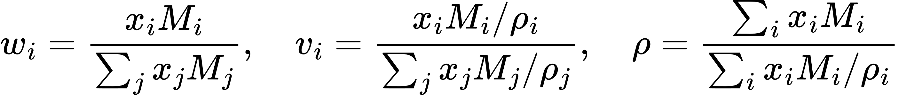
Conversion from atomic fractions to mass and additive volume fractions
Here x is atomic fraction, M is molar mass and rho is elemental density. The molar volume approximation ignores excess mixing volume. The alloy density estimate divides mean molar mass by additive molar volume. We then use volume fractions for the declared thermophysical mixture estimates. None of these estimates replaces a measured density of the processed coupon, especially when it contains pores.
A source formula such as Nb2Mo2 represents a ratio and can be normalized. An explicit recipe of atomic fractions must already sum to one. The software rejects an incomplete vector instead of dropping unknown atoms or quietly repairing a rounded composition. This is essential because properties and specimens must refer to the same chemistry.

Entropy and phase stability
A random multicomponent solution can gain configurational entropy because atoms can occupy sites in many arrangements. The ideal mixing expression assumes a random solution. The Gibbs energy also includes energetic interactions and other contributions. A competing ordered phase or multiphase mixture can still have lower free energy.
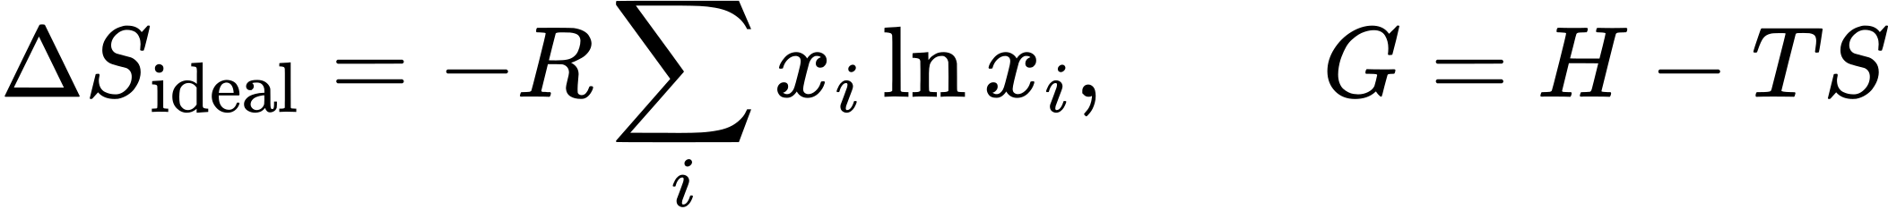
Ideal configurational entropy and the competing enthalpy and entropy terms
High entropy therefore does not mean single phase. HEA and complex concentrated alloy terminology has several conventions; the pipeline's requirement for at least five elements above 5 atomic percent is a design rule, not a universal law of materials stability. Pure elements and low component compounds in the bulk training set are property anchors, not examples of the target manufactured HEA.
Body centred cubic, or BCC, and face centred cubic, or FCC, describe crystal structures. Valence electron concentration, VEC, is a composition weighted electron count descriptor in this implementation. It can be a useful empirical indicator within some alloy families. It cannot prove a BCC structure or exclude sigma or other competing phases. The old VEC equals 5.02 therefore zero sigma risk statement is unsupported.
Sigma and Laves phases are examples of competing intermetallic structures that can affect mechanical behavior. A continuous brittle network can be harmful; a controlled precipitate distribution can sometimes strengthen a material. The relevant question is which phases exist, in what quantity, where, and after what thermal history. Our nine element binary interaction coverage is incomplete, so missing pair enthalpies are reported as unknown rather than set to zero.
CALPHAD means calculating phase equilibria using assessed thermodynamic models. It requires a database applicable to the chemistry and entered phases. A TDB containing all element names is not automatically well assessed for every multicomponent interaction. Equilibrium also does not specify the rate of precipitation or what survives a rapid cooling path. We need database review plus XRD and microscopy on actual specimens. [S7]

Strength ductility and time dependent deformation
Yield strength marks the onset of substantial irreversible deformation under a specified test. Young modulus relates small elastic strain to stress. Bulk modulus describes resistance to volume change. Hardness, tensile strength, compression yield and fracture toughness answer different questions. One cannot substitute a model's compression yield for ceramic fracture or interface adhesion.
Composition disorder can impede dislocation motion, but the mechanism depends on structure and temperature. Grain boundaries, precipitates, impurities, processing and strain rate also affect deformation. A high room temperature compression strength may coexist with poor tensile ductility or inadequate high temperature life. Our yield model uses test temperature and broad processing category, but omits many of these physical state variables.
Creep is deformation accumulated under load over time. Grain boundary diffusion, lattice diffusion and dislocation mechanisms can contribute under different conditions. A fixed 15 percent stress relaxation factor is not a creep calculation. Grain size and thermal history can change both the rate and the mechanism. The repaired implementation has removed the old assumed creep relief; no validated creep law is currently used.
Fatigue concerns damage from repeated loading. Thermal fatigue couples heating and cooling with mechanical constraint and material evolution. A sequence of steady elastic temperatures is not automatically a fatigue life simulation. A claim of surviving 1000 or 10000 cycles needs an actual cycle definition, constitutive model, failure criterion and experimental comparison.

Oxidation and environmental attack
Oxidation can consume selected elements, change surface chemistry, form scales and create new stresses. A compact adherent oxide may slow further attack; a cracked, porous or volatile scale may not. Protection depends on chemistry, oxygen potential, temperature, atmosphere, exposure time and scale adhesion. High melting temperature and ideal mixing entropy do not establish protection.
A primary study of other Mo W Ta Ti Zr refractory alloys found composition dependent oxygen interactions using atomistic methods. Its results motivate checking environmental behavior separately; they are not oxidation measurements of our candidate. [S6]
The old post optimization Al addition cannot inherit the earlier predictions. Al is outside the present model alphabet and would require new data, revalidation and an updated search. Formation of an alumina scale also depends on composition and treatment. We do not claim self healing from an arbitrary Al percentage.
Mass change in a controlled thermogravimetric test is useful but incomplete. Mass gain may indicate oxide formation; mass loss may reflect spallation or other processes. We need time history, exposed area, atmosphere and cross sections to interpret it. The existing 7.5 mg per square centimetre claim has no verified target experiment or executed model in the maintained evidence.

What the ceramic and gradient can do
LZO here means lanthanum zirconate, La2Zr2O7. A ceramic rich surface is intended to provide thermal resistance while the metallic side provides a route to mechanical attachment. The code assigns LZO reference estimates of conductivity 1.6 W per metre kelvin, coefficient of thermal expansion, CTE, 9.1 micrometres per metre kelvin and Young modulus 175 GPa. These are screening constants, not measured properties of our processed coating at service temperature.
Thermal expansion mismatch means that bonded layers would prefer different free strains. Stiffness differences determine how compatibility redistributes stress. A smooth composition transition can redistribute mismatch compared with a sharp junction. It does not eliminate stress or guarantee better performance under every boundary condition.
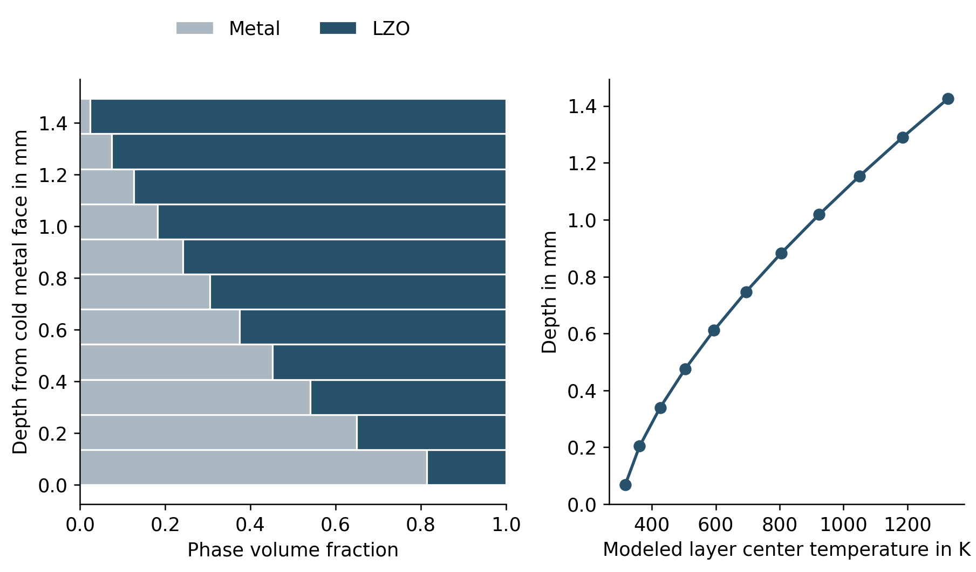
The computed 11 layer composition profile and its cold metal and hot ceramic orientation
In the checked aerospace control, the graded architecture gives about 236.7 MPa peak in plane stress versus 406.3 MPa for a sharp bilayer when both are free to curve. With flat constraint, the values are about 1389.9 and 1475.0 MPa. The compared systems have the same thickness, phase volumes and assumed constituent constants. These are reduced model results, not observed strength or bond life. Their strong boundary dependence is part of the finding.
The current harmonic conductivity plus one dimensional series conduction model gives the same total thermal resistance for the graded and sharp architectures at equal phase volumes. Thus we cannot claim that grading itself improves insulation in this model. It redistributes the mechanical response; increasing ceramic amount or thickness changes resistance. Real pore structure, interfacial resistance, reactions and temperature dependence could change this conclusion and need measurement.

Interfaces processing and competing requirements
Bonding needs wetting, contact and chemical compatibility as well as favorable bulk properties. Differential shrinkage during consolidation, thermal expansion during cooling, reaction products and residual stress can all damage an interface. Interdiffusion changes a deliberately deposited composition over time. Unequal diffusion rates can contribute to void formation; the current model does not calculate these kinetics.
A thermally grown oxide at a bond interface can both contribute to environmental protection and develop stresses that promote damage. NASA coating life work identifies oxidation and bond coat creep as important mechanisms, which is why elastic thermal stress alone is not a coating lifetime claim. [S5]
Porosity can reduce effective conductivity but may weaken a coating or affect permeability and erosion resistance. A thermal barrier for a turbine and a wear surface for a forging tool do not have identical requirements. Contact pressure, friction and surface finish may dominate the latter. A ceramic rich gradient that is attractive thermally could be unacceptable in production tooling.

Evidence needed to claim a materials advance
We need verified chemistry, phase characterization, density and porosity, temperature dependent CTE and conductivity, relevant mechanical properties, oxidation and interface behavior under a defined process and service cycle. XRD, SEM and EDS provide complementary evidence: diffraction concerns crystal phases, microscopy shows morphology and defects, and EDS maps elemental distributions. None alone proves everything.
The defensible advantage today is an auditable way to generate and compare hypotheses. A material advantage requires outperforming an incumbent and an appropriate ungraded or sharp control under equal measurement conditions. We have a computational architecture control, not that full experimental comparison. We should be ready to reject a candidate, reduce composition complexity or change the ceramic if the physical evidence demands it.

Questions to answer without jargon
What fails first in the intended application? Which property or mechanism does each design choice address? What did we actually calculate or measure? What state variables are missing from the model? What observation would make us abandon the candidate? If these answers are clear, the project is a research program with testable decisions rather than a collection of technique names.

Sources and evidence
[S5] Hillery and colleagues NASA coating life prediction report 1988. https://ntrs.nasa.gov/citations/19890004250
[S6] Osei Agyemang and Balasubramanian 2019 Surface oxidation mechanism of a refractory HEA. https://www.nature.com/articles/s41529-019-0082-5
[S7] pycalphad official equilibrium documentation. https://pycalphad.org/docs/latest/examples/EquilibriumWithOrdering.html

