# Class 01

void main() {

print("Hello World!");

}

void main() {

print(12);

}

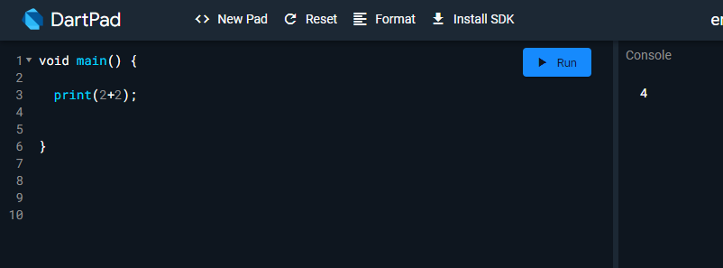

*Without Inverted Commas represent Integers*

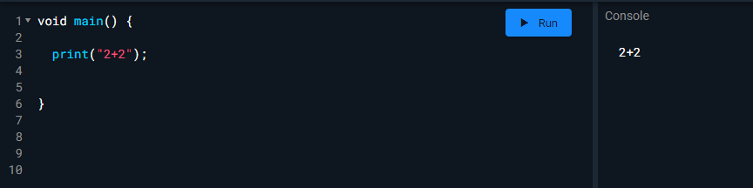

*“Anything in inverted commas” represents string, it will Print as it is*

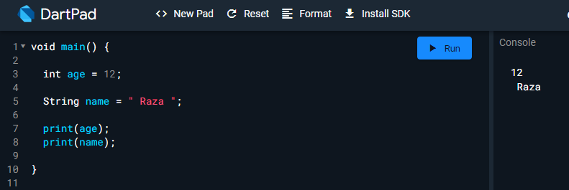

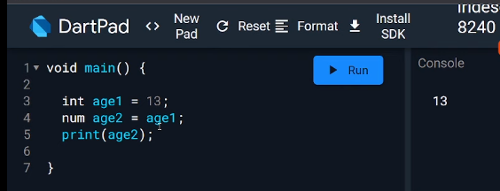

*Num passes both int (e.g 4,5,6) and double (e.g 1.5,2.2)*

# Class 02

