Project title: Develop Alexa Skill for Covid-19 Recommendation System

Date: 7/9/20

Made by: Syed Raza

**Introduction:**

Artificial Intelligence is conquering the realm of technology day by day in every aspect of our lives. Numerous applications are integrating AI based technology and provided solutions to various problems in the technology world. This surge in technology has increased our reliance on voice-controlled devices to perform everyday tasks. Voice interfaces can be used to perform a wide variety of tasks, such as ordering food from a restaurant, calling a cab, controlling Internet-of-Things (IoT) driven home devices and much more. Such a voice interface service is Alexa which is a virtual assistant AI technology developed by Amazon. It is widely used for home automation systems but is able to perform a numerous other voice driven tasks.

In this project, we use Amazon Alexa to build a Covid-19 recommendation system by utilizing the Alexa skill service for the front end as well as DynamoDB database for storing the patient registration details, a lambda function and finally a deployed API service provided by Amazon.

**Results:**

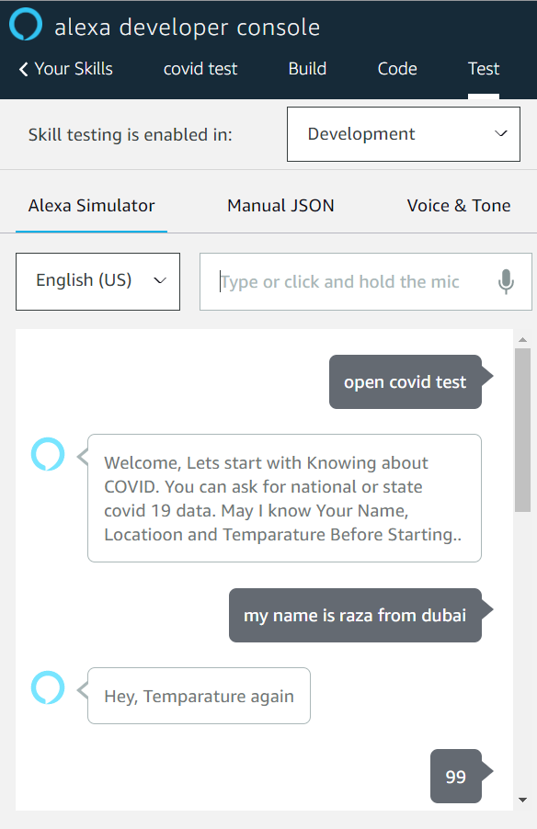

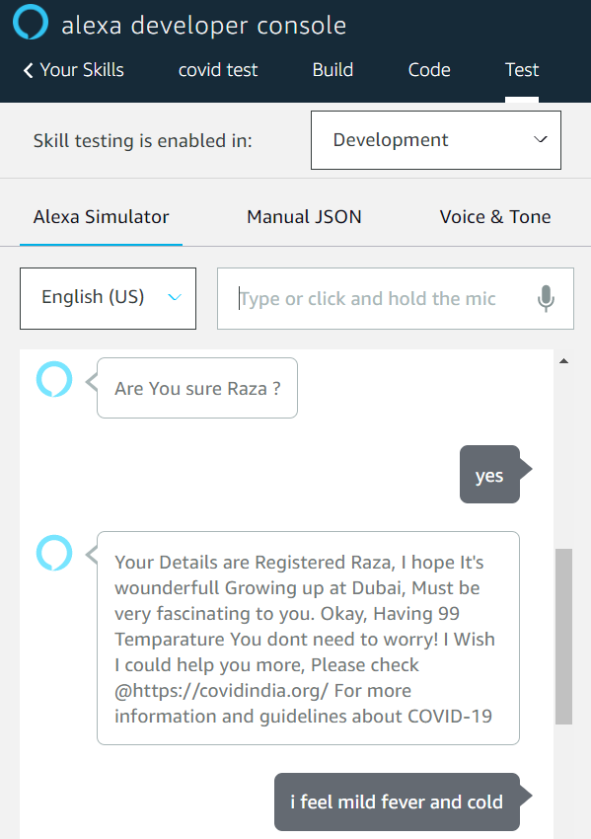



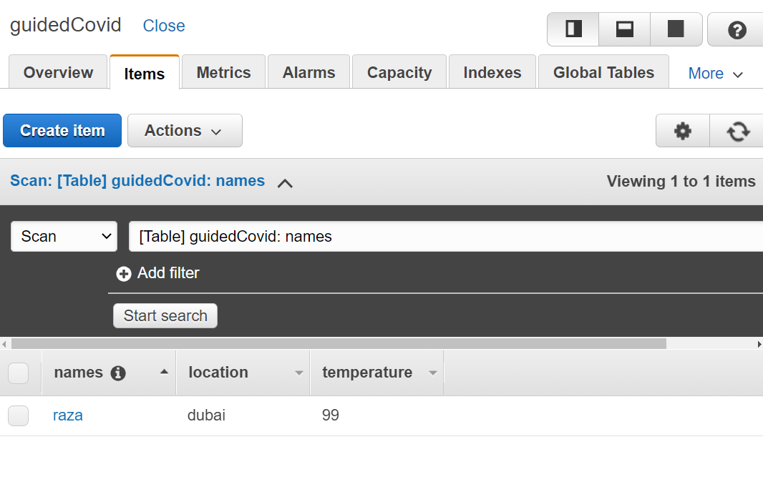

**Applications:**

The corona virus pandemic has affected people globally especially developing countries which do not possess the medical resources to combat this virus. Also, in developed countries, we have seen that hospitals have been filled to capacity. Hence, not everyone has access to hospitals. In such countries or areas, a virtual voice assistant which hears out an individual’s symptoms and provides precise recommendations could turn out extremely beneficial.

**Conclusion:**

Due to rapid technical growth, our lives are made simpler and easier. In this project, we learned how to implement an Alexa based Covid 19 recommendation system. With the help of Amazon Web Services, we were able to successfully train and deploy Alexa skill code and use an API integrated with the Lambda function to take the user details and store it in a database.

However, this project has room for improvement. Alexa Echo dot service could be added to enable voice speech recognition in this project. In addition, by coding directly in JSON instead of the environment given by Amazon, we could decrease the number of times the invocation name has to be called.