Project title: Social Distancing Detector

Date: 17/8/20

Made by: Syed Raza

**Introduction:**

The impact of the Corona virus pandemic is drastically changing the lives of people across the globe. The disease spreads so quickly that a single interaction between a person and another can cause hundreds of people to be affected. As a consequence, everything is slowly shifting online to various platforms in order to minimize human to human interaction. Since we do not have a vaccine available in the market, the primary strategy to prevent Covid-19 is to maintain social distancing. Thus, it is essential to enforce this in the public to keep the affected cases under control. To address this issue with the aid of new and enhanced technology, a social distancing detector was build using python programming language.

Thanks to the State of the Art object detection algorithm, YOLO (You Only Look Once), detecting humans from a live feed or recorded stream has never been easier. This pre-trained deep neural network, which comes with 80 classes, only looks at an image/frame once to detect multiple objects. This, along with some image analysis using OpenCV package in python, we build an application to detect whether people are maintaining social distancing by keeping atleast 2 meter distance from the adjacent person. However, if this 2 meter rule was violated, a red bounding box is shown surrounding the people.

**Results:**

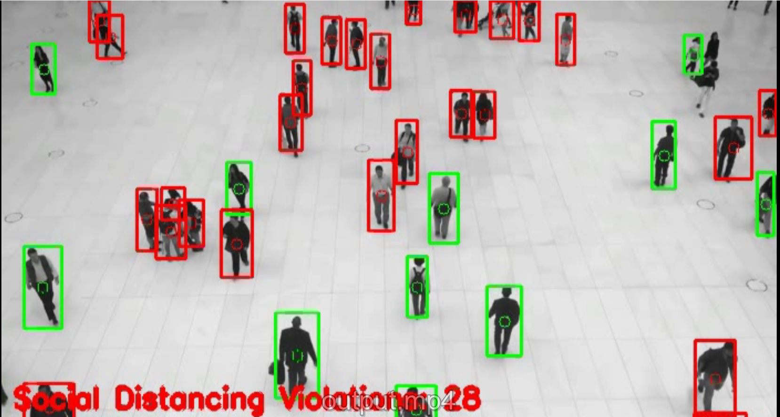

As we can see, green bounding boxes indicate that the individuals are maintaining sufficient social distance between them while the red bounding boxes indicate violations. Furthermore, the total social distancing violations are also shown at the bottom.

**Applications:**

Social distancing detector has a wide variety of real-life applications. It could be integrated within CCTV cameras to monitor people on the street, in malls and shopping centers, cinema halls etc. They could also be used personally at homes to maintain social distancing amongst family members. Apart from this, schools and airports are two very busy places on a regular basis so placing the social distancing detector there would be a good option.

**Conclusion:**

In this project, we learned how to implement a social distancing detector using OpenCV, computer vision and deep learning. . Using the YOLO object detector, we detected people in a video stream. Then we determined the centroids for each detected person and the distances of the centroids of one person with the centroids of the adjacent persons. Lastly, we performed a check to see if the distances between the centroids were less than or greater than 2 meters.

However, this project is open to research and development since it has room for improvement. For example, the distances measured between centroids of two different people is not quite accurate. It is difficult to map distances in pixels to actual distances. Camera calibration techniques could be used to more accurately detect violations and provide better results.