Transformer-Based Sentiment Analysis with Attention Visualization and Explainability (SHAP & LIME)

1. Introduction
Natural Language Processing (NLP) has significantly evolved with the introduction of Transformer-based models such as BERT. These models capture contextual relationships in text using attention mechanisms, enabling superior performance in tasks like sentiment classification.
In this project, we implement a Transformer-based sentiment classifier using the Amazon Polarity dataset. In addition to model performance, we focus on interpretability using attention visualization, SHAP, and LIME.

2. Dataset
We used the Amazon Polarity dataset from Hugging Face, which contains product reviews labeled as positive or negative.
- Total dataset: Large-scale (millions of samples)
- Used subset:
  - Training: 5000 samples
  - Testing: 1000 samples
This subset was selected due to computational constraints.
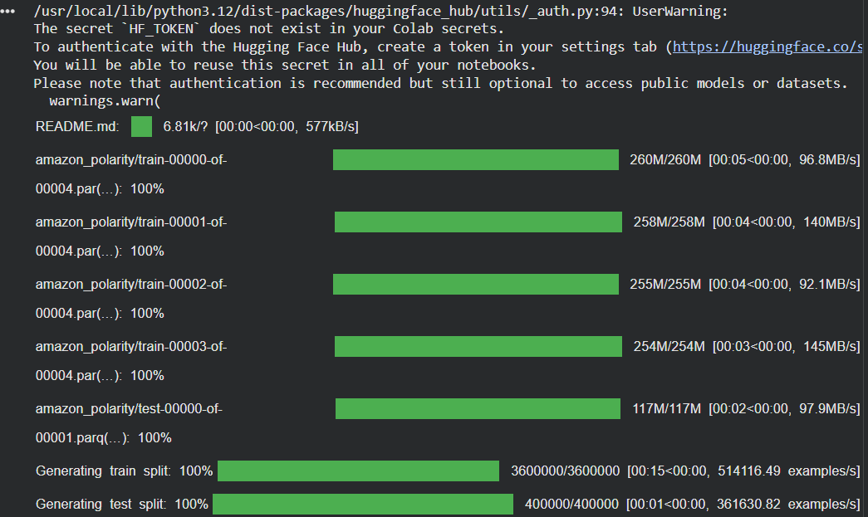
3. Methodology
3.1 Data Preprocessing
- Loaded dataset using Hugging Face datasets
- Shuffled and selected subset
- Tokenized text using BERT tokenizer
- Applied padding and truncation
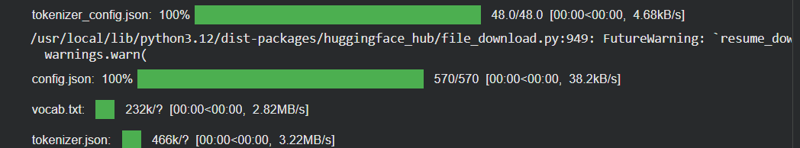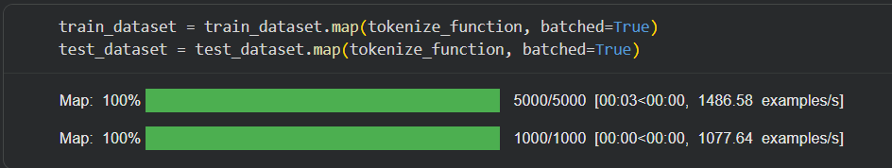
3.2 Model
We used:
- Model: BERT (bert-base-uncased)
- Task: Binary classification
- Output: Positive / Negative sentiment
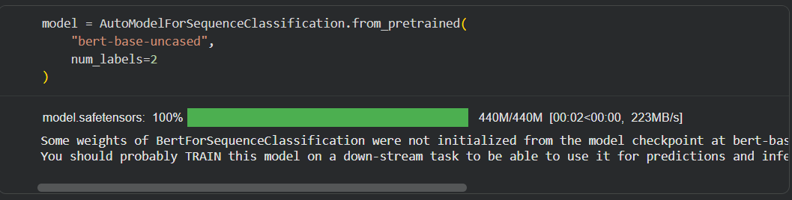
3.3 Training Setup
- Epochs: 2
- Batch size: 8
- Optimizer: AdamW (default in Trainer)
- Evaluation strategy: Per epoch
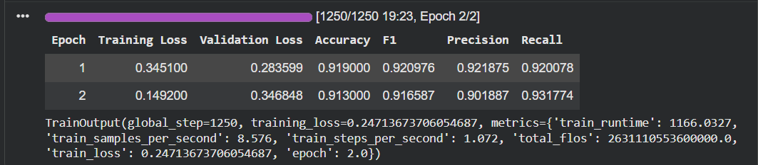
3.4 Evaluation Metrics
We evaluated the model using:
- Accuracy
- Precision
- Recall
- F1-score

4. Results
The model achieved strong performance on the test dataset:
- Accuracy: 0.913
- Precision: 0.9018867924528302
- Recall: 0.9317738791423001
- F1-score: 0.9165867689357622
This indicates that the Transformer model effectively captures sentiment patterns.

5. Attention Analysis
Transformer models use attention mechanisms to focus on important words.
We extracted attention weights from multiple layers and heads and visualized them as heatmaps.
Observations:
- Words like great, bad, excellent receive high attention
- Attention captures relationships between key tokens
- Different heads focus on different patterns
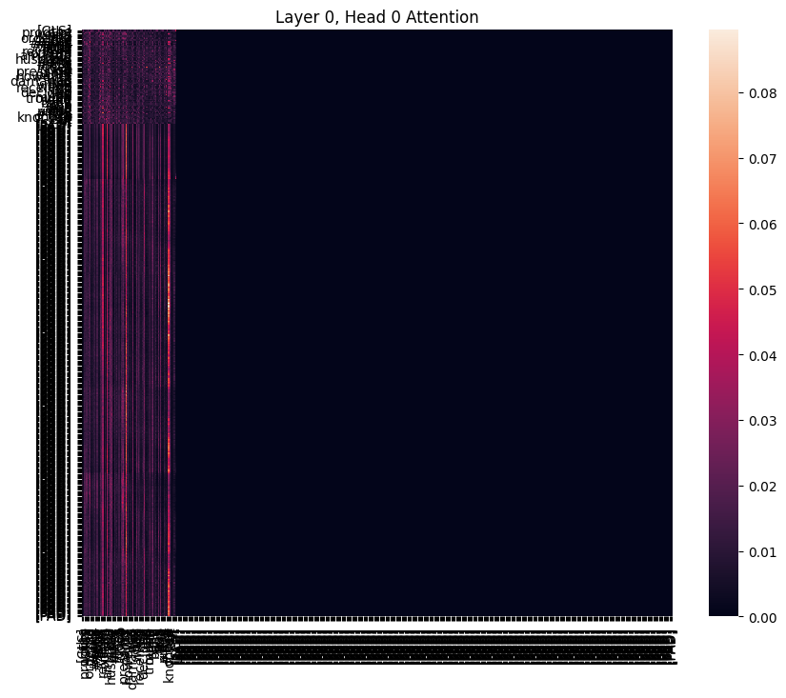
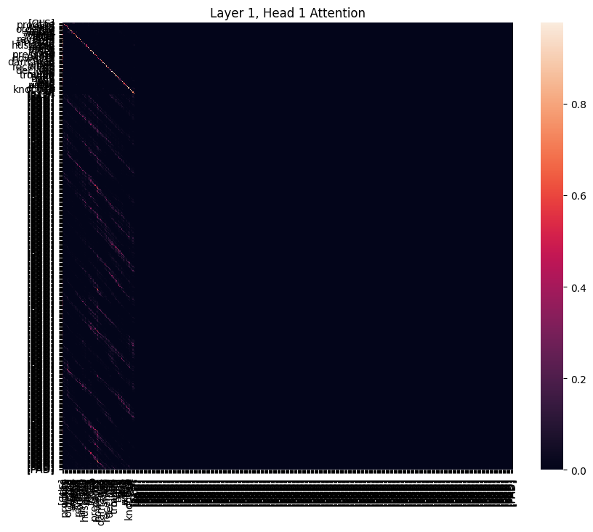

6. SHAP Explainability
SHAP (SHapley Additive exPlanations) was used to explain model predictions.
Observations:
- SHAP highlights word contributions
- Positive words → positive contribution (red)
- Negative words → negative contribution (blue)
- Provides consistent and reliable explanations
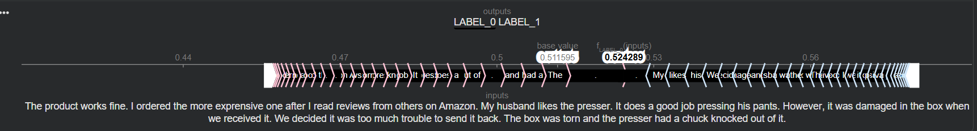
7. LIME Explainability
LIME explains predictions locally for individual samples.
Observations:
- Shows important words influencing prediction
- Faster than SHAP
- Less stable across runs

8. SHAP vs LIME Comparison
Aspect | SHAP | LIME
Faithfulness | High | Medium
Stability | High | Low
Speed | Slow | Fast
Scope | Global + Local | Local only

9. Error Analysis
We analyzed misclassified samples.
Common Issues:
- Sarcasm in reviews
- Mixed sentiment sentences
- Long complex reviews
- Ambiguous wording

10. Conclusion
This project demonstrates the effectiveness of Transformer-based models in sentiment analysis. Beyond performance, explainability techniques such as SHAP and LIME provide valuable insights into model decisions.
Attention visualization further helps understand how the model processes text.

