* 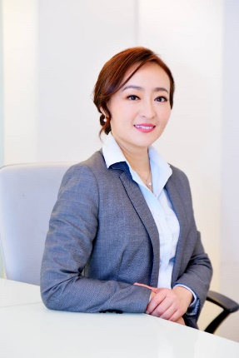

Independent Non-Executive Director

Huang Xiao Jia, Chinese, age 46. She has more than 16 years of experience in management, operation and finance in various industries, range from international trading, construction, manufacturing, IT and property development.

In year 2006, she completed Association of Chartered Certified Accountants (UK) in Malaysia, currently she is Fellow of the ACCA and Chartered Accountant (CA) of Malaysia Institute of Accountant (MIA). She also obtained a Master in Business Administration from Binary University of Management and Entrepreneurship in year 2019.

She started his career as Accounting Executive with StandleyCo Consulting Group in 2015. In 2017, she joined Sunway Construction Berhad as Assistant Accountant and assigned to overseas subsidiary and returned in year 2009, before leaving her position as Project Accountant in 2011. Subsequently, she joined BDO Binder (Kuala Lumpur) as a Consulting Manager with a focus on performing internal control reviews, business risk assessments for listed companies such as OSK Holding Berhad, Hartalega Holding Berhad.

In year 2015, she has been invited by CEO of Dataprep Holding Berhad and held the position of Business Development Director for investment and M&A related activities in China.

From Jan 2016 to June 2018, she was employed as Group Accountant for BCB Berhad. During this period, she assisted the company to improve the financial workflow and guiding the whole accounting & administration department at Kuala Lumpur region.

During July 2018 and Feb 2020, she joined Cannisapp Sdn Bhd as Chief Financial Officer. She assisted the company listed at U.S OTC Pink via Reverse Takeover exercise and held the position as Chief Financial Officer in Cannis, Inc until Feb 2020. Until today, she is acting as Independent Consultant for Cannis, Inc and other investment holding companies.