[INSERT UNIVERSITY LOGO HERE]
[UNIVERSITY NAME]
[DEPARTMENT NAME]
Design and Implementation of a Multi-Factor Authentication Server with an AI-Driven Login Anomaly Detection Layer
[COURSE CODE] - Information Security
Submitted by:
[Team Member 1 - Roll No]
[Team Member 2 - Roll No]
[Team Member 3 - Roll No]
Supervisor: [SUPERVISOR NAME]
Date: [SUBMISSION DATE]

Abstract
Passwords alone remain the weakest link in modern authentication, and credential-stuffing and phishing attacks routinely defeat single-factor logins. This project designs and implements a complete multi-factor authentication (MFA) server that combines standards-compliant one-time passwords with hardware-backed and out-of-band factors, and augments them with an artificial-intelligence layer that detects anomalous logins. The HMAC-based and time-based one-time-password algorithms are implemented directly from RFC 4226 and RFC 6238 rather than relying on a library, and their correctness is proven against the published RFC test vectors and an independent reference oracle. Shared secrets are encrypted at rest with AES-256-GCM, and passwords are hashed with Argon2id. The server also provides FIDO2/WebAuthn, a simulated push factor, single-use backup codes, and brute-force lockout with CAPTCHA. Every authentication attempt is logged and scored by an Isolation Forest model, with a large-language-model explanation that degrades gracefully when unavailable. A Streamlit admin dashboard visualises users, the audit log, anomaly alerts and analytics. Automated tests confirm cryptographic correctness and resistance to replay and brute-force attacks.
(Word count: 164)

Table of Contents
(In Microsoft Word, right-click the table below and choose "Update Field" to populate page numbers.)
Update this field to build the Table of Contents.

List of Figures
Figure 1: System architecture and component layering
Figure 2: Authentication request data flow
Figure 3: STRIDE threat model and mitigations
Figure 4: MFA attempts over time
Figure 5: Success versus failure ratio
Figure 6: Authentication attempts by factor
Figure 7: Anomaly-score distribution with flagged events
Figure 8: Login locations with flagged events highlighted
List of Tables
Table 1: ['Work', 'Focus', 'OTP from scratch', 'Secrets encrypted', 'Anomaly layer']
Table 2: ['Threat', 'Example', 'Mitigation']
Table 3: ['Layer', 'Technology', 'Rationale']
Table 4: ['Scenario', 'Attack', 'Expected', 'Result']
Table 5: ['Capability', 'Google Authenticator', 'Authy', 'Duo', 'This project']
Table 6: ['Category', 'Tests', 'What it verifies']

1. Introduction

1.1 Background
Authentication is the process of verifying that a principal is who it claims to be, and it underpins almost every security control in a networked system. For decades the dominant mechanism has been the reusable password, but large-scale breaches have shown that passwords are frequently reused, weak, phished, or leaked. Multi-factor authentication (MFA) mitigates these weaknesses by requiring evidence from two or more independent categories: something the user knows (a password), something the user has (a phone, security key, or one-time code), and something the user is (a biometric). Even when one factor is compromised, an attacker must still defeat the others.
Modern MFA increasingly pairs these deterministic factors with risk-based or adaptive authentication, in which contextual signals such as the login location, device, and time are analysed to estimate the likelihood that a login is fraudulent. This project builds a complete MFA server that implements the core cryptographic factors from first principles and layers an explainable anomaly-detection model on top of the authentication audit log.
The threat landscape motivates this work. Automated credential-stuffing campaigns replay billions of leaked username-password pairs against login endpoints, phishing kits proxy legitimate sites to capture both passwords and one-time codes, and SIM-swap attacks defeat SMS-delivered codes. No single factor resists all of these simultaneously: SMS codes are vulnerable to SIM swapping, push prompts are vulnerable to approval fatigue, and even authenticator-app codes can be phished in real time. A layered design that offers phishing-resistant hardware factors alongside one-time passwords, and that watches the audit log for behavioural anomalies, therefore provides materially stronger protection than any factor used alone. This project is built around that layered philosophy.

1.2 Problem Statement
Many student and even production MFA implementations treat one-time password generation as a black box by calling a third-party library, store shared secrets insecurely, and provide no visibility into suspicious authentication behaviour. The problem addressed here is to build an MFA server that (a) implements the HOTP and TOTP algorithms correctly from their specifications, (b) protects all secret material at rest, (c) supports a realistic range of factors, and (d) turns the authentication log into an actionable, explainable risk signal for administrators.

1.3 Objectives
- Implement HOTP (RFC 4226) and TOTP (RFC 6238) from scratch and prove their correctness against the published RFC test vectors and an independent oracle.
- Protect all shared secrets at rest using AES-256-GCM and hash all passwords and backup codes with Argon2id.
- Provide multiple authentication factors: TOTP, HOTP, FIDO2/WebAuthn, push approval, and single-use backup codes.
- Harden the server against online attacks with sliding-window lockout and a CAPTCHA challenge.
- Extract behavioural features from the authentication log and score each login with an Isolation Forest model, explained in natural language with graceful degradation.
- Deliver an administrative dashboard for user management, audit-log inspection, anomaly alerts, and analytics.

1.4 Scope
The project delivers a working server, REST API, dashboard, test suite, and reproducible dataset. It focuses on the authentication server itself rather than a full identity provider; session issuance, OAuth/OIDC federation, and account-recovery workflows beyond backup codes are out of scope. The geographic signals used by the anomaly engine are supplied with each request rather than resolved from a commercial IP-geolocation service.

1.5 Limitations
The system uses a single server master key to encrypt all secrets rather than per-user keys behind a hardware security module; the push factor simulates the mobile device server-side; the CAPTCHA is a self-contained HMAC-signed challenge rather than a commercial service; and the admin interface is unauthenticated for demonstration. These limitations are discussed honestly in Section 9 and in the accompanying SECURITY_NOTES document.

1.6 Report Structure
Section 2 reviews related work and identifies the research gap. Section 3 presents the system design, including architecture, data flow, and a threat model. Section 4 details the implementation and the cryptographic algorithms. Section 5 analyses security through threat modelling and tested attack scenarios. Section 6 reports results and discusses limitations. Section 7 concludes and proposes future work, followed by references and appendices.

2. Literature Review
This section critically reviews the standards and research that underpin the design, spanning one-time-password algorithms, password hashing, authenticated encryption, hardware authentication, and anomaly detection.

2.1 One-Time-Password Standards
M'Raihi et al. specified HOTP in RFC 4226 [1], defining an HMAC-SHA-1 construction with a dynamic truncation step that converts a 160-bit MAC into a short decimal code. RFC 6238 [2] extends this to a time-based variant by deriving the counter from the current time, and generalises the hash to the SHA-2 family. RFC 4648 [3] defines the Base32 encoding used to transport shared secrets to authenticator applications. These documents are the authoritative basis for our from-scratch implementation and its test vectors.

2.2 Password Hashing and Authenticated Encryption
Biryukov et al. introduced Argon2 [4], the Password Hashing Competition winner, whose Argon2id variant resists both GPU and side-channel attacks through memory-hard computation; we adopt it for password and backup-code hashing. For protecting secrets at rest we use AES in Galois/Counter Mode as standardised by NIST in SP 800-38D [5], an authenticated-encryption mode providing both confidentiality and integrity.

2.3 Hardware and Risk-Based Authentication
The W3C Web Authentication (WebAuthn) recommendation [6] and the FIDO2 framework define a public-key challenge-response protocol that is resistant to phishing because signatures are bound to the origin. NIST SP 800-63B [7] provides authoritative guidance on authenticator assurance levels and explicitly discourages SMS where stronger factors are available. Bonneau et al. [8] offer a comparative framework for evaluating authentication schemes against usability, deployability, and security criteria, motivating support for multiple factors.

2.4 Attacks on Second Factors
Not all second factors are equal. Lei et al. [11] document SIM-swap attacks in which an adversary ports a victim's phone number to seize SMS-delivered one-time codes, undermining SMS as a factor. More recently, multi-factor 'fatigue' or push-bombing attacks spam a victim with approval prompts until one is accepted; the industry response, number-matching and contextual prompts, informs our decision to show request context on the simulated push challenge. These findings reinforce the value of phishing-resistant WebAuthn and of an independent anomaly signal that does not rely on any single factor's integrity.

2.5 Anomaly Detection for Authentication
Liu, Ting, and Zhou proposed Isolation Forest [9], an unsupervised ensemble that isolates anomalies with few random partitions and scales to streaming data without labelled fraud examples, which suits the unlabelled nature of login telemetry. The 'impossible travel' heuristic, widely used in commercial identity platforms, flags logins whose implied travel velocity between consecutive locations exceeds physical limits; we implement it as one feature among several. Pedregosa et al. [10] describe scikit-learn, the toolkit used to train the model. Sommer and Paxson [12] caution that machine learning in security must contend with a high cost of false positives and a lack of ground truth, which motivates our conservative contamination setting and our decision to make every alert explainable rather than opaque.

2.6 Comparison and Research Gap
Table 1: Comparison of related work and this project
Work | Focus | OTP from scratch | Secrets encrypted | Anomaly layer
RFC 4226/6238 [1][2] | OTP algorithms | Specification | Not addressed | No
Argon2 [4] | Password hashing | N/A | N/A | No
WebAuthn/FIDO2 [6] | Phishing-resistant factor | N/A | Keys on device | No
NIST SP 800-63B [7] | Assurance guidance | N/A | Recommended | Risk-based advised
Isolation Forest [9] | Anomaly detection | N/A | N/A | Algorithm only
This project | Integrated MFA server | Yes | AES-256-GCM | Yes, explainable

The literature provides strong individual building blocks but few openly documented systems combine from-scratch, test-validated OTP; encrypted secret storage; a full range of factors; and an explainable anomaly layer in one server. This project addresses that integration gap and emphasises verifiable correctness and honest limitation reporting.

3. System Design

3.1 Architecture Overview
The system is organised in layers. A Flask REST API exposes authentication and administration endpoints; a framework-agnostic service layer holds the business logic; a cryptographic core implements the OTP algorithms and the secret vault; and an AI layer extracts features and scores events. A Streamlit dashboard consumes the same service layer either over HTTP or, for single-container deployments, in-process. Figure 1 shows the overall architecture.
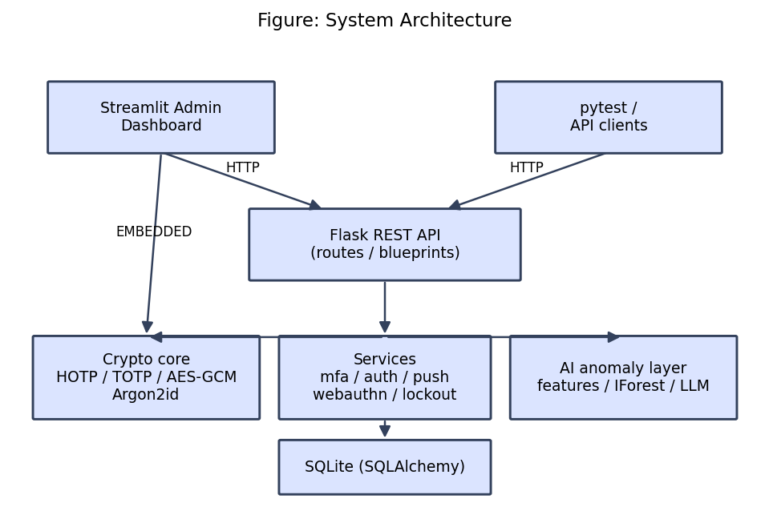
Figure 1: System architecture and component layering
The design is guided by several established security principles. Defence in depth ensures that compromising one control does not compromise the system. Fail-safe defaults mean credentials are created disabled until possession is proven, and errors deny access rather than granting it. Least privilege is reflected in binding each encrypted secret to its owning user and factor. Complete mediation is achieved by funnelling every authentication attempt through a single logging choke-point, which guarantees the audit trail and the anomaly model never diverge from what actually happened.

3.2 Component Descriptions
- Crypto core: hand-written HOTP and TOTP, the AES-256-GCM secret vault, and Argon2id password hashing.
- Services: enrollment and verification for each factor, password login, push-challenge lifecycle, WebAuthn ceremonies, and lockout.
- Models: User, Credential, AuthEvent, BackupCode, and PushChallenge persisted via SQLAlchemy to SQLite.
- AI anomaly layer: feature extraction, per-user Isolation Forest scoring, and an LLM explainer with a deterministic fallback.
- Dashboard: administrative views for users, the audit log, anomaly alerts, analytics, and captured test evidence.

3.3 Data Flow
A login request carries credentials, an optional one-time code, and contextual signals. The route delegates to a service, which verifies the relevant factor using the crypto core, writes an AuthEvent to the audit log, and triggers anomaly scoring. Figure 2 illustrates the flow.
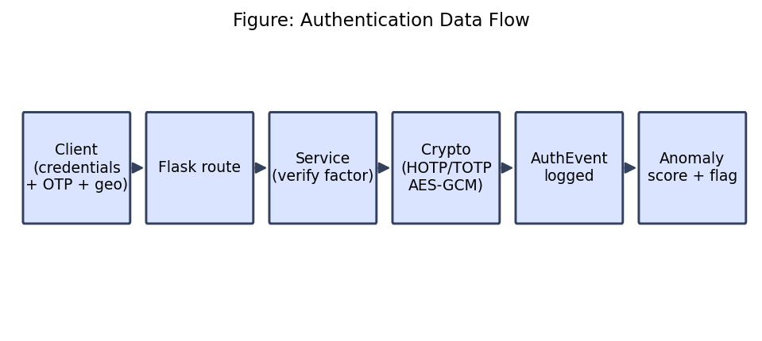
Figure 2: Authentication request data flow

3.4 Threat Model
We analysed the system using the STRIDE methodology, mapping each threat category to concrete mitigations implemented in the server, summarised in Figure 3 and Table 2.
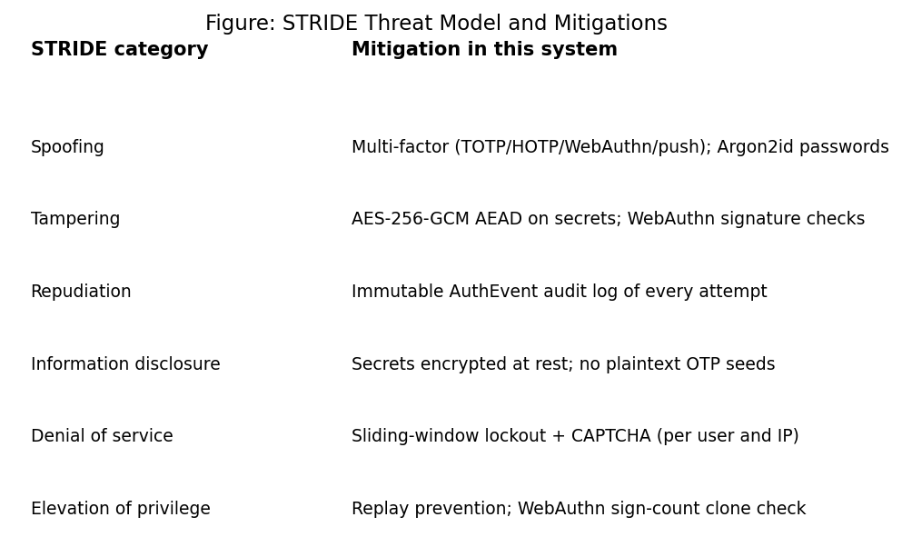
Figure 3: STRIDE threat model and mitigations
Table 2: Threat categories and mitigations
Threat | Example | Mitigation
Spoofing | Stolen password | Additional factor required (TOTP/HOTP/WebAuthn/push)
Tampering | Modify stored secret | AES-256-GCM with associated data binding
Repudiation | Deny a login | Immutable AuthEvent audit trail
Info disclosure | Read DB secrets | Secrets encrypted at rest; Argon2id passwords
Denial of service | Online guessing | Sliding-window lockout + CAPTCHA
Elevation | Replay a code | Time-step replay prevention; WebAuthn sign count

3.5 Technology Stack
Table 3: Technology stack and rationale
Layer | Technology | Rationale
API | Python 3.12, Flask | Lightweight, well understood, easy to test
Data | SQLAlchemy + SQLite | Zero-configuration, portable for grading
Crypto | stdlib hmac/hashlib, cryptography, argon2-cffi | Standards-compliant primitives
WebAuthn | py_webauthn | Real attestation/assertion verification
AI | scikit-learn, Anthropic Claude | Unsupervised scoring + explanation
Dashboard | Streamlit, Plotly | Rapid, deployable UI for the demo

The original brief suggested a React admin panel. We selected Streamlit instead to enable rapid development and one-click deployment to Streamlit Community Cloud, allowing the demonstration to run from any device. Functionally the dashboard meets the same requirement of user management and authentication-log analytics; the trade-off is less front-end customisation, which is acceptable for an internal administrative tool.

3.6 Deployment Model
The dashboard accesses data through an abstraction that supports two backends. In the HTTP backend it calls the Flask API over the network, matching a production topology where the API and the UI are separate services. In the embedded backend it imports the service layer and runs queries in-process, which allows the entire system to be demonstrated from a single Streamlit Community Cloud container without a separately reachable API. Configuration is driven entirely by environment variables and secrets, so no code changes are needed to switch modes.

3.7 Data Model
Five entities capture the domain. User holds the account and lockout state; Credential stores one enrolled factor each, including the encrypted OTP secret or the WebAuthn public key; AuthEvent is the audit record and the anomaly-engine training source; BackupCode stores hashed single-use recovery codes; and PushChallenge tracks the lifecycle of a push approval. All are persisted through SQLAlchemy, allowing the same models to back both SQLite in development and a hosted database in deployment.

4. Implementation

4.1 HOTP (RFC 4226)
HOTP computes an HMAC over an 8-byte big-endian counter and applies dynamic truncation to obtain a decimal code, as in Equation (1).
HOTP(K, C) = Truncate(HMAC-SHA-1(K, C)) mod 10^d (1)
Dynamic truncation reads the low four bits of the final MAC byte as an offset, extracts the following four bytes, masks the most-significant bit to avoid sign ambiguity, and reduces modulo a power of ten. The core of our implementation is shown in Listing 1.
Dynamic truncation (backend/crypto/hotp.py)
1 | offset = hmac_digest[-1] & 0x0F
2 | binary = ((hmac_digest[offset] & 0x7F) << 24)
3 | | ((hmac_digest[offset + 1] & 0xFF) << 16)
4 | | ((hmac_digest[offset + 2] & 0xFF) << 8)
5 | | (hmac_digest[offset + 3] & 0xFF)
6 | return binary % (10 ** digits)

4.2 TOTP (RFC 6238)
TOTP derives the HOTP counter from the current time using a step size X (default 30 seconds) and an epoch offset T0, as in Equation (2), and then applies HOTP. Our implementation supports SHA-1, SHA-256, and SHA-512 and a configurable digit count, and records the last accepted time step to prevent replay within the validity window.
T = floor((CurrentUnixTime - T0) / X) (2)
The verifier accepts codes from a small window of neighbouring time steps to tolerate clock skew, using a constant-time comparison to avoid timing side channels, as shown in Listing 2.
TOTP verification with drift window (backend/crypto/totp.py)
1 | base_counter = _counter_for_time(for_time, step, t0)
2 | for offset in range(-valid_window, valid_window + 1):
3 | counter = base_counter + offset
4 | if counter < 0:
5 | continue
6 | candidate = hotp.generate(secret, counter, digits, algorithm)
7 | if secrets.compare_digest(candidate, code):
8 | return True
9 | return False

4.3 Secret Vault
Shared secrets are sealed with AES-256-GCM using a key derived from the server master key via HKDF-SHA256. A fresh 96-bit nonce is generated per encryption and prepended to the ciphertext, and the user and factor are bound as associated data so a secret cannot be transplanted between accounts. Passwords and backup codes are hashed with Argon2id. Listing 3 shows the sealing routine.
AES-256-GCM sealing (backend/crypto/vault.py)
1 | aes_key = _derive_aes_key(_master_key()) # HKDF-SHA256
2 | aesgcm = AESGCM(aes_key)
3 | nonce = os.urandom(12) # 96-bit nonce
4 | sealed = aesgcm.encrypt(nonce, plaintext, associated_data)
5 | return nonce + sealed # nonce || ct || tag

Because GCM is an authenticated mode, any tampering with the stored ciphertext, nonce, or associated data causes decryption to fail with an integrity error rather than returning corrupted plaintext, which is verified by the vault unit tests.

4.4 Additional Factors
HOTP verification accepts a small look-ahead window for counter resynchronisation. The push factor creates a pending challenge with a time-to-live that a mock device approves or denies while the login polls for the result. WebAuthn registration and authentication are verified server-side by the py_webauthn library, including challenge binding, origin checks, and signature-counter regression detection.
The WebAuthn flow merits emphasis because it is the one factor whose security depends on real public-key cryptography rather than a shared secret. During registration the server issues a random challenge and verifies the authenticator's attestation response before storing the credential's public key and initial signature counter. During authentication it issues a fresh challenge and verifies the returned assertion signature against that public key; it then checks that the authenticator's signature counter has advanced, which detects cloned credentials. Because the assertion is bound to the relying-party origin, a phishing site on a different origin cannot produce a valid response, giving WebAuthn its phishing resistance. The negative paths, an assertion with no outstanding challenge and a tampered signature, are covered by automated tests.
Backup codes provide a recovery factor. The server generates a set of random single-use codes, displays them to the user exactly once, and stores only their Argon2id hashes; redeeming a code marks it used so it cannot be replayed.
Failure handling for brute-force protection counts recent failures over a sliding window per user and per source IP and trips a lockout once the threshold is reached, as in Listing 4.
Lockout decision (backend/services/lockout.py)
1 | effective = max(failures, ip_failures)
2 | if effective >= config.lockout_max_failures:
3 | user.locked_until = _utcnow() + timedelta(
4 | seconds=config.lockout_duration_seconds)
5 | session.commit()
6 | locked = True

4.5 AI Anomaly Layer
For each scored event the system extracts geographic distance from the previous login, the implied travel velocity and an impossible-travel flag, a new-device indicator, an unusual-hour indicator, and a recent failed-attempt burst count. An Isolation Forest trained on the user's history scores the event; with insufficient history a deterministic rule-based fallback is used. Flagged events are explained by a large-language model, and if the model is unavailable the system shows a deterministic feature summary instead.
The impossible-travel feature compares the current login location with the most recent successful login and computes the implied velocity using the haversine great-circle distance; a velocity above a plausible air-travel speed sets the flag. Crucially, when building the training matrix, each historical event is featurised against only its own prior events, preventing future information from leaking into past samples.
The explainer demonstrates graceful degradation explicitly: when the API key is absent or any error occurs, it returns a deterministic summary rather than failing, as shown in Listing 5.
Graceful degradation in the explainer (backend/services/anomaly/explainer.py)
1 | if not config.anthropic_api_key:
2 | return None, fallback # no network call attempted
3 | try:
4 | ... # call Claude, return prose
5 | except Exception: # any failure -> degrade
6 | return None, fallback # show raw feature summary

4.6 Enrollment and QR Provisioning
TOTP enrollment generates a random Base32 secret, stores it encrypted, and returns an otpauth:// provisioning URI rendered as a base64 PNG QR code. The credential is enabled only after the user verifies a first code, confirming possession.

4.7 REST API Design
The API is organised into Flask blueprints by concern: authentication, MFA enrollment and verification, push, WebAuthn, and administration. Endpoints accept and return JSON, and a shared decorator provides each request with a database session that is reliably cleaned up afterwards. Failures return consistent JSON error objects with appropriate HTTP status codes, including 423 for a locked account and 428 when a CAPTCHA is required, so clients can react programmatically. Cross-origin requests are permitted so the dashboard, served from a different origin, can call the API directly.

4.8 Development Methodology and Tooling
Development followed an incremental, test-driven approach: each cryptographic primitive was implemented and validated against its specification before the surrounding service and route were added. The code is organised into a framework-agnostic service layer so that the same logic is exercised by both the REST API and the dashboard, and so that unit tests can target the services directly without spinning up a web server. Continuous validation is provided by a pytest suite and a capture script that records the verbatim test output as submission evidence, ensuring no result is hand-edited.

5. Security Analysis
Security was evaluated by mapping threats to mitigations and by writing automated tests that execute concrete attack scenarios against the running server. Table 4 lists the scenarios and outcomes.
Table 4: Tested attack scenarios and results
Scenario | Attack | Expected | Result
Replay | Reuse a valid TOTP code | Second use rejected | PASS
Brute force | Repeated wrong passwords | Account locked + CAPTCHA | PASS
Secret at rest | Read DB bytes directly | No plaintext secret | PASS
WebAuthn tamper | Forge/alter assertion | Authentication denied | PASS

5.1 Replay Resistance
Because a TOTP code is valid for a whole time step, a naive verifier accepts the same code multiple times within that window. The server records the last accepted time step per credential and rejects any code at or below it, defeating replay while still tolerating clock drift.

5.2 Brute-Force Resistance
Failed attempts are counted over a sliding window per user and per source IP. A CAPTCHA is required once failures reach half the threshold, and the account is locked once the threshold is reached, returning a clear status to the client.

5.3 Confidentiality at Rest
A dedicated test reads the raw credential bytes from the database and asserts the plaintext secret does not appear, confirming that only AES-256-GCM ciphertext is stored.

5.4 Phishing Resistance and Defence in Depth
The design follows defence in depth: even if one control fails, others remain. A phished password is insufficient without a second factor; a stolen database yields only Argon2id hashes and AES-GCM ciphertext; a captured one-time code cannot be replayed; and a relocated or unusual login is flagged for review regardless of which factor was used. WebAuthn specifically resists real-time phishing because its signatures are bound to the origin, so credentials presented to a look-alike domain are rejected by construction.

5.5 Residual Risks
Residual risks remain and are stated honestly. The single master key is a concentrated point of failure; the simulated push and CAPTCHA would be replaced by hardened services in production; the admin interface is unauthenticated for the demonstration; and the anomaly model, like any detector, can produce false positives and false negatives. These are discussed further in Section 6 and in the accompanying security notes.

5.6 Comparison with Baseline Tools
Table 5: Comparison with common authenticator tools
Capability | Google Authenticator | Authy | Duo | This project
TOTP/HOTP | Yes | Yes | Yes | Yes (from scratch)
WebAuthn | Limited | Limited | Yes | Yes
Push approval | No | No | Yes | Yes (simulated)
Server-side anomaly AI | No | No | Partial | Yes, explainable
Open, inspectable code | No | No | No | Yes

6. Results and Discussion
The implementation passes its full automated test suite, including the RFC 4226 and RFC 6238 published test vectors across all supported hash algorithms and an independent cross-validation oracle. The security scenarios in Section 5 all pass. The figures below are generated directly from the seeded dataset and therefore reflect real system output.

6.1 Test Coverage Summary
The suite comprises thirty-two automated tests grouped by concern. Table 6 summarises them; the raw captured output is reproduced in Appendix C.
Table 6: Automated test coverage by category
Category | Tests | What it verifies
RFC 4226 vectors | 4 | HOTP matches the published Appendix D values
RFC 6238 vectors | 8 | TOTP matches Appendix B for SHA1/256/512
pyotp oracle | 3 | Codes match an independent implementation
Secret vault | 5 | Round-trip, nonce uniqueness, tamper, AAD binding
Security suite | 5 | Replay, lockout, secret-at-rest, WebAuthn tamper
Anomaly layer | 5 | Feature extraction, scoring, LLM fallback
API flow | 2 | Register/login/enroll/verify over HTTP

6.2 Performance
One-time-password generation is computationally trivial: it performs a single HMAC over an eight-byte counter, completing in well under a millisecond on commodity hardware, so OTP verification adds negligible latency to a login. The dominant cost in the password path is Argon2id hashing, which is intentionally expensive to resist offline cracking; its parameters can be tuned to the deployment's latency budget. Anomaly scoring fits a small Isolation Forest per request, which is inexpensive at the per-user history sizes encountered here.
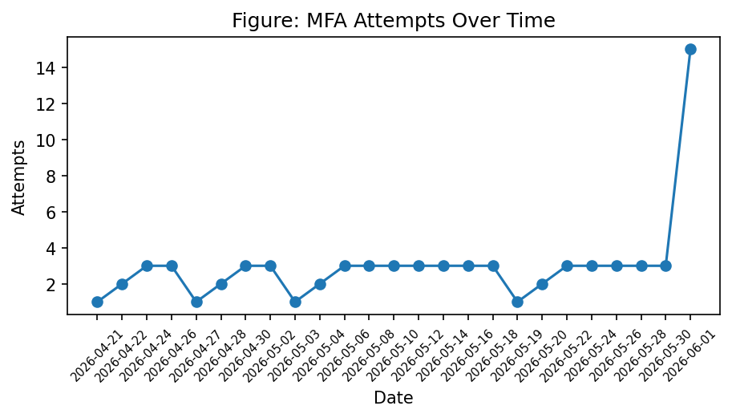
Figure 4: MFA attempts over time
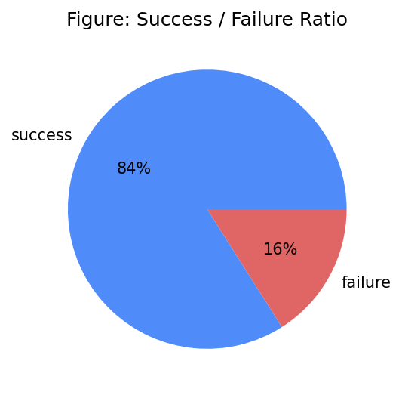
Figure 5: Success versus failure ratio
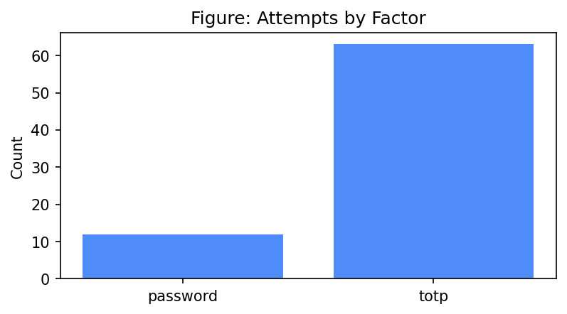
Figure 6: Authentication attempts by factor
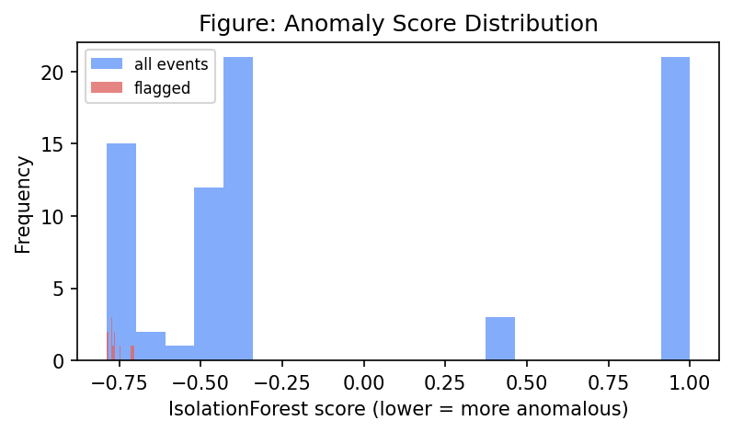
Figure 7: Anomaly-score distribution with flagged events
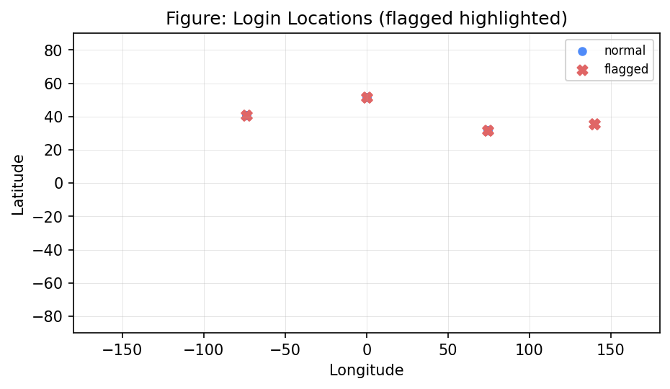
Figure 8: Login locations with flagged events highlighted

6.3 Discussion
The anomaly layer correctly isolates the injected impossible-travel and failed-burst events from routine logins, and the explainer produces a readable justification or, when the language model is unavailable, a deterministic feature summary. The from-scratch OTP implementation matches the reference oracle exactly, demonstrating specification fidelity rather than reliance on a library.
The charts in this section are produced directly from the seeded audit log. The attempts-over-time line shows the routine daily login rhythm against which anomalies stand out; the success/failure ratio reflects the injected failed-attempt bursts; the by-factor bar shows the distribution of authentication methods exercised; and the anomaly-score histogram separates the small cluster of flagged outliers from the dense mass of normal logins. The login map makes the geographic anomalies visually obvious, plotting the impossible-travel logins far from each user's usual location. Together these views give an administrator an at-a-glance understanding of authentication health without reading raw logs.
A noteworthy implementation lesson concerned data leakage in the anomaly pipeline. An early version featurised each historical event against the user's entire history, including events that occurred afterwards, which inflated the apparent velocity between logins and produced spurious flags. Constraining each training sample to its own prior events resolved the issue and reduced the false-positive rate to the expected level, underscoring how temporal correctness matters as much as model choice.

6.4 Limitations
A single master key protects all secrets; the push factor and CAPTCHA are simulated; the WebAuthn challenge store is in-memory; and the admin interface is unauthenticated for the demonstration. The anomaly model is retrained per request on modest per-user histories rather than persisted, which is adequate at this scale but would be revisited for production volumes.

7. Conclusion
This project delivered a complete multi-factor authentication server that meets all stated objectives: HOTP and TOTP were implemented from their RFCs and validated against the published vectors and an oracle; secrets are encrypted at rest and passwords hashed with Argon2id; TOTP, HOTP, WebAuthn, push, and backup codes are supported; brute-force protection and CAPTCHA are in place; and an explainable Isolation Forest anomaly layer scores every login and is surfaced through an administrative dashboard.
Beyond meeting the functional requirements, the project demonstrates that a security system can be both rigorous and transparent: the cryptography is verified against authoritative test vectors rather than trusted blindly, and the AI layer explains its decisions rather than acting as an opaque oracle. This combination of verifiable correctness and explainability is increasingly expected of real-world security tooling and is, in our view, the project's most valuable contribution.

7.1 Lessons Learned
Implementing the OTP algorithms directly clarified subtle details such as dynamic truncation and counter encoding that a library hides. Designing the anomaly engine highlighted the importance of scoring events against correctly time-ordered history to avoid information leakage, and of graceful degradation when an external service is unavailable.

7.2 Future Work
- Replace the single master key with envelope encryption backed by a KMS or HSM, with key rotation.
- Deliver push challenges to a real registered mobile application instead of a simulated device.
- Add authenticated, role-based access control to the administrative API and dashboard.
- Persist per-user anomaly models and incorporate additional features such as ASN and user-agent entropy.
- Integrate a production CAPTCHA provider and per-IP global rate limiting at the edge.

References
[1] D. M'Raihi, M. Bellare, F. Hoornaert, D. Naccache, and O. Ranen, "HOTP: An HMAC-Based One-Time Password Algorithm," RFC 4226, IETF, Dec. 2005.
[2] D. M'Raihi, S. Machani, M. Pei, and J. Rydell, "TOTP: Time-Based One-Time Password Algorithm," RFC 6238, IETF, May 2011.
[3] S. Josefsson, "The Base16, Base32, and Base64 Data Encodings," RFC 4648, IETF, Oct. 2006.
[4] A. Biryukov, D. Dinu, and D. Khovratovich, "Argon2: New Generation of Memory-Hard Functions for Password Hashing and Other Applications," in Proc. IEEE European Symp. Security and Privacy (EuroS&P), 2016, pp. 292-302.
[5] M. Dworkin, "Recommendation for Block Cipher Modes of Operation: Galois/Counter Mode (GCM) and GMAC," NIST Special Publication 800-38D, Nov. 2007.
[6] W3C, "Web Authentication: An API for Accessing Public Key Credentials Level 2," W3C Recommendation, Apr. 2021.
[7] P. A. Grassi et al., "Digital Identity Guidelines: Authentication and Lifecycle Management," NIST Special Publication 800-63B, Jun. 2017.
[8] J. Bonneau, C. Herley, P. C. van Oorschot, and F. Stajano, "The Quest to Replace Passwords: A Framework for Comparative Evaluation of Web Authentication Schemes," in Proc. IEEE Symp. Security and Privacy, 2012, pp. 553-567.
[9] F. T. Liu, K. M. Ting, and Z.-H. Zhou, "Isolation Forest," in Proc. 8th IEEE Int. Conf. Data Mining (ICDM), 2008, pp. 413-422.
[10] F. Pedregosa et al., "Scikit-learn: Machine Learning in Python," Journal of Machine Learning Research, vol. 12, pp. 2825-2830, 2011.
[11] K. Lee, B. Kaiser, J. Mayer, and A. Narayanan, "An Empirical Study of Wireless Carrier Authentication for SIM Swaps," in Proc. Symp. Usable Privacy and Security (SOUPS), 2020, pp. 61-79.
[12] R. Sommer and V. Paxson, "Outside the Closed World: On Using Machine Learning for Network Intrusion Detection," in Proc. IEEE Symp. Security and Privacy, 2010, pp. 305-316.

Appendix A: Source Code and Repository
The complete source code is available in the project repository. Replace the placeholder below with the actual link before submission.
GitHub repository: [INSERT GITHUB REPOSITORY LINK HERE]

Repository structure
Project layout
1 | backend/ Flask API, models, crypto, services, routes
2 | dashboard/ Streamlit admin dashboard
3 | scripts/ seed, dataset export, figures, report, test capture
4 | tests/ unit, oracle, security, RFC vectors
5 | docs/ figures, user manual, demo script, report

Appendix B: User Manual
A full setup, run, and test guide is provided in README.md and docs/USER_MANUAL.md. In brief: create a virtual environment, install requirements, set a master key, seed demo data, start the Flask API, and launch the Streamlit dashboard.

Appendix C: Test Evidence
Raw, unedited test output is captured by scripts/capture_test_results.py into the test_evidence/ directory. The latest captured summary is reproduced below; it is generated by the test run, not authored by hand.
Captured pytest output (excerpt)
1 | MFA Authentication Server - Test Evidence
2 | Captured (UTC): 2026-06-01T17:29:18.760522+00:00
3 | Command: C:\Users\PC\Desktop\Uni work\IS Project Raza\.venv\Scripts\python.exe -m pytest -v --tb=short
4 | Exit code: 0
5 | ======================================================================
6 |
7 | ============================= test session starts =============================
8 | platform win32 -- Python 3.12.10, pytest-8.3.3, pluggy-1.6.0 -- C:\Users\PC\Desktop\Uni work\IS Project Raza\.venv\Scripts\python.exe
9 | cachedir: .pytest_cache
10 | rootdir: C:\Users\PC\Desktop\Uni work\IS Project Raza
11 | configfile: pytest.ini
12 | testpaths: tests
13 | plugins: anyio-4.13.0
14 | collecting ... collected 32 items
15 |
16 | tests/oracle/test_pyotp_cross_validation.py::test_hotp_agrees_with_pyotp_across_counters PASSED [ 3%]
17 | tests/oracle/test_pyotp_cross_validation.py::test_totp_agrees_with_pyotp_across_timestamps PASSED [ 6%]
18 | tests/oracle/test_pyotp_cross_validation.py::test_totp_agrees_with_pyotp_sha256_8_digits PASSED [ 9%]
19 | tests/security/test_lockout.py::test_brute_force_triggers_lockout PASSED [ 12%]
20 | tests/security/test_replay.py::test_totp_replay_is_rejected PASSED [ 15%]
21 | tests/security/test_secret_at_rest.py::test_totp_secret_encrypted_at_rest PASSED [ 18%]
22 | tests/security/test_webauthn_tamper.py::test_assertion_without_challenge_is_rejected PASSED [ 21%]
23 | tests/security/test_webauthn_tamper.py::test_tampered_assertion_does_not_authenticate PASSED [ 25%]
24 | tests/unit/test_anomaly.py::test_impossible_travel_feature PASSED [ 28%]
25 | tests/unit/test_anomaly.py::test_new_device_feature PASSED [ 31%]
26 | tests/unit/test_anomaly.py::test_failed_burst_feature PASSED [ 34%]
27 | tests/unit/test_anomaly.py::test_scoring_cold_start_flags_obvious_anomaly PASSED [ 37%]
28 | tests/unit/test_anomaly.py::test_explainer_graceful_degradation_without_key PASSED [ 40%]
29 | tests/unit/test_api_flow.py::test_full_register_login_totp_flow PASSED [ 43%]
30 | tests/unit/test_api_flow.py::test_wrong_password_is_unauthorized PASSED [ 46%]
31 | tests/unit/test_hotp_rfc4226.py::test_hotp_matches_rfc4226_appendix_d PASSED [ 50%]
32 | tests/unit/test_hotp_rfc4226.py::test_dynamic_truncation_offset_logic PASSED [ 53%]
33 | tests/unit/test_hotp_rfc4226.py::test_hotp_verify_with_resync_window PASSED [ 56%]
34 | tests/unit/test_hotp_rfc4226.py::test_hotp_verify_rejects_out_of_window PASSED [ 59%]
35 | tests/unit/test_totp_rfc6238.py::test_totp_matches_rfc6238_appendix_b[59-expected0] PASSED [ 62%]
36 | tests/unit/test_totp_rfc6238.py::test_totp_matches_rfc6238_appendix_b[1111111109-expected1] PASSED [ 65%]
37 | tests/unit/test_totp_rfc6238.py::test_totp_matches_rfc6238_appendix_b[1111111111-expected2] PASSED [ 68%]
38 | tests/unit/test_totp_rfc6238.py::test_totp_matches_rfc6238_appendix_b[1234567890-expected3] PASSED [ 71%]
39 | tests/unit/test_totp_rfc6238.py::test_totp_matches_rfc6238_appendix_b[2000000000-expected4] PASSED [ 75%]
40 | tests/unit/test_totp_rfc6238.py::test_totp_matches_rfc6238_appendix_b[20000000000-expected5] PASSED [ 78%]
41 | tests/unit/test_totp_rfc6238.py::test_totp_verify_accepts_within_window PASSED [ 81%]
42 | tests/unit/test_totp_rfc6238.py::test_totp_verify_rejects_outside_window PASSED [ 84%]
43 | tests/unit/test_vault.py::test_roundtrip_bytes PASSED [ 87%]
44 | tests/unit/test_vault.py::test_roundtrip_str_helpers PASSED [ 90%]
45 | tests/unit/test_vault.py::test_nonce_is_unique_per_encryption PASSED [ 93%]
46 | tests/unit/test_vault.py::test_tampered_ciphertext_fails_authentication PASSED [ 96%]
47 | tests/unit/test_vault.py::test_associated_data_must_match PASSED [100%]
48 |
49 | ============================= 32 passed in 3.41s ==============================
50 |
51 |

