Assignment 02
Technical Analysis Using R
Student Name - .Razak Mohammad
Student ID - 664429142
Course – Data Science and Techniques (BDA400)

GitHub repository: https://github.com/Razak29142/TechnicalAnalysis
Objective and Overview
This preliminary stage establishes a GitHub repository and an R-based workflow for downloading historical stock prices, calculating descriptive statistics, and visualizing closing prices alongside 20-day simple moving averages. The five selected ticker symbols are AAPL, MSFT, GOOGL, AMZN, and TSLA.
1. GitHub Repository Setup
A public GitHub repository named TechnicalAnalysis was configured with a README file. A separate Assignment2 directory was created to organize the assignment deliverables.
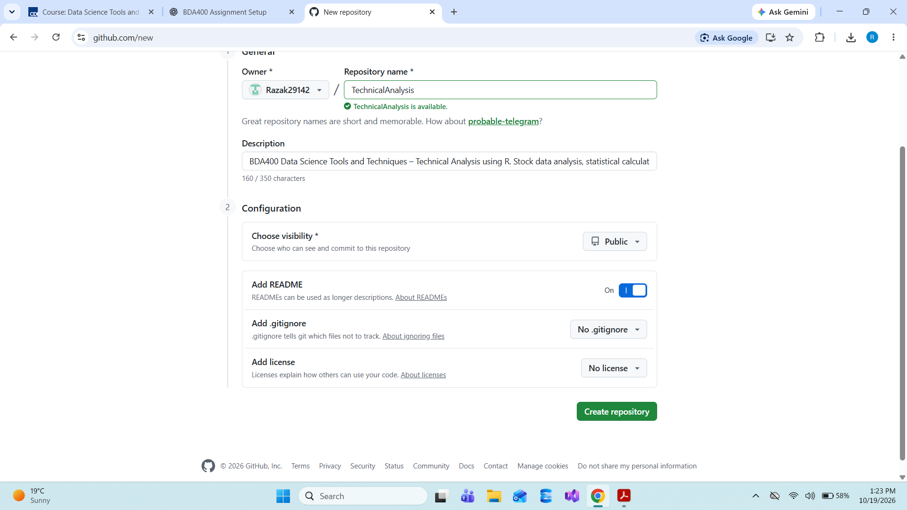

2. R and RStudio Environment
The analysis was performed in a Posit Cloud RStudio project named BDA400_TechnicalAnalysis. The screenshot displays R version. Posit Cloud is a browser-based environment the assignment also explicitly requests local installation of R and RStudio.
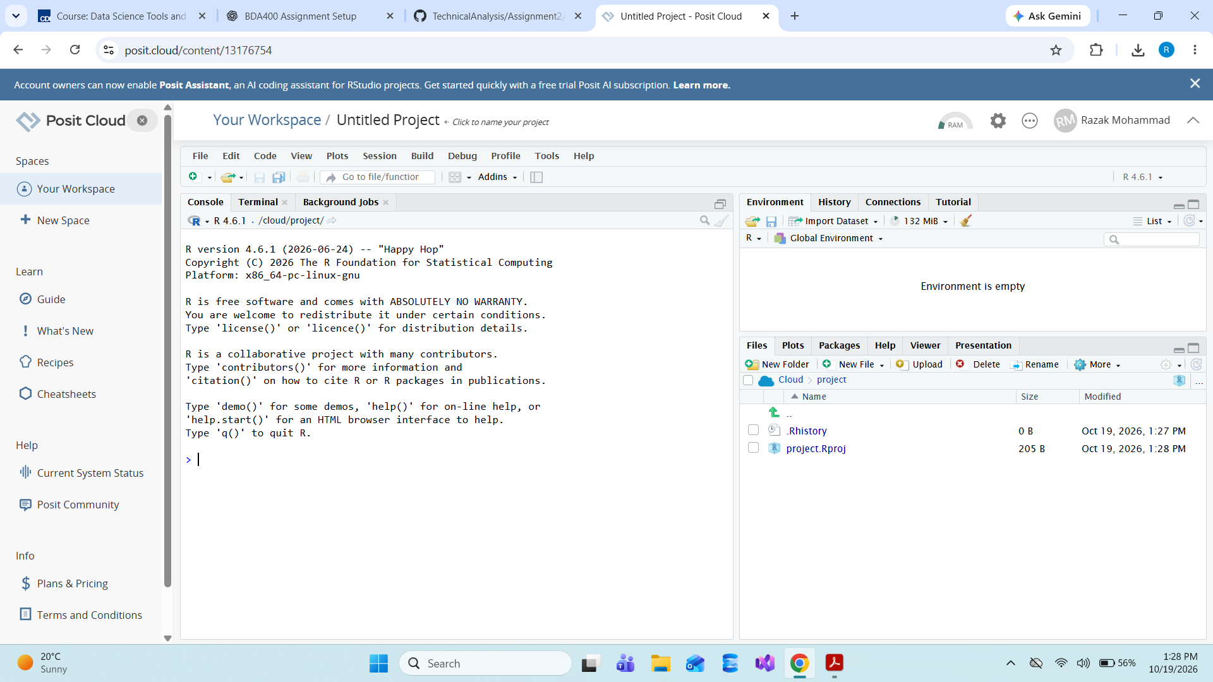
3. R Package Installation
The following packages were installed using install.packages(c("quantmod", "TTR", "ggplot2")). quantmod downloads market data, TTR supplies technical indicators, and ggplot2 creates plots. The installation output shows successful completion.
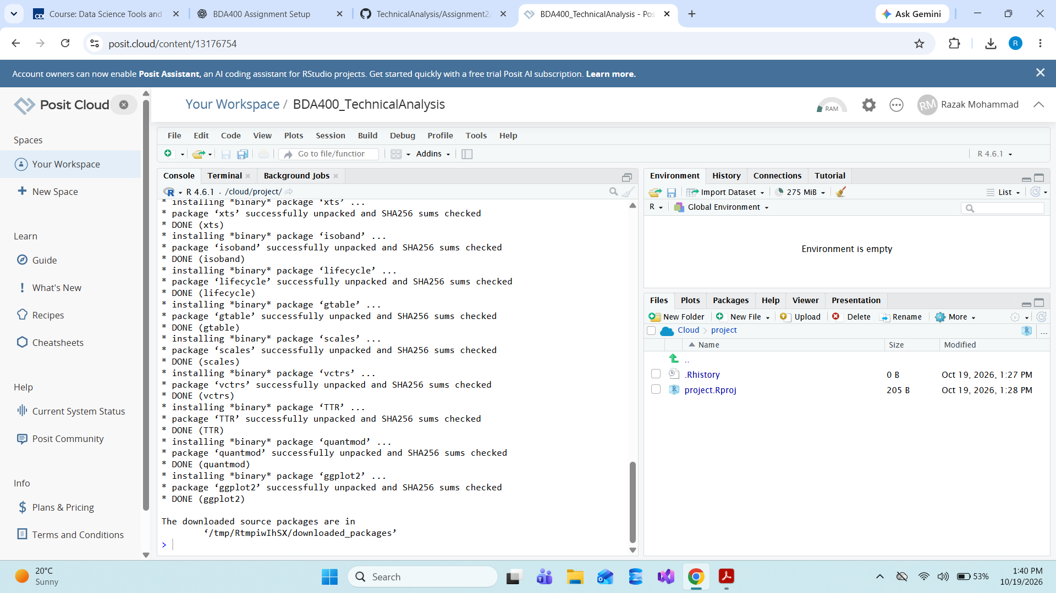
The packages were then loaded using library(quantmod), library(TTR), and library(ggplot2).
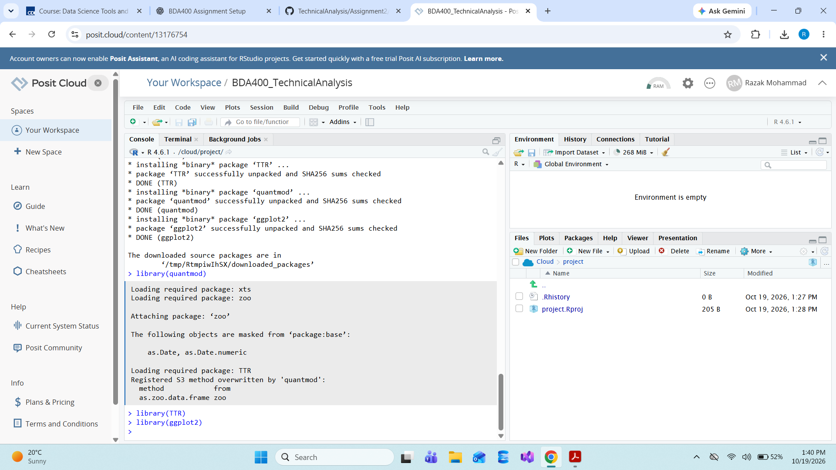
4. Portfolio Configuration
A plain-text file named portfolio.txt was created with one stock ticker per line: AAPL, MSFT, GOOGL, AMZN and TSLA. The same file was saved in the Posit Cloud project and uploaded to the GitHub Assignment2 folder.
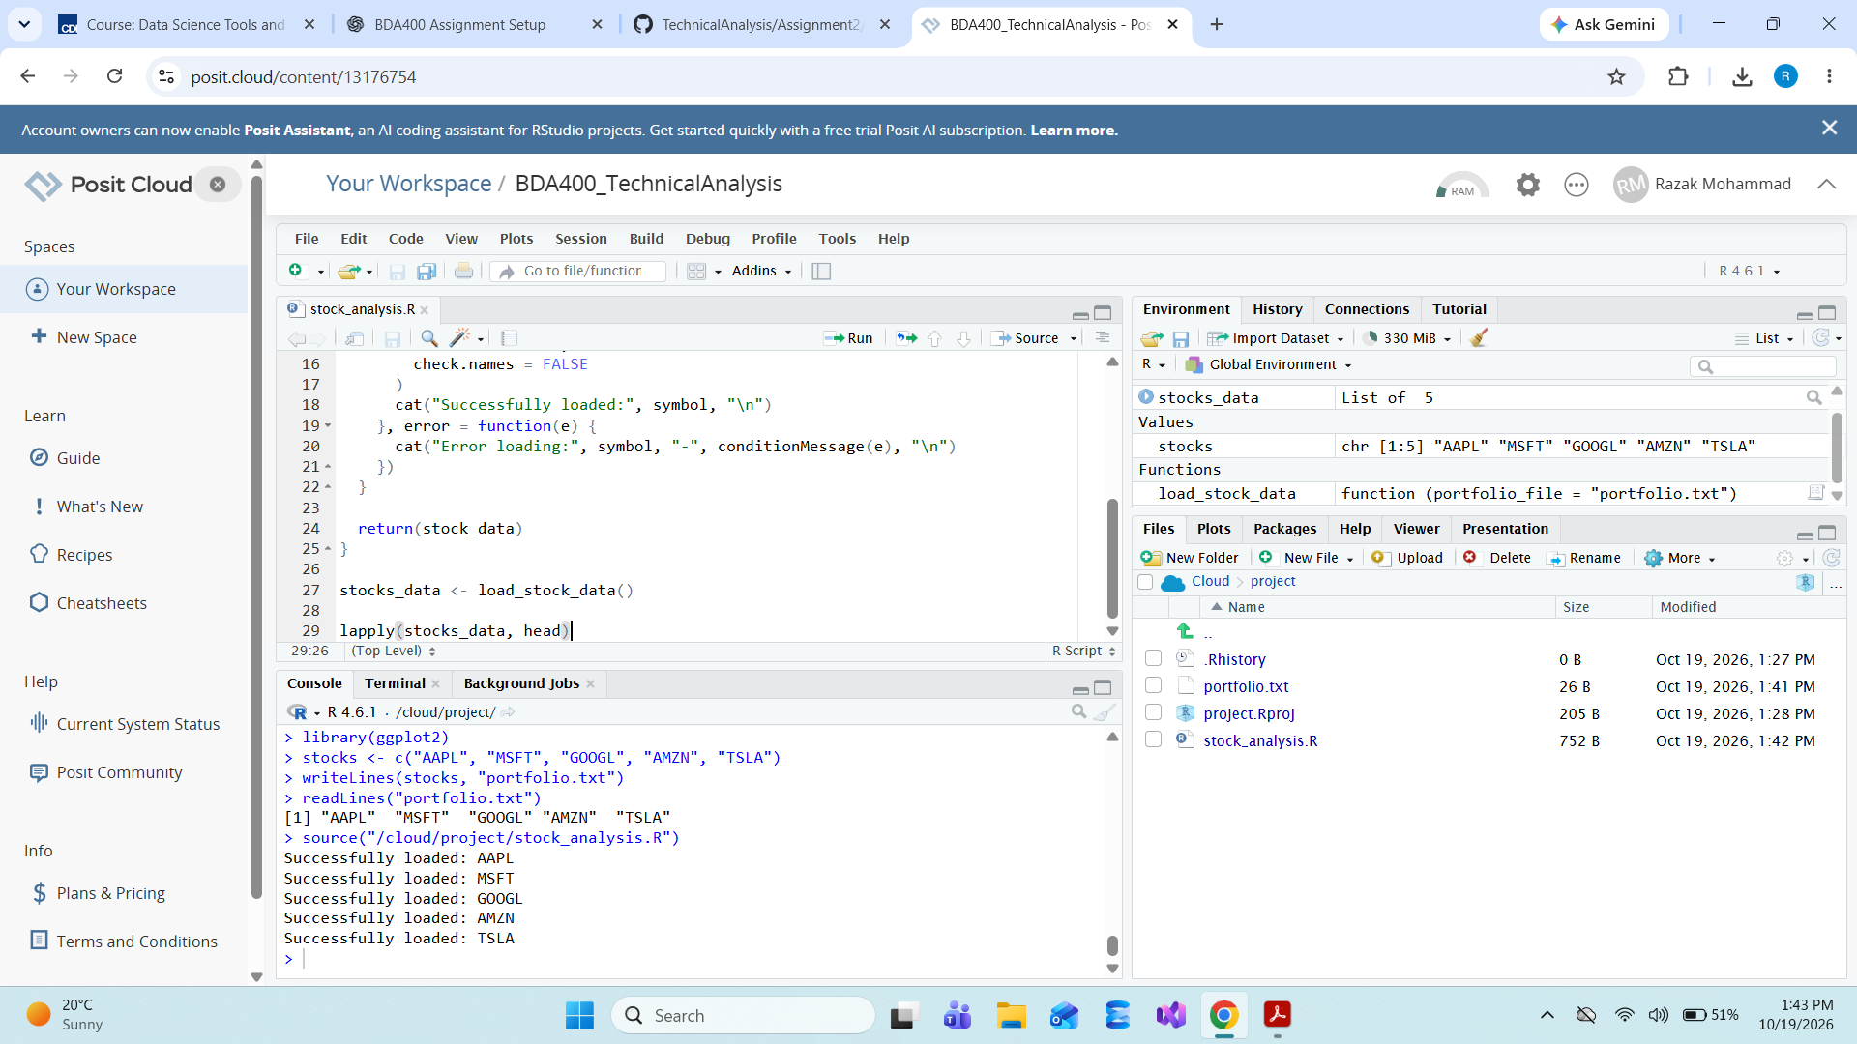
5. Stock Data Import Function
The custom load_stock_data() function reads the symbols from portfolio.txt, requests historical prices from Yahoo Finance through quantmod::getSymbols(), and converts each downloaded time series into a separate data frame stored in a named list. tryCatch() handles individual download failures without stopping the entire loop. The observed Console confirms all five symbols loaded successfully.
6. Descriptive Statistics
The calculate_statistics() function uses closing prices to compute the mean, median, a frequency-based mode, standard deviation, and the latest 20-day simple moving average. Results were calculated separately for all five symbols and printed to the Console. For continuously valued stock prices, a frequency-based mode may be less informative when prices are unique.
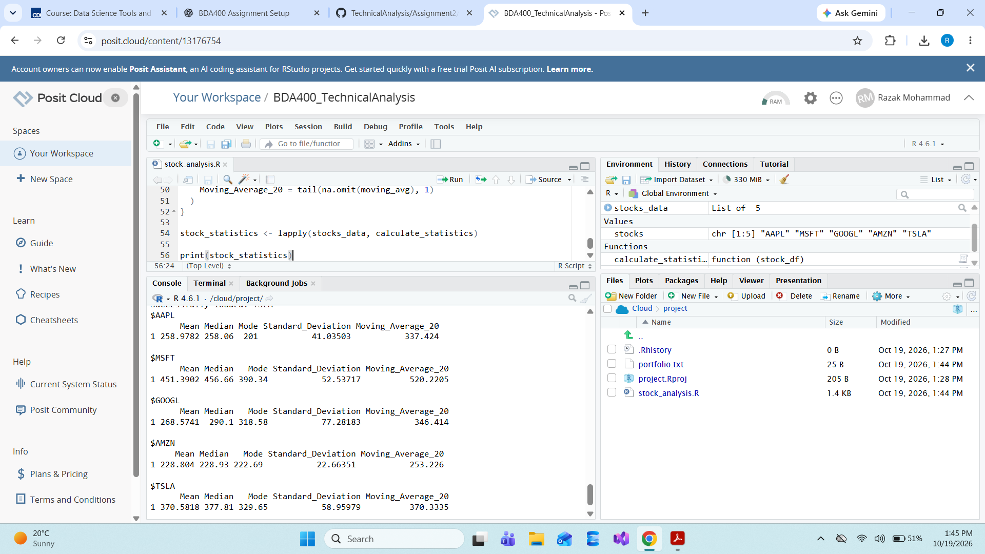
Observed results (as displayed in RStudio)
Ticker | Mean | Median | Mode | Std. dev. | Latest MA20
AAPL | 258.9782 | 258.06 | 201 | 41.03503 | 337.424
MSFT | 451.3902 | 456.66 | 390.34 | 52.53717 | 520.2205
GOOGL | 268.5741 | 290.1 | 318.58 | 77.28183 | 346.414
AMZN | 228.804 | 228.93 | 222.69 | 22.66351 | 253.226
TSLA | 370.5818 | 377.81 | 329.65 | 58.95979 | 370.3335

7. Stock Charts and Moving Averages
The ggplot2 visualization draws daily closing prices and the 20-day moving average against calendar dates. One PNG image was exported per stock. The first 19 moving-average entries are undefined because 20 prices are needed; these can be omitted during plotting with na.rm = TRUE.
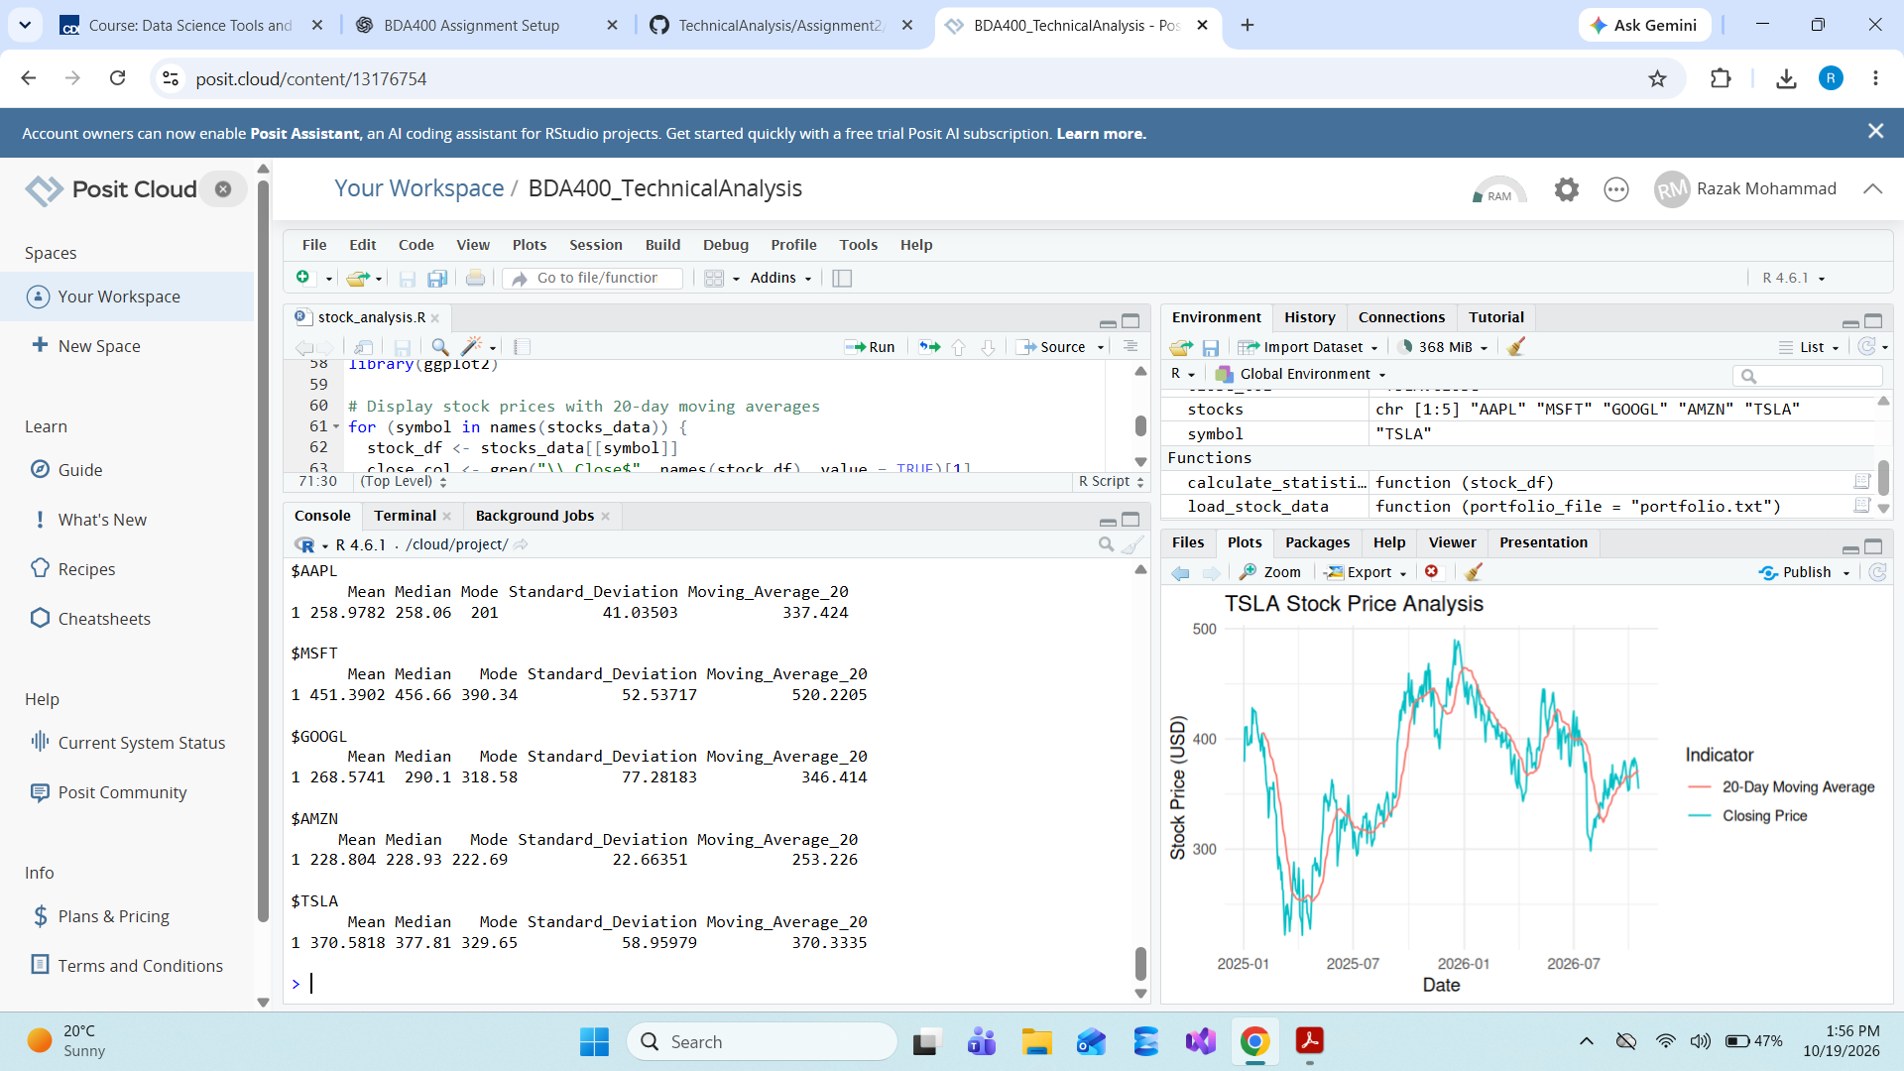
8. GitHub Submission Verification
The final GitHub Assignment2 folder visibly contains README.md, portfolio.txt, stock_analysis.R, and five PNG charts: AAPL, MSFT, GOOGL, AMZN and TSLA. The uploaded script includes both the data import/statistics and visualization code.
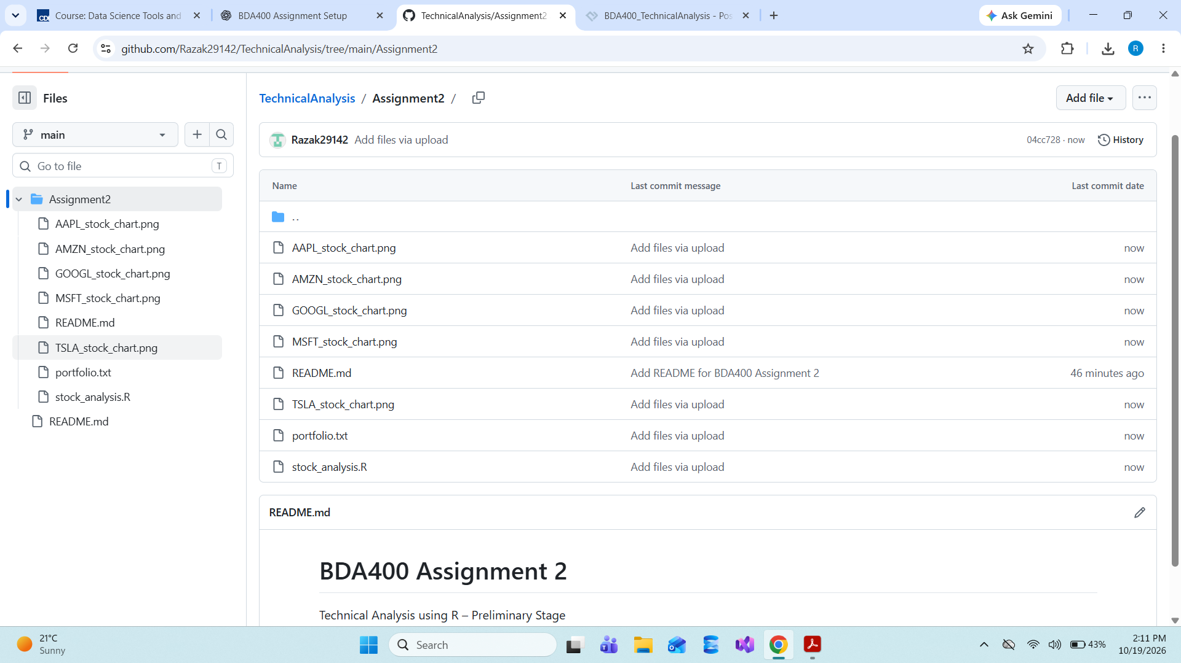

Reflection
This assignment provided practical experience in organizing reproducible analysis files, importing historical financial data, using functions to avoid repeated code, and comparing price trends with a rolling average. GitHub provides a central location for the code and generated charts. The moving average smooths daily fluctuations, but it is a descriptive indicator and does not guarantee future performance.

AI Use and Acknowledgement
I used ChatGPT as a learning and writing assistant while completing this assignment. I used it to break the assignment instructions into manageable steps, understand the GitHub and Posit Cloud workflow, draft R code for importing stock data, calculating statistics and producing charts, and explain the moving-average warnings.
I ran the code in Posit Cloud, reviewed the console output and charts, saved the generated files, and uploaded the assignment materials to my GitHub repository. I reviewed the material and remain responsible for checking the accuracy of the submitted files and explanations.

