

Kalika Manavgyan Secondary School

Butwal-10-Rupendehi
Project Work
Subject:Mathematics

Submitted To Submitted By Bimal Attreya Group:
Signature:

Declaration Letter
I hereby declare that the project work “ APPLICATIONS OF DERIVATIVE” submitted to Department of Chemistry Kalika Manavgyan Secondary School in the form of hard copy of project work which has done under the supervision of Sir Bimal Attreya and Sir Santosh Tiwari and is submitted for the partial fulfillment of mathematics grade 12.
Group Members

- Prashant Bhattrai 6. Bibek Bhandari
2. Sushant Bhattrai 7. Bishal Belbase 3. Rajan Paudel 8. Shiva Neupane
4. Shittal Bashyal 9. Samrat Bhusal
5. Nabin Gyawali

INTRODUCTION AND
APPLICATION
OF
THE
DERIVATIVES

Background of study

- Calculus is a branch of mathematics that deals with the study of rates of change and how things change over time. It has numerous applications in fields such as physics, engineering, economics, and computer science.
- The development of calculus is credited to two great mathematicians, Isaac Newton and Gottfried Wilhelm Leibniz, who worked independently in the 17th century. Newton developed calculus to solve problems in physics, while Leibniz developed it as a means of understanding the foundations of mathematics
- The study of calculus involves two main branches: differential calculus and integral calculus. Differential calculus deals with the study of rates of change and slopes of curves, while integral calculus focuses on the study of areas and volumes.

History of Calculus

The history of calculus dates back to ancient times, with early contributions from Babylonian, Egyptian, Greek, and Indian mathematicians. However, the modern development of calculus is primarily attributed to the work of two 17th-century mathematicians: Sir Isaac Newton and Gottfried Wilhelm Leibniz.
Newton is credited with the development of differential calculus, which deals with the rates of change and slopes of curves. He developed the fundamental concepts of calculus, such as limits, derivatives, and integrals, which are still widely used today..
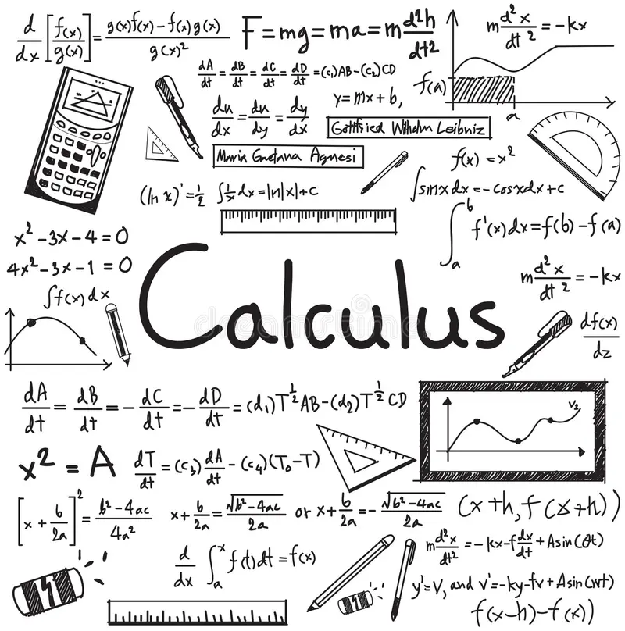

The derivative is defined as the rate of change of one quantity with respect to another. In terms of functions, the rate of change of function is defined as dy/dx = f(x) = y’.
The concept of derivatives has been used in small scale and large scale. The concept of derivatives used in many ways such as change of temperature or rate of change of shapes and sizes of an object depending on the conditions etc…

Rate of Change of a Quantity
This is the general and most important application of derivative. For example, to check the rate of change of the volume of a cube with respect to its decreasing sides, we can use the derivative form as dy/dx. Where dy represents the rate of change of volume of cube and dx represents the change of sides of the cube.

Increasing and Decreasing Functions
- To find that a given function is increasing or decreasing or constant, say in a graph, we use derivatives.
- If f is a function which is continuous in [p, q] and differentiable in the open interval (p, q), then,
- f is increasing at [p, q] if f'(x) > 0 for each x ∈ (p, q)
- f is decreasing at [p, q] if f'(x) < 0 for each x ∈ (p, q)
- f is constant function in [p, q], if f'(x)=0 for each x ∈ (p, q)
Tangent and Normal To a Curve
A tangent is a line that touches the curve at a point and doesn’t cross it, whereas normal is perpendicular to that tangent.
Let the tangent meet the curve at P(x1, y1)
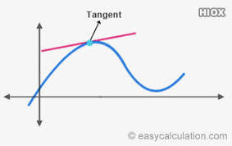

Now the straight-line equation which passes through a point having slope m could be written as;
y – y1 = m(x – x1)
We can see from the above equation, the slope of the tangent to the curve y = f(x) and at the point P(x1, y1), it is given as dy/dx at P(x1, y1) = f'(x). Therefore,
Equation of the tangent to the curve at P(x1, y1) can be written as:
y – y1 = f'(x1)(x – x1)
Equation of normal to the curve is given by;
y – y1 = [-1/ f'(x1)] (x – x1)
Or
(y – y1) f'(x1) + (x-x1) = 0

Maxima and Minima
To calculate the highest and lowest point of the curve in a graph or to know its turning point, the derivative function is used.
When x = a, if f(x) ≤ f(a) for every x in the domain, then f(x) has an Absolute Maximum value and the point a is the point of the maximum value of f.
When x = a, if f(x) ≤ f(a) for every x in some open interval (p, q) then f(x) has a Relative Maximum value.
When x= a, if f(x) ≥ f(a) for every x in the domain then f(x) has an Absolute Minimum value and the point a is the point of the minimum value of f.
When x = a, if f(x) ≥ f(a) for every x in some open interval (p, q) then f(x) has a Relative Minimum value.
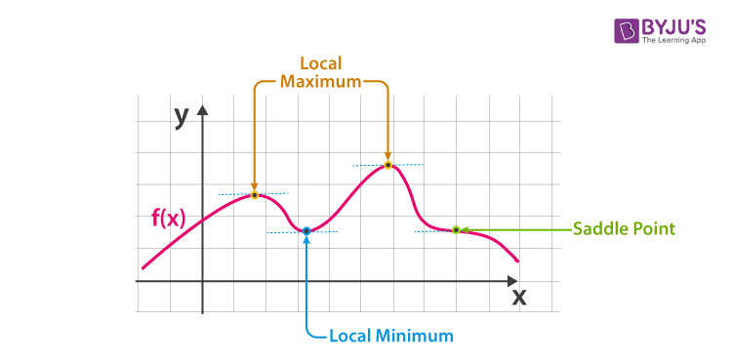

Literature review

A literature review for a calculus project would involve an in-depth analysis of previous research, studies, and publications related to calculus. The literature review would provide a comprehensive overview of the existing knowledge and understanding of calculus, and identify gaps in the literature that the project aims to address.
Some possible areas of focus for a literature review on calculus could include:
The historical development of calculus, including the contributions of Newton and Leibniz, and the evolution of calculus as a field of study.
The fundamental concepts of calculus, such as limits, derivatives, and integrals, and the applications of these concepts in various fields.
Techniques for solving calculus problems, including differentiation, integration, and optimization.
Applications of calculus in physics, engineering, economics, and finance, and the use of calculus in modeling and analyzing real-world phenomena.

Real World Application of Application of Derivative

Let’s look at a problem that may arise in our life
The length of the rectangle is decreasing at the rate of 6 cm per second and the breath is increasing at the rate of 3 cm per second find the rates of changes of a). perimeter b). area of the rectangle and the instant when the length and the breath of the rectangle are respectively 10 cm and 8 cm.
Solution: a) Perimeter:
Let's denote the current length of the rectangle as L and the current breadth as B. We know that:
Rate of change of length (dL/dt) = -6 cm/s (negative because it's decreasing)
Rate of change of breadth (dB/dt) = 3 cm/s
The perimeter (P) is given by: P = 2(L + B)
Taking the derivative of both sides with respect to time (t), we get the rate of change of the perimeter:
dP/dt = 2((dL/dt) + (dB/dt))
Substituting the known values:
dP/dt = 2((-6) + (3)) = -6 cm/s

Therefore, the perimeter of the rectangle is decreasing at a rate of 6 cm/s.

b). Solution
Area:
The area (A) of the rectangle is given by:
A = LB
Taking the derivative of both sides with respect to time (t), we get the rate of change of the area:
dA/dt = L(dB/dt) + B(dL/dt)
Substituting the known values:
dA/dt = (L)(3) + (B)(-6)
= 10*3 + 8*-6
= 30- 48
= -18 cm/sec
Hence, the area is decreasing at the rate of – 18 cm/sec.
If the distance 's' covered by a moving body in time T is given by S is equal to at^2 + bt + c, where a ,b and c are constant prove that 4a(s-c)=v^2-b^2 where v denotes the velocity of the body?
Solution: Given:
s = at^2 + bt + c, where s is distance, t is time, and a, b, and c are constants.
v = ds/dt, where v is velocity.
We want to prove:
4a(s - c) = v^2 - b^2
Differentiate s = at^2 + bt + c to find v:
v = ds/dt = 2at + b
Square v:
v^2 = 4a^2t^2 + 4abt + b^2
Substitute t^2 with (s - c)/a using the original equation for s:
v^2 = 4a(s - c) + 4abt + b^2
Rearrange terms:
4a(s - c) = v^2 - b^2
Therefore, the relationship is proven.
Learning outcomes
Objectives:
To gain a deeper understanding of the fundamental concepts of calculus, such as limits, derivatives, and integrals.
To apply calculus techniques to solve real-world problems in fields such as physics, engineering, economics, or finance.
To develop the ability to communicate mathematical ideas and solutions effectively, both verbally and in writing.
To improve critical thinking skills by analyzing and interpreting mathematical data and results.
Significance
Calculus has a significant role in mathematics and many other fields due to its ability to model and analyze complex systems and phenomena. Here are some of the significant applications of calculus in various fields:
Physics: Calculus is widely used in physics to model and analyze physical phenomena, such as the motion of objects, the behavior of fluids, and the propagation of waves.
Engineering: Engineers use calculus to design and analyze complex systems, such as electrical circuits, mechanical systems, and aerospace vehicles.
Economics: Calculus is used in economics to model and analyze the behavior of markets, prices, and economic growth.
Computer Science: Calculus is used in computer science to develop algorithms for numerical analysis, artificial intelligence, and machine learning.
Biology: Calculus is used in biology to model and analyze biological processes, such as population growth, the spread of diseases, and the behavior of neurons.Medicine: Medical professionals use calculus to model and analyze medical data, such as blood flow, drug interactions, and disease progression.

Conclusion

In conclusion, the project has highlighted the importance of calculus in various fields and its applications in real-world problems. By mastering the concepts and techniques of calculus, we can gain a deeper understanding of the world around us and apply this knowledge to a variety of fields and disciplines.

References

https://byjus.com/maths/applications-of-derivatives/
https://www.scribd.com/presentation/532221171/Maths-investigatory-project-class-12
https://www.cuemath.com/calculus/applications-of-derivatives/

