

Kalika Manavgyan Secondary School

Butwal-10-Rupendehi
Project Work
Subject:Chemistry

Detection of Presence of Acetic Acid In Vinegar

Acknowledgement
I hereby declare that the project work “ Detection of Acetic Acid in Vinegar” submitted to Department of Chemistry Kalika Manavgyan Secondary School in the form of hard copy of project work which has done under the supervision of Chemistry teachers Kabir Oli and Amrit Khanal and is submitted for the partial fulfillment of the requirements for the secondary level education of National Examination Board Chemistry Grade 12.

Group Members

- Shivpal Chaudhary 6. Samrat Basual
2. Sushant Bhattrai 3. Rajan Paudel
4. Rupesh Baral
5. Shiva Neupane

Index

- Object……………………………….……………………………….06

- Background of the study ………………………………………….07
- Materials and Chemicals …………………………………………08

- Theory…………………………………………………………………….09

- Experimental Procedure………………………………………….10

- Observation…………………………………………………………….11

- Result Conclusion and Precautions ………………………….11

- Bibliography……………………………………………………………11

TO DETECT THE PRESENCE OF ACETIC ACID IN A SAMPLE OF VINEGAR

BACKGROUND OF THE STUDY

Vinegar is a solution made from fermentation of ethanol. There are many types of vinegar each starting from different sources. The amount of acetic acid(CH3COOH) in vinegar can vary, typically between 4% to 6%.
In this project, we determine the amount of acetic acid in different vinegar using titration. Titration is a way to measure the unknown amount of a chemical(titrand) in a solution with a known concentration(titrant) and the end point is monitored.
To monitor the acidity of a vinegar solution we can add enough hydroxyl ions to balance out the added hydrogen ions from the acid. Hydroxyl ions react with hydrogen ions to give water.
For titrand we use a dilute solution of sodium hydroxide.
Sodium hydroxide is a strong base and it disassociates into sodium and hydroxyl ions in water.
In this experiment we will use phenolphthalein as indicator.
Phenolphthalein is colourless when the solution is acidic or neutral
When the solution becomes slightly basic, phenolphthalein turns pinkish.

APPARATUS REQUIRED

1.Small funnel

2. Conical flask

3. 10ml Burette

4. Stand

5. Pipette

6. Burette Clamp

CHEMICALS REQURED

1. Vinegar

2. Water

3. Sodium Hydroxide Solution

4.Phenolpthalein

THEORY
Required amount of sodium hydroxide can be calculatedby formula:
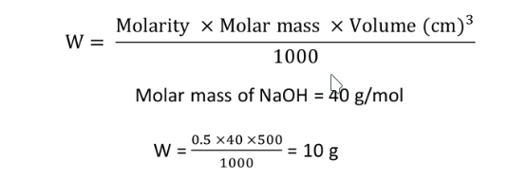

The acetic acid content of vinegar may be determined by Titrating vinegar sample with known molar concentration(molarity).
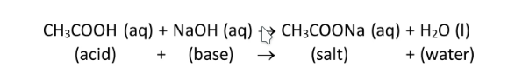

At the endpoint of titration, according to law of stociometry
N1 x V1 = N2 V2
where,
N1 = Concentration of acid
N2 = Concentration of base
V1 = Volume of acid
V2 = Volume of base

Finally, we can use the normality found to calculate the concentration of acetic acid in gram per liter as:
gram/liter = Normality(N1) x Equivalent weight
= N1 x 60 g/l
PROCEDURE

1. We poured vineger in a conical flask.

2. We added water to dissove the vinegar so that the volume of solution becomes 20ml.

3. We added 2 drops of phenolpthalein solution.

4. We used burette clamp to attach the burette to the ring stand.

5. We used funnel to fill the burette with 0.5N solution of Sodium hydroxide.

6. We noted the starting level of sodium hydroxide solution in burette.

7. We put vinegar solution to be titrated below the mouth of buertte.

8. We slowly dripped the solution of sodium hydroxide into the vinegar solution

9. When the vinegar turned pink and the color remained even after mixing, we quickly noted the level of sodium hydroxide in the burette after closing the tap.

10. We noted the remaining level of sodium hydroxide by reading from bottom meniscus.

11. We subtracted the initial level from remaining level to figure the volume of NaOH used.

12. We repeated the process for 3 times.

OBSERVATION

The following table shows the outcomes of the titration.

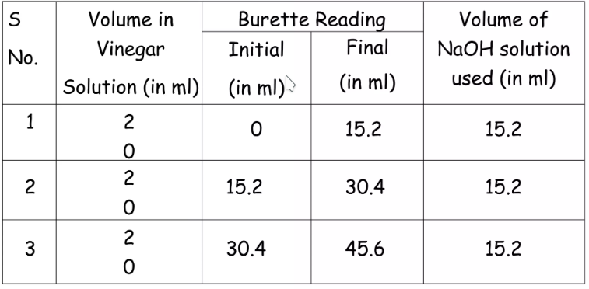
We take 15.2 ml for volume of NaOH during calculation
as it is concordant.

CALCULATION
We know that
N1 x V1 = N2 x V2
or N1 x 20 = 0.5 x 15.2
or N1= 0.38 mol/L

Now we calculate,
concentration of acetic acid= N1 * 60
= 22.8 g/litre

RESULT
So, the strength of acetic acid in a sample of vinegar is found to be 22.8 gram per litre.

CONCLUSION
Concentration of acetic acid in vinegar can be calculated by titration in lab.

PRECAUTIONS

1. Wear protective glasses and clothes during experiment.
2. We should not use more than 2-3 drops of indicator as it can alter the volume of solution.
3. NaOH should be dropped slowly drop by drop.
4. We should mix the solution properly
5. We should use clean water for solution

BIBLIOGRAPHY

www.wikipedia.org
www.slideshare.com
www.byjus.com



