## COLLEGE OF Engineering – department of computer science

Lab 1: Discover hardware

Name1: Thoraya Mousa. S19105590

Name2: Razan Almahdi. S20106649

Start by watching the following video:

until the end of the disassembly part (approximately 15 minutes of the video)

**1-List the main steps of disassembly (you don’t need to mention each cable)**

1. Unscrew the thumbscrews and take off the case of the computer.
2. Pull out the cables from the hard drives and the system board.
3. Remove the power supply.
4. Remove the hard drive.
5. Remove the CD/DVD drive.
6. Remove the system board:

Now that the system board has been removed, we could start disassembling it as well, following the upcoming steps:

1. Remove the RAM.
2. Remove the PCI card.
3. Pull out the front panel cables, and power cables.
4. Unscrew the fan, and the processor beneath it. Then, separate the processor and the fan from each other.

**2-What are the main components of a motherboard?**

1. The power
2. IDE connector
3. Internet connector
4. Floppy driver connector
5. SATA connectors
6. PCI slots
7. Ports
8. Jacks
9. RAM
10. CPU

**3-Name some of the components in the case of the computer that are not located on the motherboard.**

1. CPI card
2. SATA cables
3. CD/DVD drives
4. The power supply

**4-What should we make sure of before starting disassembling a PC?**

Make sure all powers are unplugged and all connectors are on the bottom.

**5-Which parts guarantees that the processor won’t overheat?**

The fan, and the chipset.

**6-Include the pictures of 10 parts in the case of your computer**

1. Sata cable

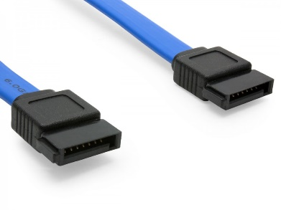

1. The fan

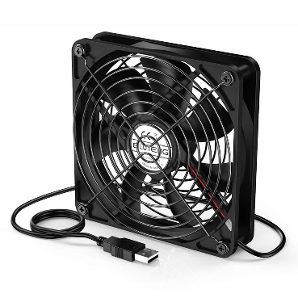

1. IDE connector

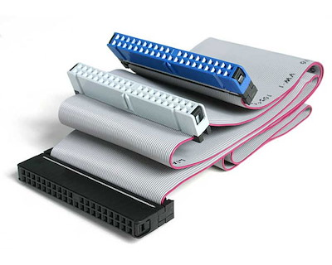

1. CD/DVD drive

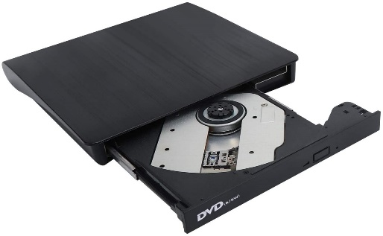

1. Power supply

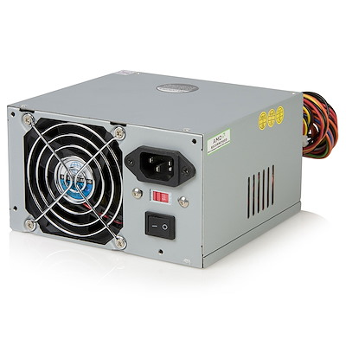

1. Processor

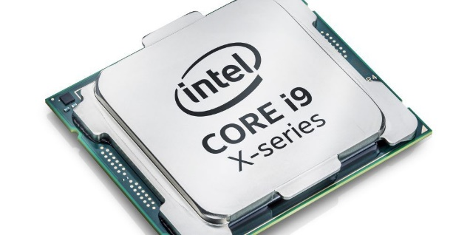

1. RAM

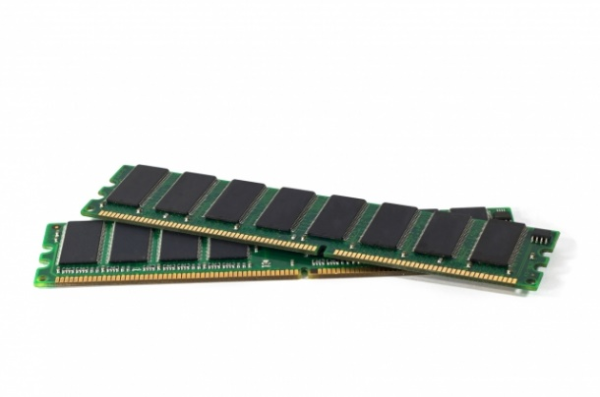

1. GPU

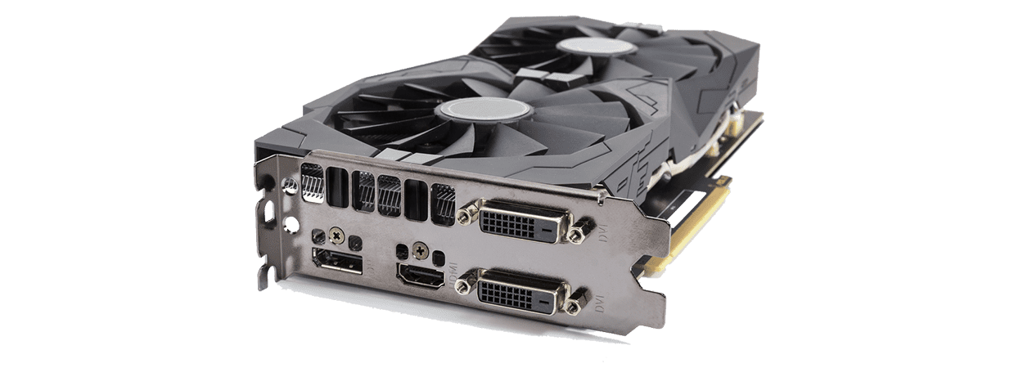

1. Hard drive

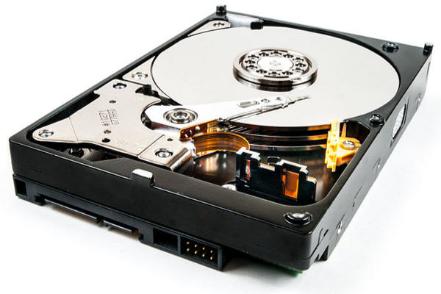

1. Sound card

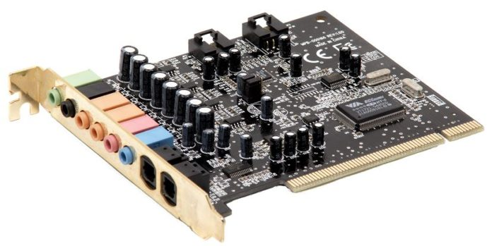

Submit your lab on BB (only one member of the group)