Lab 03

Razan Almahdi

07-05-2023

# Packages

library(tidyverse)  
library(sf)

# Data

fl_votes <- st_read("data/fl_votes.shp", quiet = TRUE)  
fl_votes %>%  
 slice(1:6)

## Simple feature collection with 6 features and 5 fields  
## Geometry type: MULTIPOLYGON  
## Dimension: XY  
## Bounding box: xmin: -85.99989 ymin: 25.95675 xmax: -80.01528 ymax: 30.58427  
## Geodetic CRS: NAD83  
## county rep16 dem16 rep20 dem20 geometry  
## 1 Alachua 46834 75820 50972 89704 MULTIPOLYGON (((-82.37389 2...  
## 2 Baker 10294 2112 11911 2037 MULTIPOLYGON (((-82.10107 3...  
## 3 Bay 62194 21797 66097 25614 MULTIPOLYGON (((-85.65968 3...  
## 4 Bradford 8913 2924 10334 3160 MULTIPOLYGON (((-82.274 29....  
## 5 Brevard 181848 119679 207883 148549 MULTIPOLYGON (((-80.49977 2...  
## 6 Broward 260951 553320 333409 618752 MULTIPOLYGON (((-80.29693 2...

# Exercise 1

fl_votes <- fl_votes %>%  
mutate(winner20 = if_else(rep20 > dem20, 'Donald Trump', 'Joe Biden'))

# Exercise 2

ggplot(fl_votes) + geom_sf(aes(fill=winner20)) +  
scale_fill_manual(values = c("#DE0100" , "#0015BC")) +  
labs(title = "Election winner 2020", fill = "winner") +  
theme_bw()

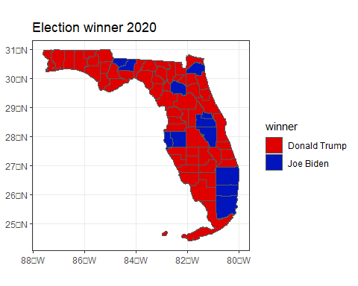

# Exercise #3

fl_votes <- fl_votes %>%  
mutate(prop_rep16= rep16/(rep16+dem16), prop_rep20= rep20/(rep20+dem20))

# Exercise 4

ggplot(fl_votes) + geom_sf(aes(fill = prop_rep20)) +  
scale_fill_gradient(low = "#0015BC", high = "#DE0100" ) +  
labs(title = "Election 2020 Results", fill = "Republican share of votes") +  
theme_bw()

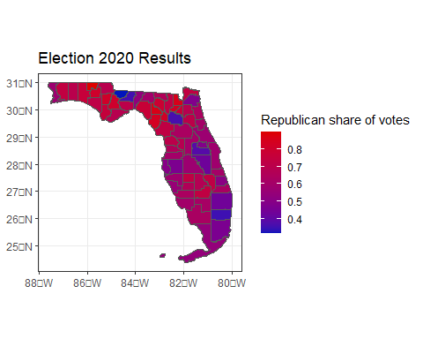

# Exercise 5

fl_votes <- fl_votes %>%  
mutate(diff_rep = prop_rep20 - prop_rep16)

# Exercise 6

ggplot(fl_votes) + geom_sf(aes(fill = diff_rep)) +  
scale_fill_gradient2(low = "#0015BC" , high = "#DE0100") +  
labs(title = "Election 2016 and 2020 results", fill = "Change in Republican share") +  
theme_bw()

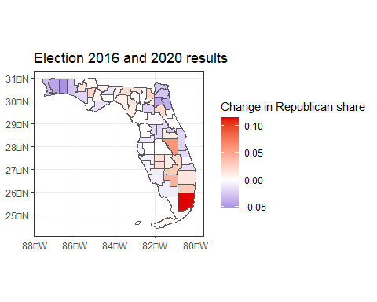

# Exercise 7

The visualizations developed in previous code chunks provide insight into the 2016 and 2020 Presidential election in Florida. Here is what these visualizations can tell us:

* The fl-plot-1 code chunk shows that Donald Trump won most of the counties in Florida during both the 2016 and 2020 elections. However, Joe Biden won more counties in 2020 than Hillary Clinton did in 2016, particularly in the southeastern part of the state.
* The fl-plot-2 code chunk shows that the Republican share of the two-party vote decreased in most counties in Florida between 2016 and 2020. However, there were some counties where the Republican share of the two-party vote increased, notably in some of the less densely populated areas of the state.
* The fl-plot-3 code chunk shows the change in Republican vote share by county between 2016 and 2020. It reveals that the strongest changes occurred in the metropolitan areas, which tend to be more Democratic-leaning.

Limitations of the visualizations include:

* These visualizations don’t provide information on other factors that could have influenced the outcomes of the elections in Florida, such as campaign spending, voter turnout, and the impact of political ads.
* The visualizations only show the change in support for the two major political parties in Florida between the two elections. They don’t provide information on the reasons behind these shifts, or on other political trends that might have emerged during this period.
* The visualizations don’t take into account demographic changes that occurred between the two elections, such as changes in the age, race, or gender makeup of Florida’s population, which could have had an impact on election outcomes.

Overall, these visualizations provide a useful starting point for analyzing the 2016 and 2020 presidential elections in Florida, but must be interpreted with caution and used in conjunction with other data to generate more complete and accurate assessments.