

**Artificial intelligence (CSC403)**

**Student name: Razan Abdulrahman Alrashed ID: 443500087**

**ASSIGNMENT 4**

from queue import PriorityQueue

class Graph:

    def __init__(self):

        self.graph = {}

        self.heuristics = {}

    def add_node(self, node):

        if node not in self.graph:

            self.graph[node] = []

    def add_edge(self, node1, node2):

        if node1 in self.graph and node2 in self.graph:

            self.graph[node1].append(node2)

            self.graph[node2].append(node1)

    def add_heuristic(self, node, heuristic):

        self.heuristics[node] = heuristic

def Greedy(graph, start, target):

    queue = PriorityQueue()

    visited = set()

    queue.put((0, start, [start]))  # (cost, node, path)

    while not queue.empty():

        cost, node, path = queue.get()  # get will remove and return from queue

        if node not in visited:

            visited.add(node)

            if node == target:

                return cost, path

            for neighbor in graph.graph[node]:

                if neighbor not in visited:

                    total_cost = graph.heuristics.get(neighbor, 0)

                    queue.put((total_cost, neighbor, path + [neighbor]))

g = Graph()

g.add_node('A')

g.add_node('B')

g.add_node('C')

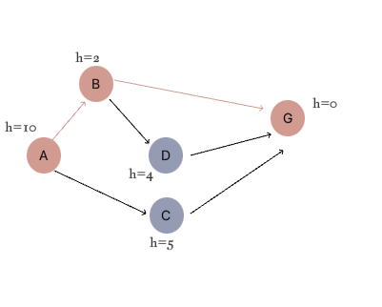g.add_node('D')

g.add_node('G')

g.add_edge('A', 'B')

g.add_edge('A', 'C')

g.add_edge('B', 'D')

g.add_edge('B', 'G')

g.add_edge('C', 'G')

g.add_edge('D', 'G')

g.add_heuristic('A', 10)

g.add_heuristic('B', 2)

g.add_heuristic('C', 5)

g.add_heuristic('D', 4)

g.add_heuristic('G', 0)

cost, path = Greedy(g, 'A', 'G')

print(f"PATH: {' -> '.join(path)}")

print(f"Cost from A to G: {cost}")

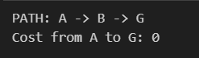

output