**Product Sales for Electronic company**

The goal of this project is to analyze sales performance for improving sales for the future months.

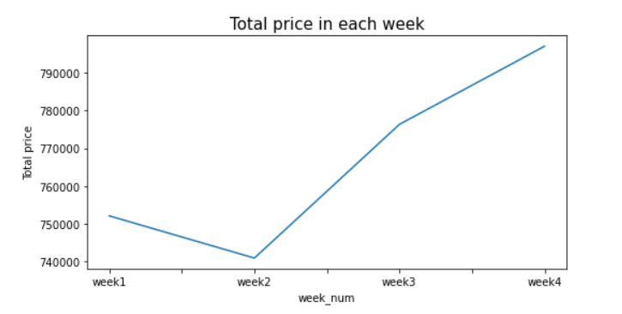

To start exploring this goal, we used a line chart model to describe total price in each week. The blue line inside graph is explains total profit per week in one month. This result suggests is the earning ​decreased on week 2 and increased on week 4 for this month