**Razat Siwakoti (20032655)**

**MIT, KOI Newcastle**

**Topic: KiddoKraft Toys: Educational Wooden Toys Handmade - sustainable wooden toys for children**

**Overview**

KiddoKraft Toys is a fictional business that focuses on handmade, sustainable wooden toys for children.

**Process of Creating Wireframes**

1. Initial Rough Sketches were drawn using paint. These drafts helped me explore ideas freely and plan the placement of major elements such as header, nav bar, contents and footer.

1. Based on rough sketch drawn on paint, I created wireframes for desktop (1440px), Tablet (768px) and Mobile (375px). The wireframes define layout structure, content placement and navigation flow before moving to visual design.

**Desktop View:**

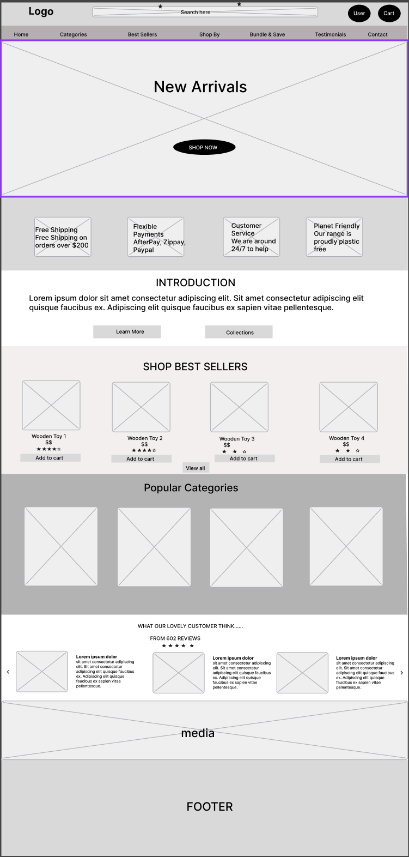

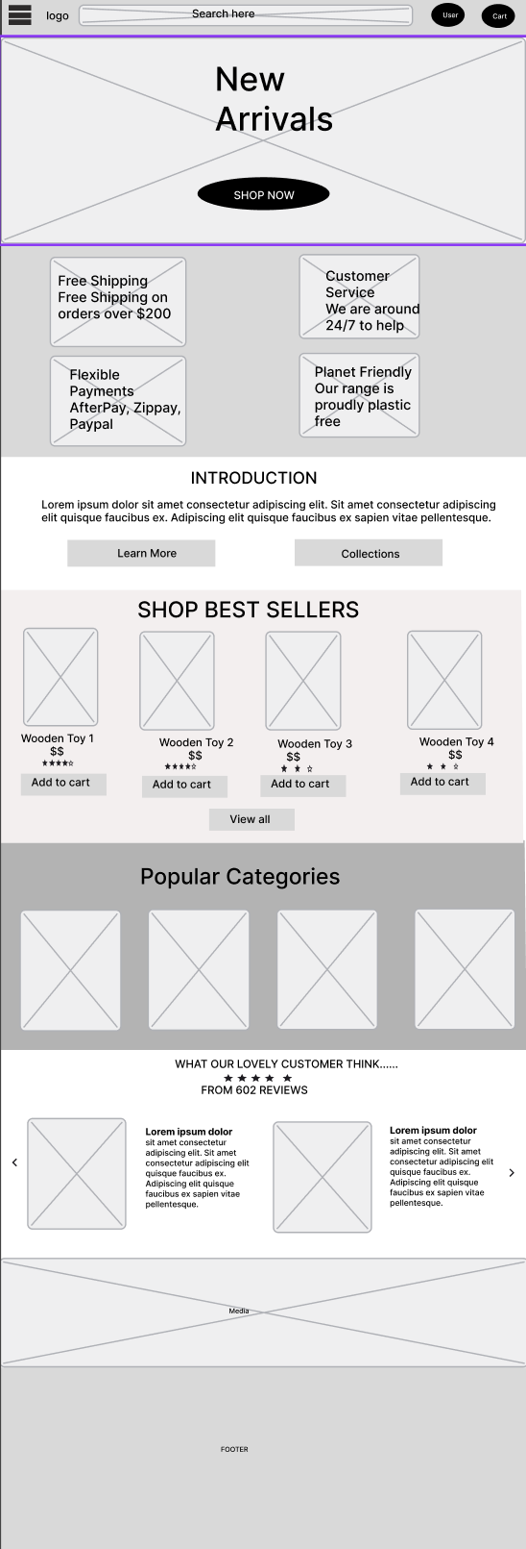Tablet View:

Mobile View:

Next Planned Step:

Creating a visual design in Figma (adding colors, images and typography) and only then proceed to implement the website using HTML, CSS and JS.

Key Features to be added in Website:

1. Clear, creative Home Page with business title and introduction paragraph.
2. Consistent header, navigation, and footer across all pages.
3. Implementation of CSS3 enhancements and JS script
4. Responsive layout that adapts desktops, tablet and mobile devices,

Consideration factors:

1. Human Centered Design (HCD) : Keeping familiar layouts to user by following patterns similar to common websites. This makes visitors feel easy and comfortable navigating.
2. Color Contrast: Planning to use high-contrast color combinations to ensure text and visuals are readable.
3. Including alt text for images, ARIA roles where needed and layouts that work with screen readers for accessibility .
4. Responsive design for different breakpoints to maintain usability on all devices

Challenges and Solution:

1. Drawing rough layout considering accessibility and human centered design guidelines. To solve this, I revisited common websites layouts for references to ensure ease navigation and consistency across pages
2. Translating rough ideas into layouts while considering responsiveness for multiple devices. I was stuck in this process for a while but overcame this by breaking down the design step by step: Drawing rough sketch on paint, refining those sketches in figma, added proper alignment and grid system for different screen sizes, and iterated the design few times in figma until the structure felt clear and user-friendly.