Supplementary Material
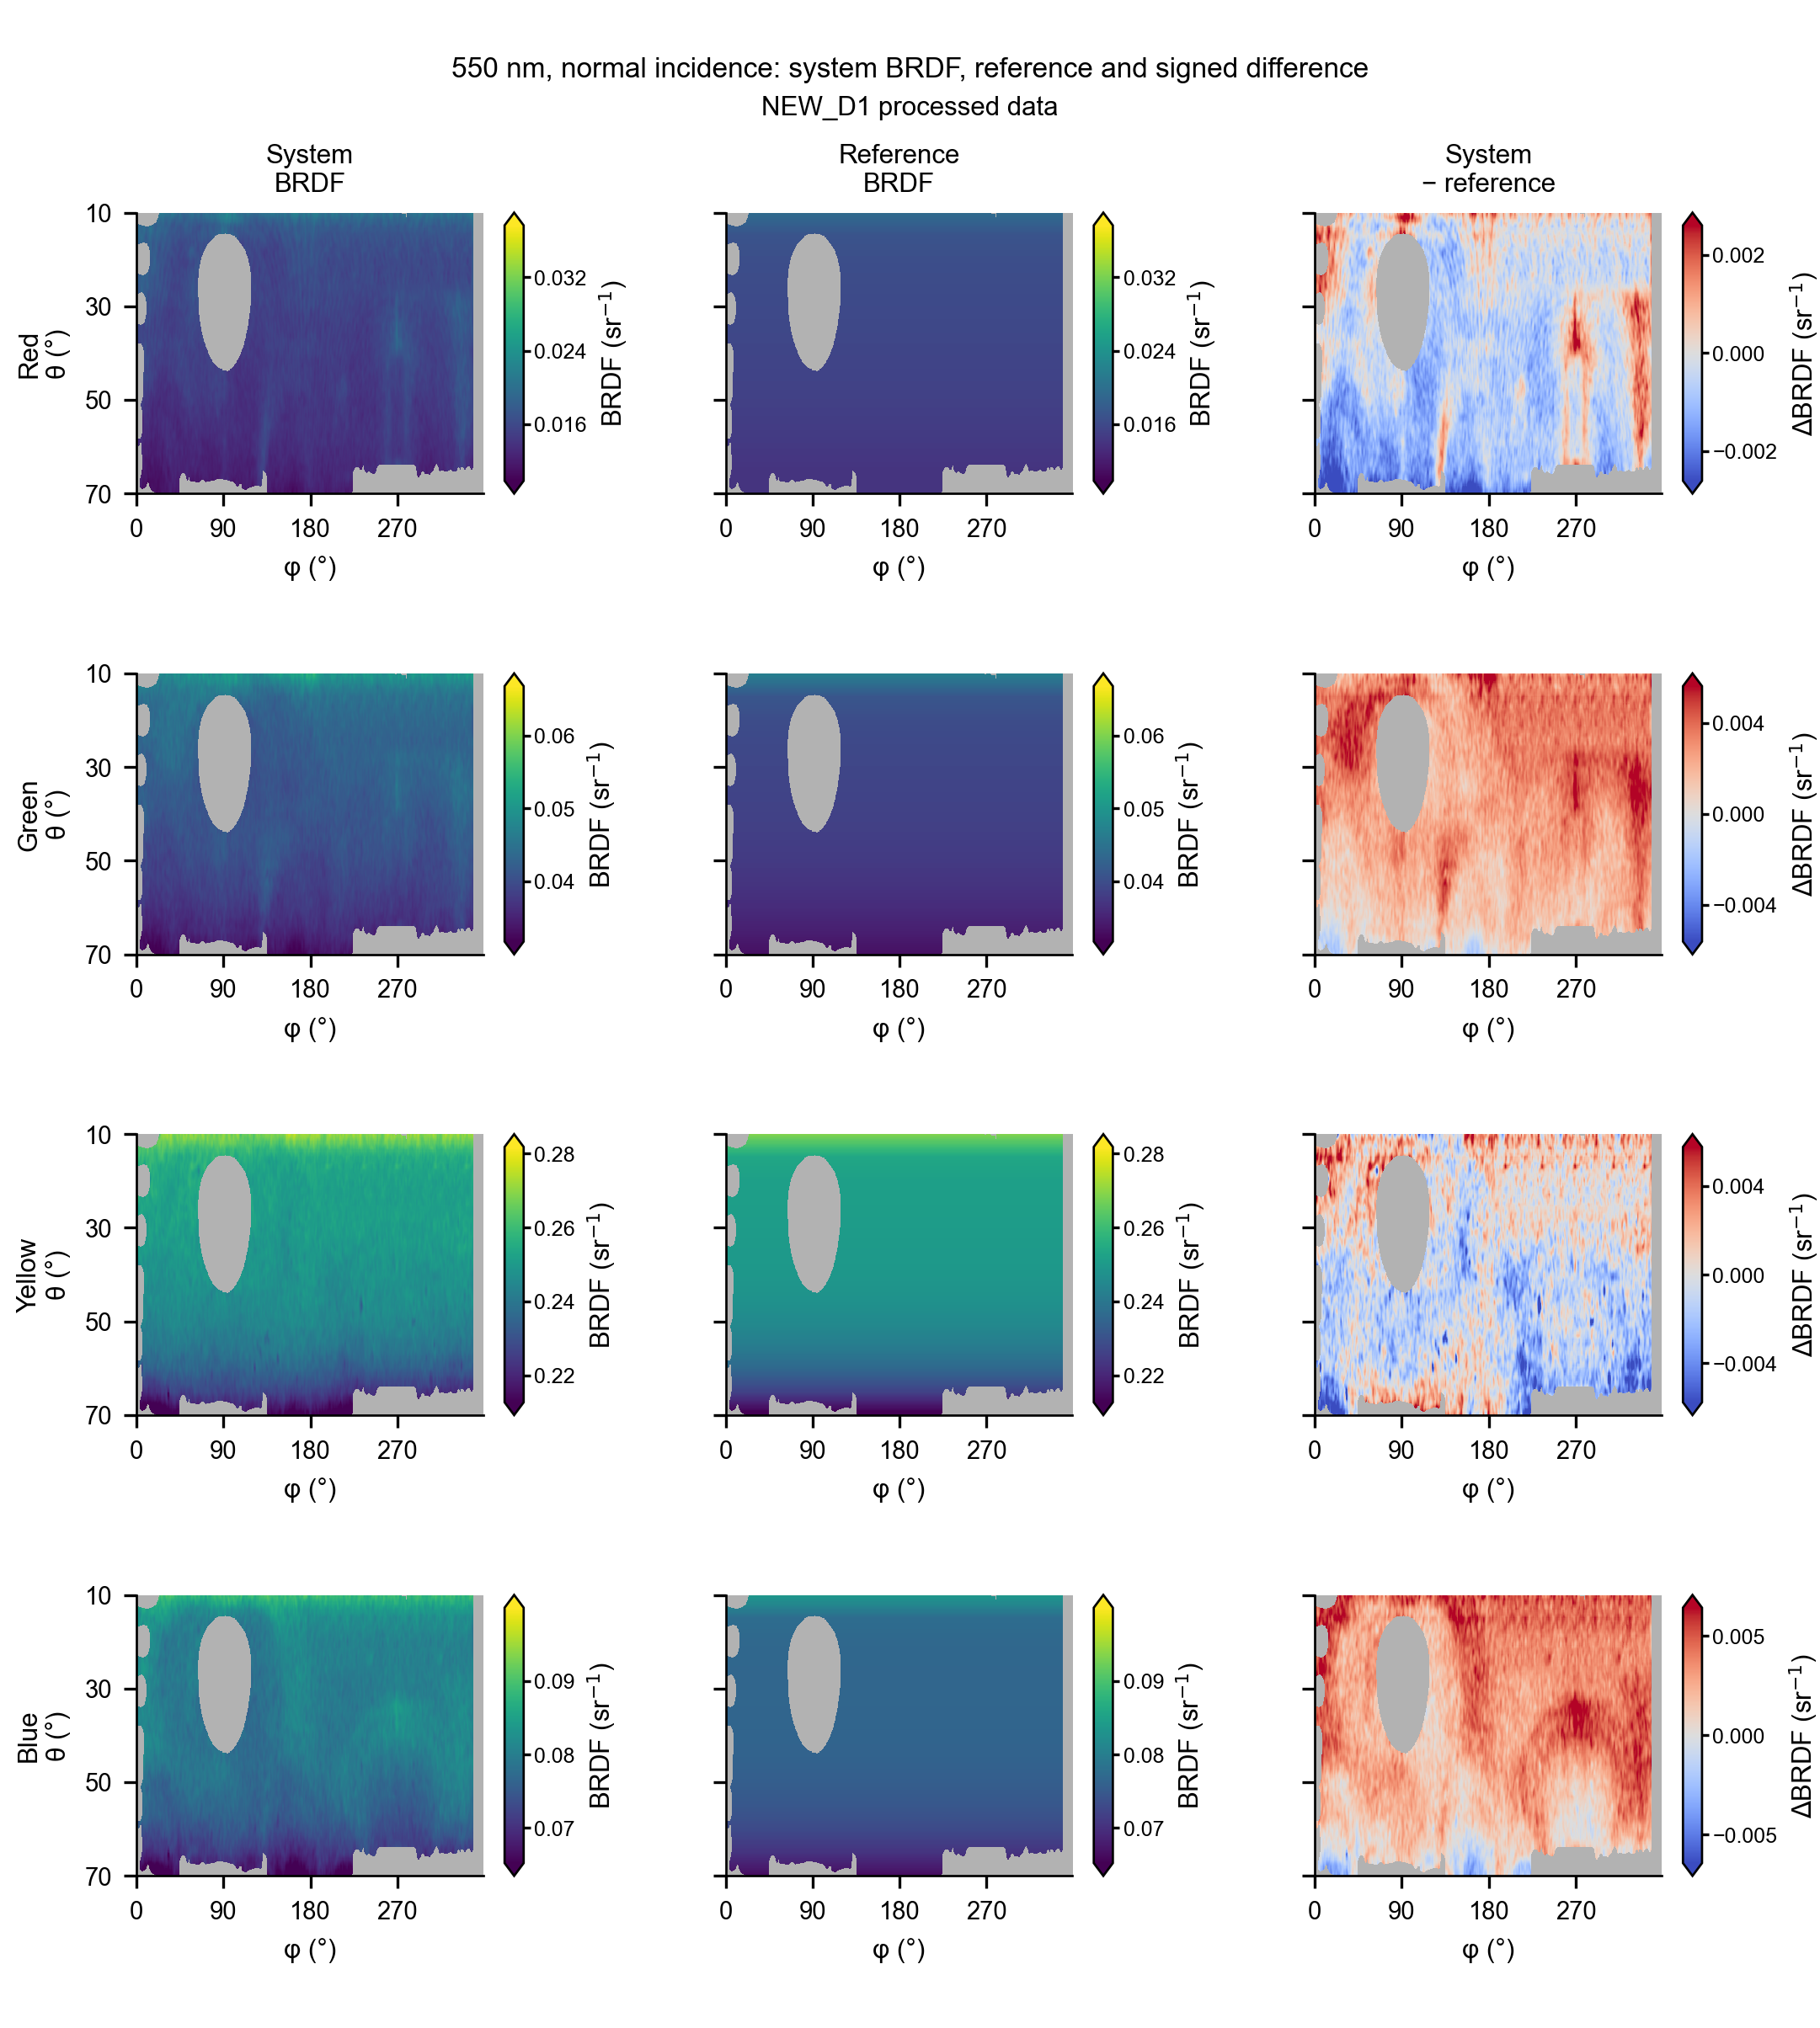
Supplementary Fig. S1. Normal-incidence BRDF distributions for the red, green, yellow and blue tiles at 550 nm. System BRDF is shown after denoising and other data processing (NEW_D1 processed data). Rows correspond to samples; columns show system BRDF, the rotationally reconstructed reference and the signed system-minus-reference difference. BRDF and difference values are in sr⁻¹. Paired system and reference maps share a color scale within each row; difference scales are symmetric about zero. Gray cells are outside the common display comparison mask. The reference azimuthal distribution is reconstructed from principal-plane scans under the normal-incidence azimuthal-symmetry approximation.

Supplementary Table S1
Common-domain integrated BSDF results for the validation samples across eight spectral channels.
Data series NEW_D1 processed data. Normal incidence; four BRDF tiles and four BTDF PMMA samples. All integrals are dimensionless.
Sample | BSDF | Wavelength  (nm) | System  Q_{CD, sys} | Reference  Q_{CD, ref} | Signed relative  discrepancy (%) | Low signal
Red tile | BRDF | 430 | 0.033312421 | 0.036757436 | -9.3723 | No
Red tile | BRDF | 460 | 0.027496987 | 0.028138236 | -2.2789 | No
Red tile | BRDF | 490 | 0.030426474 | 0.02922143 | +4.1238 | No
Red tile | BRDF | 520 | 0.036062008 | 0.029974522 | +20.3089 | No
Red tile | BRDF | 550 | 0.034647852 | 0.03566702 | -2.8575 | No
Red tile | BRDF | 590 | 0.12990241 | 0.11762443 | +10.4383 | No
Red tile | BRDF | 630 | 0.54355099 | 0.52940965 | +2.6712 | No
Red tile | BRDF | 660 | 0.58095615 | 0.57868792 | +0.3920 | No
Green tile | BRDF | 430 | 0.039271457 | 0.049587219 | -20.8033 | No
Green tile | BRDF | 460 | 0.025971821 | 0.027642418 | -6.0436 | No
Green tile | BRDF | 490 | 0.034176345 | 0.033016934 | +3.5116 | No
Green tile | BRDF | 520 | 0.065848377 | 0.074557662 | -11.6813 | No
Green tile | BRDF | 550 | 0.093529875 | 0.087640572 | +6.7198 | No
Green tile | BRDF | 590 | 0.039449105 | 0.046474563 | -15.1168 | No
Green tile | BRDF | 630 | 0.04406058 | 0.046643161 | -5.5369 | No
Green tile | BRDF | 660 | 0.065712782 | 0.06914104 | -4.9584 | No
Yellow tile | BRDF | 430 | 0.084576205 | 0.088403781 | -4.3297 | No
Yellow tile | BRDF | 460 | 0.12035359 | 0.11733655 | +2.5713 | No
Yellow tile | BRDF | 490 | 0.26449043 | 0.21761572 | +21.5401 | No
Yellow tile | BRDF | 520 | 0.43538969 | 0.43605651 | -0.1529 | No
Yellow tile | BRDF | 550 | 0.5621886 | 0.56358128 | -0.2471 | No
Yellow tile | BRDF | 590 | 0.58515678 | 0.58397556 | +0.2023 | No
Yellow tile | BRDF | 630 | 0.59632737 | 0.59753225 | -0.2016 | No
Yellow tile | BRDF | 660 | 0.59643184 | 0.59998679 | -0.5925 | No
Blue tile | BRDF | 430 | 0.34828502 | 0.35752707 | -2.5850 | No
Blue tile | BRDF | 460 | 0.36807311 | 0.37004666 | -0.5333 | No
Blue tile | BRDF | 490 | 0.32074253 | 0.33653682 | -4.6932 | No
Blue tile | BRDF | 520 | 0.26146031 | 0.25711416 | +1.6904 | No
Blue tile | BRDF | 550 | 0.17976846 | 0.17332443 | +3.7179 | No
Blue tile | BRDF | 590 | 0.11255422 | 0.12108892 | -7.0483 | No
Blue tile | BRDF | 630 | 0.092789694 | 0.093525234 | -0.7865 | No
Blue tile | BRDF | 660 | 0.098998242 | 0.10028924 | -1.2873 | No
PMMA 4 | BTDF | 430 | 0.37822705 | 0.3687774 | +2.5624 | No
PMMA 4 | BTDF | 460 | 0.5052958 | 0.45097991 | +12.0440 | No
PMMA 4 | BTDF | 490 | 0.52012377 | 0.47594946 | +9.2813 | No
PMMA 4 | BTDF | 520 | 0.5124331 | 0.47984769 | +6.7908 | No
PMMA 4 | BTDF | 550 | 0.43687344 | 0.42081081 | +3.8171 | No
PMMA 4 | BTDF | 590 | 0.30841192 | 0.33415746 | -7.7046 | No
PMMA 4 | BTDF | 630 | 0.28327135 | 0.29670483 | -4.5276 | No
PMMA 4 | BTDF | 660 | 0.31528455 | 0.3251162 | -3.0240 | No
PMMA 5 | BTDF | 430 | 0.040773316 | 0.049663798 | -17.9013 | Yes
PMMA 5 | BTDF | 460 | 0.063787655 | 0.065057964 | -1.9526 | No
PMMA 5 | BTDF | 490 | 0.1209878 | 0.11274108 | +7.3147 | No
PMMA 5 | BTDF | 520 | 0.2699544 | 0.28403765 | -4.9582 | No
PMMA 5 | BTDF | 550 | 0.44789856 | 0.413345 | +8.3595 | No
PMMA 5 | BTDF | 590 | 0.35014721 | 0.3632542 | -3.6082 | No
PMMA 5 | BTDF | 630 | 0.26568301 | 0.277478 | -4.2508 | No
PMMA 5 | BTDF | 660 | 0.27594889 | 0.28840276 | -4.3182 | No
PMMA 6 | BTDF | 430 | 0.18700823 | 0.19423999 | -3.7231 | No
PMMA 6 | BTDF | 460 | 0.20901065 | 0.20840196 | +0.2921 | No
PMMA 6 | BTDF | 490 | 0.24128977 | 0.23323609 | +3.4530 | No
PMMA 6 | BTDF | 520 | 0.33345355 | 0.33972456 | -1.8459 | No
PMMA 6 | BTDF | 550 | 0.49661351 | 0.45867786 | +8.2707 | No
PMMA 6 | BTDF | 590 | 0.52936882 | 0.48273022 | +9.6614 | No
PMMA 6 | BTDF | 630 | 0.54254112 | 0.49865103 | +8.8018 | No
PMMA 6 | BTDF | 660 | 0.54830907 | 0.50547124 | +8.4748 | No
PMMA 7 | BTDF | 430 | 0.002248884 | 0.013632853 | -83.5039 | Yes
PMMA 7 | BTDF | 460 | 0.00025222042 | 0.0073928493 | -96.5883 | Yes
PMMA 7 | BTDF | 490 | 0.0031441119 | 0.0056974492 | -44.8154 | Yes
PMMA 7 | BTDF | 520 | 0.0036449233 | 0.0038186628 | -4.5497 | Yes
PMMA 7 | BTDF | 550 | -0.00035196306 | 0.0031520405 | -111.1662 | Yes
PMMA 7 | BTDF | 590 | 0.024953908 | 0.02816128 | -11.3893 | No
PMMA 7 | BTDF | 630 | 0.31742006 | 0.29314764 | +8.2799 | No
PMMA 7 | BTDF | 660 | 0.39235217 | 0.36544367 | +7.3632 | No
Table notes
The integration uses the same sample–channel validity mask for the system and reference within 10° ≤ θ ≤ 70°, with cos(θ) dΩ weights. No normalization to a full hemisphere is applied. The reference azimuthal distribution is reconstructed from principal-plane scans under the normal-incidence rotational-symmetry approximation for diffuse samples.
The signed relative discrepancy in each row is 100 × (Q_{CD, sys} / Q_{CD, ref} − 1). Positive values indicate a larger system integral. The source permits this ratio only when |Q_{CD, ref}| > 10⁻¹²; all 64 rows meet that criterion. Signed system integrals, including negative low-signal estimates, are retained.
The signal-weighted absolute discrepancy for any group is E = 100 × Σ|Q_{CD, sys} − Q_{CD, ref}| / Σ|Q_{CD, ref}|. It is not the arithmetic mean of the signed row percentages. All cases, including the low-signal flags, enter these sums. BRDF: 2.81% (32 cases); BTDF: 6.74% (32 cases); aggregate: 5.00% (64 cases).
“Yes” marks the six prior low-signal cases. Cells below the earlier 20.5 DN criterion account for at least 50% of the original-domain cos(θ) dΩ weight. All flagged cases enter the aggregate calculations.
The system common-domain integrals are reported after denoising and other data processing (NEW_D1 processed data), alongside the reference integrals. Full-precision values, low-signal flags and source hashes accompany the table in CSV and README files.

