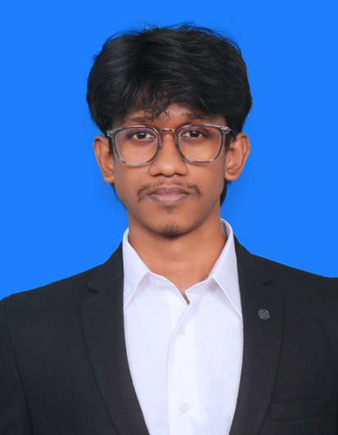
RAZEEN H
DEVOPS ENGINEER
razeen.official23@gmail.com | INR : +91 9345035514 | UAE : +971 50 769 7208
linkedin.com/in/razeen-developer | github.com/Razeen23 | razeen-portfolio.vercel.app

Professional Summary
Full Stack Developer with 3+ years moving production releases off manual work. FTP uploads and hand-built servers were the old path. GitHub Actions and SSH replaced FTP, which cut release time by 5x and deployment issues by 90%. Automated VM setup cut a 40-minute job to 5 minutes, and a Docker, Harbor, Trivy, Helm, and Kubernetes path takes a repo or ZIP to a live URL. Those pipelines ship the PHP, JavaScript, and MySQL billing platform used by 5,000+ users.

Skills
CI/CD: GitHub Actions, Git, GitHub, CI/CD pipelines, SSH deployments, Cron Jobs
Containers and runtime: Docker, Kubernetes, Helm, Harbor, Linux, Nginx, Apache
Release guardrails: Trivy image scans, namespace isolation, cert-manager, deploy logs, Slack Webhooks
Applications shipped: PHP, JavaScript, AJAX, React.js, Node.js, Express.js, Fastify, Python, FastAPI
Databases: MySQL, PostgreSQL, MongoDB

Work Experience
Full Stack Developer, Hostzop Cloud Technologies Pvt. Ltd. Aug 2023 - Present
- Problem: React.js, Node.js, and PHP releases went out by manual FTP, so a bad upload could reach the server with no build check. I replaced that with GitHub Actions and SSH. Impact: release cycle time dropped by 5x and deployment-related issues dropped by 90%.
- Problem: a new VM or VPS took about 40 minutes of hand setup, and suspending one still waited on someone to notice. I automated provisioning and added cron jobs for IP monitoring, security enforcement, and VPS suspension and unsuspension. Impact: a VM is ready in 5 minutes.
- Problem: a customer repo or ZIP went live only after someone built the image and edited the server. I built the Docker, Harbor, Trivy, Helm, and Kubernetes path, with cert-manager TLS and one namespace per app. Impact: a bad image is blocked, and the app gets a live URL with no manual server step.
- Problem: a failed release left only a raw log, and security events were easy to miss. I added live deploy logs, a success or failure status, and Slack alerts for security events and system actions. Impact: the team sees what failed without reading the server by hand.
- Linux and Nginx serve those releases, including the billing dashboards used by 5,000+ users.
Full Stack Developer Intern, Aspire Systems Apr 2023 - Jul 2023
- Engineered a real-time face recognition attendance system using Python, OpenCV, cvzone, and NumPy.
- Serialized a facial-matching model with Pickle and sent recognized attendance records to Firebase.

Projects
CI/CD and Deployment Automation
GitHub Actions, Linux, Git, SSH
- Problem: React.js, Node.js, and PHP releases depended on a person uploading files by FTP, with no standard build before the files reached production.
- What I did: designed GitHub Actions pipelines that build the React.js, Node.js, or PHP app and deploy it over SSH, and removed FTP from the release path.
- What I did: Linux and Nginx serve the release, and each release keeps live logs plus a success or failure status.
- Impact: release cycle time dropped by 5x and deployment-related issues dropped by 90%. This is the path that ships the billing platform used by 5,000+ users.

Hostzop Kubernetes PaaS (Git to Live URL)
Docker, Kubernetes, Helm, Harbor, Fastify, PostgreSQL
- Problem: a GitHub repo or a ZIP became a live URL only after someone built the image, pushed it, and set TLS and DNS by hand.
- What I did: built the deploy control plane in Fastify and PostgreSQL. It detects the stack, builds the Docker image, and pushes it to Harbor.
- What I did: Trivy scans the image before Helm installs it on Kubernetes. Each app gets its own namespace, cert-manager issues the TLS certificate, and DNS points at the release.
- Impact: a failed scan never becomes a live site, and the customer gets a URL with no manual server step.
Linux operations and provisioning
Linux, Nginx, Cron Jobs
- Problem: creating a VM or VPS took about 40 minutes of manual work, and suspending a VPS still waited on someone to check it.
- What I did: automated provisioning on Linux and scheduled cron jobs for IP monitoring, security enforcement, and VPS suspension and unsuspension. Nginx serves the apps on those machines.
- Impact: setup time fell from 40 minutes to 5 minutes, so that manual wait is no longer part of each order.
Reseller Cloud Management Platform
PHP, JavaScript, AJAX, MySQL
- Problem: a reseller order waited on someone to create the VM and to track credits, plans, and usage separately.
- What I did: built the panel in PHP, JavaScript, and AJAX so a reseller can buy and resell VMs, with credit billing, monthly plans, usage, and separate admin and reseller logins.
- Impact: setup on that order fell from 40 minutes to 5 minutes, and the reseller sees usage and billing on one account.
AI Support Assistant
Python, FastAPI, LangChain, FAISS
- Problem: server and hosting questions opened a ticket first, and DNS, SSL, and stack checks were done by support by hand.
- What I did: shipped an assistant inside the hosting account. LangChain and FAISS pull the matching internal docs and runbooks, and the model answers only from that text. FastAPI serves the reply.
- What I did: the assistant connects to the server and carries out the fix. It installs packages, creates files and folders, and runs setup actions such as DNS, SSL, and stack checks.
- Impact: those server steps no longer wait on a person. A ticket is opened only when the assistant cannot finish the fix.

Education
Bachelor of Computer Applications (BCA) 2019 - 2022
Mohamed Sathak College of Arts and Science, Chennai
Diploma in Counseling Psychology (Online) 2020 - 2021
Sypa IIE

Certifications
- Full Stack Development - Offline Training
- Back-end Development - Meta
- JavaScript - Udemy
- Fundamentals of Cybersecurity - upGrad
- UX Design Process: Empathize, Define, and Ideate - Google

Awards
- Best Performer Award during the Aspire Systems internship for technical contribution and reliability.
- Led a 10-member team during NCC Camp, with responsibility for coordination and accountability.

Languages
English (Fluent), Tamil (Native), Hindi

