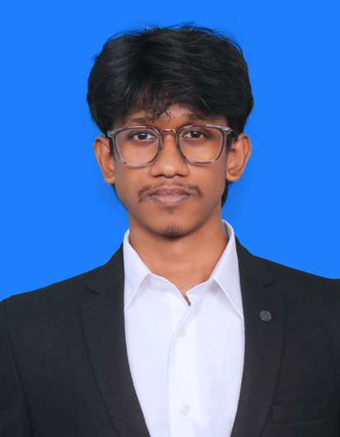
RAZEEN H
FRONT END DEVELOPER
razeen.official23@gmail.com | INR : +91 9345035514 | UAE : +971 50 769 7208
linkedin.com/in/razeen-developer | github.com/Razeen23 | razeen-portfolio.vercel.app

Professional Summary
Front-End Developer with 3+ years building the screens of a hosting SaaS and customer sites. The billing dashboards are PHP, JavaScript, and AJAX, with D3.js charts, and serve 5,000+ users. The reseller panel and the Kubernetes deploy console are React.js, and the panel is used by 1,000+ users. Memoization and shared React components improved UI responsiveness by 35%. Also shipped mobile-first React sites for events and a coaching academy.

Skills
Frontend: HTML5, CSS3, JavaScript (ES6+), PHP, AJAX, Responsive Design, Cross-Browser Compatibility
React: React.js, React Hooks, Context API, Custom Hooks, React Router, Vite
Styling: Tailwind CSS, CSS Grid, Flexbox, Emotion, Mobile-First Design
Data in the UI: D3.js, REST APIs, Axios, Fetch API
Performance and tools: Code Splitting, Lazy Loading, Memoization, Git, GitHub, Chrome DevTools

Work Experience
Full Stack Developer, Hostzop Cloud Technologies Pvt. Ltd. Aug 2023 - Present
- Problem: billing, usage, and server status were not one screen. I built those dashboards in PHP, JavaScript, and AJAX, with D3.js charts, so the numbers load without a full page reload. Impact: the dashboards serve 5,000+ users.
- Problem: a reseller had no screen to sell hosting under their own name. I built the reseller panel in React.js, with Hooks, Context, and custom hooks, for credits, plans, usage, and separate admin and reseller logins. Impact: the panel is used by 1,000+ users, and shared components and memoization improved UI responsiveness by 35%.
- Problem: a repo or ZIP became a live URL only after someone checked the server. I built the Kubernetes deploy console in React.js, with the stack, the image scan, the namespace, TLS, live logs, and a success or failure status on one screen.
- Problem: the layout broke on a phone and differed across browsers. I built the screens mobile-first with Tailwind CSS, Flexbox, and CSS Grid, and checked them across browsers.
- Also shipped the customer-facing sites in Vite and React: an event invitation product, an event marketing site, and a coaching-academy site, with images and bundles trimmed for PageSpeed.
Full Stack Developer Intern, Aspire Systems Apr 2023 - Jul 2023
- Engineered a real-time face-recognition attendance system using Python, OpenCV, cvzone, and NumPy.
- Serialized a face-matching model with pickle and sent recognized attendance records to Firebase.

Projects
Hostzop SaaS Dashboards
PHP, JavaScript, AJAX, D3.js
- Problem: billing, usage, and server status arrived as separate data, and the page reloaded to show a new number.
- Built: the billing, usage, and server screens in PHP and JavaScript, with AJAX so those numbers load without a full page reload.
- Built: D3.js charts, tables, and status indicators on those responses.
- Impact: the dashboards serve 5,000+ users.
Reseller Panel
React.js, Tailwind CSS
- Problem: a reseller had no screen of their own, and credits, plans, and usage lived in separate places.
- Built: the panel in React.js, with Hooks, Context, and custom hooks, and separate admin and reseller logins.
- Built: screens for credit billing, monthly plans, usage, and the white-label domain and brand, with loading and error states on the API calls.
- Impact: the panel is used by 1,000+ users. Shared components and memoization improved UI responsiveness by 35%.
Hostzop Kubernetes PaaS
React.js
- Problem: a GitHub repo or a ZIP became a live URL only after someone checked the server, with no screen for the build, the scan, or the result.
- Built: the deploy console in React.js. It shows the detected stack, the image build, the Trivy scan, the namespace, TLS, DNS, live logs, and a success or failure status.
- Impact: the customer watches the app reach a URL from that screen, and a failed scan never looks like a live site.
Spotcard Digital Invitation Platform
Vite, React.js, Emotion
- Problem: an event invitation was a static image, so the guest could not open a map, a schedule, or the photos on their phone.
- Built: a mobile-first React app in Vite, with Emotion, and a guest page for the host profile, map, schedule, add-to-calendar, and media gallery.
- Impact: the invitation works on a phone, and the guest can act on the event without a separate PDF or image.
Grandstand Event Website
Vite, React.js, CSS
- Problem: the event marketing page was slow on a phone and the layout did not hold from desktop to a small screen.
- Built: the site in Vite with React, using CSS Grid and Flexbox.
- Built: trimmed images and bundles for PageSpeed on desktop and mobile.
- Impact: the page stays light on both screen sizes, and the brand layout holds without a separate mobile site.
Muthayammal NEET Academy Website
React.js, Tailwind CSS
- Problem: courses, faculty, facilities, and student highlights were hard to read on a phone.
- Built: the academy site in React and Tailwind CSS, laid out for phones and tablets, with a clear page for each of those sections.
- Impact: a student or parent can read the course, the faculty, and the facilities on a phone without pinching the page.

Education
Bachelor of Computer Applications (BCA) 2019 - 2022
Mohamed Sathak College of Arts and Science, Chennai
Diploma in Counseling Psychology (Online) 2020 - 2021
Sypa IIE

Certifications
- Full Stack Development - Offline Training
- Back-end Development - Meta
- JavaScript - Udemy
- Fundamentals of Cybersecurity - upGrad
- UX Design Process: Empathize, Define, and Ideate - Google

Awards
- Best Performer Award during the Aspire Systems internship for technical contribution and reliability.
- Led a 10-member team during NCC Camp, with responsibility for coordination and accountability.

Languages
English (Fluent), Tamil (Native), Hindi

