Shaniquo Mckenzie, Jarod Lavine

CENTENNIAL COLLEGE

USER GUIDE

**HELPDESK LOGBOOK v2**

# Overview

## Dependency Diagram

## Database ERD

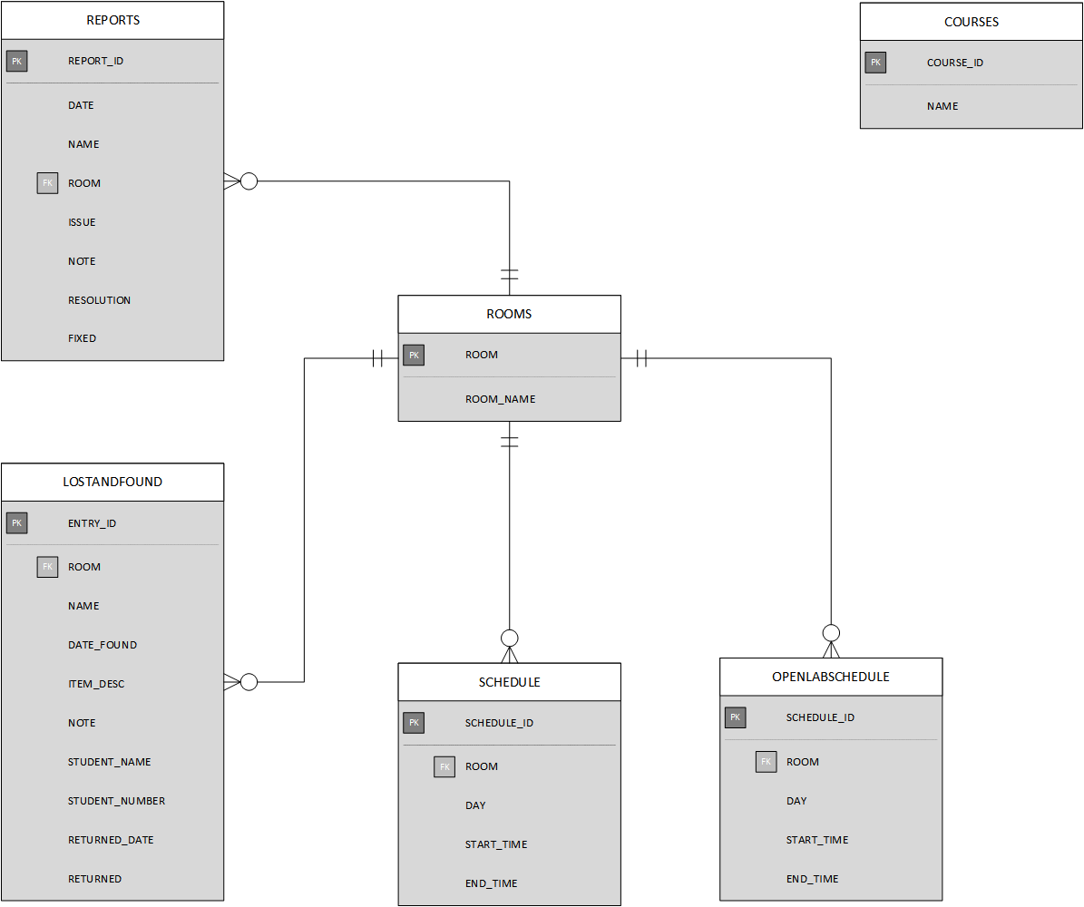

# Application Pages

## DASHBOARD

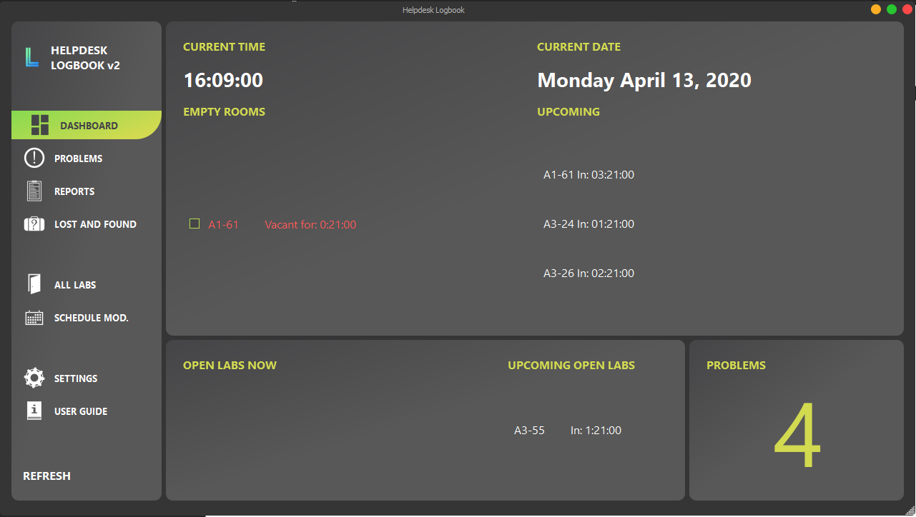

The dashboard is where you can keep track of labs that are empty, and labs that are about to be empty. It also displays the current time, date, and number of unfixed problems. Clicking the number of problems will take you to the  **PROBLEMS** page.

## PROBLEMS

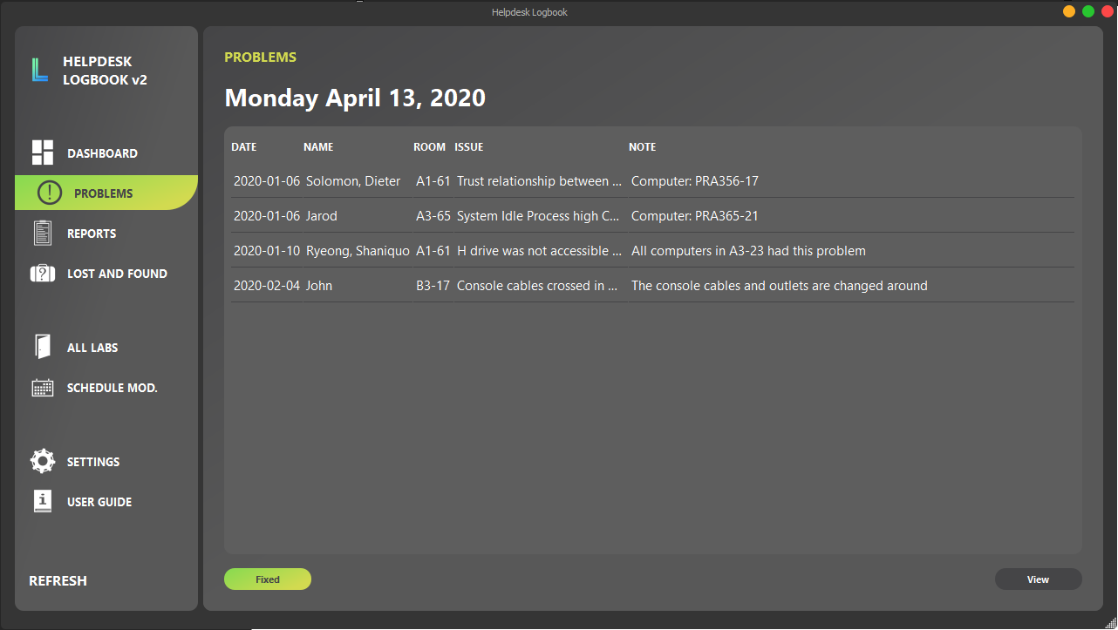

The PROBLEMS page will display all report entries that aren’t fixed. (FIXED = NO)

Clicking the “Fixed” button will take you to the edit page for the selected entry, where you can enter the resolution and mark it as fixed.

## REPORTS

### 1. Page

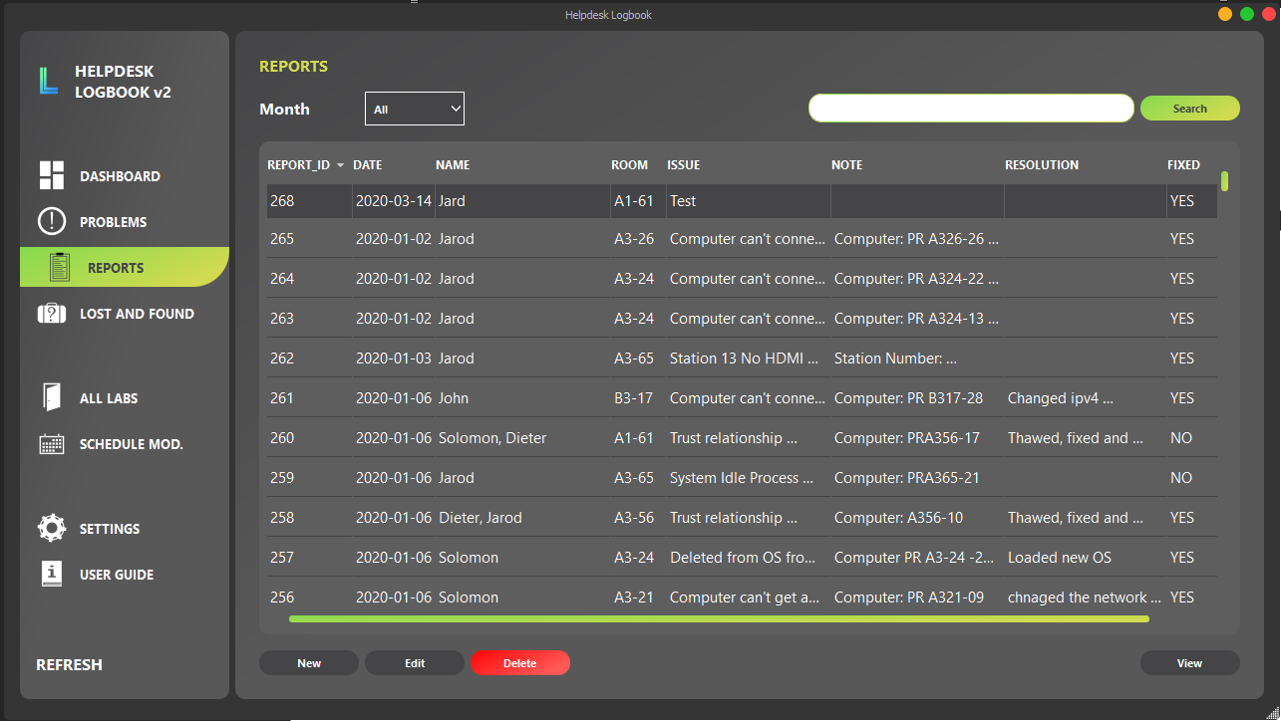

This page allows you to create new reports, edit entries, delete entries and view entries. Selecting a month will only show reports for the selected month. “All” displays all the entries in the REPORTS database.

### 2. New Log and Edit

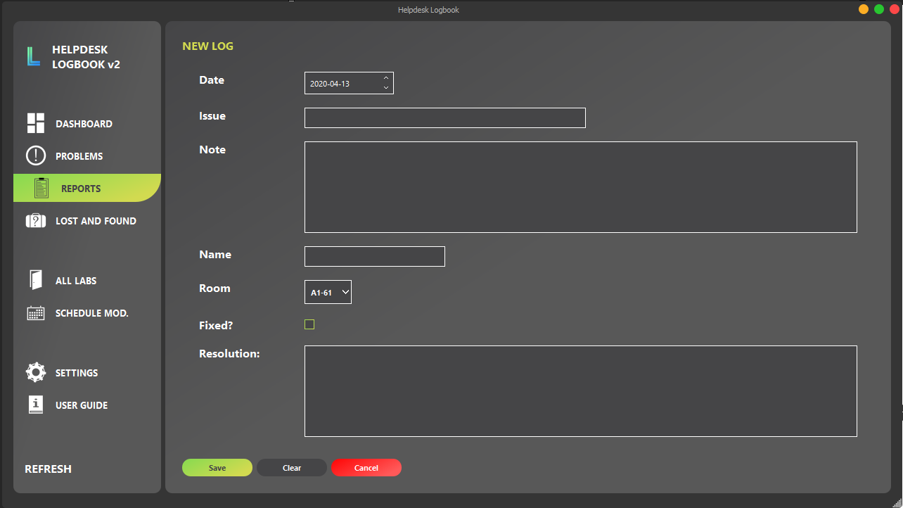

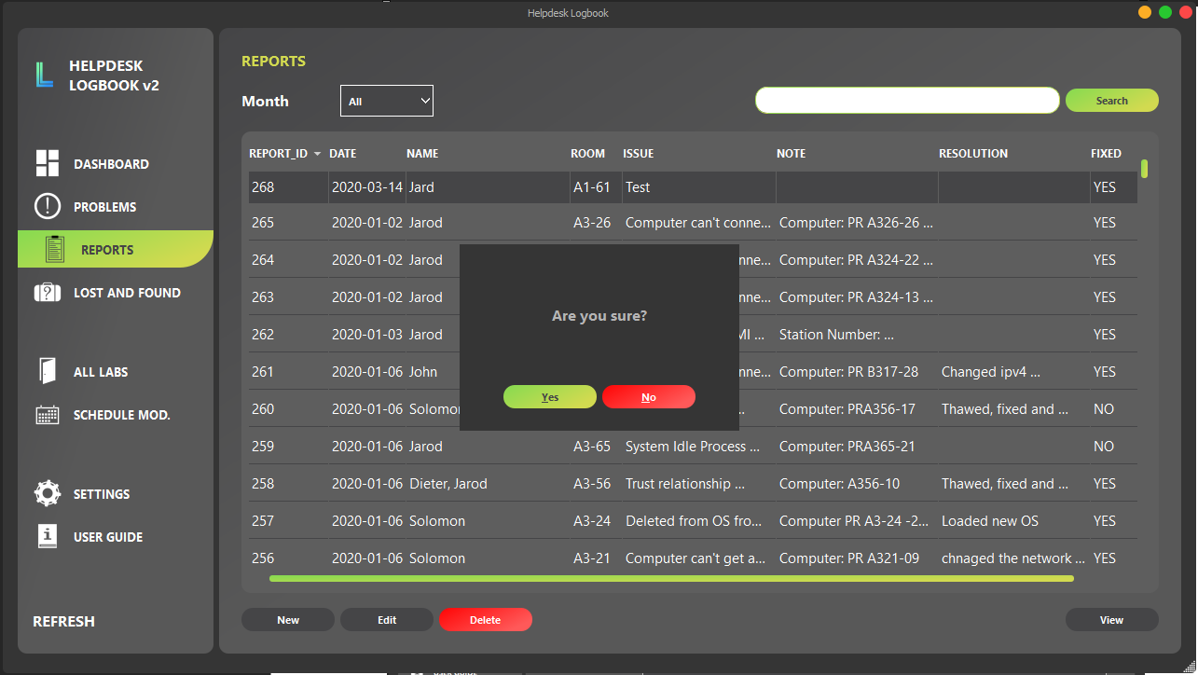

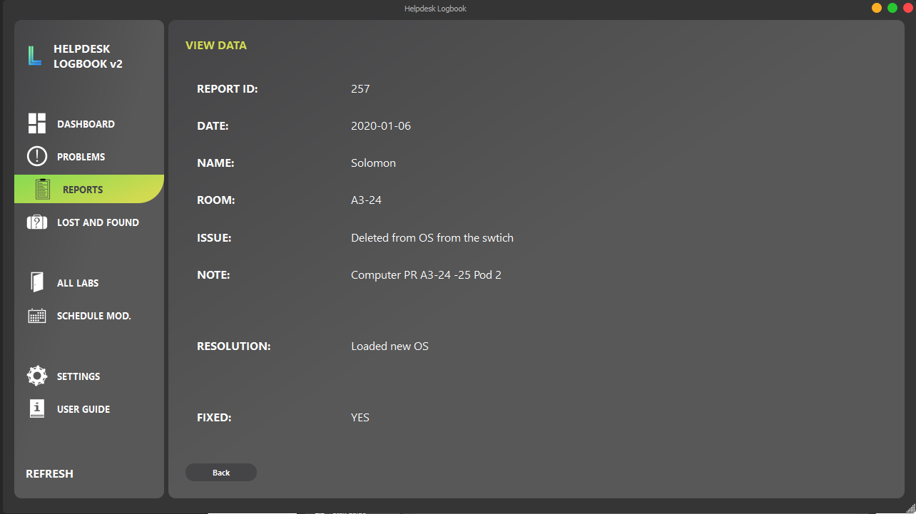

Pressing view with a row selected will view that entry on a new page.

## LOST AND FOUND

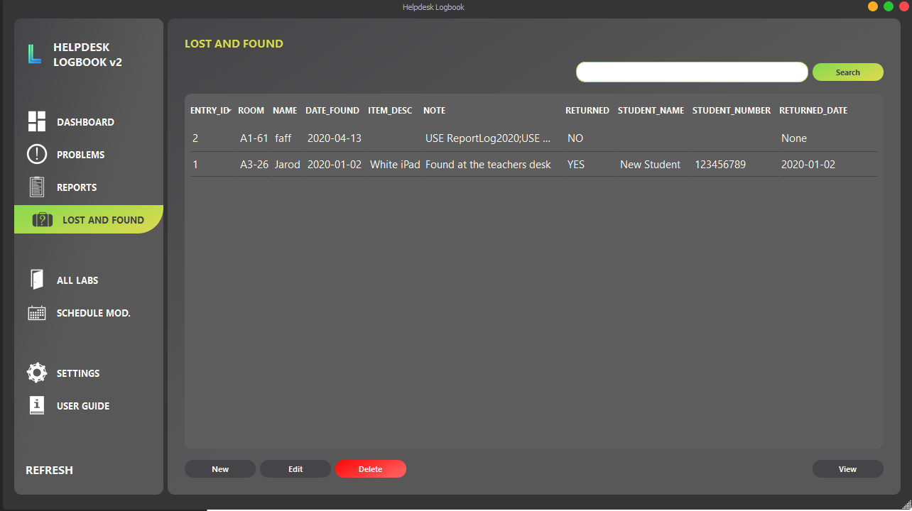

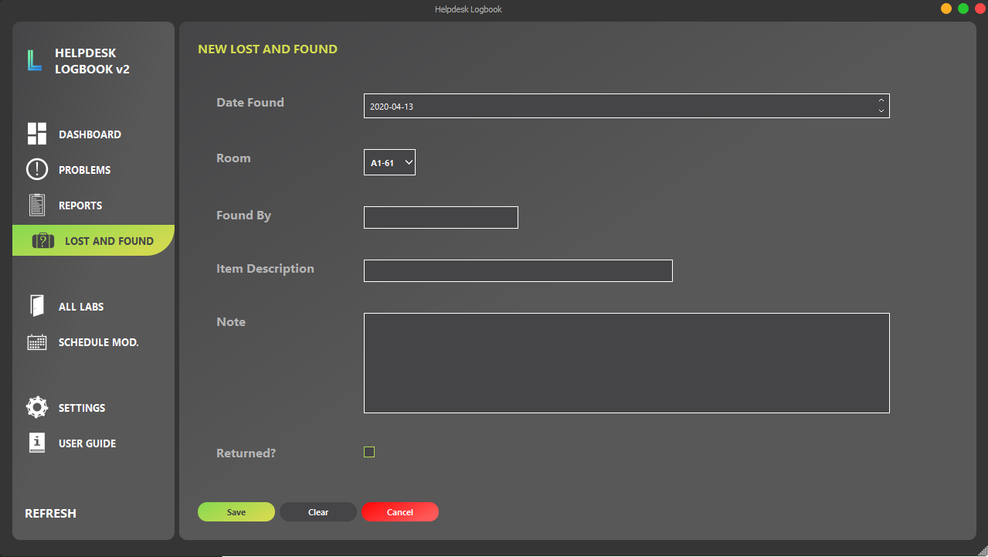

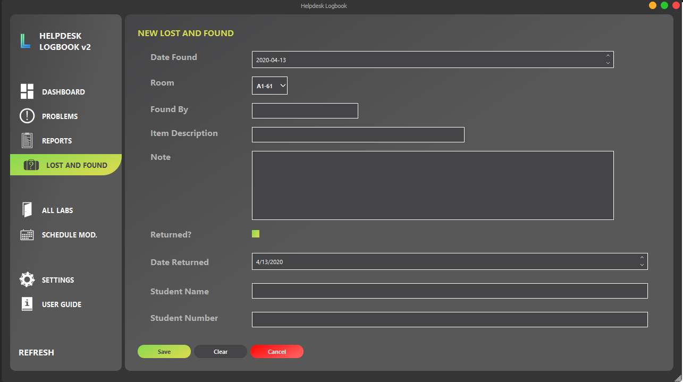

## ALL LABS

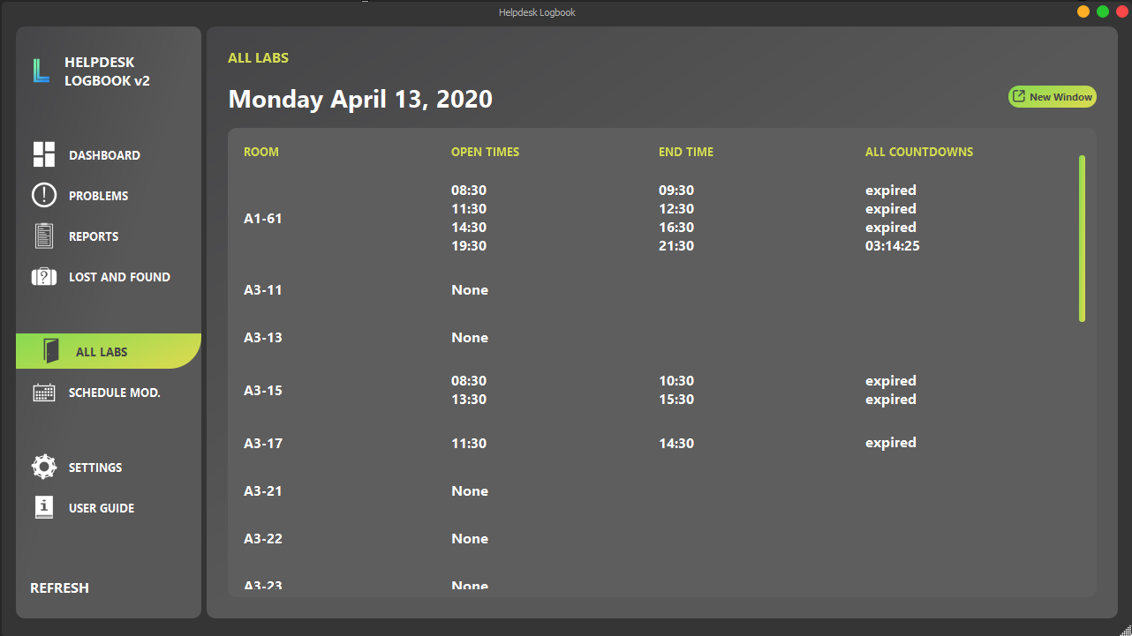

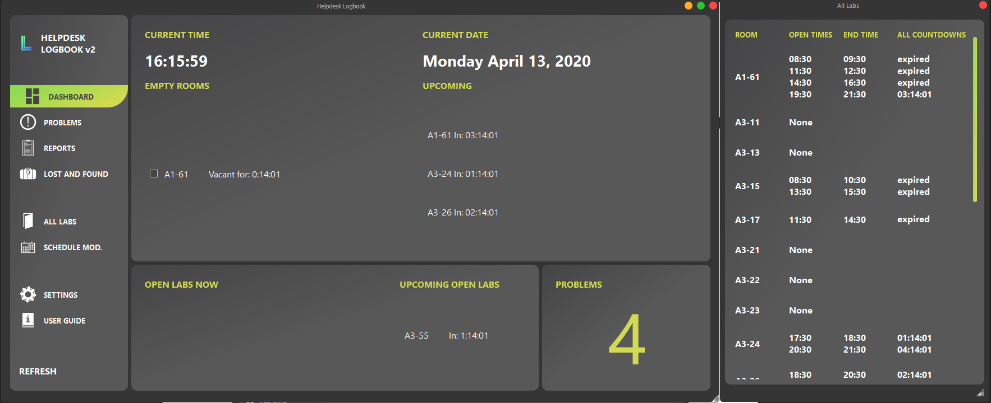

## SCHEDULE MODIFIER

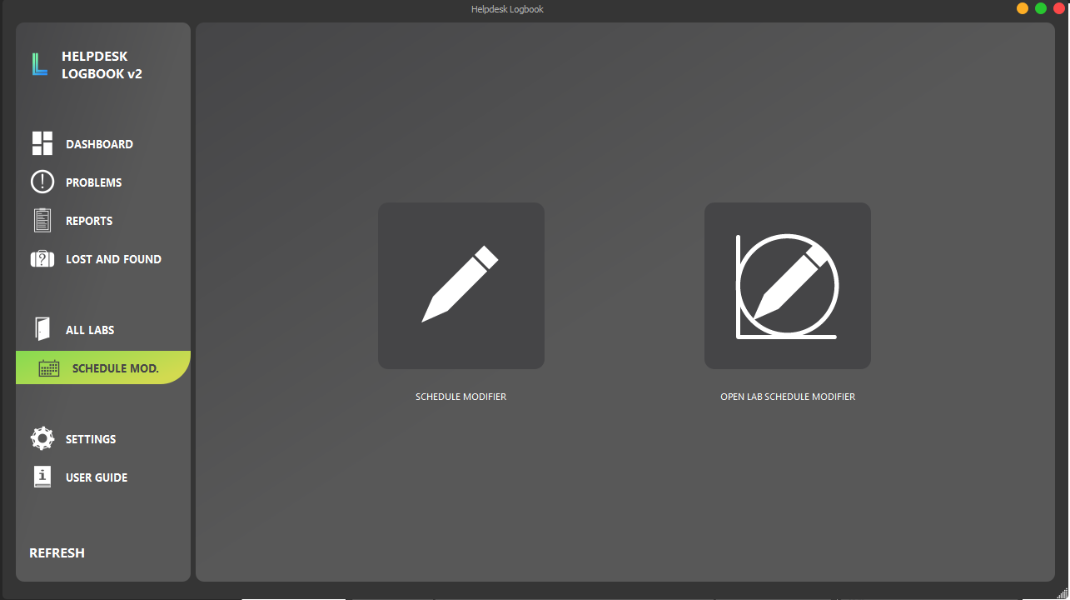

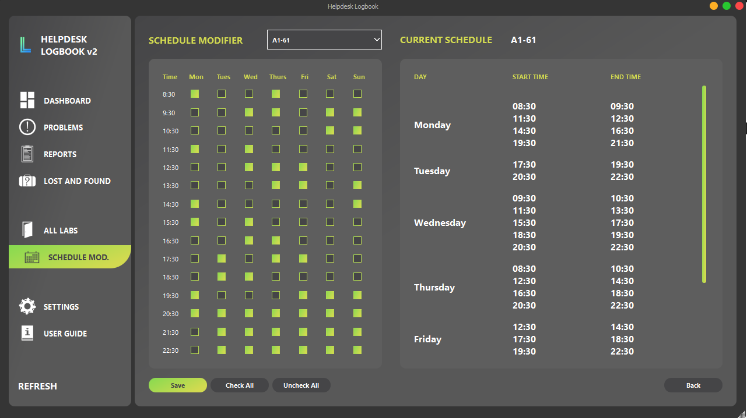

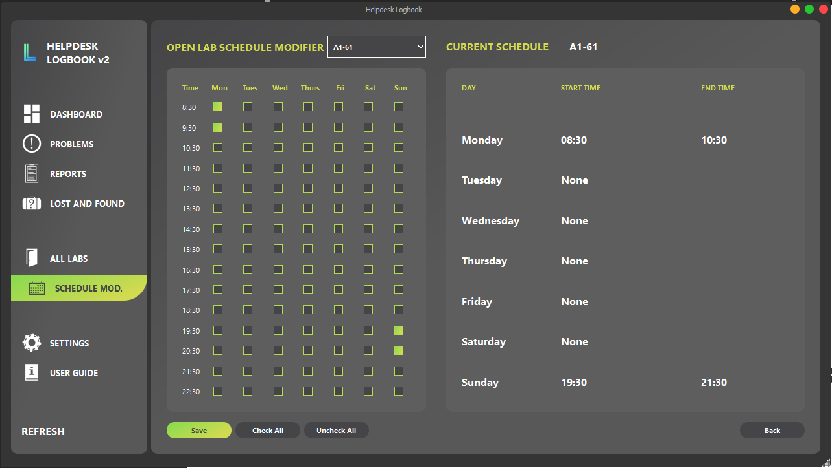

## SETTINGS

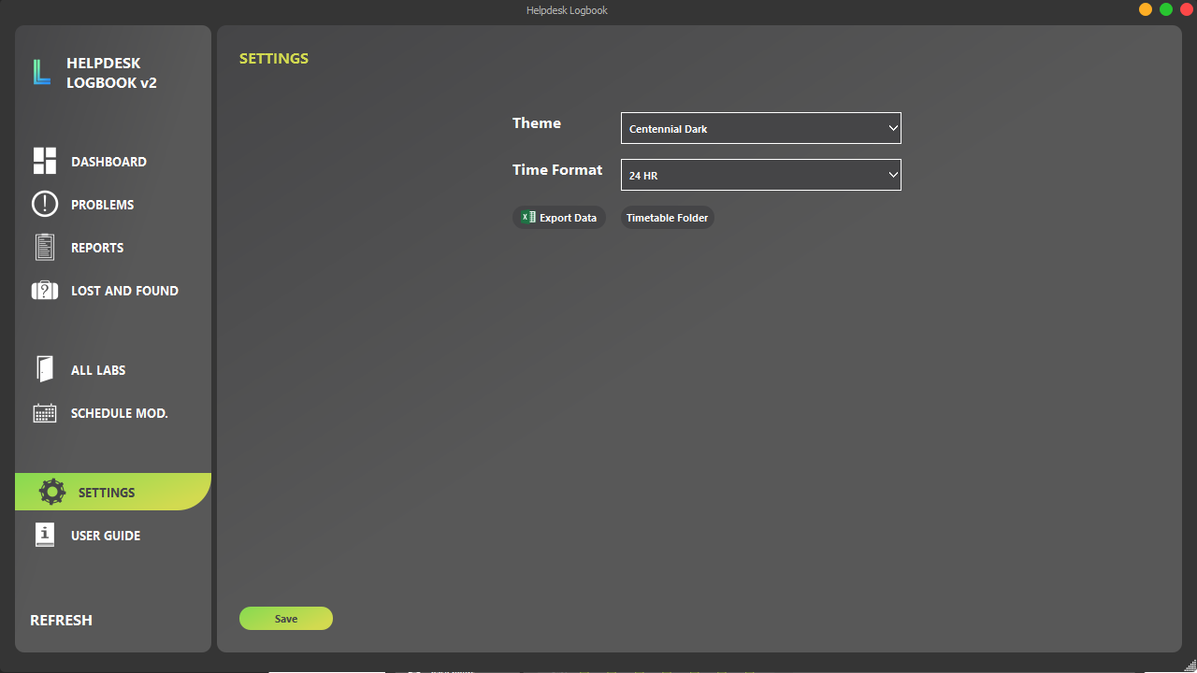

--add rooms with problems to dashboard

--lab schedule not updating

--create search bar for lost and found

--create user guide

--what is all labs?