**Page Title: Online Auction Admin Dashboard**

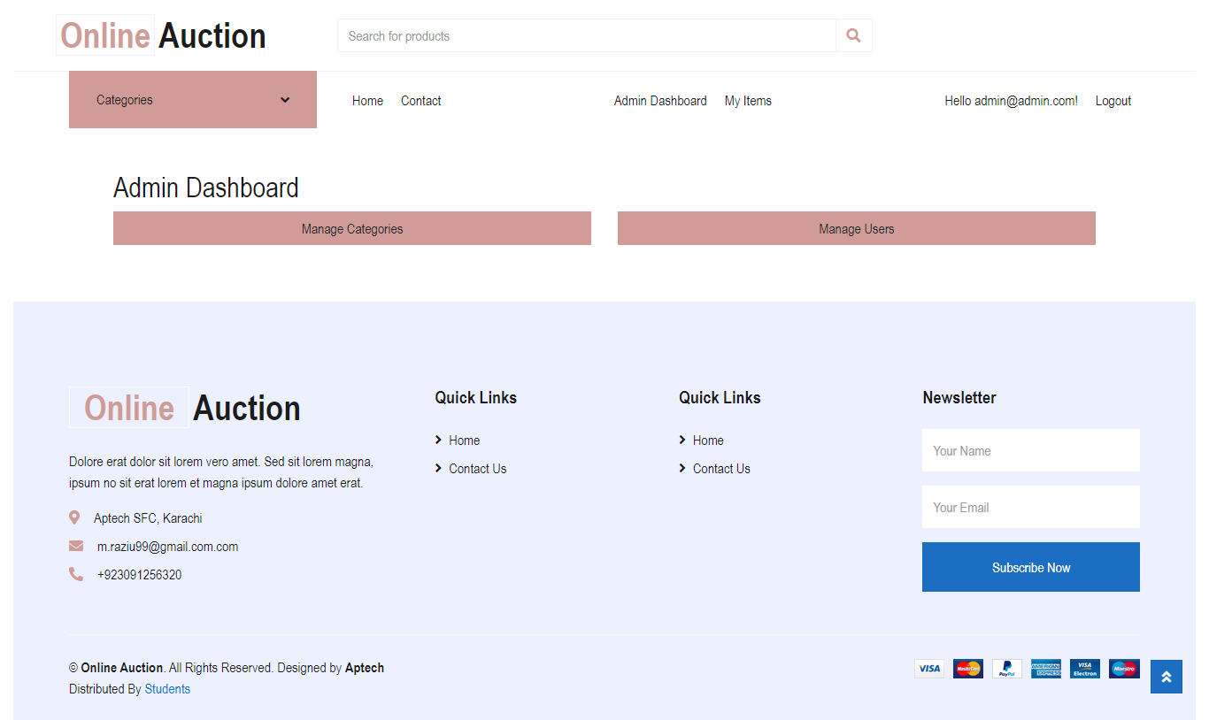

**Description:** This project is an **Admin Dashboard** designed for managing the categories and users of an **Online Auction** platform. The admin has full control over adding, updating, and deleting categories and users, ensuring smooth auction operations. The dashboard features a clean, user-friendly interface that allows administrators to easily navigate through essential functions such as managing auction items.

Additionally, the dashboard includes important quick links for home and contact pages. This project is ideal for companies or individuals managing large auction platforms, providing them with an efficient and straightforward way to handle backend operations.

**Features:**

* Manage Auction Categories
* Manage Registered Users
* Quick Access to Home and Contact Pages
* Simple and Responsive Design
* Contact Information Display

**Page Title: Single Product Auction Page**

|  |  |
| --- | --- |
| **Description:** This page is part of an **Online Auction Platform** where users can view and place bids on individual products. The page is specifically designed to display detailed information about an item, such as the **KIA Sportage AWD 2019**, including its model, mileage, and other specifications. Users can view the minimum starting bid, the current highest bid, and place their own bids through a simple and intuitive interface.  The auction start and end dates are prominently displayed to inform users about the bidding window. Additionally, users can download relevant documents and check the bid history to see how the auction is progressing in real time.  **Key Features:**   * Product Image Display with Detailed Description * Minimum and Current Bid Amount * Bid History Tracking * Bid Placement Option for Logged in Users * Auction Start and End Date Display * Auction Status Indicator * Document Download Option (For product-related files)   This auction system is ideal for selling high-value items such as cars, real estate, or electronics where competitive bidding is encouraged. The page offers a clean design, making it easy for bidders to engage in the auction. |  |

**Page Title: Online Auction Platform Home Page**

**Description:** The home page of the **Online Auction Platform** serves as the central hub where users can browse through multiple auction categories such as **Bikes**, **Cars**, **Electronics**, and **Furniture**. The layout is dynamic and designed to automatically display any new categories added to the system, providing a seamless browsing experience.

Each category showcases a carousel of products with their images, price, and a link to view more details or download relevant documents. The platform offers a user-friendly interface that enables potential buyers to easily navigate between categories and products. The design also includes essential elements like quick links to important pages (Home, Contact), and contact details for easy access to customer support.

**Key Features:**

* Dynamic category display (auto-updated with new categories)
* Product carousels with images, prices, and detailed descriptions
* Quick access to product details and downloadable documents
* Intuitive and responsive design for better user experience
* Easy navigation through multiple auction categories
* Contact details for customer support

This platform is ideal for online auction businesses looking to provide a comprehensive yet simple way to engage users and facilitate bidding on a wide range of products.

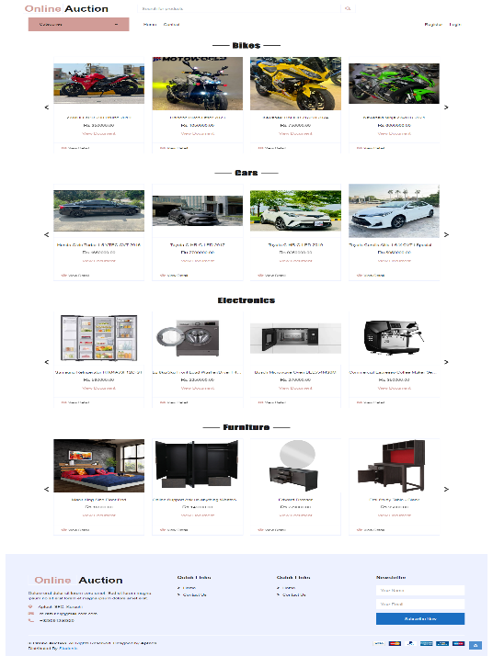

**Page Title: Online Auction Product Management Page**

|  |  |
| --- | --- |
| **Description:** This **Product List Page** allows administrators to view and manage all auction items in one place. Each product in the auction is displayed with its title, a brief description, the minimum bid amount, and the start and end dates of the auction. Administrators have access to various actions, such as editing a product, deleting it, or viewing more details.  Additionally, the page features a product image for easy identification and a downloadable document (if available) for users to access more information. This page is essential for keeping the auction inventory up to date and ensuring smooth management of listed items.  **Key Features:**   * Displays a list of all auction items with title, description, and image uploaded by User * Shows minimum bid and bid start/end dates for each item * Admin actions: Edit, Delete, View Details * Document download option for each product * User-friendly interface for easy navigation and management   This page is ideal for administrators of products who need a centralized place to manage auction products efficiently. It offers simple controls for adding, updating, or removing auction items while providing important product information to users. |  |

**Page Title: Single Category Product Listing Page**

|  |  |
| --- | --- |
| **Description:** This page is designed to display products from a single category on the **Online Auction Platform**. It specifically showcases items from one category, such as **Bikes**, **Cars**, **Electronics**, or **Furniture**. Each product is listed with its image, name, price, and options to view more details or download relevant documents.  Users can easily browse through the products within the selected category, allowing for a focused shopping experience. The layout is clean and responsive, making it easy for users to explore the auction items and place bids.  **Key Features:**   * Displays products from a single category (e.g., Bikes, Cars, Electronics, Furniture) * Product images with detailed descriptions and prices for each item * **View Details** and **View Document** options for additional product information * Focused layout for easy navigation within a specific category * Dynamic updates as new products are added within the selected category   This page offers a streamlined way for users to browse and bid on auction items in a specific category, ensuring a more organized and user-friendly experience. |  |

**Page Title: Online Auction Login Page**

**Description:** The **Login Page** for the **Online Auction Platform** allows users to securely access their accounts. By entering their email and password, users can log in to the platform to place bids, view their items, and manage their profiles.

The design is minimal and user-friendly, ensuring that users can quickly and easily log in. The page also features essential quick links to the home and contact pages.

**Key Features:**

* Simple and secure login form with email and password input
* Quick links to home and contact pages for easy navigation
* Contact information for support

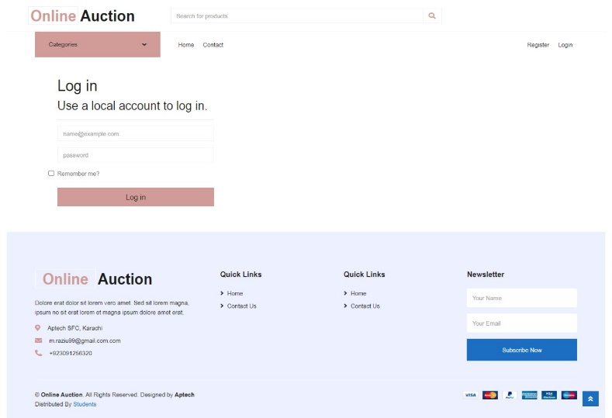This login page is essential for providing users with secure access to the **Online Auction Platform**, allowing them to manage their auction-related activities efficiently.

**Page Title: User Management Page**

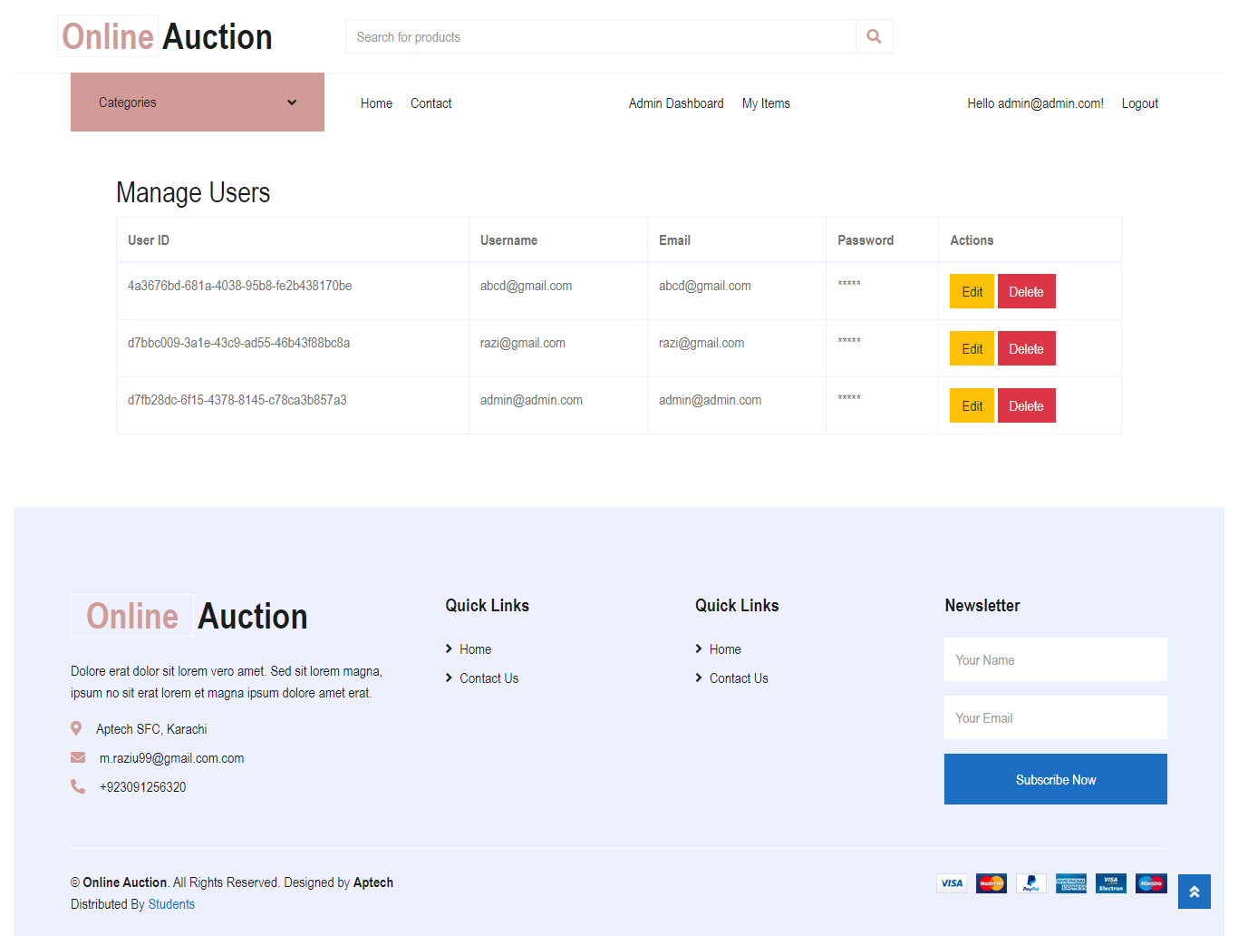

**Description:** The **User Management Page** for the **Online Auction Platform** allows administrators to view and manage all registered users. Each user is displayed with their **User ID**, **Username**, **Email**, and an encrypted password. The page provides administrative controls for editing or deleting user accounts, enabling effective management of user information.

This functionality is critical for platform administrators to ensure the security and proper handling of user accounts. It also provides a streamlined interface for managing user access and information.

**Key Features:**

* Displays user information including User ID, Username, Email, and Password
* Administrative controls for **Edit** and **Delete** actions for each user
* Simple and responsive layout for easy navigation
* Essential for managing user access and maintaining platform security
* Supports efficient user account management for administrators

This page is essential for the overall maintenance and administration of users on the platform, ensuring that user data is up-to-date and can be modified or removed as needed.

**Page Title: Category Management Page**

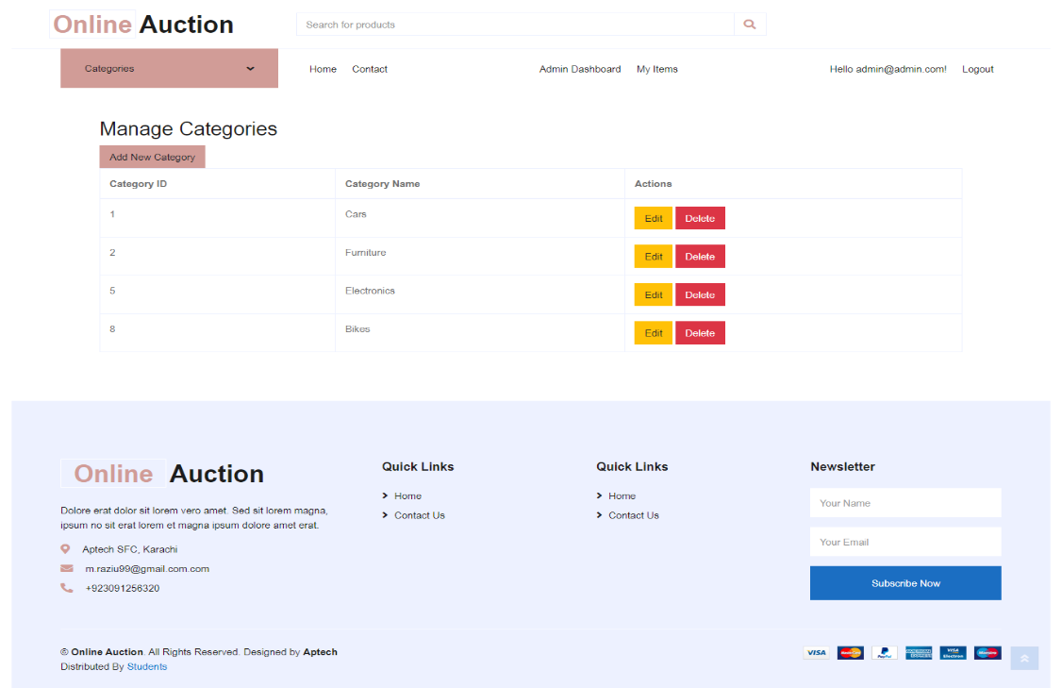

**Description:** The **Category Management Page** allows administrators to efficiently manage the product categories on the **Online Auction Platform**. Each category is listed with a unique Category ID and name, and administrators have the ability to edit or delete any category as needed. A dedicated **Add New Category** button is also provided for adding new auction categories, making the platform flexible and adaptable to different types of auctions.

This page is essential for keeping the auction platform organized, ensuring that all items are categorized correctly, and making it easy to introduce or remove categories based on the platform's needs.

**Key Features:**

* Display of existing categories with Category ID and Name
* **Edit** and **Delete** options for each category
* **Add New Category** button for quick category creation
* Simple and intuitive layout for easy navigation
* Efficient management of auction categories

This page is crucial for the administration of product categories on the platform, ensuring that new categories can be added and existing ones can be modified or removed without hassle.

**Page Title: Products Search Result Page**

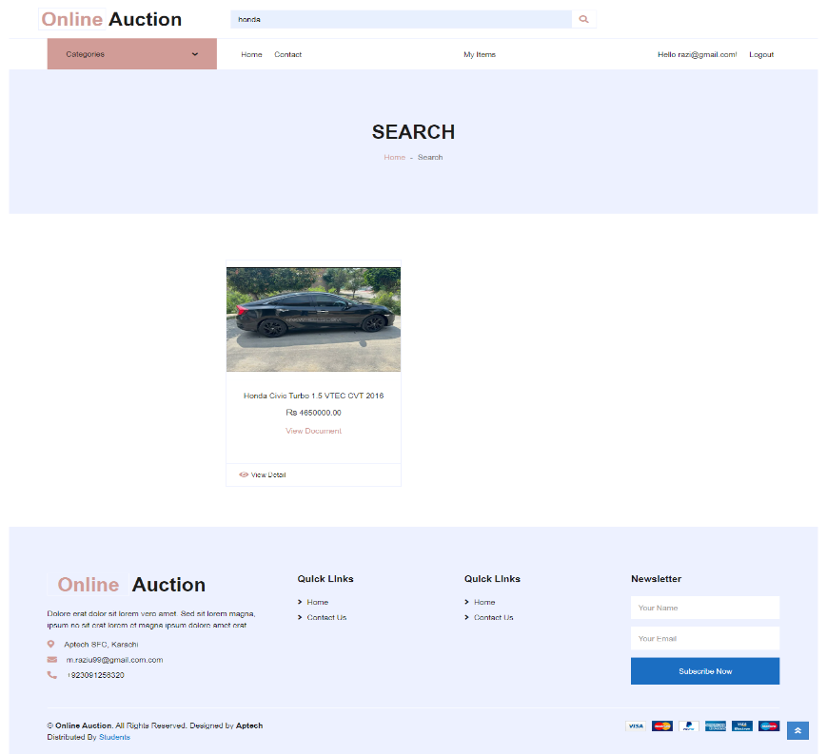

**Description:** The **Product Search Result Page** displays the results of a user’s search query on the **Online Auction Platform**. In this case, the search for "Honda" has returned one product: the **Honda Civic Turbo 1.5 VTEC CVT 2016**. The page provides essential information about the product, including its image, price, and options to view detailed information or download relevant documents.

This page is designed to deliver precise search results, making it easier for users to find specific items they are looking for in the auction. The layout is clean and minimal, ensuring that the user’s attention is focused on the relevant product.

**Key Features:**

* Displays search results for products
* Product information includes image, name, price, and links to detailed views
* **View Document** option for additional product information
* Simple, responsive layout for a smooth user experience

This page is critical for improving user engagement on the platform by ensuring that users can quickly find and bid on the products they are interested in.

**Page Title: User Registration Page**

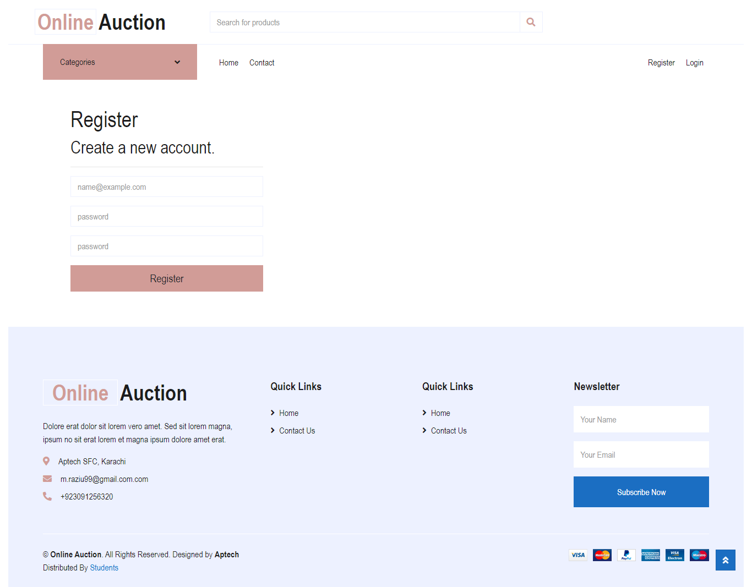

**Description:** The **Registration Page** on the **Online Auction Platform** allows new users to create an account by entering their email and password. This simple and secure registration process ensures that users can quickly sign up and start participating in the auction activities, such as placing bids, viewing items, and managing their profiles.

The layout is clean and intuitive, making it easy for new users to register. Once registered, users will have access to all platform features, ensuring a seamless experience.

**Key Features:**

* Simple registration form with email and password fields
* **Password confirmation** option for secure account creation
* User-friendly layout to streamline the registration process
* Quick links to **Home** and **Contact Us** pages for easy navigation

This page is essential for onboarding new users to the platform, offering them a hassle-free registration experience while ensuring the security of their credentials.

**Page Title: Edit Profile Page**

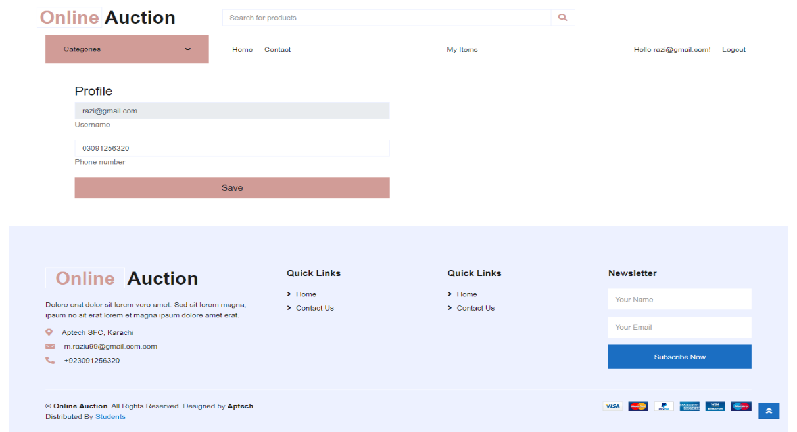

**Description:** The **Edit Profile Page** on the **Online Auction Platform** allows users to update their personal details, such as email, username, and phone number. This page provides an easy-to-use interface for users to keep their information up-to-date, ensuring smooth communication and personalized experience on the platform.

With a simple layout, the page ensures that users can quickly make changes and save their profile information with minimal effort. This functionality is important for maintaining accurate user data on the platform.

**Key Features:**

* Editable fields for **email**, **username**, and **phone number**
* Simple, intuitive design for easy navigation
* **Save** button to update and store new profile information
* Enhances user experience by allowing real-time profile updates
* Ensures accurate and up-to-date user data on the platform

This page is essential for users to manage and update their personal information, contributing to a personalized and seamless experience on the auction platform.

**Thank you for being a part of our journey, we look forward to your continued support**