**Authentication & Onboarding**

**Epic: As a new recruiter, I want to create an account so that I can access the system.**

* **User Story 1.1: Registration Form**
  + As a new recruiter,
  + I want to see a simple registration form with fields for my first name, last name, email, and password,
  + So that I can input my details to create an account.
  + **Wireframe Elements:** Textboxes for First Name, Last Name, Email, Password; a "Create Account" button; a link to "Already have an account? Log in".

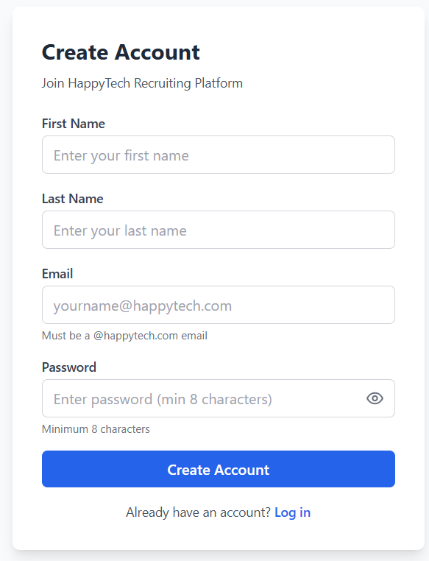

* **User Story 1.2: Registration Validation & Confirmation**
  + As a new recruiter filling out the form,
  + I want the system to validate my inputs (e.g., email has @happytech.com, password is 8+ chars, fields are <50 chars) and show clear error messages,
  + So that I can correct any mistakes before submitting.
  + After successful registration, I want to see a confirmation screen with a success message and a button to go to the login page.
  + **Wireframe Elements:** Error message labels near fields; a "Confirmation" screen with a success icon/message and a "Proceed to Login" button.

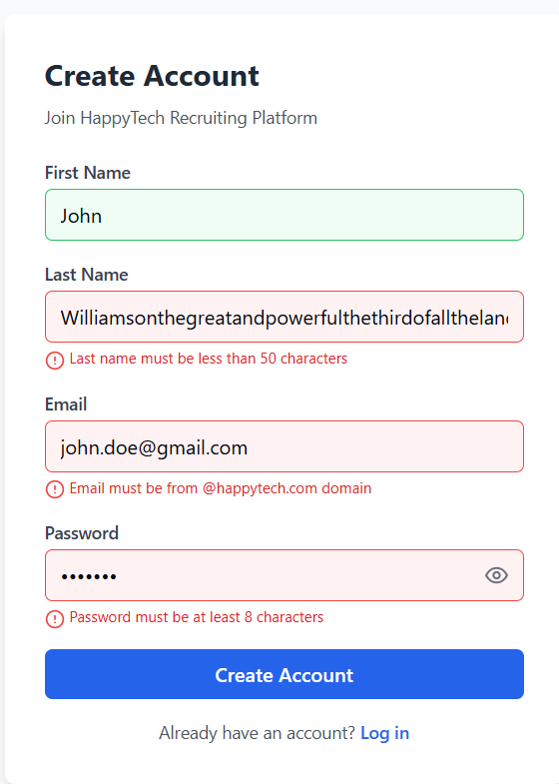

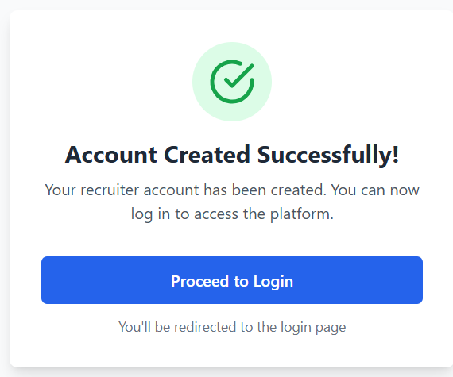

**Epic: As a registered recruiter, I want to log in securely so that I can start providing feedback.**

* **User Story 1.3: Login Form**
  + As a registered recruiter,
  + I want to see a login form where I can enter my email and password,
  + So that I can access my dashboard.
  + **Wireframe Elements:** Textboxes for Email and Password; a "Login" button; a "Show Password" (eye) icon; a "Create Account" link.

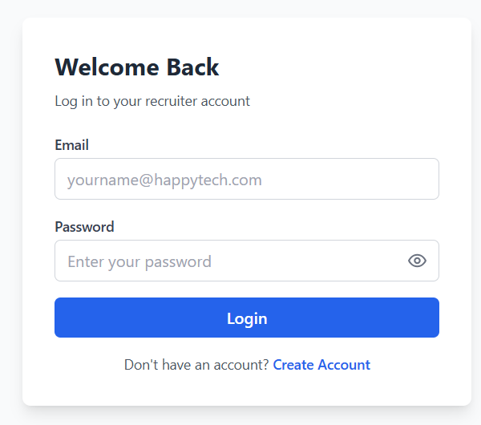

**Dashboard & Applicant Management**

**Epic: As a logged-in recruiter, I want to manage applicants and select templates from a central dashboard.**

* **User Story 2.1: Main Dashboard**
  + As a recruiter on the dashboard,
  + I want to see a form to add a new applicant (Name, Email, Job Position) and a list of available templates (e.g., "CV Feedback", "Interview Feedback") to select from,
  + So that I can quickly start the feedback process.
  + **Wireframe Elements:** Textboxes for Applicant Name, Email, Job Position; a group of selectable template cards/buttons; a "Save" button; a list/view of "Current Applicants".

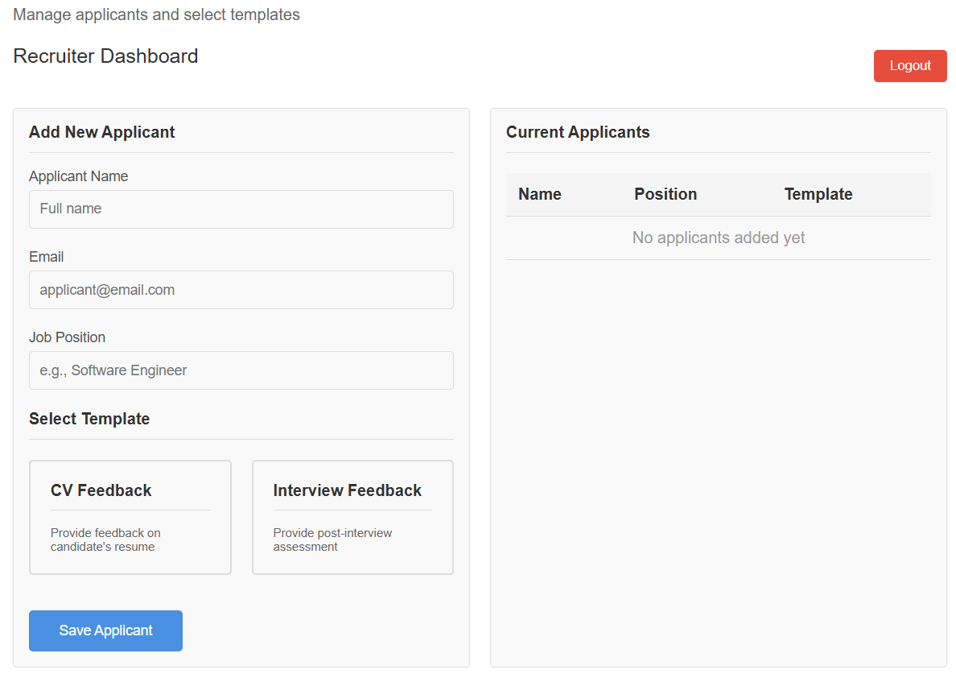

* **User Story 2.2: Confirm Applicant Addition**
  + After saving an applicant,
  + I want to see a confirmation screen that shows the applicant was added, displays the updated list of all applicants for this session, and gives me options to "Add Next Applicant" or "Begin Feedback",
  + So that I can verify the action and decide what to do next.
  + **Wireframe Elements:** Success message; a data grid/table showing Applicant Name, Email, Job, Template; buttons for "Add Next Applicant" and "Begin Feedback".

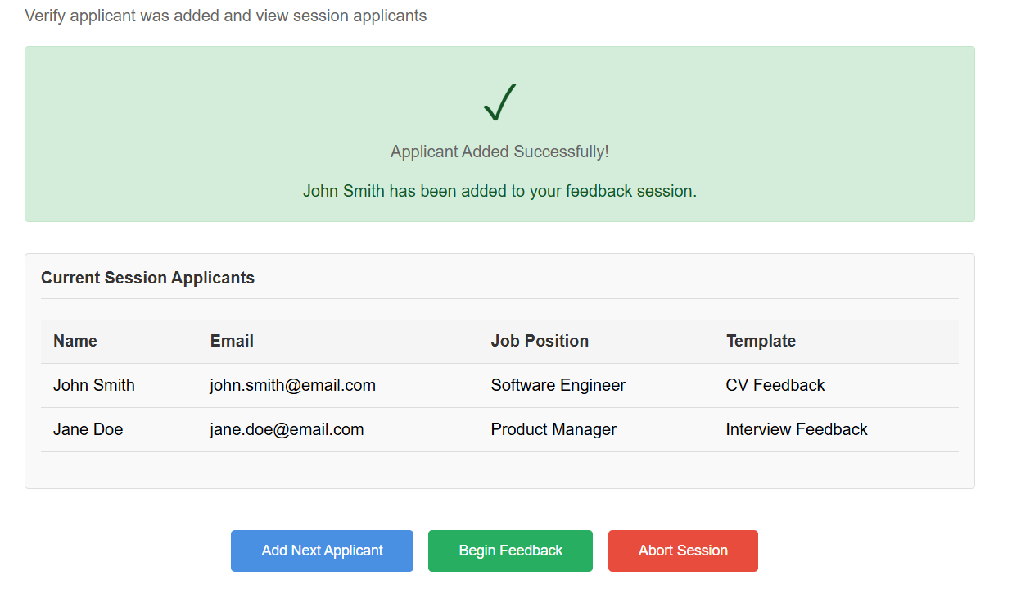

**Feedback Creation**

**Epic: As a recruiter, I want to write feedback efficiently by selecting pre-defined codes.**

* **User Story 3.1: Feedback Form Layout**
  + As a recruiter writing feedback,
  + I want a clear interface divided into sections: a list of available codes, a large area for the generated feedback text, a field for additional comments, and applicant details,
  + So that I can understand the layout and navigate easily.
  + **Wireframe Elements:** Panel 1: "Codes List" (with checkboxes). Panel 2: "Feedback Document" (rich text box). Panel 3: "Additional Comments" (textbox). Panel 4: "Applicant Details" (name, email, job, template type). Buttons: "Back", "Next".
* **User Story 3.2: Iterate Through Applicants**
  + As a recruiter with multiple applicants,
  + I want to click "Next" and "Back" buttons to move between applicants,
  + So that I can manage feedback for all of them in sequence without returning to the dashboard.
  + **Wireframe Elements:** Clearly labeled "Back" and "Next" buttons, ideally with a counter (e.g., "Applicant 2 of 5").
* **User Story 3.3: Select Codes to Build Feedback**
  + As a recruiter on the feedback form,
  + When I click a checkbox next to a code, I want its corresponding paragraph to be instantly added to the feedback document in the main text area,
  + So that I can build the feedback quickly without typing.
  + **Wireframe Elements:** Interactive checklist in the "Codes List". The main "Feedback Document" area should update in real-time.

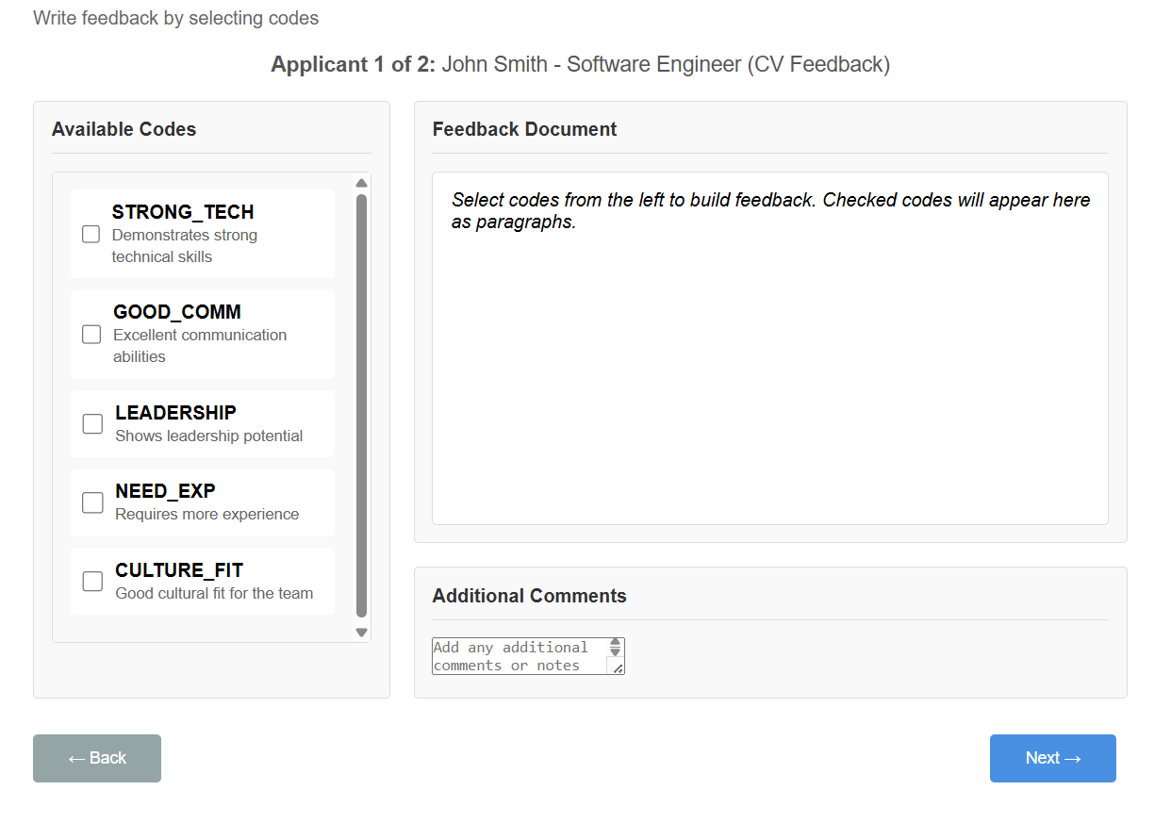

**Preview & Send Feedback**

**Epic: As a recruiter, I want to review and finalize feedback before sending it.**

* **User Story 4.1: Preview Feedback Summary**
  + After finishing all feedback,
  + I want to see a summary screen listing all applicants and their associated feedback files,
  + So that I can review everything before sending.
  + **Wireframe Elements:** A list or data grid with columns: Applicant Name, Feedback Title, Preview Button, and a "Send All" button.

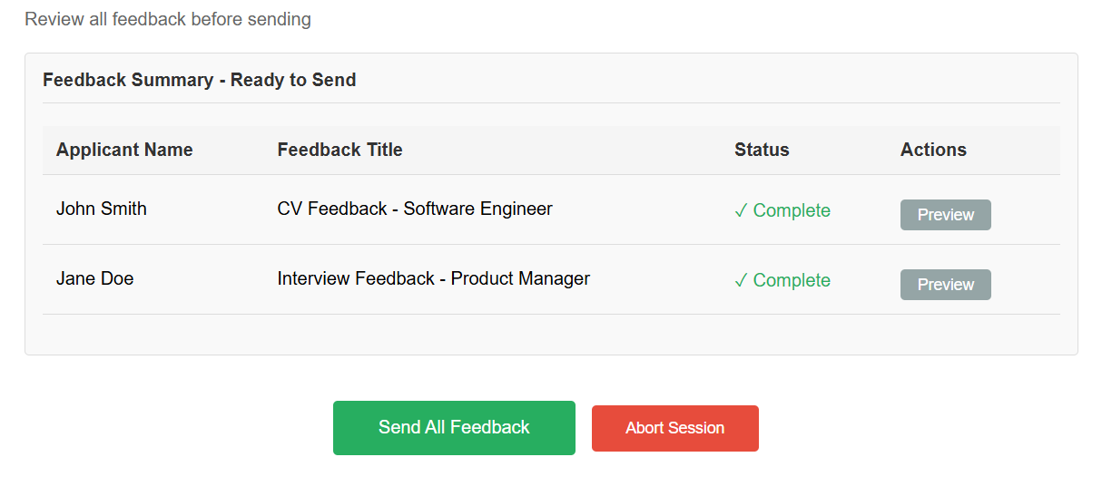

* **User Story 4.2: Preview Individual Feedback**
  + From the summary screen,
  + I want to click a "Preview" button next to an applicant's name to open a read-only view of their full feedback document,
  + So that I can double-check it for errors.
  + **Wireframe Elements:** A modal window or new screen displaying the formatted feedback, with a "Back" button to return to the summary.

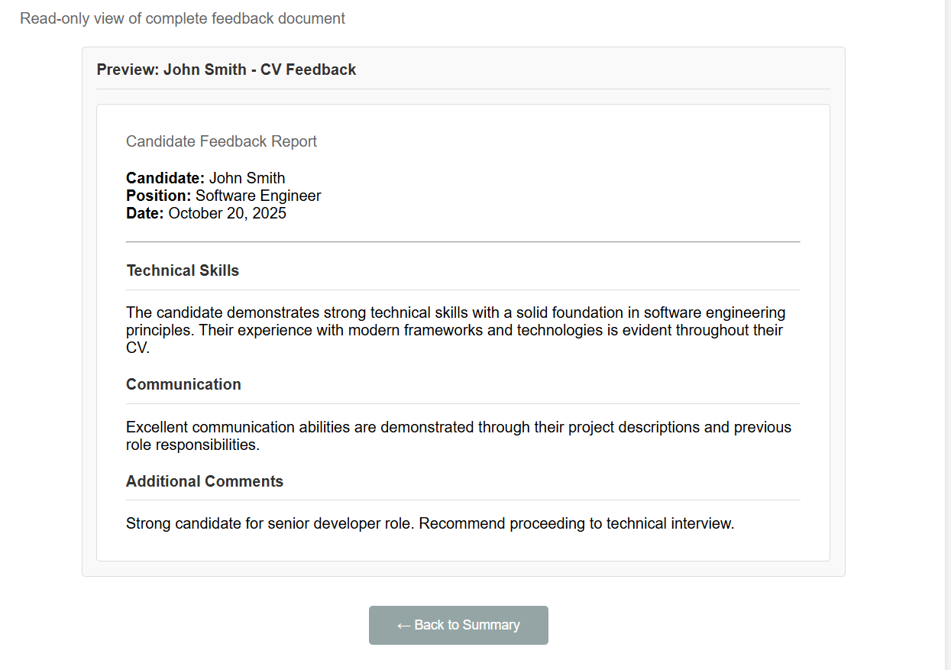

* **User Story 4.3: Send All Feedback**
  + From the summary screen,
  + I want to click a "Send All" button to convert all feedback to PDF and trigger the email process,
  + So that I can complete my task efficiently.
  + **Wireframe Elements:** A prominent "Send All" button. A confirmation dialog ("Are you sure?") and a subsequent success message.

**System Administration (Editor)**

**Epic: As a recruiter, I want to manage the building blocks of feedback (codes, sections, templates).**

* **User Story 5.1: Editor Dashboard**
  + As a recruiter,
  + I want to access an "Editor" section from the main dashboard with clear modes for managing "Templates", "Sections", and "Codes",
  + So that I can choose what I want to edit.
  + **Wireframe Elements:** A landing page with three large buttons/tabs: "Templates", "Sections", "Codes".

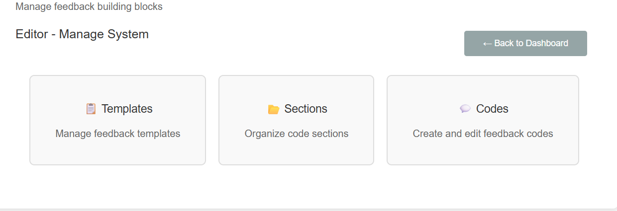

* **User Story 5.2: Create a New Code**
  + In the "Codes" editor mode,
  + I want to see a form to create a new code, with fields for "Code Name", "Code Paragraph", and a dropdown to assign it to a "Section",
  + So that I can expand the library of feedback snippets.
  + **Wireframe Elements:** Textboxes for Name and Paragraph (multi-line). A dropdown for "Section". "Save" and "Cancel" buttons.
* **User Story 5.3: Edit/Delete an Existing Code**
  + In the "Codes" editor mode,
  + I want to select an existing code from a dropdown list, have its details auto-populate the form, and then have the option to edit them or delete the code entirely,
  + So that I can maintain and update the code library.
  + **Wireframe Elements:** A dropdown labeled "Choose Existing Code". The form fields (Name, Paragraph, Section) populate upon selection. "Save", "Delete", and "Cancel" buttons.
* **User Story 5.4: Manage Template-Section Links**
  + In the "Templates" editor mode,
  + I want to select a template from a dropdown and see a list of all available sections with checkboxes, allowing me to select which sections belong to that template,
  + So that I can easily group related codes for different types of feedback.
  + **Wireframe Elements:** Dropdown for "Select Template". A checklist of all sections. "Save" and "Cancel" buttons.

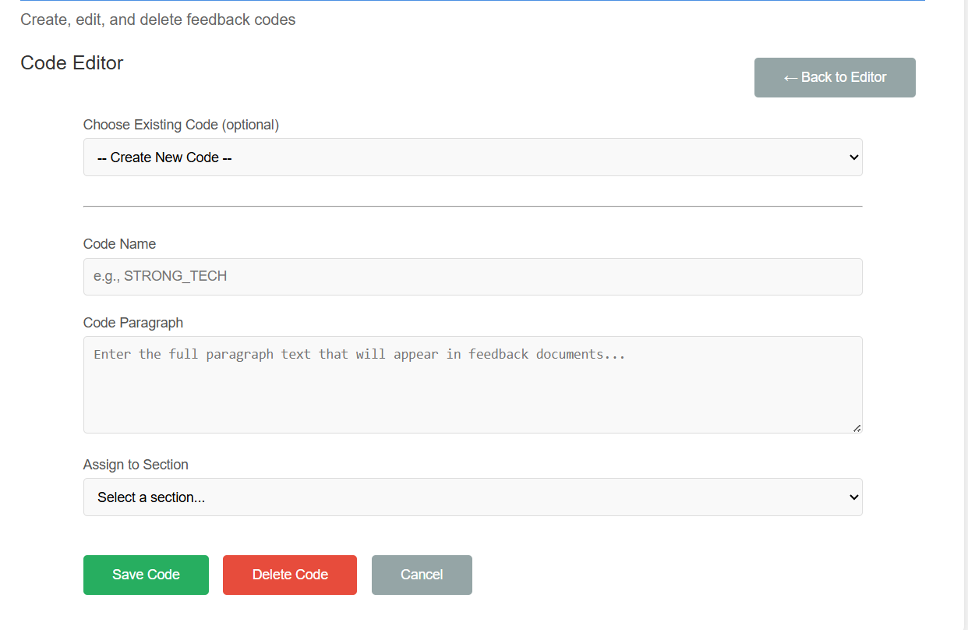

**Session Management**

**Epic: As a recruiter, I want to control my session to prevent errors or data loss.**

* **User Story 6.1: Logout**
  + From the main dashboard,
  + I want to click a "Logout" button, be asked for confirmation ("Are you sure?"), and then be returned to the login screen,
  + So that I can securely end my session.
  + **Wireframe Elements:** "Logout" button (often in top-right corner). A confirmation dialog/modal.
* **User Story 6.2: Abort/Reset Session**
  + From the "Confirm Applicant" or "Preview" screens,
  + I want to click an "Abort" or "Cancel" button to reset my progress, clear all current applicants, and return to the default dashboard,
  + So that I can start over if I make a mistake or no longer wish to continue.
  + **Wireframe Elements:** "Abort" or "Cancel" button (often red or secondary). A confirmation dialog ("This will delete all current applicants. Are you sure?").

