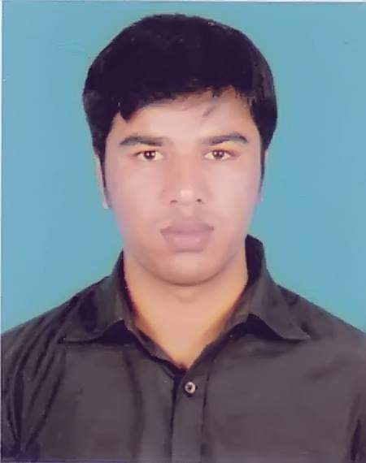

Php

Javascript

Html & css

Laravel

Bootstrap

Jquery

Microsoft Office

PSD To HTML

Responsive Design

**EXPERIENCE**

Study : CSE

Since: 2016 – Present

CGPA: 3.50 – present

I am web developer. I am working with this field more than 3 hours. I have experience of Html, Css, Javascript, Php, Laravel, Bootstrap, Jquery.

I have more than 10 Project of different fileds.

I hope I am able to complete any project.

UNIVERSITY OF GB

Bachelor in Infomation

**CONTACT**

Writhing

Music

Reading

Travel

www.websolves.net

Savar, Dhaka

+8801795805817

razibhossen8566@gmail.com

**Ω**

**Ω**

**Ω**

**Ω**

**Ω**

**Ω**

**Ω**

**Ω**

**EDUCATION**

**HOBBIES**

**PROFILE**

**RAZIB HOSSEN**

**CURICULUM VITA**