
EMPLOYEE DATA ANALYSIS REPORT
A Python Data Analysis Project
Prepared by: Mohd. Razi Khan
Course: Data Science
Tools Used: Python, Pandas, NumPy, Matplotlib, Seaborn
Dataset: Employee Details (Kaggle)
Date: July 30, 2026

Table of Contents
Table of Contents 2
1. Introduction 3
2. Objectives 3
3. Dataset Overview 3
4. Data Cleaning 4
5. Steps of Data Cleaning 5
6. Visualizations, Analysis & Key Findings 6
6.1 Histogram — Employee Age Distribution 6
Description 6
Key Findings 6
6.2 Pie Chart — Top 5 Department Regions 6
Description 6
Key Findings 6
6.3 Count Plot — Employee Status Count 8
Description 8
Key Findings 8
6.4 Histogram with KDE — Salary Distribution 8
Description 8
Key Findings 8
6.5 Line Plot — Salary vs Performance Score 10
Description 10
Key Findings 10
6.6 Horizontal Bar Chart — Employees by Department Region 10
Description 10
Key Findings 10
7. Conclusion 12

1. Introduction
Employee data analysis helps organizations manage employee information and make better decisions. This project uses an employee dataset to perform data cleaning and analysis using Python, Pandas, NumPy, Matplotlib, and Seaborn. The dataset was cleaned by handling missing values, removing duplicate records, and correcting data types. After cleaning, various charts were created to visualize employee age, salary, department region, performance score, and other important insights.

2. Objectives
- Clean the employee dataset using Pandas and NumPy.
- Handle missing values and duplicate records.
- Analyze employee data.
- Create visualizations using Matplotlib and Seaborn.
- Extract meaningful insights from the cleaned dataset.

3. Dataset Overview
The dataset used in this project is an Employee Dataset containing employee-related information such as employee ID, name, age, department region, employment status, joining date, salary, email, phone number, performance score, and remote work status. The dataset was used to perform data cleaning, analysis, and visualization using Python.
Property | Value
Dataset Name | Employee Dataset
Source | Public Dataset
Total Rows | 10,000
Total Columns | 12
Tools Used | Python, Pandas, NumPy, Matplotlib, Seaborn

4. Data Cleaning
An initial check of the employee dataset revealed missing values in the Age and Salary columns. These missing values were identified using Pandas and later filled using the mean calculated with NumPy. Duplicate records were also checked to ensure data consistency before analysis.
Column Name | Missing Values | Action Taken
Age | 211 | Filled with Mean (NumPy)
Salary | 24 | Filled with Mean (NumPy)
Employee_ID | 0 | No Cleaning Required
First_Name | 0 | No Cleaning Required
Last_Name | 0 | No Cleaning Required
Department_Region | 0 | No Cleaning Required
Status | 0 | No Cleaning Required
Join_Date | 0 | Converted to Date Format
Email | 0 | No Cleaning Required
Phone | 0 | No Cleaning Required
Performance_Score | 0 | No Cleaning Required
Remote_Work | 0 | No Cleaning Required

5. Steps of Data Cleaning
- Loaded the Dataset
  - Imported the employee dataset using Pandas.
- Checked Dataset Information
  - Examined the number of rows, columns, data types, and basic information.
- Identified Missing Values
  - Used isnull().sum() to find missing values in each column.
- Handled Missing Values
  - Filled missing values in the Age and Salary columns using the mean calculated with NumPy.
- Checked Duplicate Records
  - Identified duplicate rows using duplicated().
- Removed Duplicate Records
  - Deleted duplicate rows using drop_duplicates().
- Converted Data Types
  - Converted the Join_Date column to datetime format.
- Verified the Cleaned Dataset
  - Rechecked missing values and data types to ensure the dataset was clean.
- Saved the Cleaned Dataset
  - Exported the cleaned data to a new CSV file for further analysis and visualization.

6. Visualizations, Analysis & Key Findings

6.1 Histogram — Employee Age Distribution

Description
This histogram illustrates the distribution of employee ages in the dataset. It helps identify the age groups that have the highest number of employees.

Key Findings
- Most employees are between 30 and 40 years of age.
- The 30–32 and 39–40 age groups have the highest number of employees.
- Fewer employees are found around the 34–35 age range compared to other groups.
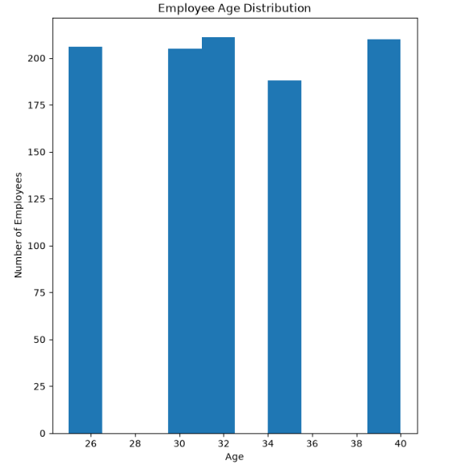
Figure 6.1: Employee Age Distribution

6.2 Pie Chart — Top 5 Department Regions

Description
This pie chart shows the distribution of employees across the top five department regions. Each slice represents the percentage of employees working in a specific department and region.

Key Findings
- HR–Florida has the highest share of employees (22.9%).
- DevOps–California and Sales–Nevada each account for 19.6% of the employees.
- Admin–Nevada and Admin–California each contribute 19.0%.
- The employee distribution among the top five department regions is fairly balanced.
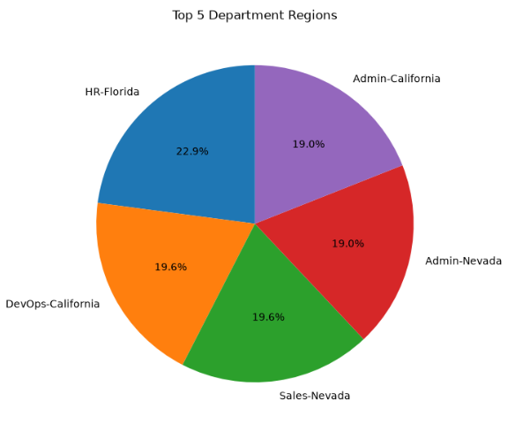
Figure 6.2: Top 5 Department Regions

6.3 Count Plot — Employee Status Count

Description
This count plot shows the number of employees in each employment status category: Active, Pending, and Inactive. It provides a quick comparison of employee status across the organization.

Key Findings
- Pending has the highest number of employees.
- Active employees are slightly fewer than Pending employees.
- Inactive has the lowest employee count.
- The difference between Active and Pending is small, while Inactive is noticeably lower.
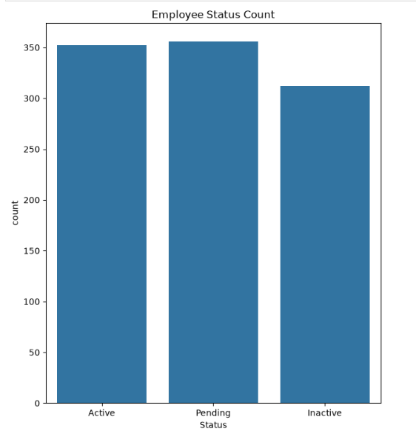
Figure 6.3: Employee Status Count

6.4 Histogram with KDE — Salary Distribution

Description
This histogram with a KDE (Kernel Density Estimation) curve shows the distribution of employee salaries in the dataset. It helps visualize how salaries are spread across different salary ranges.

Key Findings
- Most employee salaries fall between ₹80,000 and ₹100,000.
- The highest concentration of employees is around ₹90,000.
- Fewer employees have salaries near the lower (₹50,000–₹60,000) and higher (₹110,000–₹120,000) salary ranges.
- The salary distribution is fairly balanced without any extreme peaks.
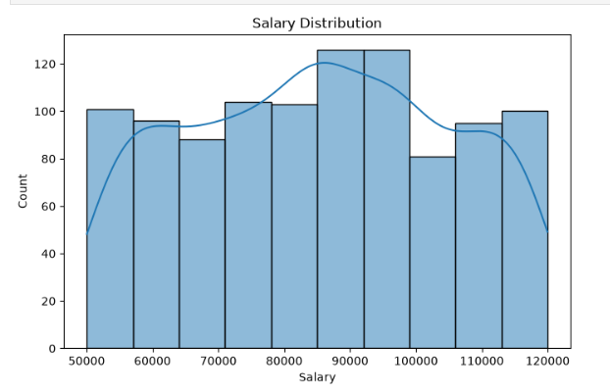
Figure 6.4: Salary Distribution

6.5 Line Plot — Salary vs Performance Score

Description
This line plot shows the relationship between employee Performance Score and Salary. It compares the average salary across different performance categories: Average, Excellent, and Poor.

Key Findings
- Average performance score employees receive the highest salary.
- The salary for employees with an Excellent performance score is slightly lower than the Average category.
- Poor performance score employees have the lowest salary.
- The salary difference between the performance categories is relatively small.
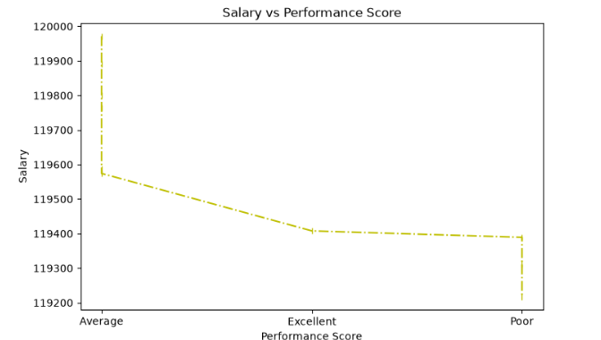
Figure 6.5: Salary vs Performance Score

6.6 Horizontal Bar Chart — Employees by Department Region

Description
This horizontal bar chart displays the number of employees across different department regions. It compares the employee count for the top department-region combinations in the organization.

Key Findings
- HR–Florida has the highest number of employees (about 41).
- Sales–Nevada and DevOps–California have around 35 employees each.
- Most department regions have employee counts between 33 and 36, indicating a balanced distribution.
- DevOps–Illinois, Sales–Florida, HR–New York, and DevOps–New York have similar employee counts.
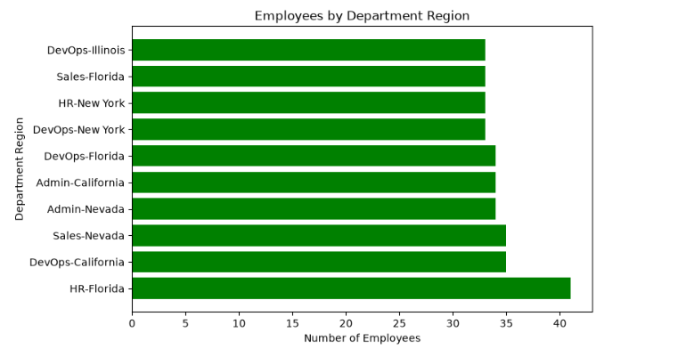
Figure 6.6: Employees by Department Region

7. Conclusion
This project successfully demonstrated the process of data cleaning, analysis, and visualization using an Employee dataset. Missing values and duplicate records were handled using Pandas and NumPy, making the dataset clean and suitable for analysis. Various charts were created using Matplotlib and Seaborn to understand employee age distribution, salary distribution, department regions, employee status, and performance scores. The analysis provided meaningful insights into employee data and showed how Python libraries can be used for effective data preprocessing and visualization. Overall, this project improved the understanding of data cleaning techniques and exploratory data analysis using Python.

