Construct AI Agent
UI Walkaround & Feature Tour

Version 0.1.0-alpha
Date: May 29, 2026
Repository: github.com/Razisafir/construct-ai-agent

Confidential — Internal Use Only

1. Introduction
This document provides a comprehensive visual walkthrough of the Construct AI Agent desktop application. Construct is a Tauri v2 desktop app that combines a Rust backend shell, a React/TypeScript frontend, and a Python FastAPI sidecar to deliver an AI coding assistant with persistent memory, autonomous agent capabilities, and multi-agent team orchestration. The walkthrough covers every major UI panel, from the initial splash screen through the main IDE interface, agent controls, memory browser, MCP connectors, and chat functionality.
The application follows a dark terminal-inspired aesthetic with a monospace font stack (Geist Mono, JetBrains Mono), a Catppuccin-inspired color scheme featuring deep navy backgrounds (#0c0c10), subtle indigo accents (#6366f1), and careful use of whitespace and border transparency to create a premium developer-focused interface. Every UI element is designed to feel like a natural extension of a developer's existing terminal and IDE workflow.

2. Splash Screen & Startup
When Construct launches, the user is greeted by a minimal splash screen that performs a backend health check before loading the main interface. The splash screen features the Construct logo mark (a geometric square-within-square SVG), the application name in uppercase tracking, and a status indicator that cycles through initializing, checking backend, and ready states. A thin progress bar at the bottom provides visual feedback during the loading process.
The splash screen is critical because it bridges the gap between the Tauri Rust shell starting up and the Python FastAPI backend becoming ready. The health check polls the backend's /health endpoint up to 10 times with 500ms intervals. If the backend is not available after all retries, the app proceeds in offline mode, allowing the user to access the UI with reduced functionality. This graceful degradation ensures that the application is never stuck on a loading screen.
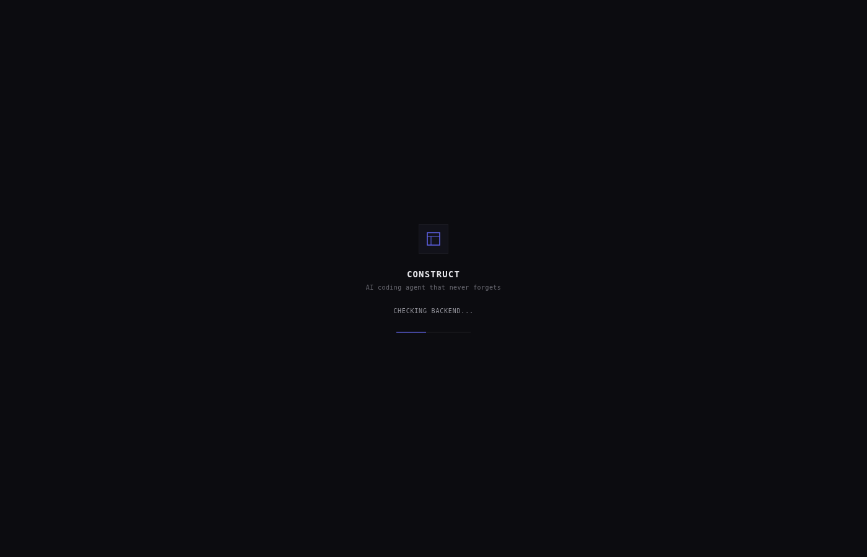
Figure 1: Splash screen with backend health check progress indicator

3. Onboarding Wizard
First-time users are presented with an onboarding wizard that guides them through the initial configuration. The wizard collects essential information such as the user's preferred LLM provider (OpenAI, Anthropic, Google, or local Ollama), API keys, default project directory, and coding style preferences. This data is stored in the persistent memory system so that the agent can immediately begin understanding the user's workflow from the very first interaction.
The onboarding wizard also introduces the three core concepts of Construct: persistent memory (the agent remembers everything), autonomous execution (the agent can work independently on tasks), and local-first processing (all data stays on the user's machine). Each concept is presented on a separate screen with a brief explanation and a visual illustration. The wizard can be skipped and accessed later from the settings panel, and it only appears once unless the user resets their configuration.
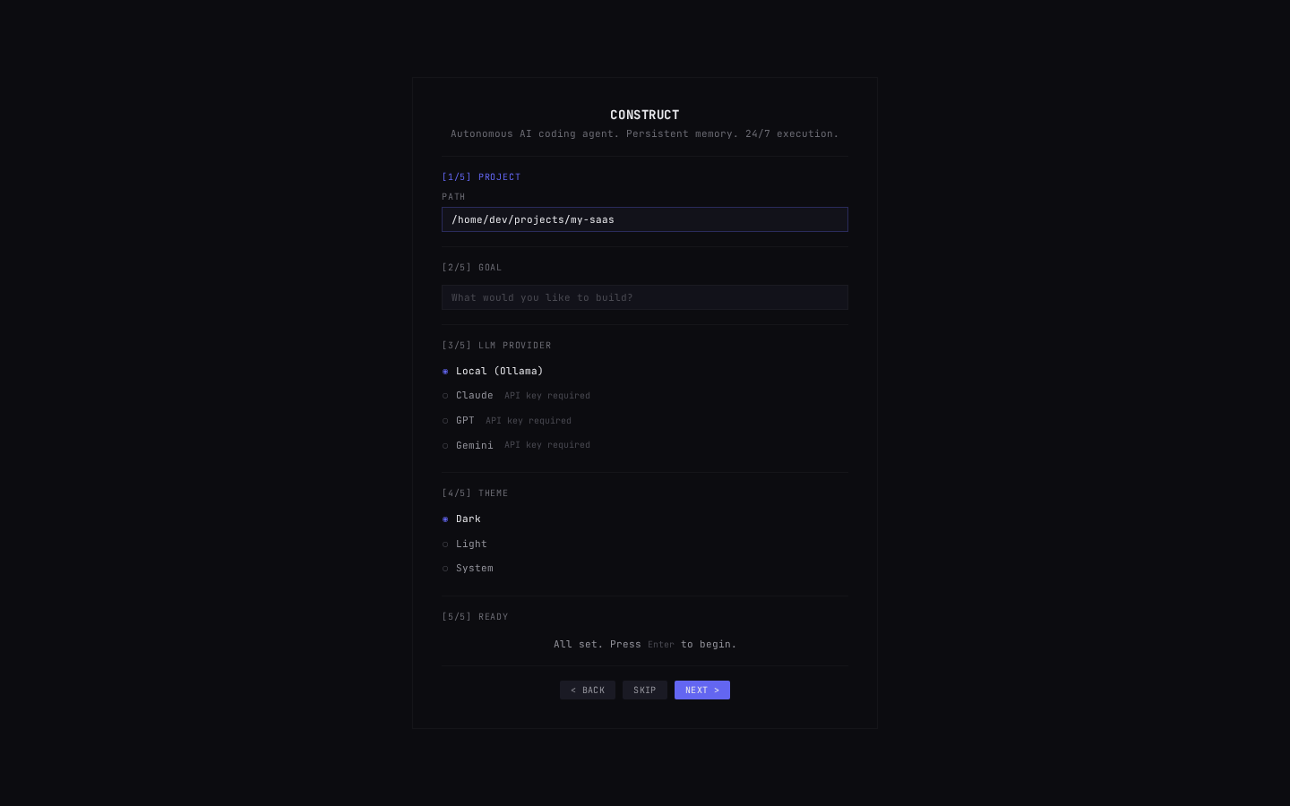
Figure 2: Onboarding wizard showing initial configuration steps

4. Main IDE Interface
The main Construct interface is organized into four primary zones: the title bar at the top, the sidebar on the left, the central editor area, and the bottom panel. This layout mirrors the familiar IDE pattern used by VS Code and other popular editors, reducing the learning curve for new users. The entire interface uses a consistent dark theme with the color palette defined in the Tailwind CSS configuration and CSS custom properties.

4.1 Title Bar
The title bar spans the full width of the window and displays the application name (CONSTRUCT) in uppercase tracking on the left and the version number on the right. The title bar is minimal and does not include navigation tabs or menus, keeping the interface clean and focused. The height is fixed at 28 pixels with a slightly lighter background (#12121a) compared to the base background, providing subtle visual separation without creating harsh borders.

4.2 Sidebar
The sidebar is divided into two sections: a narrow icon rail on the left (32 pixels wide) and a wider content panel on the right (approximately 248 pixels). The icon rail provides one-click access to six primary features through vertically stacked icon buttons: Files (file tree browser), Git (version control status), Agent (AI agent control), Memory (persistent memory browser), Skills (skill marketplace), and MCP (Model Context Protocol connectors). Each icon button can display a badge showing relevant counts, such as the number of memory contexts (1,247) or active MCP connections.
The sidebar content panel changes based on which icon rail button is active. In the default Files view, it displays a hierarchical file tree with expandable folders, file type icons (TypeScript, JSON, Markdown), and modification badges ([M] for modified, [A] for agent-added, [E] for error). Below the file tree, the Active Context section shows tags representing the current working context (e.g., auth-flow, api-integration, ui-components), and at the very bottom, a Memory Stats bar displays the total number of stored contexts.
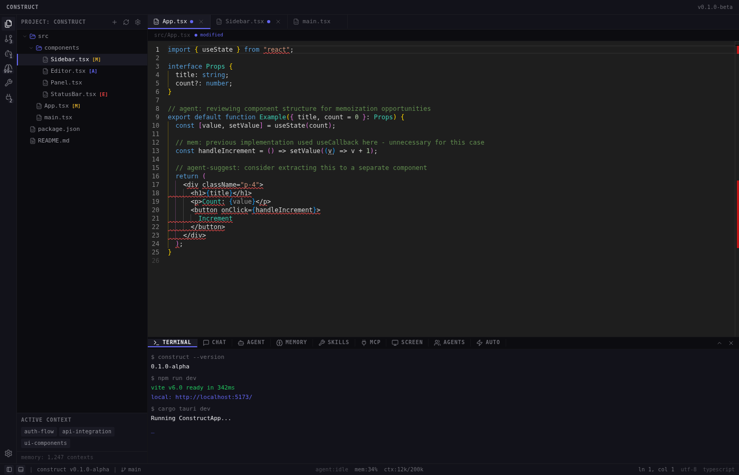
Figure 3: Main IDE interface showing sidebar, editor, and bottom panel

4.3 Central Editor
The central area of the interface contains a Monaco Editor instance loaded from CDN with a custom construct-dark theme. The editor supports syntax highlighting for all common programming languages, multi-cursor editing, code folding, and integrated diff views. Files opened from the sidebar appear as tabs in the editor, and the agent can also open files automatically when referencing code during a session. The editor is lazy-loaded using React.lazy() to improve initial startup time, with a minimal loading placeholder displayed while the Monaco bundle is being fetched.

4.4 Bottom Panel
The bottom panel is a resizable area (default 240 pixels tall) that contains nine tabbed sub-panels, each representing a different functional area of the application. The tab bar uses icon-plus-label buttons with the active tab indicated by an indigo underline and a slightly lighter background. The nine tabs are: Terminal, Chat, Agent, Memory, Skills, MCP, Screen, Agents, and Auto. This panel can be toggled with the Ctrl+` keyboard shortcut or by clicking the panel toggle in the status bar.
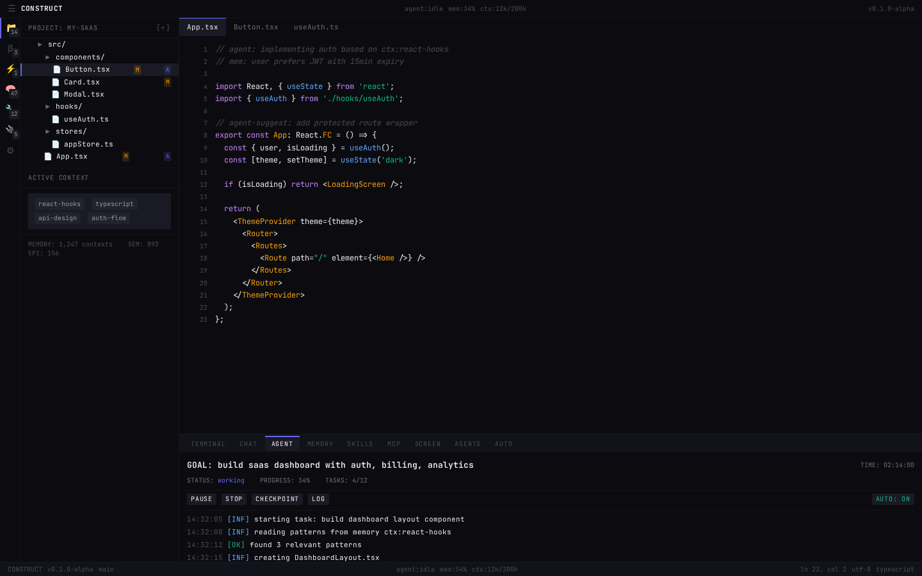
Figure 4: Main IDE view with file tree sidebar and editor area

5. Agent Panel
The Agent panel is the primary interface for interacting with the AI coding agent. It displays the current agent status (idle, running, paused, or completed), the active LLM model (e.g., claude-sonnet-4-20250514), and provides controls for starting, pausing, resuming, and stopping agent sessions. When an agent session is active, this panel streams real-time output events including the agent's thoughts, tool calls, generated code, and task progress.
The agent operates on a session-based model. Each session starts with a goal description provided by the user (e.g., 'Create a Counter component with increment and decrement buttons'). The agent then enters its execution loop: observe the project state, plan a sequence of tasks, execute each task using available tools, and verify the results before continuing. Output events are streamed to the frontend via Tauri's event system on a per-session channel (agent:{sessionId}), allowing multiple concurrent sessions to be tracked independently.
Key Commands: start_agent (begin a new session with a goal), get_agent_status (retrieve session state), pause_agent (temporarily halt execution), resume_agent (continue a paused session), stop_agent (terminate a session).
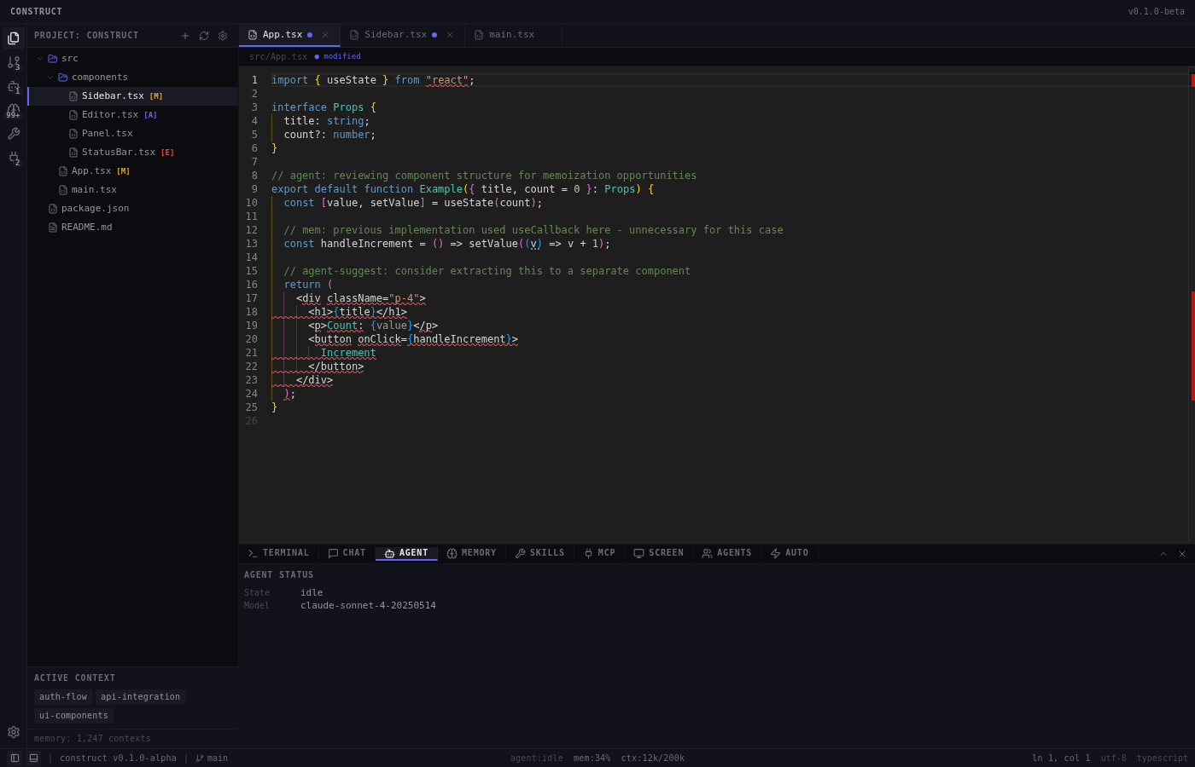
Figure 5: Agent panel showing status, model selection, and output stream
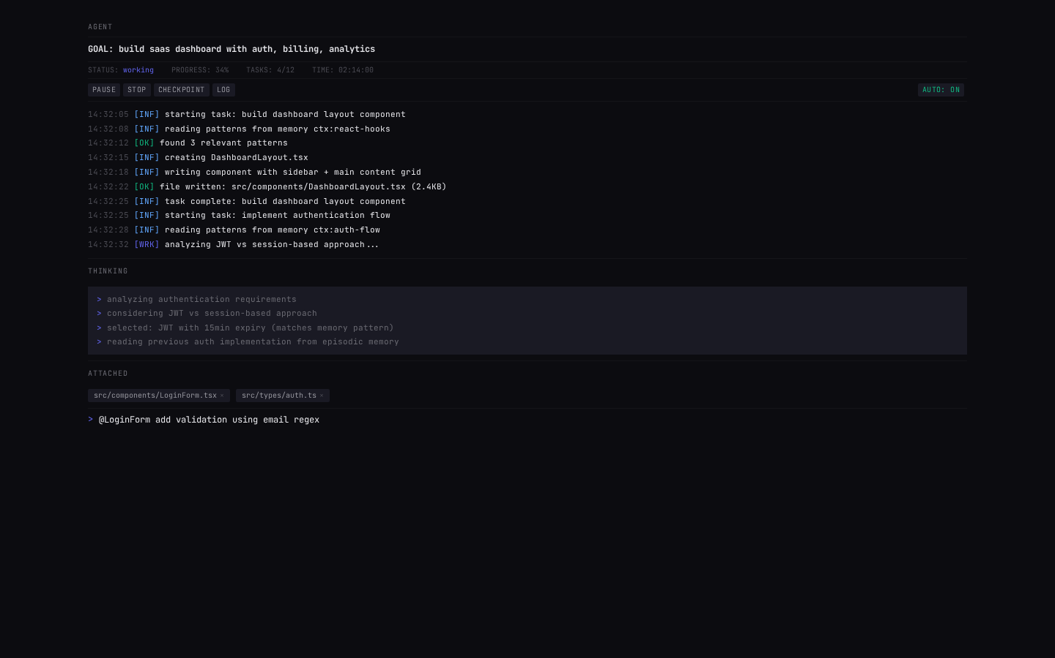
Figure 6: Agent panel with active session and task progress

6. Memory Panel
The Memory panel provides visibility into Construct's dual-layer persistent memory system. It displays memory usage statistics including the total number of contexts (1,247 in the demo), vector embeddings stored in ChromaDB (8,932), token usage (12,456 out of 200,000), and overall memory utilization percentage (6.2%). These metrics give users a clear understanding of how much the agent has learned and how much capacity remains.
The memory system is Construct's most distinctive feature. Layer 1 (SQLite, managed by the Rust backend) stores structured data in four tables: conversations (all user/agent message history), code_events (file changes, diffs, summaries), user_preferences (learned preferences with confidence scores), and project_state (current project snapshots). Layer 2 (ChromaDB, managed by the Python backend) stores vector embeddings of conversations and code events, enabling semantic search across all stored knowledge.
Users can search through their memory using the recall_context command, which combines keyword matching on the SQLite layer with semantic similarity search on the ChromaDB layer. This dual approach ensures that both exact matches and conceptually related memories are retrieved, providing the agent with rich context for every interaction.
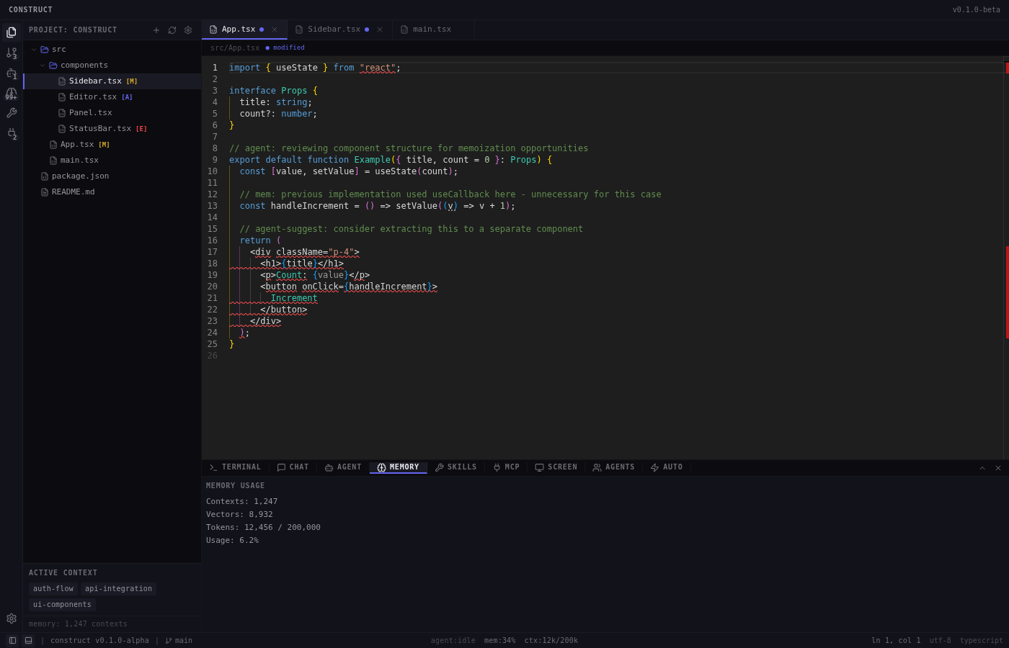
Figure 7: Memory panel showing usage statistics and context browser

7. Chat Panel
The Chat panel provides a conversational interface for interacting with the AI assistant. Unlike the Agent panel which manages autonomous sessions, the Chat panel is designed for quick questions, explanations, and collaborative coding where the user maintains direct control. The interface consists of a message display area and an input field with a Send button. Users can type natural language questions and receive streaming responses from the configured LLM provider.
The Chat panel integrates with the memory system, meaning that conversations are automatically stored in the persistent memory layer and become part of the agent's knowledge base for future sessions. This creates a continuously improving feedback loop where the agent becomes more contextually aware with every interaction. The chat input also supports image pasting via the ImagePasteHandler component, allowing users to share screenshots or diagrams with the AI for visual analysis.
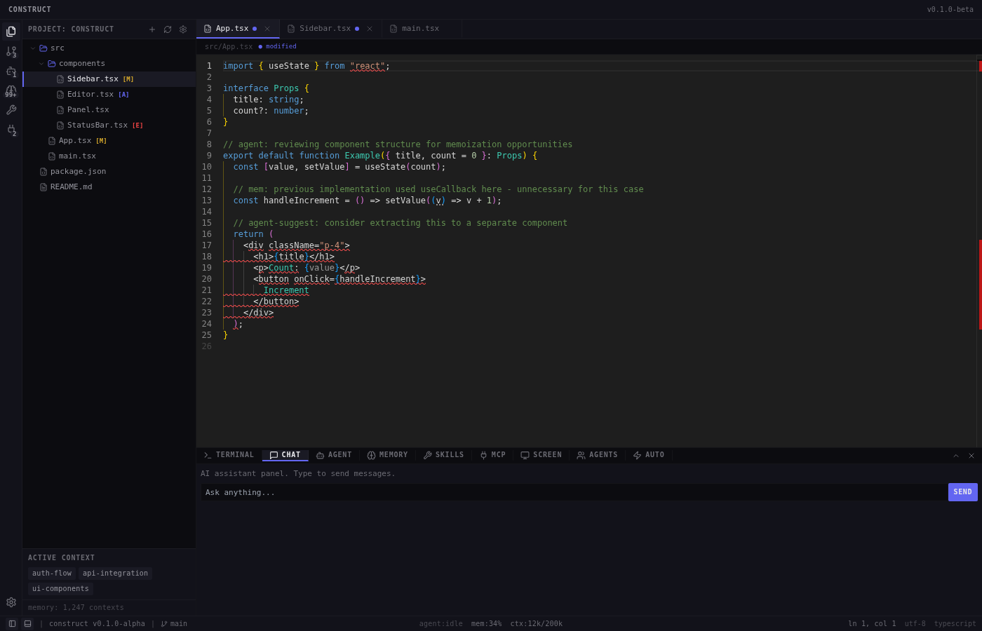
Figure 8: Chat panel with conversational AI interface

8. MCP Connectors Panel
The MCP (Model Context Protocol) panel manages connections to external tool servers that extend the agent's capabilities beyond its built-in tools. Construct supports integration with over 20 MCP servers, enabling the agent to interact with external services such as databases, APIs, file systems, and cloud platforms. The panel displays the connection status of each configured MCP server and provides controls for adding, removing, and testing connections.
The MCP integration uses a connection manager that handles rate limiting, fallback chains, and automatic reconnection. When an MCP server becomes unavailable, the fallback chain mechanism automatically routes requests to alternative servers that provide similar functionality, ensuring that the agent can continue operating even when individual services are down. The rate limit handler prevents the agent from overwhelming external services with too many requests in a short time period.
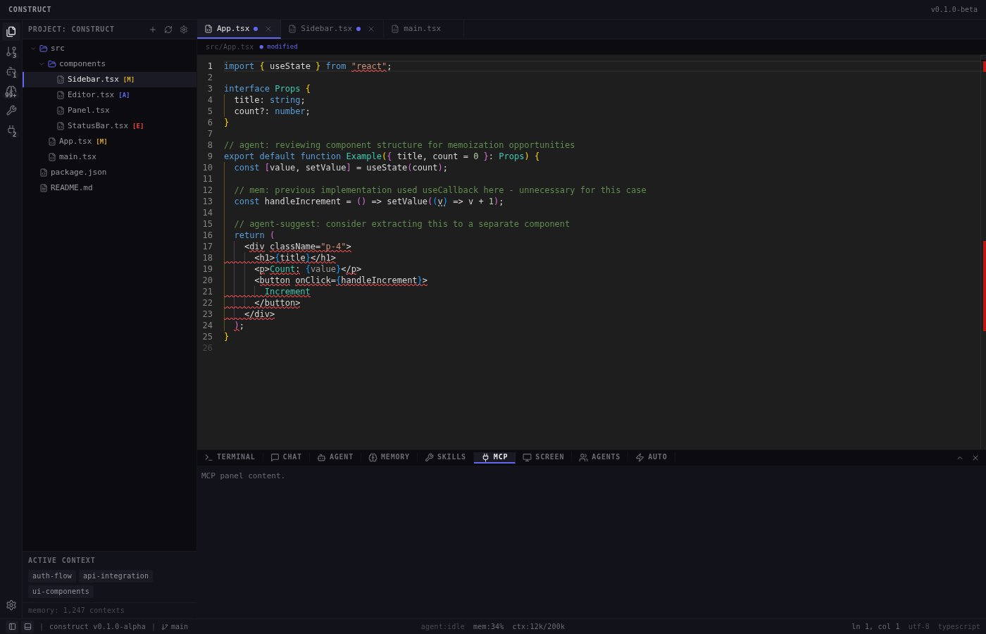
Figure 9: MCP connectors panel showing server connections and status

9. Skills Marketplace
The Skills panel provides access to Construct's skill system, which allows the agent to learn new capabilities through a document-to-skill pipeline. The app ships with 25 bundled skills covering the full software development lifecycle, from planning and task breakdown through implementation, testing, and deployment. Each skill is defined by a SKILL.md file that describes the skill's purpose, inputs, outputs, and execution instructions.
The bundled skills include both development-focused and strategic capabilities: planning-and-task-breakdown, incremental-implementation, test-driven-development, debugging-and-error-recovery, code-review-and-quality, security-and-hardening, performance-optimization, frontend-ui-engineering, api-and-interface-design, git-workflow-and-versioning, ci-cd-and-automation, documentation-and-adrs, context-engineering, source-driven-development, spec-driven-development, doubt-driven-development, code-simplification, deprecation-and-migration, shipping-and-launch, competitor-analysis, market-research-brief, repo-audit, browser-testing-with-devtools, brand-name-forge, and legal-risk-assessment.
The skill marketplace framework also supports custom skills created by users. The skill parser reads SKILL.md files and converts them into executable agent instructions, while the skill executor manages the runtime environment for skill execution. The installer component handles downloading and installing community-contributed skills from the marketplace, with validation and security checks to ensure that third-party skills do not compromise the user's system.
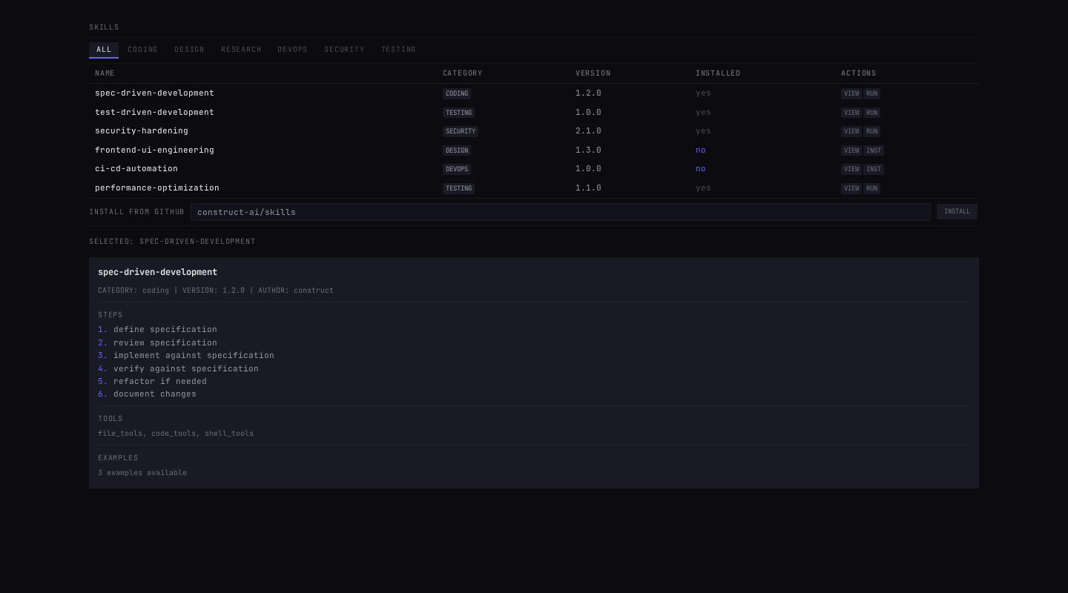
Figure 10: Skills marketplace showing bundled and community skills

10. Multi-Agent & Autonomous Mode
Construct's Multi-Agent panel allows multiple specialized agent roles to collaborate on complex tasks. The system includes seven predefined roles: Code Engineer, Test Engineer, Security Auditor, DevOps Engineer, UI Designer, Researcher, Project Manager, and Legal Reviewer. Each role has its own system prompt, tool access permissions, and output format preferences. The orchestrator manages communication between agents through a context bus that shares relevant information without flooding agents with unnecessary details.
The Autonomous mode (Auto tab) enables the agent to execute multi-step plans without continuous human oversight. When autonomous mode is enabled, the agent can queue goals with priority levels (critical, high, normal, low), execute them sequentially, handle errors through the circuit breaker pattern, and automatically checkpoint its progress for fault tolerance. Resource monitoring ensures that the agent does not consume excessive CPU or memory during background execution, throttling its activity when the user is actively working on the machine.
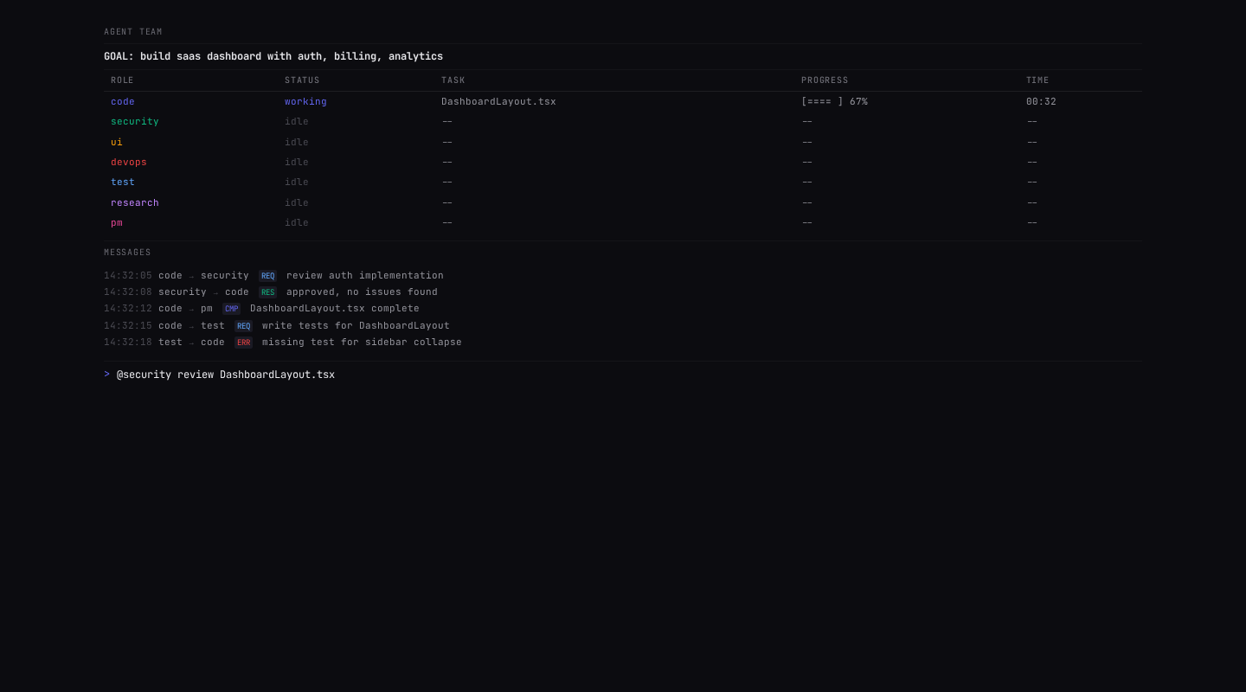
Figure 11: Multi-agent panel showing collaborative agent roles

Figure 12: Main interface with autonomous mode indicator in status bar

11. Status Bar
The Status Bar at the bottom of the application provides at-a-glance information about the current state. It displays the current git branch, the active LLM provider and model, the agent status (idle/running/paused), memory context count, and the current project path. Clicking on different sections of the status bar opens the corresponding panel or settings view. The status bar uses the same monospace font and dark color scheme as the rest of the interface, with accent-colored indicators for active states.

12. Keyboard Shortcuts & Command Palette
Construct includes a comprehensive keyboard shortcut system and a Command Palette (Ctrl+Shift+P / Cmd+Shift+P) for quick access to all features. The keyboard shortcuts are organized into four categories: File operations (Ctrl+N new file, Ctrl+O open file, Ctrl+S save, Ctrl+Shift+S save all, Ctrl+W close tab), Edit operations (Ctrl+Z undo, Ctrl+Shift+Z redo, Ctrl+F find, Ctrl+H replace, Ctrl+G go to line), View operations (Ctrl+B toggle sidebar, Ctrl+` toggle terminal, F11 fullscreen), and Agent actions (Ctrl+Shift+P command palette, F5 run current file).
The Command Palette is a searchable dropdown that provides access to every available command in the application. It follows the same pattern popularized by VS Code and Sublime Text, allowing users to type a few characters to find and execute any command without reaching for the mouse. The palette is implemented as a React component with fuzzy search, keyboard navigation, and recently-used command tracking.

13. Settings Panel
The Settings panel (Ctrl+, / Cmd+,) provides a comprehensive configuration interface organized into sections for LLM providers, memory configuration, agent behavior, appearance, and keyboard shortcuts. Each section contains form fields with clear labels, descriptions, and default values. The LLM provider section allows users to configure API keys for OpenAI, Anthropic, and Google, set the Ollama host and model, and configure the smart routing rules that automatically select the best provider based on prompt complexity.
The memory configuration section controls the SQLite database path, ChromaDB storage directory, embedding model selection, and memory retention policies. The agent behavior section sets the default agent mode (interactive or autonomous), approval requirements for destructive operations, and the tool access whitelist. All settings are persisted locally and are immediately reflected in the agent's behavior without requiring a restart.

14. Feature Summary Table
The following table provides a quick reference for all major UI features and their locations within the application.
Feature | Location | Description
Splash Screen | Startup | Backend health check and loading indicator
Onboarding Wizard | First launch | LLM provider setup, API keys, preferences
File Tree | Sidebar (Files) | Project file browser with mod badges
Git Status | Sidebar (Git) | Branch status, diff viewer, commit controls
Code Editor | Center panel | Monaco editor with construct-dark theme
Terminal | Bottom panel | Integrated terminal with shell access
Chat AI | Bottom panel | Conversational AI with memory integration
Agent Control | Bottom panel | Start/pause/resume agent sessions
Memory Browser | Bottom panel | SQLite + ChromaDB context search
Skill Marketplace | Bottom panel | 25 bundled + community skills
MCP Connectors | Bottom panel | 20+ external server integrations
Screen Control | Bottom panel | Desktop automation capabilities
Multi-Agent | Bottom panel | 7 specialized agent roles collaborating
Autonomous Mode | Bottom panel | Background execution with goal queue
Command Palette | Ctrl+Shift+P | Searchable command execution
Settings | Ctrl+, | LLM, memory, agent, appearance config
Status Bar | Bottom | Git branch, LLM model, agent status, memory count

