**1. Isilah kolom dibawah ini:**

|  |  |
| --- | --- |
| **APLIKASI** | APLIKASI PERPUSTAKAAN SEKOLAH (Versi 1) |
| **AKTOR** | Administrator |
| **AKTIVITAS** | Administrator:   * Login * Kelola Data Admin * Kelola Data Siswa * Kelola Data Buku * Kelola Peminjaman * Kelola Pengembalian * Kelola Denda * Kelola Buku Rusak/Hilang * Cetak Laporan |
| **BUAT USECASENYA** | ... |

**2. Isilah kolom dibawah ini:**

|  |  |
| --- | --- |
| **APLIKASI** | APLIKASI PERPUSTAKAAN SEKOLAH (Versi 2) |
| **AKTOR** | Administrator, Siswa |
| **AKTIVITAS** | Administrator:   * Login * Kelola Data Admin * Kelola Data Siswa * Kelola Data Buku * Kelola Peminjaman * Kelola Pengembalian * Kelola Denda * Kelola Buku Rusak/Hilang * Cetak Laporan   Siswa:   * Melihat Daftar Buku * Login * Transaksi Peminjaman * Scan Buku * Checkout Peminjaman |
| **BUAT USECASENYA** | ... |

3. Silahkan buat Usecase serupa dengan gambar berikut :

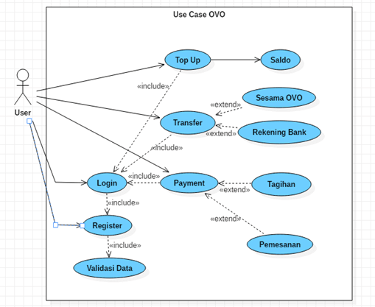

|  |  |
| --- | --- |
| Usecase | ... |

4. Analisis Kebutuhan Tabel untuk Soal 1 / Soal 2 :

|  |  |
| --- | --- |
| Usecase Soal No 1/2 : |  |

|  |  |
| --- | --- |
| Perkiraan Tabel yang dibutuhkan : | 1. Tabel Data Admin 2. … 3. … 4. dst |

Rancangan Tabel :

Tabel Data Admin

|  |  |  |  |
| --- | --- | --- | --- |
| Nama Field | Tipe | Ukuran | Kunci |
| id_admin | Char | 15 | Primary Key |
| Nama_Admin | Varchar | 50 |  |
| Username | Varchar | 100 |  |
| Password | Varchar | 50 |  |
| Tanggal Lahir | Date |  |  |
| Alamat | Text |  |  |
| no_tlp | Char | 15 |  |

Tabel Data Siswa

|  |  |  |  |
| --- | --- | --- | --- |
| Nama Field | Tipe | Ukuran | Kunci |
| NIS | Char | 15 | Primary Key |
| Nama_Siswa | Varchar | 50 |  |
| Username | Varchar | 100 |  |
| Password | Varchar | 50 |  |
| no_tlp | Char | 15 |  |
| Alamat | Text |  |  |

Tabel Data Buku

|  |  |  |  |
| --- | --- | --- | --- |
| Nama Field | Tipe | Ukuran | Kunci |
| Kode_Buku(ISBN) | Char | 15 | Primary Key |
| Nama_Buku | Varchar | 50 |  |
| Penerbit | Varchar | 100 |  |
| Pengarang | Varchar | 50 |  |
| Harga_buku | Text |  |  |
| Genre | Varchar | 20 |  |

Tabel Data Peminjaman & Pengembalian

|  |  |  |  |
| --- | --- | --- | --- |
| Nama Field | Tipe | Ukuran | Kunci |
| Kode_peminjaman | Char | 15 | Primary Key |
| Kode_peminjam(NIS) | Varchar | 50 | Foreign Key |
| Kode_buku_Yang_Dipinjam(ISBN) | Varchar | 100 | Foreign Key |
| Tanggal_Peminjaman | Date |  |  |
| Tanggal_Pengembalian | Date |  |  |

Tabel Data Denda

|  |  |  |  |
| --- | --- | --- | --- |
| Nama Field | Tipe | Ukuran | Kunci |
| Kode_denda | Char | 15 | Primary Key |
| Kode_peminjaman | Char | 15 |  |
| Status | Text |  |  |

Tabel Data Buku Rusak

|  |  |  |  |
| --- | --- | --- | --- |
| Nama Field | Tipe | Ukuran | Kunci |
| Kode_Peminjaman | Char | 15 | Foreign Key |
| ISBN | Varchar | 50 | Foreign key |
| Status | Text |  |  |

|  |
| --- |
| CREATE TABLE siswa(  id_admin char(15) PRIMARY KEY,  nama_admin varchar(50),  username varchar(100),  pasword varchar(50),  Tanggal_lahir date,  alamat text,  no_telepon char(15)  ) |

|  |
| --- |
|  |

|  |
| --- |
|  |

|  |
| --- |
|  |