OpenCL on FPGA
Arnaud Garin

École Polytechnique Fédérale de Lausanne , EPFL
Laboratoire d’Architecture des Processeurs
Supervisor : René Beuchat

January 13, 2017
Contents
Chapter 1

Introduction

1.1 Background

In this report we are going to learn how to use the framework OpenCl (Open Computing Language). OpenCl is meant to be used for programming parallel systems. One of the key features of the language is to be very portable. In this project we focus the development on an FPGA platform.
There have been already two projects about OpenCl on FPGA in this laboratory . It raises the question of what might be the utility of making another one. One good answer will be that both of those older project were design to run on very expensive boards worth a couple thousands dollars each. But in our case the hardware we are going to use will be much cheaper. But since the usage of this kind of board is slightly more marginal, and therefore with less support and feedback available. One of the main challenge of all this project was to find a convenient way to setup and implement OpenCL on said device.

1.2 Goals
This report present an interesting way of using the framework on an FPGA board by going from nothing to a full implementation of a line detection algorithm followed by a performance analysis.
The objectives for this project can be formulated as followed:
1. Implementation of a line detection algorithm using Hough transform.
2. Benchmark and analyze of performances between several devices.
Chapter 2

Theory

2.1 OpenCL
OpenCL stands for Open Computing Language it was initially developed by Apple, which still holds the trademark rights, in collaboration with Intel, AMD and Nvidia. From 2008 to today the language is developed and maintained by the Khronos Group. The Khronos Group is a non-profit member-funded industry consortium whose goal is to promote open standards for parallel computation. The fact that the language was developed by companies that are all major manufacturer in very specific computer parts made the major quality of the language. It is very portable. We can do parallel computation on a wide range of devices including processors, graphical cards, filed programmable gate arrays and digital signal processors. This portability comes in very handy for multi platform development but it has a price. Each vendor must have their own implementation which means that devices with almost identical performances from two different vendors might have quite a different run time for the same execution.
Implementation wise OpenCl distinguish two parts. A host and a device. The host program act like a semaphore. It is the one responsible for the setup of the device and then manage the way data comes in and out of said device. The device is an accelerator of some sort compatible with OpenCL his works is calculating heavy parallel workload designed through functions written in a C-like programming language (based on C99) named kernels. The way the host treat with the device is the following. The host sees the device like a huge array of registers where he can put data into and then wait for a kernel to compute. A special status register indicate to the host when the computation is over.
Now on a practical point of view it goes as follows. First of all the host must find if there is any OpenCL compatible platform present on the system. Each platform has an id assigned it. From this id we can create a context and a command queue. Then we create the program by either getting the already computed binary (compiled previously with an offline compiler given by the manufacturer) or compile it from scratch during the execution. At this point we have everything to begin the usage of the device. All we need is create buffers to hold the data specify which function of the kernel we want to use send said buffers to said kernel, launch the kernel all this through the command queue and when the execution is over read back the results.
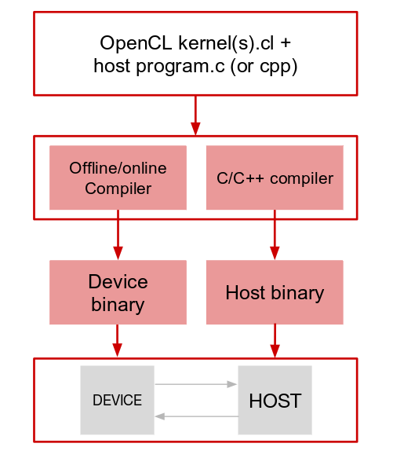

Figure 2.1 An OpenCl program’s routine. Image taken from my own presentation of the project
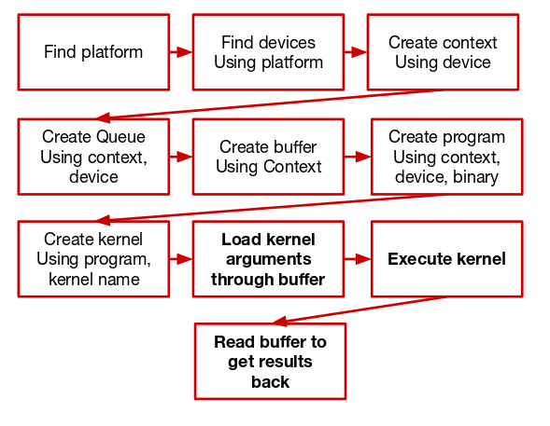

Figure 2.2 Host program’s routine. Image taken from my presentation of the subject

2.2 Line detection
The algorithm chose to be implemented for our study of the OpenCL language is a line detection algorithm. This procedure follows roughly fours steps. All of them will be precisely described in this section. The reasons we will implement this algorithm are following. First there are two parts where we manipulate each pixel independently from each other therefore making this a perfect case for parallel computing. Second there is another part where we, again, treat each pixel independently but we also fill up an accumulator at the same time. This algorithm gives us different kind of parallelism for a more diverse run and therefore a better rating of the accelerator performances.

2.2.1 From color image to grayscale
First of all we obviously need an image from which we want to detect the lines but once we find one what happens? To begin with we want to remove all color from the image. To do so we have a couple of algorithm to chose from. The one implemented in this project is the averaging value. Basically we take each pixel and there respectively red, green, blue color (between 0 and 256) and make the average of those three values and assign it to the three color values. In reality a grayscale image is computed with corrected values to be more suitable for human eyes (since we do not perceive each color equally). But in this step we do not value the beauty of the image but more a strict value of what the color is a this precise point. In the project we are going to use the following formula on each pixel of the image.

On thing less obvious about this algorithm is that since all the values of red, green and blue are strictly equal we can for further calculation use only one of the three component and therefore reducing by three the volume of data we are working with.

2.2.2 Edge detection
F

Valette Laurent, OpenCL on Altera FPGA: a Mandelbrot set renderer, LAP, 2013
Kashani-Akhavan Sepand, OpenCL on Altera FPGA: Matrix Algebra & Kalman Filtering, LAP, 2012
Nallatech. Nallatech 385 – with Stratix V A7 FPGA URL: http://www.nallatech.com/store/pcie-accelerator-cards/385-a7/ (visited 06/01/2017)
Nallatech. 385 – with Stratix V D5 FPGA URL: http://www.nallatech.com/store/fpga-accelerated-computing/pcie-accelerator-cards/385-stratix-v-d5-fpga/ (visited 06/01/2017)
Terassic. Terassic – SoC Platform – Cyclone – De1-SoC Board, URL: http://www.terasic.com.tw/cgi-bin/page/archive.pl?Language=English&CategoryNo=205&No=836&PartNo=1 (visited 06/01/2017)
Wikipedia, Khronos Group URL: https://en.wikipedia.org/wiki/Khronos_Group (visited 06/01/2017)
Tanner Helland (dot) com. Seven grayscale conversion algorithms (with pseudocode and VB6 source code) URL: http://www.tannerhelland.com/3643/grayscale-image-algorithm-vb6/ (visited on 01/01/2017)

