OpenCL on FPGA
Arnaud Garin

École Polytechnique Fédérale de Lausanne , EPFL
Laboratoire d’Architecture des Processeurs
Supervisor : René Beuchat

January 13, 2017

Table of Contents
1. Introduction 3
1.1 Background 3
1.2 Goals 3
2. Theory 4
2.1 OpenCL 4
2.2 Line detection 8
2.2.1 From color image to greyscale 8
2.2.2 Edge detection 8
2.2.3 Line detection 9
2.2.4 Line drawing 11
3. Method 12
3.1 Hardware 12
3.2 Software 13
3.2.1 Altera DE1-SoC board 13
3.2.2 Other software for benchmarking 14
3.3 Algorithm implementation 14
3.4 Method for Benchmarking 16
Results 17
4.1 Line detection algorithm 17
4.2 Benchmarks 20
5. Conclusion 23
Acknowledgment 24
References 25
Appendix I: OpenCL code 26
Appendix: II Host code 28
Appendix III: PNG manipulation code 43
PNGimg.h: 43
PNGimh.cpp: 43
Appendix IV: OpenCL setup 49
Software 49
Setup of the board 49
Execute code on the board 50
Compile host code 50
Compile kernel / emulator kernel 51
Usage of the emulator 51
Documentation 52

Illustration Index
Illustration 1: An OpenCl program routine. 6
Illustration 2: Host program routine 6
Illustration 3: Generating all lines passing through three different points 9
Illustration 4: Line representation on polar coordinates 10
Illustration 5: The Rolex learning center 17
Illustration 6: Rolex Learning center after 20 line detection on DE1-SoC 17
Illustration 7: Rolex learning center vertical lines detection on DE1-SoC 18
Illustration 8: Rolex learning center 100 lines detection Intel CPU i7-3520M 18
Illustration 9: 4k image used for line detection 19
Illustration 10: 4k imge. 100 most important lines on FPGA 19
Illustration 11: Benchmark for RLC image line detection performances 20
Illustration 12: Benchmark for 4k image line detection performances 21

1. Introduction
The aim of this project was to run OpenCL (Open Computing Language) code on an FPGA board. OpenCL is meant to be used for programming parallel systems and one of its key features is that it is very portable. This will allow an FPGA board to be programmed into a dedicated hardware structure for a dedicated task. The use of OpenCL is likely to spread in the coming years and this report provides a method to set it up on an FPGA board.

1.1 Background
The LAP has already supported two projects of OpenCL on FPGA . Both of those projects were designed to run on very expensive boards (about US$5’000) , however in the case of this project the hardware used is much cheaper (about US$300).
The main challenge of this project was finding a convenient way to set up and implement OpenCL on the DE1-SoC board. Since the usage of this board is more marginal there is little support and feedback available.

1.2 Goals
This report will outline a method to use the OpenCL framework onto the DE1-SoC FPGA board and to implement a line detection algorithm and analyze the performance.
The objectives of this project are as follows:
1. Implementing of a line detection algorithm using Hough transform.
2. Benchmark and analyze the performance of the code on several devices and comparing the performance of the FPGA board.

2. Theory

2.1 OpenCL
OpenCL stands for Open Computing Language. It was initially developed by Apple, which still holds the trademark rights, in collaboration with Intel, AMD and Nvidia. From 2008 until today the language was developed and maintained by the Khronos Group. The Khronos Group is a non-profit member-funded industry consortium whose goal is to promote open standards for parallel computation. The fact that the language was developed by companies that are all major manufacturer in very specific computer parts probably contributed to the quality of the language.
On of its biggest advantages is that it is very portable. It is possible to do parallel computation on a wide range of devices including processors, graphical cards, filed programmable gate arrays and digital signal processors. This portability is useful for multi platform development. However, one of the downsides of OpenCL is that each vendor must have their own implementation of the API. This means that devices with almost identical performances from two different vendors might have a different run time for the same program.
The implementation of OpenCL is separated in two parts: code running on the host and code running on the device. The host program acts like a semaphore. It is responsible for the setup of the device and the management of the input and output of data. The device is an accelerator compatible with OpenCL, it calculates heavy parallel workloads through functions written in a C-like programming language (based on C99). These functions are called kernels. The interactions between the host and the device are characterized by the host recognizing the device as an array of registers into which it can input data and wait for a kernel to compute. A special status register indicates to the host when the computation is over.
To set up the device, the host must first find if there are any OpenCL compatible platforms on the system. Each platform has an assigned identification number (id). Secondly, using this id a context and command queue are created. Thirdly, the program can be created either by getting the already compiled binary (compiled previously with an offline compiler given by the manufacturer) or by compiling it from scratch during the execution. At this point the device is operational.
To run calculations, the host must create buffers to hold the data, then specify which function of the kernel it will to use, and send the buffers to the kernel. The last steps are to manually launch the computation through the command queue and retrieve the results when the execution is finished.
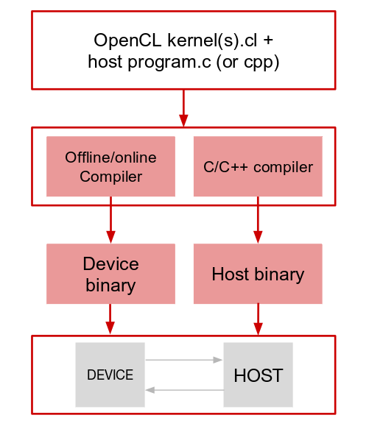
Illustration 1: An OpenCl program routine.

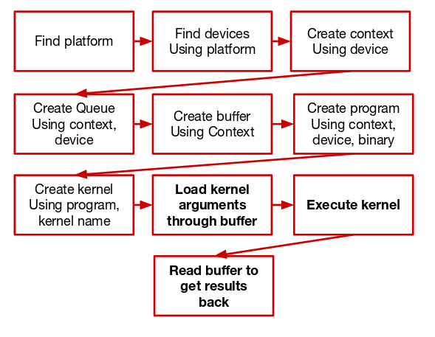
Illustration 2: Host program routine

2.2 Line detection
The algorithm implemented in this OpenCL project is a line detection algorithm. The algorithm was chosen because it requires different kinds of parallelism, in the first stage each pixel must be manipulated independently, which is an optimal case of parallel computing. Then in a second stage an array must be filled out concurrently, which is a second type of parallelism and overall covers a wide range of OpenCL capabilities. The implementation of the algorithm is separated into four steps: transfer of the image from color to greyscale, edge detection, line detection, and line drawing.

2.2.1 From color image to greyscale
Once an image has been selected, all color must be removed from it. There are various algorithms available to do so, the one chosen for this project is the averaging value algorithm. It is applied by taking each individual pixel and their respective red, green, and blue color intensity value (between 0 and 255) and calculating the average color intensity for each pixel. This color intensity value gives the grey intensity and consequently transfers the image into greyscale. This is not a traditional method, normally a greyscale image is computed with corrected coefficients to be more suitable for the human eye (since we do not perceive each color equally). However, for the application of a line detection algorithm it is more important to have a strict representation of the image, rather than a beautiful picture.
One further advantage of using greyscale is that it reduces the volume of data threefold. Since all the values of red, green and blue intensity are strictly the same (in this case, the average), it is possible to use only one of the three components for calculation, instead of all three.

2.2.2 Edge detection
The aim of this stage is to identify the edges of each object in the image. To do so, each pixel must be analyzed individually, as it is assumed that edges are located where there is a sudden change of brightness between a pixel and its neighbors.
The greyscale image is nothing less than a map of each pixel’s brightness, which can be used to quantify the color differences in a picture. This is done by calculating the gradient of color intensity for each pixel in the image using the Sobel algorithm. This algorithm takes the gradients of the eight closest surrounding pixels in a nested pattern (which gives a higher coefficient for closer pixels) and normalizes them. The implementation then uses two matrices that are convolved along both the horizontal and vertical axes to obtain a good approximation of the color intensity gradient.
This color intensity gradient is then used to determine the edge points. To do so a threshold is set manually and only the points above this threshold are drawn in white onto the image, all the other pixels remain black.

2.2.3 Line detection
The image now consists solely of edges and the straight lines must be identified using the Hough transform. The natural approach to finding lines in an image is to define them using the mathematical formula:, where m is the slope and b is the intersection with the y axis. First, generating every possible line passing through each non black pixel (see: Illustration 3) and then isolating the lines, which intersect with a high number of edge points (white pixels). Theoretically this method works, however it cannot be applied practically because vertical lines have an infinite slope, which the computer cannot deal with.
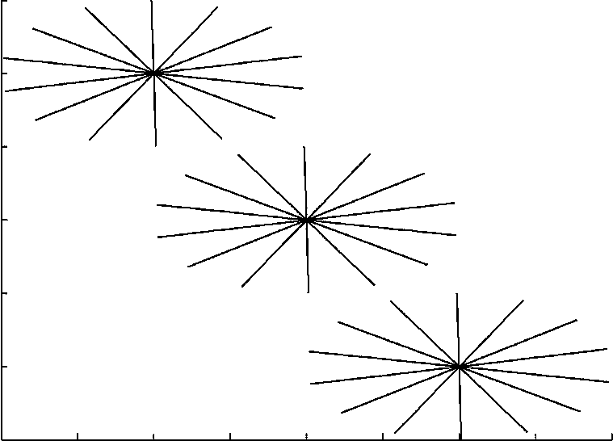
Illustration 3: Generating all lines passing through three different points

To solve this problem, it is possible to use polar coordinates to describe the lines instead of the regular line equation described above. Polar coordinates use the distance (ρ) and angle (θ) to describe a line, where ρ is the length of the perpendicular to the line passing through the origin and θ is the angle between the x axis and ρ (see: Illustration 4). This representation ensures that each line in the image has its own unique representation.

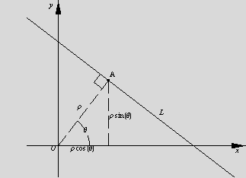
Illustration 4: Line representation on polar coordinates

Therefore, polar coordinates are a means to describe any line that could appear in the picture, even vertical ones. The equation for a line using polar representation (ρ,θ) is as follows:

For the line detection itself, an array of discrete values of ρ and θ is generated. This array describes all the lines possible inside the image, it is called the accumulator. In purely mathematical terms ρ and θ are continuous, however to implement they must be discretized to fit into the accumulator. Each edge point, defined by its x,y coordinates, will then have all the possible lines passing through it be generated by solving the aforementioned equation for every discrete value of θ. Every time a line is computed its value in the accumulator will increase by 1. At the end of the execution the lines with the highest value in the accumulator will be the lines intersecting the highest number of edge points. These will be the lines drawn onto the image.

2.2.4 Line drawing
Once the lines in the image have been detected, they must be drawn onto the picture. The lines must first be sorted according to their value in the accumulator. This means that the most popular lines can be identified.
To draw the line onto the image it is simply a matter of working backwards from the polar coordinates. Using the distance and the angle from the accumulator it is possible to deduce the closest point from the origin in x,y coordinates. The slope of ρ can be calculated using these coordinates, which can then be used to describe the orthogonal line. In other words, this is the line that will be drawn onto the image.

All that remains is to output the newly generated image. Overall, this process allowed the transformation of a simple picture to a greyscale image, to an edge image, which helped apply the Hough transform to determine the most important straight lines and draw them.

3. Method
This part of the report will outline the implementation of the algorithm, the setup of the environment, the hardware and software used during the project. As said in the introduction one of the main challenges of this project was managing to find a way to use OpenCL on the DE1-SoC board. An exhaustive “how to” method to setup an OpenCL environment on the FPGA device is provided in the appendix (Appendix IV).

3.1 Hardware
One of the strengths of OpenCL is its very high portability. Therefore, it is relevant to compare the implementation of the kernels on different hardware, other than the FPGA board. Other than the DE1-SoC board the line detection algorithm will be run on three different devices: Two CPUs and one GPU. The list of the devices and their specifications is as follows:
- DE1-SoC Board: Altera System-on-Chip FPGA. This board includes a 800 MHz dual-core Cortex-A9 ARM processor. 85K programmable logic elements.
- Intel Core i7-3520M CPU. 4M cache, 2 cores, 4 threads, 2.90GHz.
- Intel Core i7-2600 CPU. 8M cache, 4 cores, 8 threads, 3.40GHz
- NVIDIA GeForce GTX 970. 4GB cache, 1664 cores, engine clock 1050 Mhz, memory clock 7.0 Gbps

3.2 Software
This section describes the type of software and its versions used in this project. As a basis Vim and the compiler g++ were used to write, edit and compile the C code and make was used for an automated build routine.

3.2.1 Altera DE1-SoC board
Firstly, the computer in the laboratory was running under a linux distribution named CentOS 7, which is based on the Red Hat Enterprise Linux distribution. It is worth mentioning this because there are only three linux distribution officially supported by Altera and all three are different releases of Red Hat Enterprise (5.10, 6.5, 7.2).
The software used to code OpenCL on the workstation was firstly the “DE1SoC OpenCL Boards Support Package” (BSP) from Terasic, version 14.0 and secondly all the OpenCL suite from Altera: Quartus II, Altera OpenCL SDK and Altera SoC EDS. For this project all Altera software component were version 14.0.
During the development process an Altera FPGA board emulator was used, which allowed the compilation and execution of the kernels on the workstation without having to compile them from scratch after each modification. The emulator was useful to circumvent a full compilation, which took more than an hour. However, for an unknown reason the 14.0 version did not provide a library to allow the emulator run. We managed to discover that the missing dependence was no longer included in any of the OpenCL SDK after version 13.0. To run the emulator we had to download and look for the said library manually. The name of the dependence is libalterammdpcie and we used the implementation provided by Altera OpenCL SDK 13.1.
The software minicom was also used to setup a communication line between the board and the host pc by setting up a remote serial console.

3.2.2 Other software for benchmarking
The same software was used on the Intel CPUs and the GPU for benchmarking. All devices were used on a computer running, once again, a linux distribution. Since the alternative devices were not Altera’s product, there were no restrictions on the choice of operating system. The host computer was running the arch linux distribution, with the 4.8.13 kernel release. The development environment was given by the following packages: ocl-icd, opencl-headers. Additionally, as each vendor provides his own implementation of OpenCL other packages both for Intel and NVIDIA products had to be downloaded.
The runtime and SDK for Intel’s product are given by the following packages: intel-opencl-runtime^{AUR} and intel-opencl-sdk^{AUR}. The runtime and SDK for NVIDIA’s product are given by the packages: opencl-nvidia and cuda. Inline compiling in both cases, as compilation is almost immediate.

3.3 Algorithm implementation
The following sections will outline practical process of the development of the kernels. The exhaustive implementation of the algorithm is available in the appendix (Appendix I, II and III).
It is important to note that for the image processing the PNG format was used. Firstly, because PNG is an open format with development libraries easily accessible for every operating system. Secondly, it is a lossless format, which is practical for a precise pixel by pixel calculation. Lastly, there is a git repository available to deal with PNG files, which was extremely helpful.
As stated above in the theory section, the input image must be transferred to greyscale by removing the colors. The three color components of each pixel were averaged using the following formula:

The kernel will have three input buffers, one for each color, and one output buffer that holds the greyscale values, each pixel will be calculated by one thread. Since each pixel is treated individually and each pixels is mapped to one gray value, there is no problem using parallelism, as there are absolutely no data races.
For the second part, the edge detection, the gradient between each pixel was calculated. To do so two matrices, described by the Sobel algorithm, were convolved along the greyscale image.
For x-axis: For y-axis: Gradient value:
Computing the gradient involves the pixel and its eight closest neighbors. Since the goal is optimal parallelism, ideally every single pixel should be computed at the same time. The pixels are not independent from each others, so the edge image cannot be written above the greyscale and a new image must be output. The trick used was to have one buffer containing the gray values and another to output the edge image, which helps avoid data races. In the edge detection kernel each thread computes one pixel by fetching its value and the value of its neighbors to compute the gradient and place it in the output image.
For benchmarking, Intel and NVIDIA did not implement all the operation like Altera did. There was no square root operator to calculate the gradient in the Sobel algorithm for the CPUs and the GPU. For this reason, we implemented a small computing variation for the gradient approximation:

Unfortunately the approximation will result in an edge picture of slightly lower quality.
For the third step, the Hough transform implementation, a discrete array of lines, or accumulator, must be prepared. Since the computer cannot deal with an infinite amount of lines, a finite amount of lines is generated for the array. Then, for each point found by the Sobel algorithm (non black pixel), all the lines passing through it are calculated and the accumulator keeps track of how many points each line intersects.
To prepare the array with a discrete number of values for both ρ and θ, two discrete factors a and b are chosen, such that:
and
The accumulator size is max(ρ)/a by max(θ)/b and each cell holds an integer keeping track of how many edge points the line intersects.
Inside the kernel each thread will compute every the lines passing through a non black pixel in the edge image. For each non black pixel with (x,y) coordinates, the following equation will be solved for each discrete values of θ and the results will be rounded to the closest value of ρ.

Each answer corresponds to a unique line inside the accumulator. This specific line is “upvoted” by adding one to the number currently sitting at this place in the accumulator. At the end of the execution the accumulator holds the number of points that a particular line intersects, which gives its importance score.
The last step is sorting the accumulator and drawing the lines with the most votes. Unfortunately, the sorting and the drawing of the lines from the accumulator is done inside the processor, so there is no convenient way to use parallelism for the drawing part. The reason for this is that OpenCL does not support pointers of pointers inside the device and the PNG format uses them to generate an output image.

3.4 Method for Benchmarking
This section describes the conditions under which the benchmarks were measured. As described above, two kernels compute perfectly independently using pixel by pixel manipulation for maximum parallel usage of the accelerators, a third kernel concurrently fills the accumulator. The advantage of having different types of parallelism is that it will produce a more precise evaluation of the scaling capabilities of OpenCL. Two parameters will be varied for benchmarking: the number of pixels in the image (by taking two different images, one 1200x800 and another 3840x2160) and the size of the accumulator (by modifying the discretion steps for both ρ and θ). As stated above, there will be a small output difference between the FPGA device and the other devices because the manufacturers did not implement a square root operator.
Chapter 4

Results

4.1 Line detection algorithm
The first part of this results section will be dedicated of the algorithm itself. Two different images with very different resolutions, colors, and shapes were used to ensure that the implementation on different types of images and not just one well formatted image.
Since this project was developed at the EPFL, we chose to analyze a picture of the Rolex learning center.
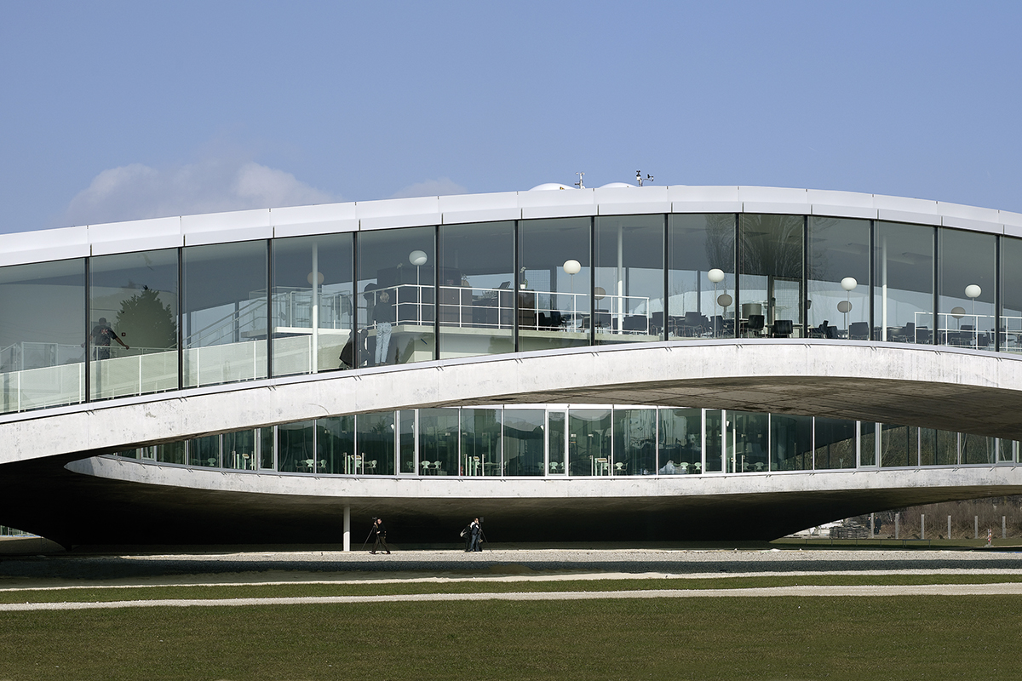
Illustration 5: The Rolex learning center

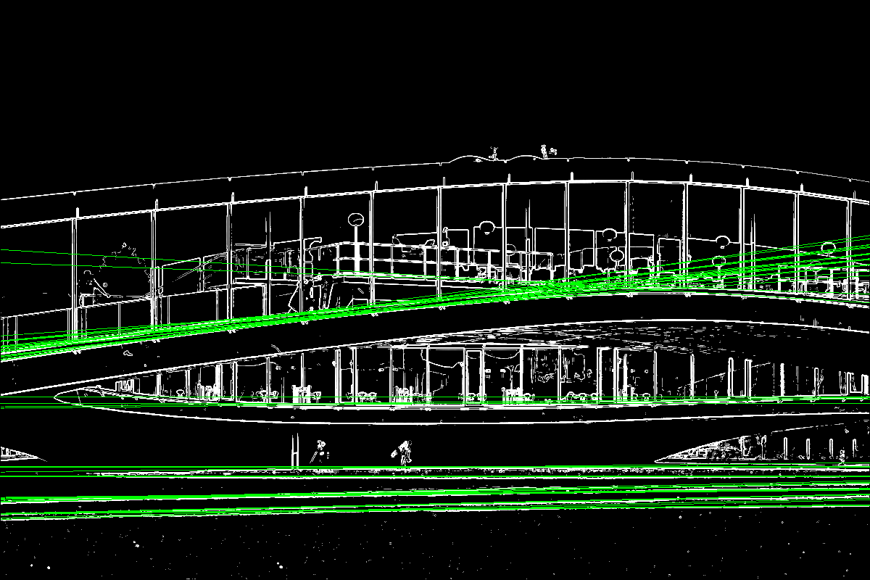
Illustration 6: Rolex Learning center after 20 line detection on DE1-SoC

The reason all the lines are horizontal is because the image has a greater width than height. However, the Hough transform algorithm is very versatile and in the next image only the 20 most important vertical lines are drawn by sorting only the values where .
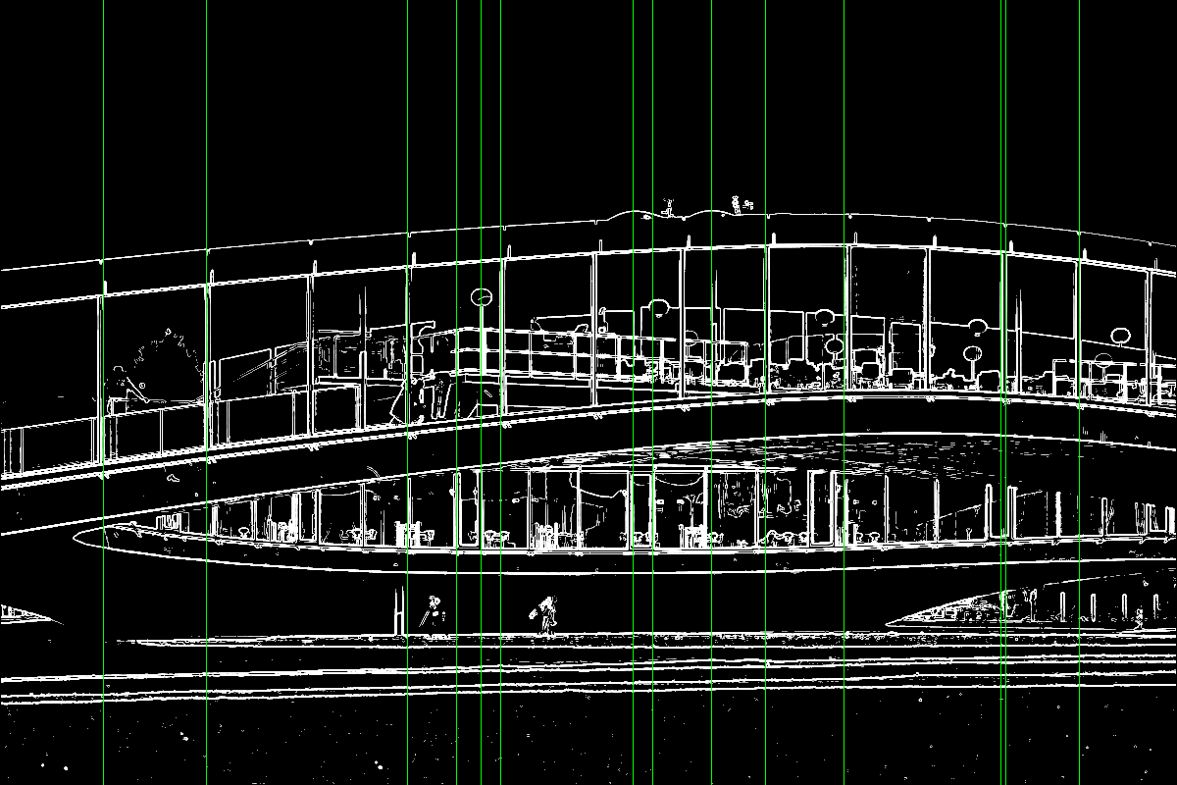
Illustration 7: Rolex learning center vertical lines detection on DE1-SoC

The number of lines detected can be changed, however, the more lines are drawn, the higher the chance that non-relevant lines will be detected.
The next illustration (Illustration 8) shows the same image with the 100 most important lines drawn. The kernels were computed on the Intel core i7-3520M CPU using OpenCL and it can be seen that the quality of the edge detection is slightly lower. This image also shows that when too many lines are drawn, irrelevant lines also appear.
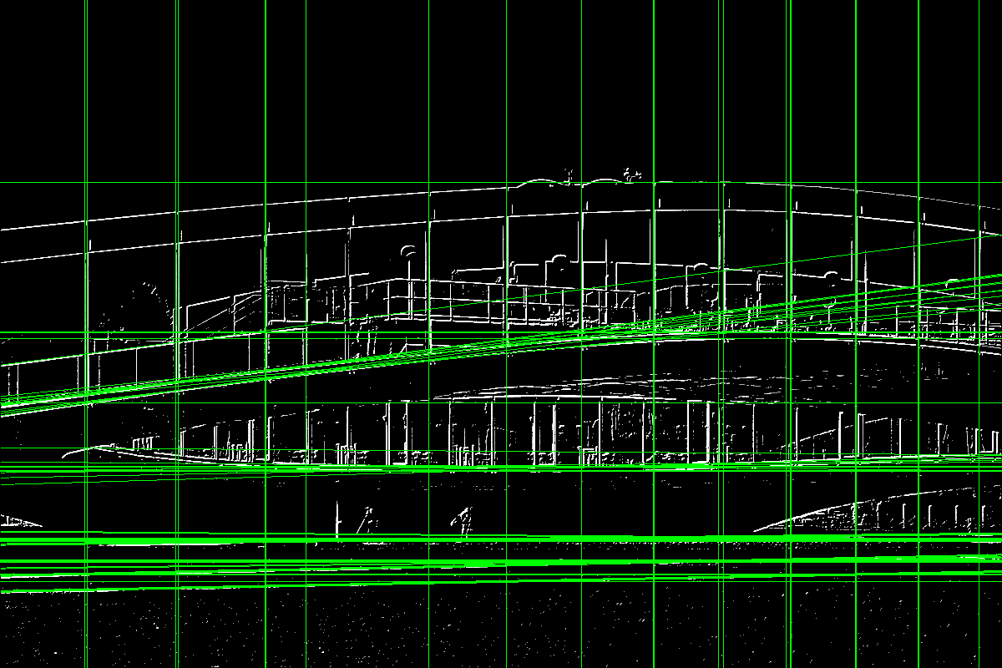
Illustration 8: Rolex learning center 100 lines detection Intel CPU i7-3520M

The last pictures of this section will show the control image used during the benchmark and the results after computing the 100 most important lines (100 is the standard number lines drawn in the benchmark).
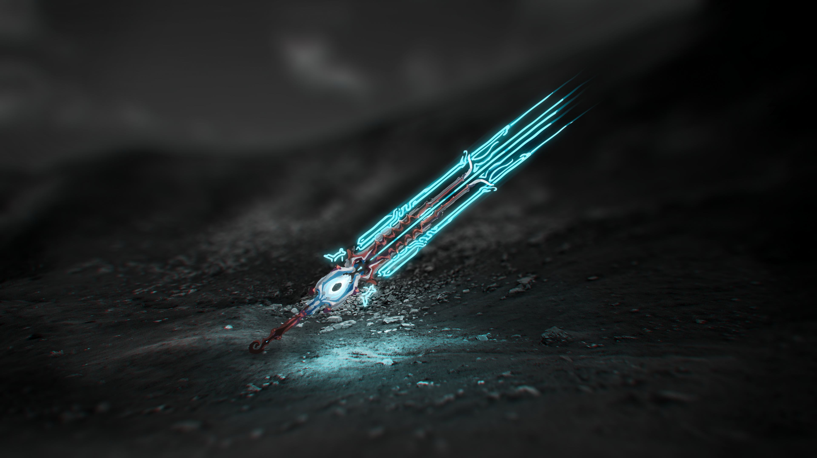
Illustration 9: 4k image used for line detection

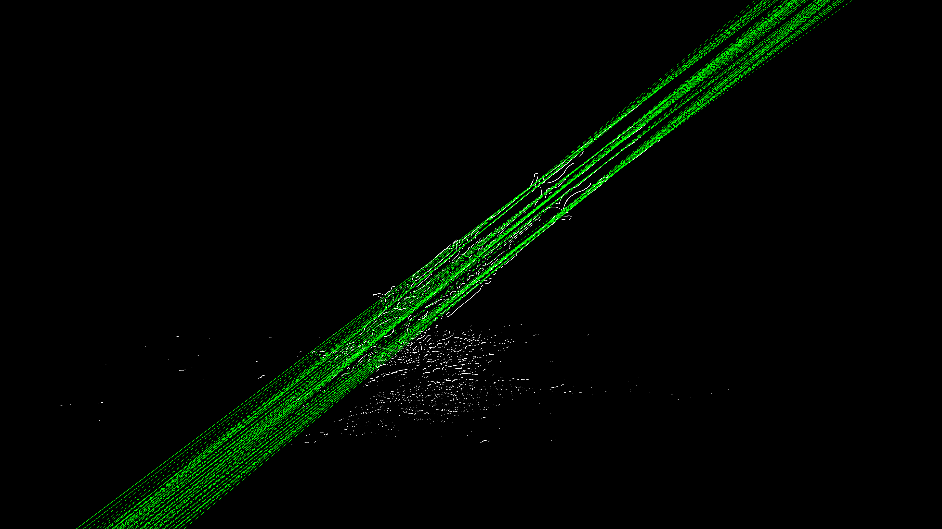
Illustration 10: 4k imge. 100 most important lines on FPGA

In conclusion, this algorithm works well from a purely practical point of view. It has been properly implemented and the line detection works well.

4.2 Benchmarks
This section will display the performances of all the different devices used to test the execution of the algorithm.

Illustration 11: Benchmark for RLC image line detection performances

Illustration 12: Benchmark for 4k image line detection performances
This graph suggests that the FPGA board is under-performing. However, the hardware itself must be taken into account, the frequency of the DE1-SoC CPU is two to four times lower and as a consequence slower than other processors. Moreover, as each of devices hosted four to eight threads the FPGA was at a disadvantage because it could process fewer operations per second than the other CPUs. Additionally, the GPU, GTX 970, is a high end graphic card, which means that its raw power was vastly superior to the FPGA board.
Also, both the CPUs and the GPU were running on computers with a power supply of several hundreds watts (600W and 94W) powered by a 220V sector plug, whereas the FPGA board was powered by only 12V. There is no clear statement from Altera concerning the power consumption of the board but it is estimated to lie between 1 and 6 watts, which is significantly lower than both intel CPUs (35 watts for the i7-3520M and 95 watts for the i7-2600) and the GPU (145 watts for the GTX 970).
The execution time of OpenCL took roughly 50% of the total run time on all devices. This would indicate that OpenCL itself scales the same way on all devices.
To sum up, the only means to establish the raw performance of the FPGA board was to examine its run time. It appears that the FPGA board is slower than the other devices. However, with a total power consumption of less than 10Watts it clearly outperforms the other devices. Additionally, OpenCL appears to scale the same on all devices.

5. Conclusion
First of all the implementation of the algorithm was a success. The FPGA board detects straight lines using OpenCL technology.
On the one hand, the OpenCL implementation scales just as well on the FPGA board as on other devices. It has also been shown that in term of power consumption the FPGA is much cheaper. OpenCL on FPGA appears to be a good trade off between performance and power consumption.
On the other hand, the limited number of logical elements inside the board might limit the use of the FPGA to compute more complex algorithms. In this project the algorithm already uses 65% of all logic unit available, which means that algorithms needing more operations to complete might quickly run out of space.
In my opinion, further considerations will be to optimize the OpenCL code. I might have missed a parallel optimization by not using local work size. Additionally, it may be possible to use OpenCL in the sorting process of the accumulator by using a sorting algorithm designed for parallel computing devices. However, I do not know how this would affect the usage of logical elements of the board. All in all, I am satisfied with the general implementation of the algorithm and the final result of the project.

Acknowledgment
This project has been quite an adventure. It was the first time I was confronted with a project this big. There have been many obstacles throughout the development, particularly at the beginning, but in the end I always managed to pull through. And for this I would like to thank my supervisor René Beuchat who was there to help me through the ups and downs of the projects.

References
Altera. SDK for OpenCL. URL: https://www.altera.com/products/design-software/embedded-software-developers/opencl/overview.html (visited 06/01/2107)
Altera, Altera SDK for OpenCL Best Practices Guide, 2015.05.04
Aletra, Intel FPGA SDK for OpenCL Getting Started Guide, 2016.10.31
Tanner Helland (dot) com. Seven grayscale conversion algorithms (with pseudocode and VB6 source code). URL: http://www.tannerhelland.com/3643/grayscale-image-algorithm-vb6/ (visited on 01/01/2017)
IMAGE PROCESSING LEARNING RESSOURCES. Sobel Edge Detector URL: http://homepages.inf.ed.ac.uk/rbf/HIPR2/sobel.htm (visited on 01/01/2017)
Hart, P. E., "How the Hough Transform was Invented", IEEE Signal Processing Magazine, Vol 26, Issue 6, pp 18 – 22 (November, 2009).
Terasic Technologies Inc, DE1-SoC OpenCL User Manual, November 27, 2014
Terasic, DE1-SoC Board URL: http://www.terasic.com.tw/cgi-bin/page/archive.pl?Language=English&CategoryNo=205&No=836&PartNo=4 (visited on 09/01/2017)
Terasic Technologies Inc, DE1-SoC User manual (rev.F Board), August 24, 2016
GitHubGist. How to read and write PNG file using libpng. Covers trivial method calls like png_set_filler. URL: https://gist.github.com/niw/5963798 (visited 01/01/2017)
Deviant Art, War Warframe Wallpaper 4K, URL: http://tinajra.deviantart.com/art/War-Warframe-Wallpaper-4k-625744684 (visited 31/12/2016)
descarta2d, Index of /BookHTML/Chapters/HTMLFiles
URL: http://www.descarta2d.com/BookHTML/Chapters/HTMLFiles/lns_113.gif (visited on 01/01/2017)

Appendix I: OpenCL code
__kernel void grey_shade(__global const int* restrict R,
__global const int* restrict G,
__global const int* restrict B,
__global int* restrict grey){
int id = get_global_id(0);
grey[id] = (R[id] + G[id] + B[id])/3;

}

__kernel void sobel( __global const int* restrict img,
int w,
int totPx,
__global int* restrict sobel){

int id = get_global_id(0);

int gradX = 0;
int gradY = 0;
int grad = 0;

// we dont want to evaluate anything on the sides
if( id < w ||
id > (totPx - w) ||
id % w == 0 ||
id % w == (w - 1) ){
}else{
gradX = - img[id - w -1] - 2 * img[id -1] - img[id + w -1]
+ img[id - w +1] + 2 * img[id +1] + img[id + w +1];

gradY = - img[id - w -1] - 2 * img[id -w] - img[id - w +1]
+ img[id + w -1] + 2 * img[id +w] + img[id + w +1];

grad = sqrt(gradX * gradX + gradY * gradY); // FPGA code
//grad = gradX + gradY; // intel CPU code

if(grad < 150){
sobel[id] = 0;
}else if (grad > 255){
sobel[id] = 255;
}else{
sobel[id] = grad;
}
}
}

__kernel void houghLine( __global const int* restrict img,
__global const float* restrict cosinus,
__global const float* restrict sinus,
int width,
int rDim,
int phiDim,
float discStepR,
__global int* acc){

int id = get_global_id(0);

// pos in x = k * width + posX in current line
// pos in y = id / width
int x = id % width;
int y = id / width; // always floored result when div two positive int

// if the pixel is not 0 we are on an edge
if(img[id] != 0){
for(int phi = 0; phi < phiDim; phi ++){
float rFloat = x * cosinus[phi] + y * sinus[phi];
int r = (int) (rFloat / discStepR);
acc[ rDim * phi + r ] += 1;
}
}

}

Appendix: II Host code

#include <stdio.h>
#include <stdlib.h>
#include <math.h>
#include <png.h>
#include <time.h>
#include <sys/time.h>
#include "CL/opencl.h"
#include "PNGimg.h"

#define NB_LINES 100
#define DISCRETE_PHI 0.0033
#define DISCRETE_R 0.33

// prototype
bool init();
void cleanup();
cl_platform_id findPlatform(const char *platformName);
cl_device_id findDevices(cl_platform_id pid);
cl_context createContext(cl_device_id dID);
cl_command_queue createQueue(cl_context ctx, cl_device_id dID);
cl_mem createRWBuffer(cl_context ctx, size_t size, void* data);
cl_mem createRBuffer(cl_context ctx, size_t size, void* data);
cl_mem createWBuffer(cl_context ctx, size_t size, void* data);
cl_program createProgram(cl_context ctx, cl_device_id dID);
cl_kernel createKernel(cl_program prog, char* kernel_name);
void blackAndWhite(int* r, int* g, int* b, int** ret,
size_t nb_pixel, size_t data_size);
void edgeD(int* gShades , int** sobel, int width, int height,
size_t nb_pixel, size_t data_size);
void houghLine( int* sobel, int** houghL, int width, int height,
size_t nb_pixel, size_t data_size);
void findLine(int* accumulator, size_t nbLine, size_t accSize, int** ids);

void checkErr(cl_int status, const char *errmsg);

// openCL variables
cl_int status; // for error code
cl_platform_id platform = NULL;
cl_device_id device = NULL;
cl_context context = NULL;
cl_command_queue queue = NULL;
cl_program program = NULL;

int accumulator_s;
int rDim_s;
int phiDim_s;

int main(){
// time
struct timeval tp;
int start, openCL, stop;

gettimeofday(&tp, NULL);
start = tp.tv_sec * 1000 + tp.tv_usec/1000;

// begin main

// image paremeters
int width;
int height;
int *r,*g,*b,*img,*sobel,*accumulator,*lineIDs;
png_bytep *row_pointers;

// Kernel var
if(openImg(&width, &height, &row_pointers) != 0){
printf("Failed opening image\n");
exit(1);
}

size_t nb_pixel = width * height;
size_t data_size = nb_pixel * sizeof(int);

if(getRGBpixel(&r,&g,&b,width,height, row_pointers) != 0){
printf("Failed getting RGB composants\n");
exit(1);
}

init();

// apply kernel to output black and white png
blackAndWhite(r, g, b, &img, nb_pixel, data_size);

// edge detection
edgeD(img, &sobel, width, height, nb_pixel, data_size);

// line detection accumulator : r,phi accumulator : (r,phi)
houghLine(sobel,&accumulator, width, height, nb_pixel, data_size);

// end of openCl part
gettimeofday(&tp, NULL);
openCL = tp.tv_sec * 1000 + tp.tv_usec /1000;

// find NB_LINES best lines
findLine(accumulator, NB_LINES, accumulator_s, &lineIDs );

process(width, height, row_pointers, sobel);

printf("Draw lines \n");
for(int i = 0 ; i < NB_LINES ; i++){
draw_line(row_pointers, rDim_s, phiDim_s, lineIDs[i],
DISCRETE_R, DISCRETE_PHI, width, height);
}
write_png_file(width, height, row_pointers);

printf("Cleaning up data (avoid memory leaks)\n");
cleanup();

free(lineIDs);
free(accumulator);
free(sobel);
free(img);

if(row_pointers){
for(int y = 0; y < height ; y++){
free(row_pointers[y]);
row_pointers[y] = NULL;
}
free(row_pointers);
row_pointers = NULL;
}

gettimeofday(&tp,NULL);
stop = tp.tv_sec * 1000 + tp.tv_usec /1000;

printf("Time all : %d , Time openCL execution : %d, acc size %d\n",
stop - start, openCL - start, accumulator_s);

return 0;
}

bool init(){
// find platform id
platform = findPlatform("Altera");

// find devices
device = findDevices(platform);

// create context
context = createContext(device);

// create command queue
queue = createQueue(context, device);

// create program
program = createProgram(context, device);

}

cl_platform_id findPlatform(const char *platformName){
cl_uint num_platforms;

printf("Getting number of openCL platform avialable : ");

status = clGetPlatformIDs(0,NULL, &num_platforms);
checkErr(status, "Failed getting number of openClPlatoform");

printf("Number of openCL plateform : %d\n", num_platforms);

cl_platform_id pIDs [num_platforms];

printf("Getting all platforms IDs : ");

// Get a list of all those platofrms IDs
status = clGetPlatformIDs(num_platforms, pIDs, NULL);
checkErr(status, "Failed retriving all platforms IDs");

return pIDs[0];
}

cl_device_id findDevices(cl_platform_id pid){
cl_uint num_devices;

printf("Getting number of openCL devices : ");

status = clGetDeviceIDs(pid, CL_DEVICE_TYPE_ALL ,0 , NULL, &num_devices);
checkErr(status, "No AOCL devices found");

cl_device_id dIDs [num_devices];

printf("Retriving device ID : ");

status = clGetDeviceIDs(pid, CL_DEVICE_TYPE_ALL, num_devices, dIDs,NULL);
checkErr(status, "Failed retriving device ID");

char deviceName[1024]; // gonna hold device name
char vendorName[1024]; // gonna hold vendor name

clGetDeviceInfo(dIDs[0], CL_DEVICE_NAME, sizeof(deviceName), deviceName, NULL);
clGetDeviceInfo(dIDs[0], CL_DEVICE_VENDOR, sizeof(vendorName), vendorName, NULL);

printf("Executing openCL kernel on %s\n", deviceName);
printf("Sold by : %s\n", vendorName);

return dIDs[0]; // only keep first one
}

cl_context createContext(cl_device_id dID){
cl_context ctx;

printf("Create context : ");

ctx = clCreateContext(NULL, 1, &dID, NULL, NULL, &status);
checkErr(status,"Failed while creating context");

return ctx;
}

cl_mem createWRBuffer(cl_context ctx, size_t size, void*data){
cl_mem buff;

printf("Creating buffer of type ");

if(data != NULL){
printf("Read / write with datas : ");
buff = clCreateBuffer(
ctx, CL_MEM_READ_WRITE | CL_MEM_COPY_HOST_PTR,
size, data, &status);
checkErr(status, "Failed while creating buffer");
}
if(data == NULL){
printf("Read / write without datas : ");
buff = clCreateBuffer(
ctx, CL_MEM_READ_WRITE,size, NULL, &status);
checkErr(status, "Failed while creating buffer");
}

return buff ;
}
cl_mem createRBuffer(cl_context ctx, size_t size, void*data){
cl_mem buff;

printf("Creating buffer of type ");

if(data != NULL){
printf("Read with datas : ");
buff = clCreateBuffer(
ctx, CL_MEM_READ_ONLY | CL_MEM_COPY_HOST_PTR,
size, data, &status);
checkErr(status, "Failed while creating buffer");
}
if(data == NULL){
printf("Read without datas : ");
buff = clCreateBuffer(
ctx, CL_MEM_READ_ONLY, size, NULL, &status);
checkErr(status, "Failed while creating buffer");
}

return buff ;
}

cl_mem createWBuffer(cl_context ctx, size_t size, void*data){
cl_mem buff;

printf("Creating buffer of type ");

if(data != NULL){
printf("Write with datas : ");
buff = clCreateBuffer(
ctx, CL_MEM_WRITE_ONLY | CL_MEM_COPY_HOST_PTR,
size, data, &status);
checkErr(status, "Failed while creating buffer");
}

if(data == NULL){
printf("Write without datas : ");
buff = clCreateBuffer(
ctx, CL_MEM_WRITE_ONLY, size, NULL, &status);
checkErr(status, "Failed while creating buffer");
}

return buff ;
}

cl_command_queue createQueue(cl_context ctx, cl_device_id dID){
cl_command_queue queue;

printf("Create command queue : ");

queue = clCreateCommandQueue(ctx, dID, CL_QUEUE_PROFILING_ENABLE, &status);
checkErr(status, "Failed creating command queue");

return queue;
}

cl_program createProgram(cl_context ctx, cl_device_id dID){

/* //CODE FOR INLINE COMPILING
FILE* fp;
const char fileName[] = "./device/kernel.cl";
size_t source_size;
char* source_str;
cl_int ret;

fp = fopen(fileName, "r");

source_str = (char*) malloc(0x100000);
source_size = fread(source_str,1, 0x100000,fp);
fclose(fp);

cl_program prog = clCreateProgramWithSource(ctx, 1, (const char **)&source_str, (const size_t *)&source_size, &ret);
checkErr(ret, "Failed create program");

ret = clBuildProgram(prog, 1, &dID, NULL,NULL,NULL);
checkErr(ret, "Failed build program");

return prog;
*/
// CODE FOR OFFLINE COMPILED BINARY (FPGA)
cl_program prog;
FILE* fp;
size_t size;
unsigned char* binary = NULL;
cl_int binaryStatus;

printf("Looking for .aocx file\n");

// Open file and get size
fp = fopen("bin/kernel.aocx","r");

if(fp == NULL){
printf("Cannot find AOCX file \n");
exit(1);
}

fseek(fp, 0, SEEK_END);
size = ftell(fp);
rewind(fp);

// read .aocx
binary = (unsigned char*)malloc(size + 1);
binary[size] = '\0'; // EOF char
fread(binary, sizeof(char), size, fp);
fclose(fp);
fp = NULL;

printf("Creating program : ");

prog = clCreateProgramWithBinary(ctx, 1, &dID, &size,
(const unsigned char**)(&binary),
&binaryStatus,
&status);
checkErr(status, "Failed creating program");
free(binary); // free binary
binary = NULL;

printf("Building program : ");

status = clBuildProgram(prog, 0, NULL, "", NULL, NULL);
checkErr(status, "Failed building program");

return prog;
}

cl_kernel createKernel(cl_program prog, char *kernel_name){
cl_kernel ker;

printf("Creating kernel : ");

ker = clCreateKernel(prog, kernel_name, &status);
checkErr(status, "Failed building kernel");

return ker;
}

void blackAndWhite(int* r, int* g, int* b, int** ret,
size_t nb_pixel, size_t data_size){

// Create buffers
cl_mem red = createRBuffer(context, data_size, r);
cl_mem green = createRBuffer(context, data_size, g);
cl_mem blue = createRBuffer(context, data_size, b);
cl_mem grey = createWBuffer(context, data_size, NULL);

// Free rgb buffers
free(r);
free(g);
free(b);

// create kernel
cl_kernel greyshades = createKernel(program, "grey_shade");

//loading kernel arguments
printf("Loading kernel args\n");
printf("Red, ");
status = clSetKernelArg(greyshades, 0, sizeof(cl_mem), &red);
checkErr(status, "Failed loading kernel args");
printf("green, ");
status = clSetKernelArg(greyshades, 1, sizeof(cl_mem), &green);
checkErr(status, "Failed loading kernel args");
printf("blue, ");
status = clSetKernelArg(greyshades, 2, sizeof(cl_mem), &blue);
checkErr(status, "Failed loading kernel args");
printf("grey, ");
status = clSetKernelArg(greyshades, 3, sizeof(cl_mem), &grey);
checkErr(status, "Failed loading kernel args");

size_t globalWorkSize[1];
globalWorkSize[0] = nb_pixel;

int *img = (int*)malloc(data_size);

// Executing kernel
printf("Executing kernel : ");
status = clEnqueueNDRangeKernel(
queue, greyshades, 1, NULL, globalWorkSize, NULL, 0, NULL,NULL);
checkErr(status, "Failed executing kernel");

// Reading results
printf("Reading results : ");
status = clEnqueueReadBuffer(
queue, grey, CL_TRUE, 0, data_size, img, 0, NULL, NULL);
checkErr(status, "Failed reading result from buffer");

*ret = img;

// Cleanup
if(red){
clReleaseMemObject(red);
red = NULL;
}
if(green){
clReleaseMemObject(green);
green = NULL;
}
if(blue){
clReleaseMemObject(blue);
blue = NULL;
}
if(grey){
clReleaseMemObject(grey);
grey = NULL;
}
if(greyshades){
clReleaseKernel(greyshades);
greyshades = NULL;
}
}

void edgeD( int* gShades , int** sobel, int width, int height,
size_t nb_pixel, size_t data_size){

// ret value
int* edgeImg = (int*) malloc(data_size);

// create buffers
cl_mem grey = createRBuffer(context, data_size, gShades);
cl_mem edges = createWBuffer(context, data_size, NULL);

// create kernel
cl_kernel edgeDetection = createKernel(program, "sobel");
size_t globalWorkSize[1];
globalWorkSize[0] = nb_pixel;

// Load kernel args
printf("Loading kernel args :\n");
printf("Grey shades, ");
status = clSetKernelArg(edgeDetection, 0, sizeof(cl_mem), &grey);
checkErr(status, "Failed loading kernel args");

printf("width, ");
status = clSetKernelArg(edgeDetection, 1, sizeof(int), &width);
checkErr(status, "Failed loading kernel args");

printf("total pixels, ");
status = clSetKernelArg(edgeDetection, 2, sizeof(int), &nb_pixel);
checkErr(status, "Failed loading kernel args");

printf("Sobel buffer, ");
status = clSetKernelArg(edgeDetection, 3, sizeof(cl_mem), &edges);
checkErr(status, "Failed loading kernel args");

// Executing kernel
printf("Executing kernel : ");
status = clEnqueueNDRangeKernel(
queue, edgeDetection, 1,NULL, globalWorkSize, NULL, 0, NULL,NULL);
checkErr(status, "Failed executing kernel");

printf("Reading results : ");
status = clEnqueueReadBuffer(
queue, edges, CL_TRUE, 0, data_size, edgeImg, 0, NULL, NULL);
checkErr(status, "Failed reading result from buffer");

*sobel = edgeImg;

// cleanup
if(grey){
clReleaseMemObject(grey);
grey = NULL;
}
if(edges){
clReleaseMemObject(edges);
edges = NULL;
}
if(edgeDetection){
clReleaseKernel(edgeDetection);
edgeDetection = NULL;
}
}

void houghLine( int* sobel, int** houghL, int width, int height,
size_t nb_pixel, size_t data_size){

float discStepPhi = DISCRETE_PHI;
float discStepR = DISCRETE_R;

// dimension of accumaltor
int phiDim = (int) (M_PI/ discStepPhi);
int rDim = (int) (((width + height) * 2 + 1) / discStepR);

rDim_s = rDim;
phiDim_s = phiDim;

printf("Accumulator size : %d\n",rDim_s * phiDim);

int* acc = (int*) malloc(phiDim * rDim * sizeof(int));

accumulator_s = phiDim * rDim;

// pre compute cos and sin
float *tabSin, *tabCos;

tabSin = (float*) malloc(phiDim * sizeof(float));
tabCos = (float*) malloc(phiDim * sizeof(float));

if(tabSin == NULL || tabCos == NULL){
printf("Failed memory allocation\n");
exit(1);
}

float invR = 1.0/discStepR;

for(int phi = 0 ; phi < phiDim ; phi++){
float phiFloat = phi * discStepPhi;

tabSin[phi] = (float)(sin(phiFloat));
tabCos[phi] = (float)(cos(phiFloat));
}

// create buffers
cl_mem sinBuf = createRBuffer(context, phiDim * sizeof(float), tabSin);
cl_mem cosBuf = createRBuffer(context, phiDim * sizeof(float), tabCos);
cl_mem edges = createRBuffer(context, data_size, sobel);
cl_mem lines = createWBuffer(context, phiDim * rDim * sizeof(int),NULL);

// create kernel
cl_kernel houghLineKer = createKernel(program, "houghLine");
size_t globalWorkSize[1];
globalWorkSize[0] = nb_pixel;

//load kernel args
printf("Loading kernel args :\n");
printf("Edge image, ");
status = clSetKernelArg(houghLineKer, 0, sizeof(cl_mem), &edges);
checkErr(status, "Failed loading kernel args");

printf("Cosinus table, ");
status = clSetKernelArg(houghLineKer, 1, sizeof(cl_mem), &cosBuf);
checkErr(status, "Failed loading kernel args");

printf("Sinus table, ");
status = clSetKernelArg(houghLineKer, 2, sizeof(cl_mem), &sinBuf);
checkErr(status, "Failed loading kernel args");

printf("Width, ");
status = clSetKernelArg(houghLineKer, 3, sizeof(int), &width);
checkErr(status, "Failed loading kernel args");

printf("rDim, ");
status = clSetKernelArg(houghLineKer, 4, sizeof(int), &rDim);
checkErr(status, "Failed loading kernel args");

printf("Dicrete step phi, ");
status = clSetKernelArg(houghLineKer, 5, sizeof(int), &phiDim);
checkErr(status, "Failed loading kernel args");

printf("Discrete step r, ");
status = clSetKernelArg(houghLineKer, 6, sizeof(float), &discStepR);
checkErr(status, "Failed loading kernel args");

printf("Accumulator, ");
status = clSetKernelArg(houghLineKer, 7, sizeof(cl_mem), &lines);
checkErr(status, "Failed loading kernel args");

// Executing kernel
printf("Executing kernel : ");
status = clEnqueueNDRangeKernel(
queue, houghLineKer,1, NULL,globalWorkSize,NULL, 0, NULL, NULL);
checkErr(status, "Failed executing kernel");

// Read result back
printf("Reading results : ");
status = clEnqueueReadBuffer(
queue, lines, CL_TRUE, 0, phiDim * rDim * sizeof(int), acc,0,NULL,NULL
);
checkErr(status, "Failed reading results");

// Assign acc for return value
*houghL = acc;

// cleanup
free(tabSin);
free(tabCos);

if(sinBuf){
clReleaseMemObject(sinBuf);
sinBuf = NULL;
}
if(cosBuf){
clReleaseMemObject(cosBuf);
cosBuf = NULL;
}
if(edges){
clReleaseMemObject(edges);
edges = NULL;
}
if(lines){
clReleaseMemObject(lines);
lines = NULL;
}
if(houghLineKer){
clReleaseKernel(houghLineKer);
houghLineKer = NULL;
}

}
void findLine(int* accumulator, size_t nbLine, size_t accSize, int** ids){

int *id , *score;

printf("Find the %d most important lines\n", nbLine);

id = (int*) malloc(nbLine * sizeof(int));
score = (int*) malloc(nbLine * sizeof(int));

if(id == NULL || score == NULL){
printf("Failed memory allocation\n");
exit(1);
}

for(int i = 0 ; i < nbLine ; i++){ // use calloc instead ?
score[i] = 0;
id[i] = 0;
}

for(int i = 0; i < accSize; i++){
if(accumulator[i] > score[0]){
// if vote greater than smaller value add it
score[0] = accumulator[i];
id[0] = i;

for(int j = 0; j < (nbLine-1); j++){
if(score[j] > score[j + 1]){
// swap value if it is greater than before
int tmpS = score[j];
int tmpI = id[j];
score[j] = score[j+1];
score[j+1] = tmpS;
id[j] = id[j+1];
id[j+1] = tmpI;
}
}
}
}

// Return id free vote count
free(score);
*ids = id;
}

void cleanup(){
// here free all program , queue , context
if(program){
clReleaseProgram(program);
program = NULL;
}
if(queue){
clReleaseCommandQueue(queue);
queue = NULL;
}
if(context){
clReleaseContext(context);
context = NULL;
}
}

void checkErr(cl_int status, const char *errmsg){
if(status != CL_SUCCESS){
printf("\nOperation failed : %s\n", errmsg);
exit(status);
}else{
printf("SUCCESS\n");
}
}

Appendix III: PNG manipulation code

PNGimg.h:
#include <stdio.h>
#include <stdlib.h>
#include <png.h>
#include <math.h>

int openImg(int* a_width, int* a_height, png_bytep **rows);
int getRGBpixel(int **r, int **g, int **b, int width, int height, png_bytep *rows);
void write_png_file(int width, int height, png_bytep *row_pointers);
void process(int width, int height, png_bytep *rows, int* grey);
void draw_line( png_bytep *rows, int rDim, int phiDim, int accPos,
float discR, float discPhi, int width, int height);

PNGimh.cpp:
#include "PNGimg.h"

int openImg(int* a_width, int* a_height, png_bytep **rows){
printf("Opening img\n");

FILE* img = NULL;
int width;
int height;
png_byte color_type;
png_byte bit_depth;
png_bytep *row_pointers;

img = fopen("./bin/rlc.png", "rb");

if(img == NULL){
printf("Error opening image\n");
return -1;
}

png_structp png = png_create_read_struct(PNG_LIBPNG_VER_STRING,NULL,NULL,NULL);
if(!png){printf("Error creating read struct\n"); return -1;}

png_infop info = png_create_info_struct(png);
if(!info){printf("Error creating info struct\n"); return -1;}

if(setjmp(png_jmpbuf(png))) return -1;

png_init_io(png, img);

png_read_info(png, info);

width = png_get_image_width(png, info);
height = png_get_image_height(png, info);
color_type = png_get_color_type(png, info);
bit_depth = png_get_bit_depth(png, info);

// FORMAT

if(bit_depth == 16){
png_set_strip_16(png);
}
if(color_type == PNG_COLOR_TYPE_PALETTE){
png_set_palette_to_rgb(png);
}
if(color_type == PNG_COLOR_TYPE_GRAY && bit_depth < 8){
png_set_expand_gray_1_2_4_to_8(png);
}
if(png_get_valid(png, info, PNG_INFO_tRNS)){
png_set_tRNS_to_alpha(png);
}
if( color_type == PNG_COLOR_TYPE_RGB ||
color_type == PNG_COLOR_TYPE_GRAY ||
color_type == PNG_COLOR_TYPE_PALETTE){
png_set_filler(png, 0xFF, PNG_FILLER_AFTER);
}
if( color_type == PNG_COLOR_TYPE_GRAY ||
color_type == PNG_COLOR_TYPE_GRAY_ALPHA){
png_set_gray_to_rgb(png);
}

png_read_update_info(png, info);

// STOP FORMAT

row_pointers = (png_bytep*)malloc(sizeof(png_bytep) * height);
for(int y = 0; y < height; y++) {
row_pointers[y] = (png_byte*)malloc(png_get_rowbytes(png,info));
}

png_read_image(png, row_pointers);

printf("W : %d, H : %d\n", width, height);

png_bytep row = row_pointers[12];
png_bytep px = &(row[2 * 4]);

fclose(img);
img = NULL;

*a_width = width;
*a_height = height;
*rows = row_pointers;

// FREE all the memory
if (png && info){
png_destroy_read_struct(&png, &info, NULL);
png = NULL;
info = NULL;
}

return 0;
}

int getRGBpixel(int **r, int **g, int **b, int width, int height, png_bytep *rows)
{
int nbPixel = width * height;
int datasize = nbPixel * sizeof(int);
int *red, *green, *blue;

red = (int*)malloc(datasize);
green = (int*)malloc(datasize);
blue = (int*)malloc(datasize);

if(red == NULL or green == NULL or blue == NULL){
printf("Out of memory");
return -1;
}
for(int y = 0; y < height; y++){
png_bytep row = rows[y];
for(int x = 0; x < width; x++){
png_bytep px = &(row[x * 4]);
red[y * width + x]= px[0];
green[y * width + x] = px[1];
blue[y * width + x] = px[2];
}
}

*r = red;
*g = green;
*b = blue;

printf("RGB copied\n");

return 0;
}

void process(int width, int height, png_bytep *rows, int* grey){
for(int y = 0; y < height; y++){
png_bytep row = rows[y];
for(int x = 0; x < width; x++){
png_bytep px = &(row[x * 4]);
px[0] = grey[y * width + x];
px[1] = grey[y * width + x];
px[2] = grey[y * width + x];
}
}
}

void write_png_file(int width, int height, png_bytep *row_pointers) {
int y;

FILE *fp = fopen("out.png", "wb");
if(!fp) abort();

png_structp png = png_create_write_struct(PNG_LIBPNG_VER_STRING, NULL, NULL, NULL);
if (!png) abort();

png_infop info = png_create_info_struct(png);
if (!info) abort();

if (setjmp(png_jmpbuf(png))) abort();

png_init_io(png, fp);

// Output is 8bit depth, RGBA format.
png_set_IHDR(
png,
info,
width, height,
8,
PNG_COLOR_TYPE_RGBA,
PNG_INTERLACE_NONE,
PNG_COMPRESSION_TYPE_DEFAULT,
PNG_FILTER_TYPE_DEFAULT
);
png_write_info(png, info);

png_write_image(png, row_pointers);
png_write_end(png, NULL);

png_destroy_write_struct (&png, &info);

fclose(fp);
}

void draw_line( png_bytep *rows, int rDim, int phiDim, int accPos,
float discR, float discPhi, int width, int height ){
// accumulator format (r,phi)

// Since width of acc is rDim -> Xpos = pos % rDim
// Ypos = pos / rdim -> int / int always floored (if both positive)
float r = (accPos % rDim) * discR ;
float phi = (accPos / rDim) * discPhi ;

int xPixel = (int) ( r * cos( phi ) );

int yPixel = (int) ( r * sin( phi ) );

png_bytep row ;

png_bytep pixel;

/**
* Since we have (x,y) pixel the line goes from (0,0) to (x,y)
* we can find his slope (y-0)/(x-0) invert it to make it go
* if slope = y/x then perpendicular orthSlope = - 1/slope = -x/y
*/

//if(yPixel != 0 ){return;}// uncomment for vertical focus

if(xPixel == 0){ // horizontal line
for(int i = 0 ; i < width; i++){
row = rows[yPixel];
pixel =&(row[i * 4]);
pixel[0] = 0;
pixel[1] = 255;
pixel[2] = 0;
}
}else if(yPixel == 0){ // vertical line
for(int i = 0 ; i < height; i++){
row = rows[i];
pixel = &(row[xPixel * 4]);
pixel[0] = 0;
pixel[1] = 255;
pixel[2] = 0;
}
} else{ // all other lines
float orthSlope = - xPixel/(float)yPixel;
int pxR = xPixel;
float pyR = yPixel;

int pxL = xPixel;
float pyL = yPixel;

while(pxR < width){ // Right side pf orthogonal line
pxR++;
pyR+=orthSlope;

if(pxR > 0 && pyR > 0 && pxR < width && pyR < height){
row = rows[(int)pyR];
pixel = &(row[pxR * 4]);
pixel[0] = 0;
pixel[1] = 255;
pixel[2] = 0;
}
}

while(pxL > 0){ // left side
pxL--;
pyL -=orthSlope;

if(pxL > 0 && pyL > 0 && pxL < width && pyL < height){
row = rows[(int)pyL];
pixel = &(row[pxL * 4]);
pixel[0] = 0;
pixel[1] = 255;
pixel[2] = 0;
}
}
}
}

Appendix IV: OpenCL setup

Software
The software needed to run OpenCL on a DE1-SoC are:
- Quartus prime (altera)
- Intel FPGA SDK for OpenCL WITH Cyclone V device support (altera)
- SoC EDS (altera)
- De1-SoC OpenCL Board Supprot Packager (terasic)
- Minicom (use local package manager)
In this method it is assumed that the version of both altera and terasic products is 14.0.
To setup the OpenCL suite use the installation script provided with the download. Install the products in that order: Intel FPGA SDK for OpenCl, Quartus prime, SoC EDS, Cyclone V device support. It appears that sometimes computer miss some dependencies for the Cyclone V device support in that case the user has to use his local package manager to download and install the missing dependencies.

Setup of the board
First go to terasic website and download the linux image
After extracting the image use the dd command to write the linux image the SD card.
Under the board there are five switches put them in the following position: 01010
Insert the SD into the socket
Create the following file into your system : /etc/udev/rules.d/51-altera-usb-blaster.rules
Write the following inside and then run : sudo udevadm control --reload
SUBSYSTEM=="usb", ATTR{idVendor}=="09fb", ATTR{idProduct}=="6001", MODE="0666"
SUBSYSTEM=="usb", ATTR{idVendor}=="09fb", ATTR{idProduct}=="6002", MODE="0666"
SUBSYSTEM=="usb", ATTR{idVendor}=="09fb", ATTR{idProduct}=="6003", MODE="0666"
SUBSYSTEM=="usb", ATTR{idVendor}=="09fb", ATTR{idProduct}=="6010", MODE="0666"
SUBSYSTEM=="usb", ATTR{idVendor}=="09fb", ATTR{idProduct}=="6810", MODE="0666"
Plug the micro USB and the UART cable from the board to the computer
Now under /dev you should see a device entry named ttyUSB0 if not it might be because the Cyclone V sdevice support is not correctly installed.
Run sudo minicom -s to enter minicom setup mode
Select Serial port setup
Change serial device to /dev/ttyUSB0
Change port settings select : 115200 for speed and set data/parity/stopbits to 8-N-1
Save setup as dfl to save the setup as default
Restart the board and normally the remote serial console will show the boot of the board
Active local echo to start writing commands

Execute code on the board
In the home directory of the DE1-SoC run the command: source ./init_opencl.sh
Go to the directory containing your program and run: aocl program /dev/acl0 “yourKernel.aocx”
A message will indicate if the board has been successfully reprogrammed
Type ./”yourPreogram” to execute it

Compile host code
First setup the following environment variables in a small script (ex : init.sh) write:
export QUARTUS_ROOTDIR=/.../altera/14.0/quartus
export ALTERAOCLSDKROOT=/.../altera/14.0/hld
PATH="$QUARTUS_ROOTDIR"/bin:"$ALTERAOCLSDKROOT"/linux64/bin:"$ALTERAOCLSDKROOT"/bin:/home/amgarin/AOCL/altera/14.0/embedded/ds-5/bin:$PATH
LD_LIBRARY_PATH=”$ALTERAOCLSDKROOT”/linux64/lib
export
AOCL_BOARD_PACKAGE_ROOT=”$ALTERAOCLSDKROOT”/ board/terasic/de1soc
export QUARTUS_64BIT=1
export LM_LICENSE_FILE= “license file path”

When this task is done run: source ./init.sh
Use your standard compiler (gcc, g++) to compile and link your data your data
Add both $(shell aocl compile-config) during the compilation step and $(shell aocl link-config) during the linkage over any other libraries included in your project.
Example:
g++ -c host/src/hello.cpp $(shell aocl compile-config)
g++ -o hello hello.o $(shell aocl link-config)
This method works for both the workstation and the DE1-SoC

Compile kernel / emulator kernel
There is two way of compiling an OpenCL kernel for FPGA. Regular way if the kernel is meant to run on the board (the compilation may last more than an hour). Or compile the kernel to be executed the workstation via the emulator (less than a minute)
Regular way:
aoc –-board de1soc_sharedonly device/”kernelName.cl” -o kernel.aocx -v
Emulator :
aoc -march=emulator –board de1soc_sharedonly deevice/”kernlName.cl” -o kernel.aocx

Usage of the emulator
For an unknown reason altera stopped providing a key library mandatory for the usage of the emulator after the OpenCL SDK 13.X.
To use the DE1-SoC emulator altera OpenCl SDK 13.1 has to be downloaded
Copy the whole …/altera/13.1/hld/linux64 directory and add it inside a new directory in for example …/altera/14.0/hld/linux64_13
Update the init.sh script and change the line of export LD_LIBRARY_PATH with
exportLD_LIBRARY_PATH="$ALTERAOCLSDKROOT"/linux64/lib:"$ALTERAOCLSDKROOT"/host/linux64/lib:"$ALTERAOCLSDKROOT"/linux64_13/lib

Update the linkage in the makefile by adding
-L/…/altera/14.0/hld/linux64_13.1/lib/

To run your host program with the emulator on your workstation run
CL_CONTEXT_EMULATOR_DEVICE_ALTERA=de1soc_sharedonly ./”yourExecutable”

Documentation
These instructions have been gathered from the following documents
DE1-SoC OpenCL User Manual by Terasic
Intel FPGA SDK for OpenCL: Cyclone V SoC Getting Started Guide by Intel
Altera design software from the Arch Linux wiki
My own experience on the subject

Valette Laurent, OpenCL on Altera FPGA: a Mandelbrot set renderer, LAP, 2013
Kashani-Akhavan Sepand, OpenCL on Altera FPGA: Matrix Algebra & Kalman Filtering, LAP, 2012
Nallatech. Nallatech 385 – with Stratix V A7 FPGA URL: http://www.nallatech.com/store/pcie-accelerator-cards/385-a7/ (visited 06/01/2017)
Nallatech. 385 – with Stratix V D5 FPGA URL: http://www.nallatech.com/store/fpga-accelerated-computing/pcie-accelerator-cards/385-stratix-v-d5-fpga/ (visited 06/01/2017)
Terasic. Terasic – SoC Platform – Cyclone – De1-SoC Board, URL: http://www.terasic.com.tw/cgi-bin/page/archive.pl?Language=English&CategoryNo=205&No=836&PartNo=1 (visited 06/01/2017)
KHRONOS GROUP, The Khronos Group URL: https://www.khronos.org (visited 06/01/2017)
Altera. SDK for OpenCL. URL: https://www.altera.com/products/design-software/embedded-software-developers/opencl/overview.html (visited 06/01/2107)
Tanner Helland (dot) com. Seven grayscale conversion algorithms (with pseudocode and VB6 source code) URL: http://www.tannerhelland.com/3643/grayscale-image-algorithm-vb6/ (visited on 01/01/2017)
IMAGE PROCESSING LEARNING RESSOURCES. Sobel Edge Detector URL: http://homepages.inf.ed.ac.uk/rbf/HIPR2/sobel.htm (visited on 01/01/2017)
Hart, P. E., "How the Hough Transform was Invented", IEEE Signal Processing Magazine, Vol 26, Issue 6, pp 18 – 22 (November, 2009).
An additional advantage of a polar representation is that it is more versatile. It is possible to sort certain types of lines by bounding their polar parameters. For example, it is easy to isolate vertical lines by bounding θ to 0.
Terasic. DE1-SoC Board URL:http://www.terasic.com.tw/cgi-bin/page/archive.pl?Language=English&No=836 (visited on: 09/01/2017)
ARM The architecture for the Digital Wolrd. Cortex-A9 Processor https://www.arm.com/cortex-a9.php (visited on 09/01/2017)
Terasic Technologies Inc. DE1-SoC User manual (rev.F Board) .2016-08-24. Page 9
Intel. Intel Core i7-3520M Processor. URL: http://ark.intel.com/fr/products/64893/Intel-Core-i7-3520M-Processor-4M-Cache-up-to-3_60-GHz (visited on 09/01/2017)
Intel. Intel Core i7-2600 Processor. URL: http://ark.intel.com/fr/products/52213/Intel-Core-i7-2600-Processor-8M-Cache-up-to-3_80-GHz (visited on 09/01/2017)
GEFORCE. GeForce GTX 970 URL: http://www.geforce.com/hardware/desktop-gpus/geforce-gtx-970/specifications (visited on 09/01/2017)
NVIDIA. Carte graphique GeForce GTX 970. URL : http://www.nvidia.fr/object/geforce-gtx-970-fr.html#pdpContent=2 (visited on 09/01/2017)
CentOS. About CentOS. URL: https://www.centos.org/about/ (visited on 09/01/2017)
Altera. Operating System Support. URL : https://www.altera.com/support/support-resources/download/os-support.html (visited on 09/01/2017)
Terasic, DE1-SoC Board URL: http://www.terasic.com.tw/cgi-bin/page/archive.pl?Language=English&CategoryNo=205&No=836&PartNo=4 (visted on 09/01/2017)
There is a newer version of the BSP by Terasic, version 16.0, but the release date was December 2016 and at that time the project was already in an advanced development stage, so the 14.0 version was maintained.
Altera. Download Center. URL: https://www.altera.com/downloads/download-center.html (visited on 09/01/2017)
Altera Forum. Missing libs for the emulation. URL: http://www.alteraforum.com/forum/showthread.php?t=45726 (visited on 01/01/2017)
Ubuntu documentation. Minicom. URL: https://help.ubuntu.com/community/Minicom (visited on 09/01/2017)
Archlinux. Releases. URL: https://www.archlinux.org/releng/releases/ (visited on 09/01/2017)
GitHubGist. How to read and write PNG file using libpng. Covers trivial method calls like png_set_filler. URL: https://gist.github.com/niw/5963798 (visited 01/01/2017)
Altera Forum. DE1-SOC Power Consumption. URL: http://www.alteraforum.com/forum/showthread.php?t=48618 (visited on 03/01/2017)
PassMark SOFTWARE. CPU Benchmarks. URL: https://www.cpubenchmark.net/compare.php?cmp%5B%5D=1&cmp%5B%5D=890 (visited on 03/01/2017)
NVIDIA. Carte graphique GeForce GTX 970 URL:http://www.nvidia.fr/object/geforce-gtx-970-fr.html#pdpContent=2 (visited on 03/01/2017)

