SolarAgent Pro
Software Requirements Specification
& Project Initiation Document
WEEK 1 DELIVERABLE — INITIATION & SRS
Prepared by
Razu Sarder
Student ID 220220 · Batch 22
Department of Computer Science & Engineering, Khulna University
Course: [ course name / code ] · Supervisor: [ if applicable ]
Version 1.0 · August 17, 2026

Table of Contents

1. Project Initiation

1.1 Introduction
SolarAgent Pro is an AI-guided solar energy consultation system that takes a homeowner or shop owner from an initial expression of interest — “I want solar” — through to a complete, numerically grounded installation plan: site suitability, energy load, system sizing, exact components, a cost range, and a step-by-step installation roadmap. The system pairs five deterministic engineering calculation engines with a conversational AI agent, so that every number the user sees traces back to a specific, auditable calculation rather than to the language model’s own estimate.
This document records the Week 1 deliverables of the project’s initiation phase: scope, objectives, and roles; the Software Requirements Specification (Section 2); and the initial repository and task-list setup that Week 2 onward builds on (Sections 3–4).

1.2 Project Scope
The scope below reflects what has actually been implemented and verified as of this document’s date, not an aspirational target — every in-scope item was built, run, and checked against real inputs during development. Anything not yet integrated is listed explicitly as future work rather than left ambiguous.
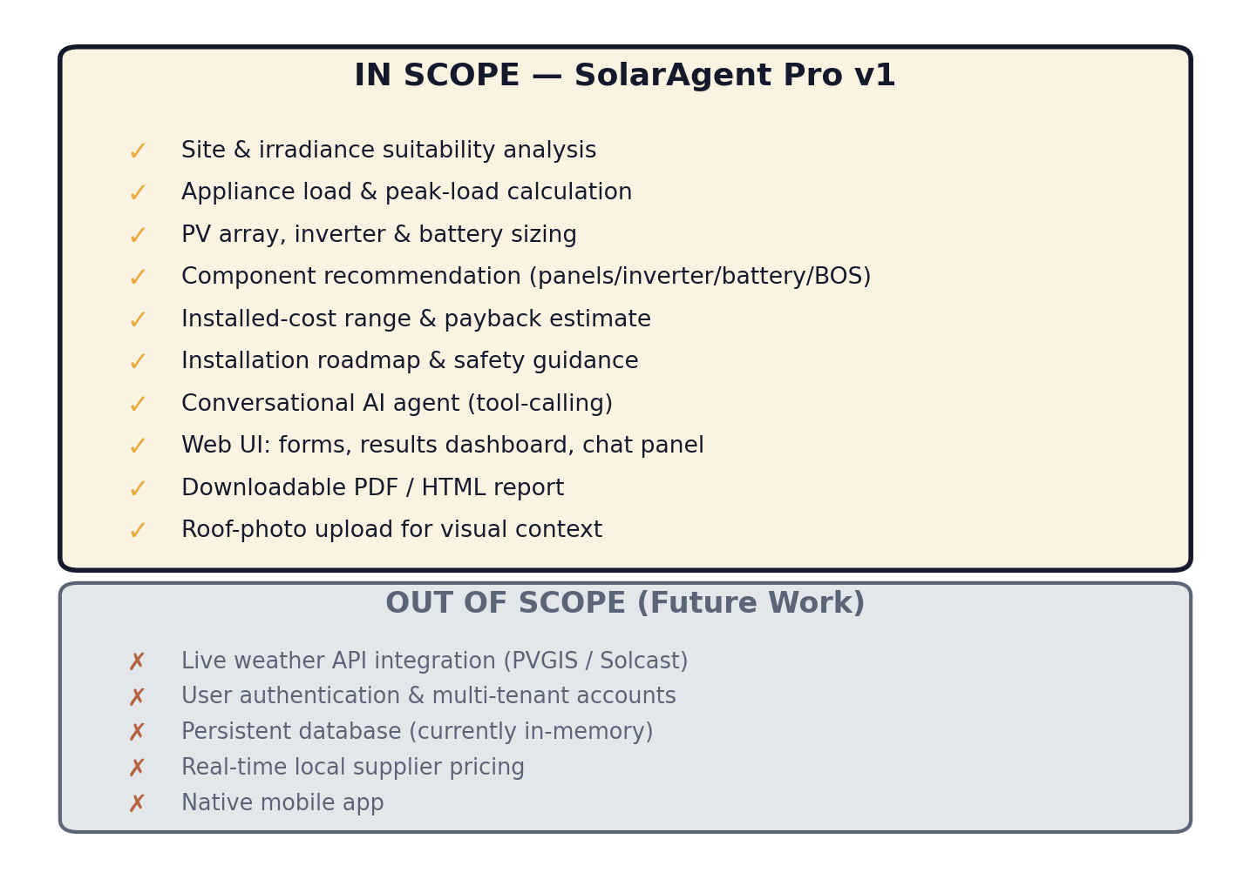
Figure 1.1 — Project scope: implemented v1 functionality vs. future work

1.3 Objectives
- O1 — Reduce the expertise barrier to a preliminary solar system design from “requires a site engineer” to “a guided conversation,” without sacrificing calculation rigor.
- O2 — Ground every numeric output (energy, sizing, cost, payback) in an explicit, inspectable formula rather than an LLM estimate, so results are reproducible and auditable.
- O3 — Deliver a working full-stack reference implementation (FastAPI + React) that a developer can run locally within about 10 minutes of extracting the repository.
- O4 — Produce documentation and diagrams to a standard suitable for academic submission and for onboarding a new contributor without a walkthrough call.
- O5 — Establish a repeatable, AI-assisted development workflow (the “Agentic Engineering Development Lifecycle,” Section 1.6) that can be evaluated and refined across the remaining five weeks of the project.

1.4 Roles & Responsibilities
Table 1.1 below is shown as a diagram for readability; roles marked with a placeholder are included so this document is directly reusable for a team submission — fill in a name or remove the row if the project remains solo.
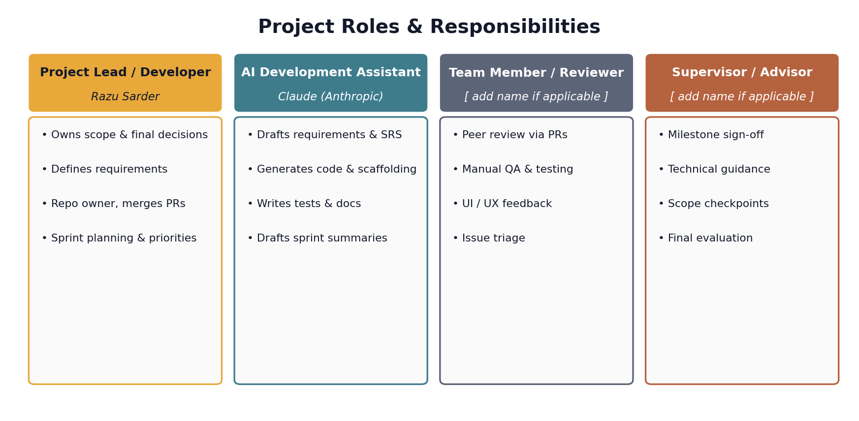
Figure 1.2 — Project roles and responsibilities

1.5 Project Timeline Overview
The six-week plan below is the one this document itself follows. Week 1 (this deliverable) is complete; Weeks 2–6 are planned and scoped in Section 1.6.
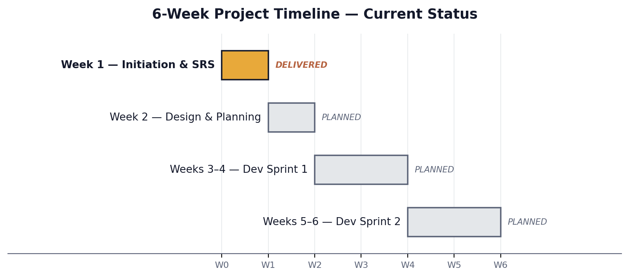
Figure 1.3 — Six-week project timeline and current status

1.6 AI-Assisted Development Methodology (AEDL)
This project follows a hybrid Agentic Engineering Development Lifecycle (AEDL): a standard six-week SDLC structure (initiation → design → two development sprints, a compressed Agile cadence) in which an AI assistant (Claude) is used deliberately at every stage — not merely for isolated code snippets, but for requirement drafting, full-stack implementation, test scaffolding, documentation, and sprint reporting — while the human developer retains ownership of scope decisions, architectural review, and final acceptance. Table 1.2 maps each week’s planned AI-assisted activity to this project’s actual artifact.
Week | Planned AI-Assisted Activity | This Project’s Artifact
1 | AI-assisted requirement writing; AI generates README & task list | This SRS; README.md; docs/initial_task_list.md; CONTRIBUTING.md
2 | AI design tools for wireframes; AI auto-generates architecture diagrams (ER, flowcharts) | Planned next — not yet started
3–4 | AI (Copilot-style) code scaffolding; AI-generated unit tests & weekly progress summaries | Planned — core engines/agent/UI already implemented ahead of schedule; formal sprint framing pending
5–6 | AI monitors sprint velocity, suggests backlog adjustments; AI-generated retrospectives | Planned — not yet started

Note: because the AEDL approach front-loaded a working implementation during scoping conversations, several Sprint 1 code deliverables (the five calculation engines, the tool-calling agent, and the React UI) already exist ahead of the Week 3–4 slot in which the original plan places them. Section 4 reconciles this by marking those backlog items “Done” rather than re-scheduling already-complete work.

2. Software Requirements Specification

2.1 Introduction

2.1.1 Purpose
This Software Requirements Specification defines the functional and non-functional requirements for SolarAgent Pro v1, as actually implemented in the backend (FastAPI, Python) and frontend (React, Vite, Tailwind) delivered alongside this document. It is written to IEEE 830-style conventions, adapted for a project of this scale, and is intended to serve both as a specification a reader can trace directly to the shipped code, and as the requirements baseline for Weeks 2 through 6.

2.1.2 Document Conventions
Functional requirements are numbered FR-1 through FR-10 and grouped by the engine or module that implements them. Non-functional requirements are numbered NFR-1 through NFR-6. Priority is expressed as High / Medium / Low, where High indicates the requirement is on the critical path for a usable end-to-end plan.

2.1.3 Intended Audience
- The project developer — as a design and implementation reference.
- A course instructor or evaluator — for requirements traceability against the delivered system.
- Any future contributor — extending the system in Weeks 2–6 and beyond.

2.1.4 Scope of Product
See Section 1.2 and Figure 1.1.

2.1.5 References
- IEEE Std 830-1998, Recommended Practice for Software Requirements Specifications.
- Anthropic, Claude API documentation — platform.claude.com/docs
- Project repository — solaragent-pro (see README.md for setup).

2.2 Overall Description

2.2.1 Product Perspective
SolarAgent Pro is a new, standalone system — it does not replace or integrate with an existing product. It depends on exactly one external service for its conversational layer (the Anthropic Claude API) and is designed so that a second external dependency (a live weather/irradiance API) can be added later without changing any other component, as shown in Figure 2.1.
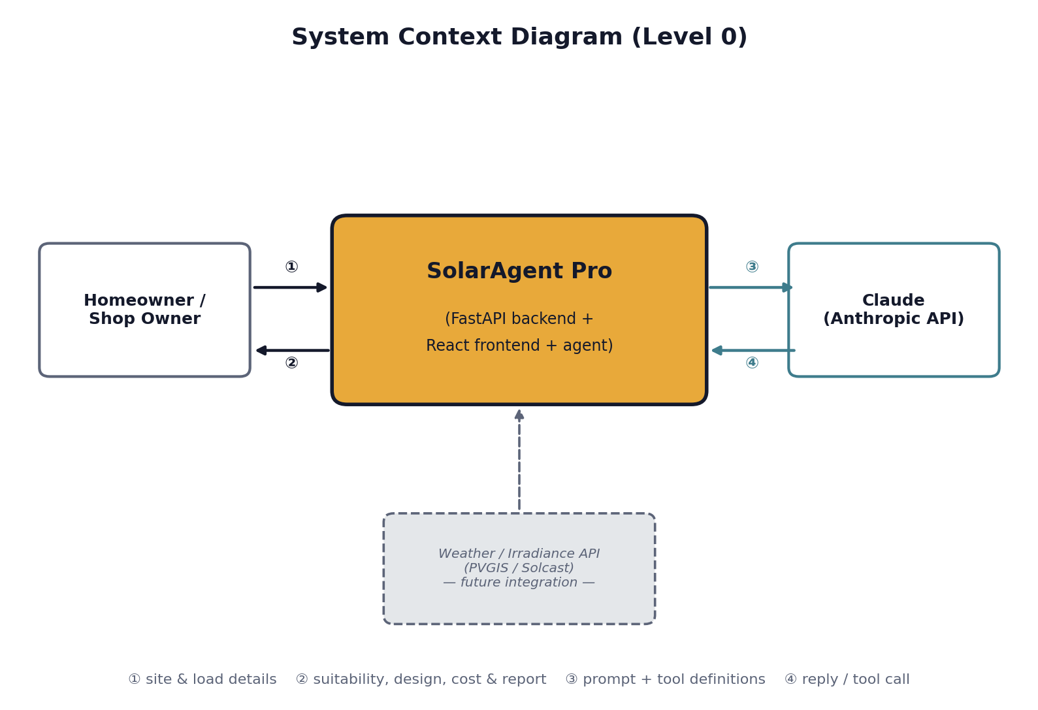
Figure 2.1 — System context diagram (Level 0)

2.2.2 Product Functions
- Estimate site solar resource and score installation suitability.
- Calculate daily energy consumption and peak load from an appliance list.
- Size a PV array and, where applicable, a battery bank.
- Recommend specific components (panels, inverter, battery, mounting, BOS).
- Estimate installed cost range and payback period.
- Generate an installation roadmap with safety and maintenance guidance.
- Provide a conversational agent that explains and answers questions about the above.
- Generate a downloadable report.

2.2.3 User Classes and Characteristics
Primary user class: a homeowner or small-shop owner considering solar, with no assumed technical or electrical-engineering background. The system is designed to be usable end-to-end by this class without external help, per Objective O1. No secondary or administrative user class exists in v1 (see NFR-3 and the Out-of-Scope items in Figure 1.1 regarding authentication).

2.2.4 Operating Environment
Backend: any environment capable of running Python 3.10+ and Uvicorn. Frontend: any modern evergreen browser, served as a static Vite build. There is no mobile-native runtime; the web UI is responsive down to mobile viewport widths.

2.2.5 Design and Implementation Constraints
- Must use the Anthropic Claude API (Messages API, Python SDK) for the conversational layer.
- Numeric outputs must derive from deterministic Python functions, never from unvalidated model output — a self-imposed constraint driving the tool-calling architecture (see FR-7).
- No cloud-vendor-specific services, to keep the reference implementation portable (NFR-6).

2.2.6 Assumptions and Dependencies
- Assumes the operator supplies a valid Anthropic API key at deployment time.
- Assumes the built-in irradiance/tariff estimation model is acceptable for preliminary planning; final designs are assumed to be validated by a licensed electrician/engineer against local code (this is stated explicitly to the end user in-product).
- Assumes single-instance deployment for v1 (in-memory session store; see NFR-2).

2.3 Functional Requirements
ID | Requirement | Priority | Source Module
FR-1 | Accept country, city, roof type, roof area, shading, and building type; estimate peak sun-hours, average temperature and tariff; compute a 0–100 suitability score with contributing factors. | High | engines/site_analysis.py
FR-2 | Accept an appliance list (name, power, hours/day, quantity, simultaneity flag) and compute daily energy (kWh/day) and estimated peak load (W) using a diversity factor. | High | engines/energy_engine.py
FR-3 | Compute required PV array size (kW) via the peak-sun-hour method, and required battery capacity (kWh) via depth-of-discharge and autonomy-day targets for hybrid/off-grid modes. | High | engines/energy_engine.py
FR-4 | Recommend panel tier/count/wattage, inverter type/size, battery chemistry/voltage/capacity, mounting structure, and balance-of-system items. | High | engines/component_engine.py
FR-5 | Compute installed-cost range, estimated annual generation and savings, and payback period. | High | engines/cost_engine.py
FR-6 | Generate a phased installation roadmap, safety notes, common mistakes, and a maintenance schedule, adapted to the selected system mode. | Medium | engines/roadmap_engine.py
FR-7 | Provide a chat interface backed by an LLM agent that calls FR-1–FR-6 as tools, explains results in plain and technical language, asks clarifying questions, and never states a figure not derived from a tool call. | High | agent.py, system_prompt.py
FR-8 | Generate a downloadable report (PDF via backend, HTML via live demo) summarizing site analysis, design, cost, and roadmap. | Medium | report_generator.py
FR-9 | Allow an optional roof-photo upload, passed to the AI agent as visual context. | Low | frontend + agent.py
FR-10 | Support toggling between dark and light visual themes. | Low | frontend

2.4 Use Cases
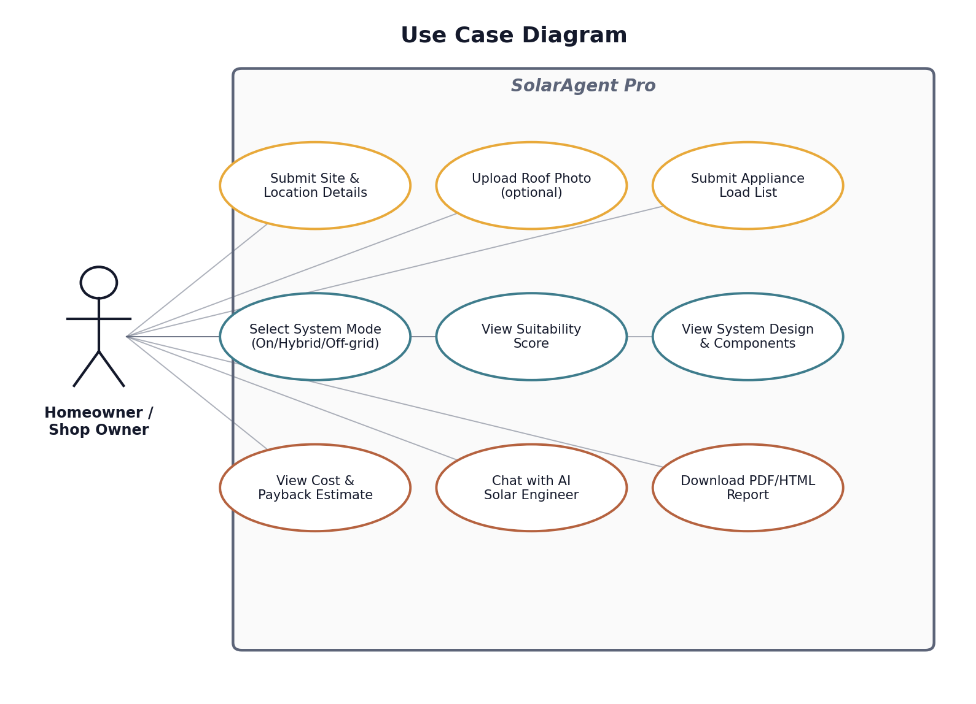
Figure 2.2 — Use case diagram
ID | Name | Precondition | Main Flow | Postcondition
UC-1 | Submit Site Details | Session created | User enters country, city, roof type, area, shading, building type and submits. | Suitability + resource estimate available
UC-2 | Submit Appliance Load | Site details submitted | User adds appliances (presets or manual), selects system mode & autonomy days. | Full design, cost, roadmap computed
UC-3 | View Results Dashboard | Load submitted | System displays suitability gauge, system design, cost, and roadmap. | User has a complete plan
UC-4 | Chat with AI Engineer | Session exists (site/load optional) | User asks a question; agent calls relevant tools and/or grounds its answer in existing session data. | User receives a grounded explanation
UC-5 | Download Report | Design computed | User requests the report; system generates a PDF (backend) or HTML (live demo). | User has a downloadable file

2.5 External Interface Requirements

2.5.1 User Interfaces
A responsive web UI (React): structured forms for site and load input, a results dashboard, and a chat panel, with dark/light theming.

2.5.2 Software Interfaces
The Anthropic Messages API (HTTPS/JSON) via the official Python SDK, with the model configurable through an environment variable. Frontend-to-backend communication is REST/JSON over HTTP with CORS enabled for the configured origin.

2.5.3 Hardware Interfaces
None specific — a standard client device capable of running a modern browser.

2.5.4 Communication Interfaces
HTTPS to the Anthropic API; HTTP between frontend and backend in local development (HTTPS recommended for any real deployment).

2.6 Non-Functional Requirements
ID | Category | Requirement
NFR-1 | Performance | Deterministic engine calculations complete in well under 100 ms; conversational turns are bounded by LLM API latency plus a hard cap of 6 tool-loop iterations to prevent runaway calls.
NFR-2 | Reliability | All five engines are pure functions (identical input → identical output), giving reproducible results. The current session store is in-memory only and does not survive a backend restart — flagged for hardening in a later sprint.
NFR-3 | Security | No authentication is implemented in v1. The Anthropic API key lives server-side only and is never exposed to the frontend. CORS is restricted to configured origins.
NFR-4 | Usability | Responsive layout for mobile and desktop. Every suitability score is shown with its contributing factors, never as a bare number. The agent's system prompt requires plain-language explanations alongside technical detail.
NFR-5 | Maintainability | Each engine is isolated with no cross-dependencies beyond explicit function parameters — e.g. the irradiance model can be replaced with a live weather API without touching sizing, cost, or roadmap logic.
NFR-6 | Portability | Backend is a standard FastAPI/Uvicorn service; frontend is a standard Vite/React static build. Neither depends on a specific cloud vendor.

2.7 Data Requirements
Session state (site input, computed site analysis, load input, energy/design/cost/roadmap results, and conversation history) is held per session in the backend’s SessionStore. No personally identifying information is collected beyond what the user voluntarily enters into the site/load forms or chat, and no data is persisted beyond process memory in v1 (see NFR-2 and the Out-of-Scope items in Figure 1.1).

3. GitHub Repository & Contribution Setup

3.1 Repository Structure
The repository is organized as two independently runnable applications sharing one methodology, plus documentation and a standalone demo:
- backend/ — FastAPI service: app/main.py (routes), app/agent.py (tool-calling agent), app/engines/ (five calculation engines), app/report_generator.py (PDF).
- frontend/ — React + Vite + Tailwind: src/components/ (forms, dashboard, chat), src/context/ (session state), src/api.js (backend client).
- docs/ — example_conversations.md, sample_report.md, initial_task_list.md, and this SRS.
- live-demo/ — a self-contained single-file version for zero-setup evaluation.
- .github/ — pull request template.

3.2 Branching Strategy
This project uses GitHub Flow rather than full GitFlow, since a six-week project of this size does not benefit from GitFlow’s release/hotfix branch overhead:
- main is always in a runnable state.
- New work happens on feature/<short-description> or fix/<short-description> branches cut from main.
- Work merges back to main via Pull Request, even for a solo contributor — this preserves the PR description and review-comment trail as part of the project’s documentation.

3.3 Commit Message Convention
Commits follow the Conventional Commits format — <type>: <short imperative description> — so the history itself is a readable changelog:
- feat: — a new capability (e.g. “feat: add battery sizing to energy engine”)
- fix: — a bug fix
- docs: — documentation only
- refactor: — code change with no behavior change
- test: — adding or updating tests
- chore: — tooling, dependencies, config

3.4 Contribution Guidelines Summary
Full guidelines live in CONTRIBUTING.md at the repository root. In summary: branch from main, keep PRs scoped to one logical change, run the relevant app locally before opening a PR (see README.md “Quick start”), and fill in the PR template’s checklist.

3.5 Code Review Process
Every PR is reviewed against a short checklist before merge: does it run locally as described; are new environment variables documented in the relevant .env.example; if behavior changed, was README.md or this SRS updated to match; and — specific to this project’s architecture — does any new numeric output trace to an engine function rather than to unvalidated model output (per FR-7 and the constraint in Section 2.2.5).

4. Initial Task List (Week 1 Output)
This is the seed backlog Week 2 will load into a GitHub Projects board. It is intentionally an epic-level summary; the granular, board-ready version lives in docs/initial_task_list.md so it can be copied directly into GitHub Issues.
Epic | Task | Target | Priority | Status
E1 | Site analysis engine | Wk 1–2 | High | Done
E2 | Load & sizing engine | Wk 1–2 | High | Done
E3 | Component & cost engines | Wk 3–4 | High | Done
E4 | Tool-calling conversational agent | Wk 3–4 | High | Done
E5 | React frontend (forms, dashboard, chat) | Wk 3–4 | High | Done
E6 | PDF/HTML report generation | Wk 5–6 | Medium | Done
E7 | UI wireframes & architecture diagrams | Wk 2 | Medium | Not started
E8 | GitHub Projects board configuration | Wk 2 | Medium | Not started
E9 | Authentication & persistent session store | Wk 5–6 | Medium | Not started
E10 | Live weather API integration | Post-Wk 6 | Low | Not started
E11 | Automated test suite for engines | Wk 5–6 | Medium | Not started

Appendix A: Glossary & Acronyms
Term | Definition
SRS | Software Requirements Specification.
PSH | Peak Sun-Hours — the number of hours per day at which solar irradiance would need to be 1,000 W/m² to deliver the day’s actual total irradiation.
DoD | Depth of Discharge — the fraction of a battery’s capacity usable before recharging.
BOS | Balance of System — every component in an installation other than panels, inverter, and battery (cabling, protection devices, mounting, etc.).
MPPT | Maximum Power Point Tracking — a charge-controller technique that maximizes power draw from a PV array.
LiFePO4 | Lithium Iron Phosphate — a lithium battery chemistry favored for solar storage for its safety and cycle life.
kW / kWp | Kilowatt / kilowatt-peak — unit of PV array rated capacity.
BOM | Bill of Materials.
REST | Representational State Transfer — the API architecture style used by the backend.
CORS | Cross-Origin Resource Sharing.

Appendix B: Document Revision History
Version | Date | Author | Change
1.0 | August 17, 2026 | Razu Sarder / Claude (AI-assisted) | Initial Week 1 SRS & Project Initiation Document.
1.1 | August 18, 2026 | Razu Sarder / Claude (AI-assisted) | Added Acknowledgement section.

Acknowledgement
This project was completed with the support of several tools and technologies. Each is acknowledged briefly below, along with the reason it was chosen.
- Claude (Anthropic) — used for AI-assisted requirement drafting, code generation, and documentation throughout this project (Section 1.6), chosen for its tool-calling capability, which lets the agent ground every answer in a real calculation rather than a guess.
- GitHub — used for version control and the pull-request review workflow described in CONTRIBUTING.md, chosen for its ubiquity and traceable change history.
- FastAPI (Python) — used for the backend API, chosen for built-in request validation and automatic interactive API documentation.
- React, Vite & Tailwind CSS — used for the frontend, chosen for fast component-based development and consistent design-system styling.
- Anthropic Claude API (Messages API) — powers the conversational agent itself, distinct from Claude's use as a development assistant above, chosen specifically for its structured tool-use support (FR-7).
- matplotlib & docx (Node.js) — used to generate this document and its diagrams as code, chosen to keep them reproducible and easy to update as the project changes.
- reportlab (Python) — used for the in-app PDF report feature, chosen for lightweight PDF generation without a browser-rendering dependency.

