*Тема работы:* Верстка основных элементов макета. Создание стилей для контента сайта. Создание CSS анимации.

*Номер учебной группы* Пк-31

*Фамилия, инициалы обучающегося* Разумов Д.А.

*Дата выполнения работы* 04.06.2025

*Цель работы:*

Верстать основные элементы макета. Создавать стили для сайта. Создавать CSS анимации.

*Задание:*

1. Продолжить верстку сайта по макету.
2. Изучить примеры эффектов и CSS анимации. Создать стили для анимации и эффектов на странице.
3. Из статьи «CSS-анимация с помощью свойства transition» применить не менее 3-х эффектов на страницу.

*Оснащение работы:* инструкционная карта, веб-браузер (Opera, Google Chrome, Mozilla Firefox и др.), html-редакторы (Notepad++, Sublime Text и др.).

*Результаты выполнения работы:*

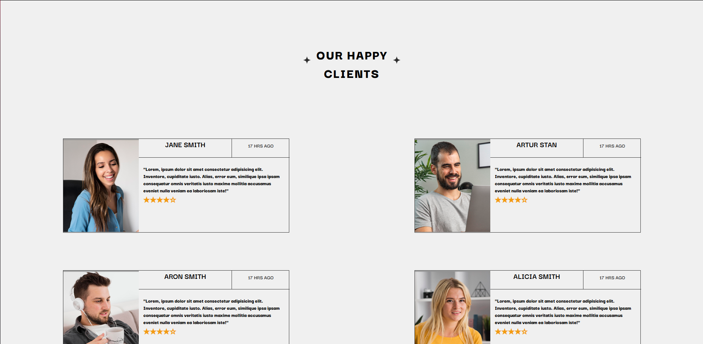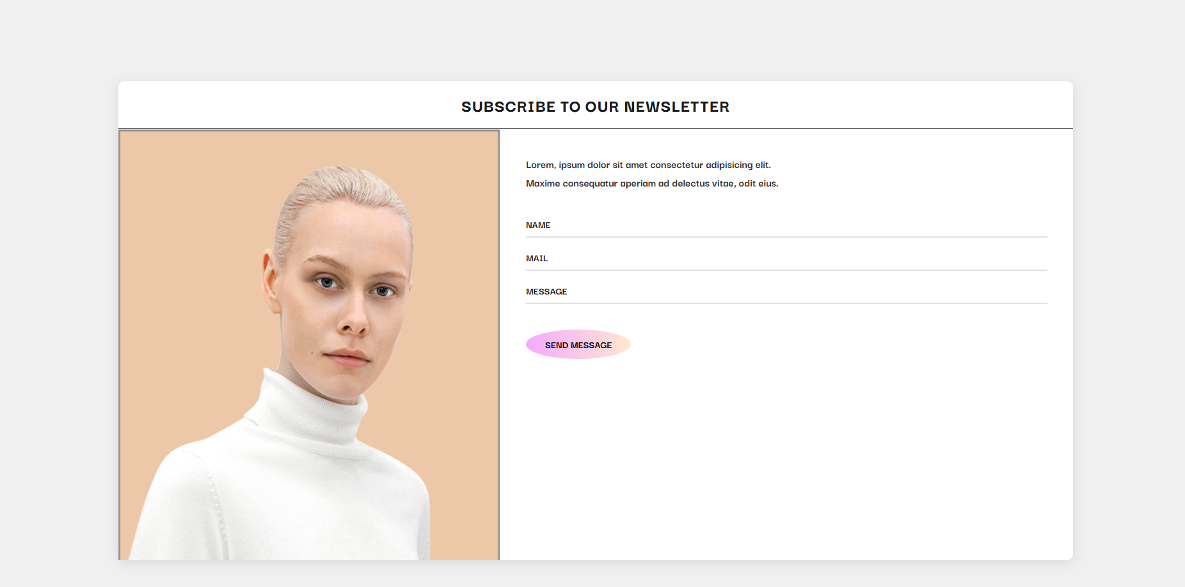

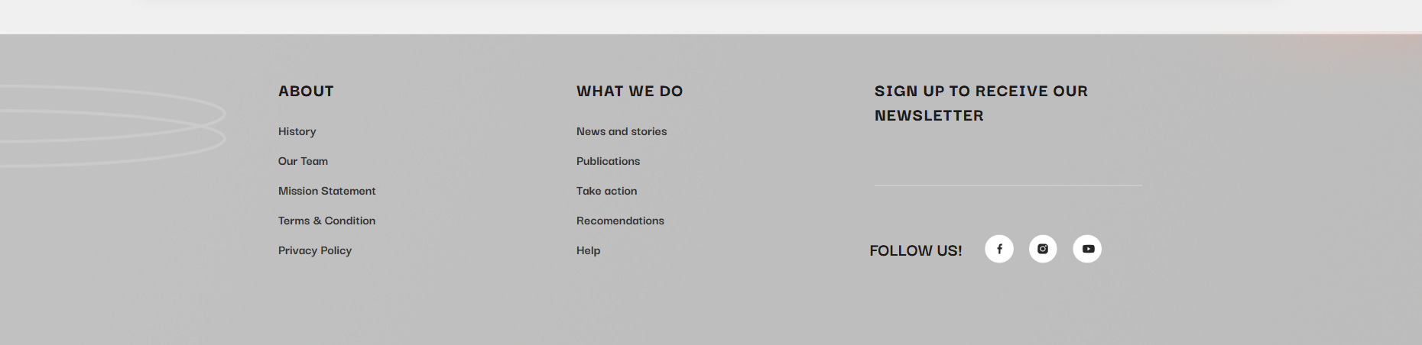

Рисунок 1 – Шапка сайта

**Код страниц сайта HTML:**

<div class="kartochkii">

<div class="head">

<img src="img/Star 1.png" alt="">

<div class="zag"><h3>OUR HAPPY<br>CLIENTS</h3></div>

<img src="img/Star 2.png" alt="">

</div>

<div class="group1">

<div class="kard1">

<div class="kardleft">

<img src="img/jane.png" alt="">

</div>

<div class="kardright">

<div class="werhcontainer">

<div class="werhleft">

<h2>JANE SMITH</h2>

</div>

<div class="werhright">

<p>17 HRS AGO</p>

</div>

</div>

<div class="nizbottom">

<p>"Lorem, ipsum dolor sit amet consectetur adipisicing elit. Inventore, cupiditate iusto. Alias, error eum, similique ipsa ipsam consequatur omnis veritatis iusto maxime mollitia accusamus eveniet nulla veniam ea laboriosam iste!"</p>

<div class="stars">★★★★☆</div>

</div>

</div>

</div>

<div class="kard1">

<div class="kardleft">

<img src="img/ARTURPlace Your Image Here (Double Click to Edit).png" alt="">

</div>

<div class="kardright">

<div class="werhcontainer">

<div class="werhleft">

<h2>ARTUR STAN</h2>

</div>

<div class="werhright">

<p>17 HRS AGO</p>

</div>

</div>

<div class="nizbottom">

<p>"Lorem, ipsum dolor sit amet consectetur adipisicing elit. Inventore, cupiditate iusto. Alias, error eum, similique ipsa ipsam consequatur omnis veritatis iusto maxime mollitia accusamus eveniet nulla veniam ea laboriosam iste!"</p>

<div class="stars">★★★★☆</div>

</div>

</div>

</div>

</div>

<div class="group2">

<div class="kard2">

<div class="kardleft">

<img src="img/ARONPlace Your Image Here (Double Click to Edit).png" alt="">

</div>

<div class="kardright">

<div class="werhcontainer">

<div class="werhleft">

<h2>ARON SMITH</h2>

</div>

<div class="werhright">

<p>17 HRS AGO</p>

</div>

</div>

<div class="nizbottom">

<p>"Lorem, ipsum dolor sit amet consectetur adipisicing elit. Inventore, cupiditate iusto. Alias, error eum, similique ipsa ipsam consequatur omnis veritatis iusto maxime mollitia accusamus eveniet nulla veniam ea laboriosam iste!"</p>

<div class="stars">★★★★☆</div>

</div>

</div>

</div>

<div class="kard2">

<div class="kardleft">

<img src="img/ALICIAPlace Your Image Here (Double Click to Edit).png" alt="">

</div>

<div class="kardright">

<div class="werhcontainer">

<div class="werhleft">

<h2>ALICIA SMITH</h2>

</div>

<div class="werhright">

<p>17 HRS AGO</p>

</div>

</div>

<div class="nizbottom">

<p>"Lorem, ipsum dolor sit amet consectetur adipisicing elit. Inventore, cupiditate iusto. Alias, error eum, similique ipsa ipsam consequatur omnis veritatis iusto maxime mollitia accusamus eveniet nulla veniam ea laboriosam iste!"</p>

<div class="stars">★★★★☆</div>

</div>

</div>

</div>

</div>

</div>

<div class="wrapper11">

<div class="lastakran">

<div class="headerakrana">

<h2>SUBSCRIBE TO OUR NEWSLETTER</h2>

</div>

<div class="formmess">

<div class="leftakrana">

<!-- <img src="img/MADAMPlace Your Image Here (Double Click to Edit).png" alt=""> -->

</div>

<div class="rightakrana">

<div class="righttxt">

<p>Lorem, ipsum dolor sit amet consectetur adipisicing elit. <br> Maxime consequatur aperiam ad delectus vitae, odit eius.</p>

</div>

<div class="name">

<p>NAME</p>

</div>

<div class="mail">

<p>MAIL</p>

</div>

<div class="message">

<p>MESSAGE</p>

</div>

<a href="#" class="sendbtn">SEND MESSAGE</a>

</div>

</div>

</div>

</div>

<div class="footer">

<footer>

<div class="dis">

<div class="onepart">

<h2>ABOUT</h2>

<p>History</p>

<p>Our Team</p>

<p>Mission Statement</p>

<p>Terms & Condition</p>

<p>Privacy Policy</p>

</div>

<div class="twopart">

<h2>WHAT WE DO</h2>

<p>News and stories</p>

<p>Publications</p>

<p>Take action</p>

<p>Recomendations</p>

<p>Help</p>

</div>

<div class="theardpart">

<h2>SIGN UP TO RECEIVE OUR NEWSLETTER</h2>

<div class="inp"><input type="text"></div>

</div>

</div>

<div class="FOLLOW">

<p>FOLLOW US!</p>

<img src="img/Facebook.png" alt="">

<img src="img/Instagram.png" alt="">

<img src="img/Youtube.png" alt="">

</div>

</footer>

</div>

<script src="script.js"></script>

</body>

</html>

**Код страниц сайта CSS:**

**.scpecial img{**

**width: 15px;**

**height: 15px;**

**}**

**.leimg{**

**width: 100%;**

**overflow: hidden;**

**height: 400px;**

**}**

**.container33{**

**display: flex;**

**height: 400px;**

**}**

**.leimg img{**

**width: 100%;**

**height: 105%;**

**object-fit: cover;**

**transform: translateY(-20px);**

**}**

**.ritext{**

**width: 100%;**

**height: 400px;**

**text-align: center;**

**justify-content: center;**

**background-image: url('img/06.png');**

**}**

**.ritext h3{**

**/* word-spacing: 500px; */**

**padding-top: 20px;**

**color: #747474;**

**font-size: 66px;**

**font-weight: 900;**

**letter-spacing: 2px;**

**font-family: 'Darker Grotesque';**

**}**

**.ritext p{**

**padding-bottom: 5%;**

**}**

**.bttn{**

**padding: 10px 30px;**

**background: linear-gradient(to right, #f4aaff, #ffe8d0);**

**color: #000;**

**text-decoration: none;**

**border-radius: 80% 80% / 80% 80%;**

**font-weight: bold;**

**font-size: 16px;**

**}**

**.kartochkii{**

**width: 100%;**

**height: 900px;**

**}**

**.head{**

**margin-bottom: 150px;**

**margin-top: 100px;**

**display: flex;**

**justify-content: center;**

**}**

**.head h3{**

**padding-top: 10%;**

**font-size: 36px;**

**text-align: center;**

**justify-content: center;**

**font-weight: 900;**

**letter-spacing: 2px;**

**}**

**.head img{**

**aspect-ratio: 1/1;**

**object-fit: contain;**

**padding: 15px;**

**}**

**.kard1{**

**width: 600px;**

**height: 250px;**

**display: flex;**

**border: 1px solid #373737;**

**}**

**.kardleft{**

**width: 200px;**

**height: 250px;**

**}**

**.kardleft img{**

**width: 200px;**

**height: 250px;**

**object-fit: cover;**

**}**

**.kardright{**

**width: 400px;**

**height: 250px;**

**}**

**.werhcontainer{**

**width: 400px;**

**height: 50px;**

**display: flex;**

**justify-content: space-around;**

**}**

**.werhleft{**

**width: 100%;**

**border-bottom: 1px solid #373737;**

**text-align: center;**

**}**

**.werhright{**

**width: 60%;**

**padding: 2%;**

**border-bottom: 1px solid #373737;**

**border-left: 1px solid #373737;**

**text-align: center;**

**color: #373737;**

**}**

**.nizbottom{**

**padding-top: 5%;**

**padding-left: 3%;**

**padding-right: 3%;**

**font-weight: 900;**

**}**

**.stars{**

**color: #f39c12;**

**font-size: 1.5em;**

**}**

**.kard2{**

**width: 600px;**

**height: 250px;**

**display: flex;**

**border: 1px solid #373737;**

**}**

**.group1{**

**display: flex;**

**justify-content: center;**

**justify-content: space-around;**

**margin-bottom: 50px;**

**}**

**.group2{**

**padding-top: 50px;**

**display: flex;**

**justify-content: center;**

**justify-content: space-around;**

**}**

**.wrapper11 {**

**margin-top: 100px;**

**width: 100%;**

**display: flex;**

**justify-content: center;**

**background: #f0f0f0;**

**padding: 50px 0;**

**}**

**.lastakran {**

**width: 80%;**

**height: 750px;**

**background: white;**

**box-shadow: 0 4px 20px rgba(0, 0, 0, 0.1);**

**border-radius: 10px;**

**}**

**.headerakrana {**

**width: 100%;**

**height: 10%;**

**display: flex;**

**justify-content: center;**

**align-items: center;**

**border-bottom: 1px solid #373737;**

**}**

**.headerakrana h2 {**

**font-size: 28px;**

**font-weight: 800;**

**color: #1a1a1a;**

**letter-spacing: 1px;**

**text-transform: uppercase;**

**}**

**.formmess {**

**display: flex;**

**height: 90%;**

**}**

**.leftakrana {**

**width: 40%;**

**height: 100%;**

**background: #d8d8d8;**

**display: flex;**

**justify-content: center;**

**align-items: center;**

**overflow: hidden;**

**background-image: url('img/MADAMPlace\ Your\ Image\ Here\ \(Double\ Click\ to\ Edit\).png');**

**background-repeat: no-repeat;**

**background-size: 100% 115%;**

**}**

**.leftakrana img {**

**width: 100%;**

**height: 100%;**

**object-fit: cover;**

**}**

**.rightakrana {**

**width: 60%;**

**padding: 40px;**

**display: flex;**

**flex-direction: column;**

**}**

**.righttxt {**

**margin-bottom: 40px;**

**}**

**.righttxt p {**

**font-size: 18px;**

**line-height: 1.6;**

**color: #333;**

**}**

**.name, .mail, .message {**

**margin-bottom: 20px;**

**}**

**.name p, .mail p, .message p {**

**font-size: 16px;**

**font-weight: bold;**

**color: #1a1a1a;**

**margin-bottom: 8px;**

**}**

**.name::after, .mail::after, .message::after {**

**content: '';**

**display: block;**

**width: 100%;**

**height: 2px;**

**background: #e0e0e0;**

**margin-top: 5px;**

**}**

**.sendbtn {**

**display: inline-block;**

**padding: 12px 30px;**

**color: #000;**

**text-decoration: none;**

**border-radius: 5px;**

**font-weight: bold;**

**font-size: 16px;**

**text-align: center;**

**margin-top: 20px;**

**align-self: flex-start;**

**transition: all 0.3s ease;**

**background: linear-gradient(to right, #f4aaff, #ffe8d0);**

**border-radius: 80% 80% / 80% 80%;**

**}**

**.sendbtn:hover {**

**transform: translateY(-2px);**

**box-shadow: 0 4px 10px rgba(160, 160, 255, 0.4);**

**}**

**.footer {**

**width: 100%;**

**height: auto;**

**background-color: #f0f0f0;**

**padding: 60px 0 30px;**

**font-family: 'Darker Grotesque', sans-serif;**

**background-image: url('img/1111106.png');**

**background-repeat: no-repeat;**

**background-size: cover;**

**}**

**footer {**

**max-width: 1200px;**

**margin: 0 auto;**

**padding: 0 20px;**

**}**

**.dis {**

**display: flex;**

**justify-content: space-between;**

**margin-bottom: 40px;**

**flex-wrap: wrap;**

**}**

**.onepart,**

**.twopart,**

**.theardpart {**

**flex: 1;**

**min-width: 250px;**

**margin: 0 15px 30px;**

**}**

**.onepart h2,**

**.twopart h2,**

**.theardpart h2 {**

**font-size: 24px;**

**font-weight: 800;**

**color: #1a1a1a;**

**margin-bottom: 25px;**

**letter-spacing: 1px;**

**}**

**.onepart p,**

**.twopart p {**

**font-size: 18px;**

**color: #333;**

**margin-bottom: 15px;**

**cursor: pointer;**

**transition: color 0.3s;**

**}**

**.onepart p:hover,**

**.twopart p:hover {**

**color: #ffffff;**

**}**

**.theardpart {**

**max-width: 350px;**

**}**

**.inp input {**

**width: 100%;**

**padding: 12px 15px;**

**border: none;**

**border-bottom: 2px solid #ccc;**

**background: transparent;**

**font-size: 16px;**

**margin-top: 10px;**

**outline: none;**

**transition: border-color 0.3s;**

**}**

**.inp input:focus {**

**border-bottom-color: #ffffff;**

**}**

**.FOLLOW {**

**float: right;**

**width: 500px;**

**display: flex;**

**justify-content: right;**

**margin-top: -10%;**

**margin-right: 5%;**

**}**

**.FOLLOW p {**

**font-size: 24px;**

**font-weight: bold;**

**margin-right: 20px;**

**color: #1a1a1a;**

**align-content: center;**

**}**

**.FOLLOW img {**

**width: 2vw;**

**aspect-ratio: 1/1;**

**margin: 0 10px;**

**cursor: pointer;**

**transition: transform 0.3s;**

**}**

**.FOLLOW img:hover {**

**transform: scale(1.1);**

**}**