Android Homework Documentation

1. Teamwork

I did the assignments alone, so it doesn’t apply to me. But I did help some colleagues that had some problems with their applications.

1. Introduction

The purpose of this application is to learn how to use the Android platform. By making this application I have learned to use: APIs, Databases, XML, Activities and JSON.

In it’s current stage the application allows the following actions:

* Registering and account
* Logging into the application
* Changing the password
* Seeing the weather in any city entered by the user

1. Application requirements

* Android powered device
* The device must have an internet connection

1. Wireframe

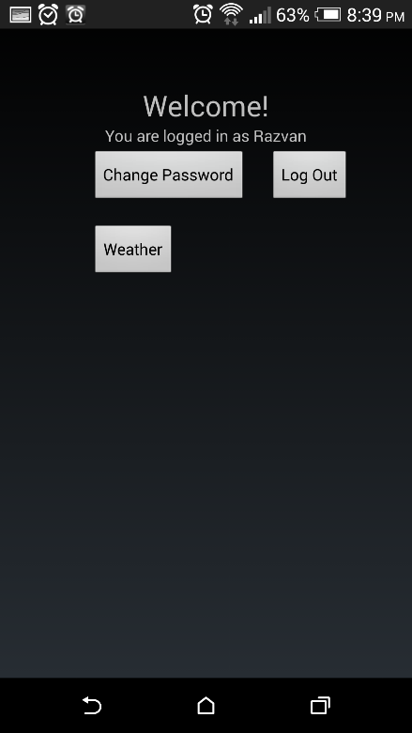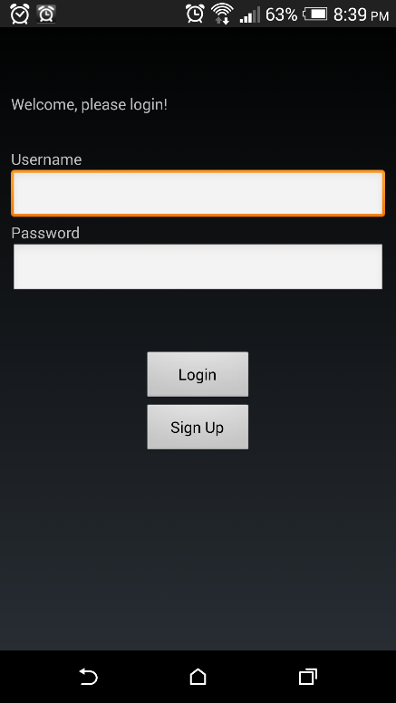

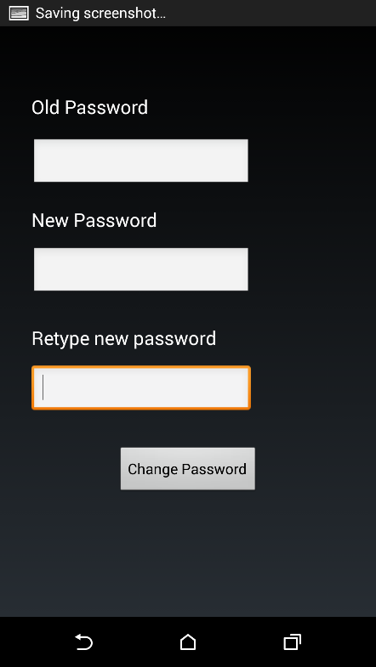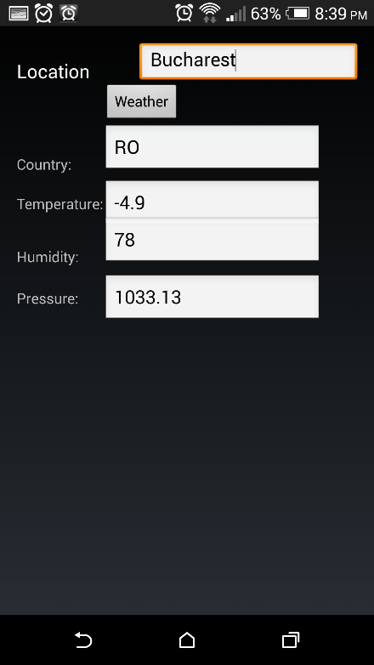

After we launch the application, we are presented with a Login/ Sign Up screen. Basically, if someone tries to Login without having an account, he will be presented with an error message in the form of a toast.

The user can press Sign Up to register an account. After this, the user is free to login to the app.

After logging in, the user is presented the main activity of the application. The user also receives a welcome message. Also, under the welcome you can see the currently logged in user.

From here, you can eighter, log out, check the weather or change your password.

The weather functionality works for any city in the world. Just type in the desired city and information will pop in the empty spaces designated for temperature, hummidity and pressure.

1. Implementation

For the database part of the application I used Parse. It is a platform that handles everything you need to store data securely and efficiently in the cloud. Practically, it takes care of all the back end part of the application, allowing developers to focus on the user experience.

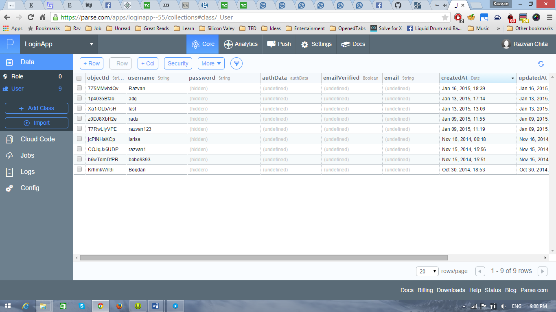

For the weather part of the application, I used Open Weather Map and JSON.

1. Conclusions

In this application I have implemented basic functionalities which can be used to further develop it. It is connected to a database, it has login and sign up functions, and it has the weather part.

I consider it a very good exercise for me. I’ve learned more about android since starting to make it than I had hoped. It has sparked my interest in Android development and I will try and develop it even after I present it for Mobile Devices.

1. References:

<http://developer.android.com/index.html>

<https://parse.com/>

<http://openweathermap.org/>