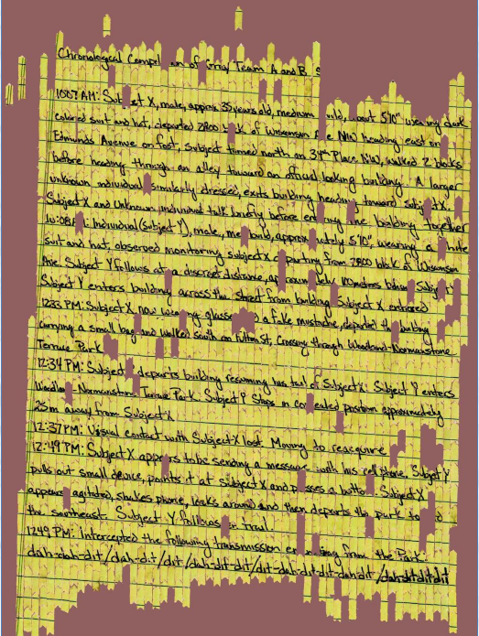
Unshredding
Student: Razvan Ranca
Supervisor: Iain Murray
Subject Areas:
Machine Learning/Neural Networks
Principal goal of the project:
Decompose the problem of reconstructing shredded documents into a manageable pipeline, investigate the performance of algorithms for each stage, and identify where the biggest open challenges are. Produce an unshredder that works at least on some type of documents.
Description of the project:
Ever since the paper shredder was invented, people have worked on sticking the pieces back together again. For instance, during the Iranian Revolution carpet weavers were enlisted to manually reconstruct shredded documents.
Recently there has been a surge of interest in this area. One example is the 2011 DARPA shredding challenge, which offered a $50,000 prize for the first team to successfully solve puzzles printed on 5 shredded documents (the picture above is the winning team’s reconstruction of part of puzzle 5). Though technology has certainly eased the document reconstruction task somewhat, most modern approaches still rely on human expertise. The approaches attempted in the DARPA challenge, for instance, ranged from crowd sourcing the task on mechanical turk to mostly automated approaches that only relied on a human to solve tough cases or correct mistakes made by the algorithm.
This project will depart slightly from these previous attempts and focus instead on automatic, computational means to unshredding. That is, unshredding without any human in the loop.
The project involves reviewing of existing work, dividing the problem into several cases, based on the type of document and the method by which it was shredded and then decomposing the problem into separate parts. For example, investigating different ways to measure the compatibility of pieces or groups of pieces and investigating search methods for maximizing this compatibility measure.
Timeline - Sem1
Week 5 – Implement Greedy2D & Cost function as in Azzam Sleit et. al. Paper.
Weeks 6-7 – Get Integer Linear Programming approach working, see what complexity it can handle.
Weeks 8-9 – Look into Optical Character Recognition approaches. Try to determine importance of cost function vs. searching method for different document types
Weeks 10 – 12 – Depending on previous results, focus further on either cost functions or search methods.
Sem2
Weeks 1 Write up interim report, start running experiments for inclusion in final report
Weeks 2 – 5 Look into expanding the scope. Better handling of multiple documents mixed together, better handling of torn/missing pieces, better handling of different types of documents.
Weeks 6-8 Run experiments, start on report, make any last improvements.
Weeks 9-12 Run any last experiments, finish report

