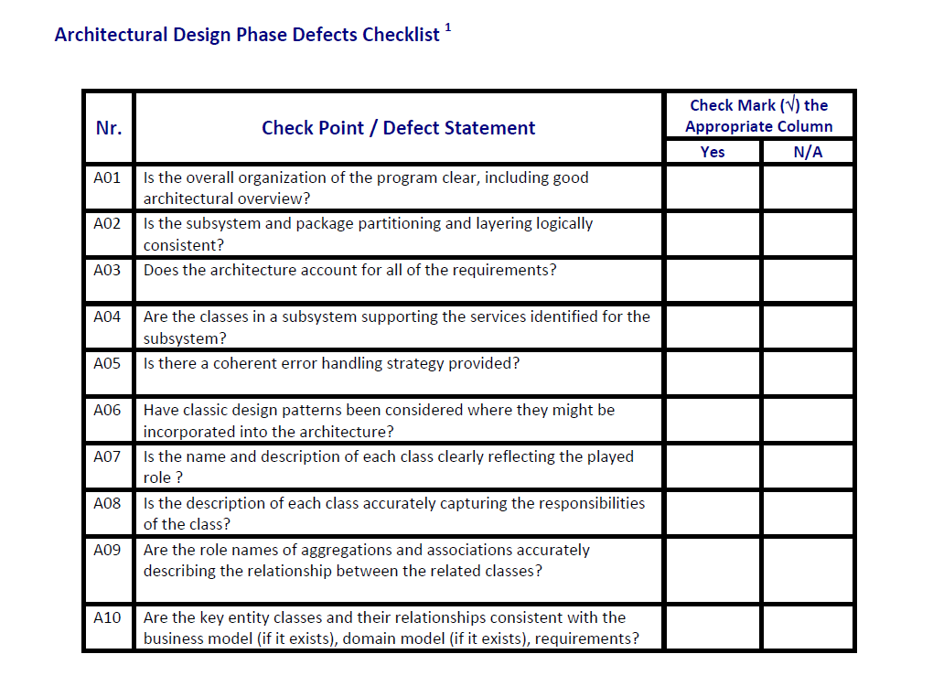

X

X

X

X

X

X

X

X

X

X

|  |  |  |  |
| --- | --- | --- | --- |
| Nr.crt | Checked Item | Doc page | Comments |
| 1 | A03 |  | I cannot see the functions which displays the earnings when the app gets closed |
| 2 | A05 |  | There is no exception validator in the diagram |
| 3 |  |  |  |
| 4 |  |  |  |
| 5 |  |  |  |
| 6 |  |  |  |