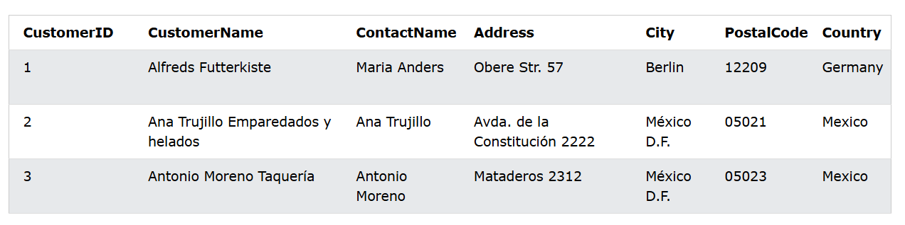

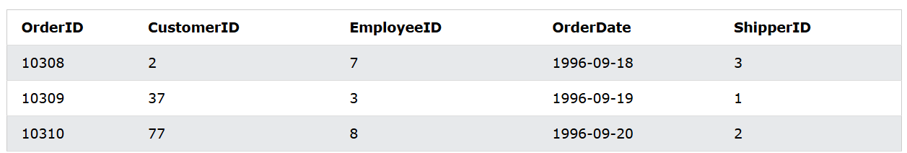

Left Join:

SELECT Customers.CustomerName, Orders.OrderID  
FROM Customers  
LEFT JOIN Orders ON Customers.CustomerID = Orders.CustomerID  
ORDER BY Customers.CustomerName;

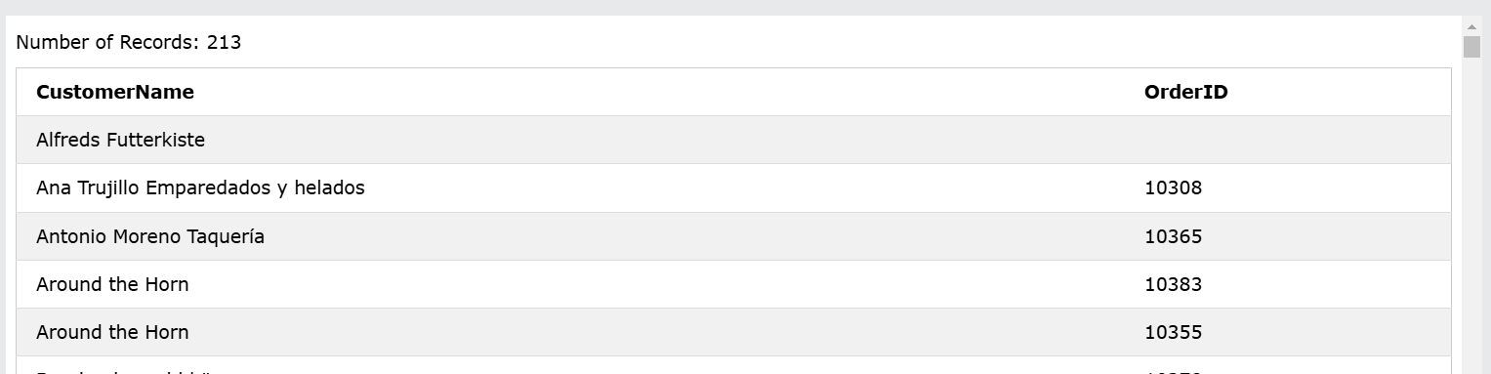

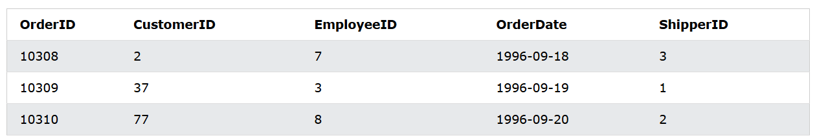

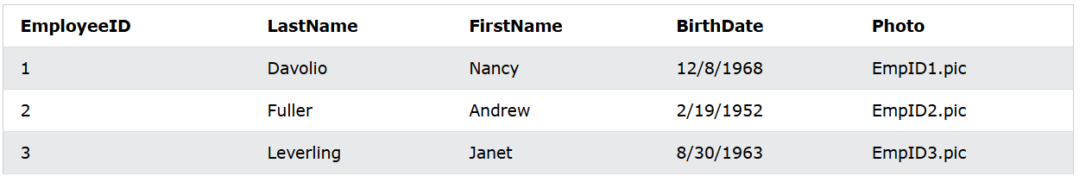

Right Join:

SELECT Orders.OrderID, Employees.LastName, Employees.FirstName  
FROM Orders  
RIGHT JOIN Employees ON Orders.EmployeeID = Employees.EmployeeID  
ORDER BY Orders.OrderID;

Full Join:

SELECT Customers.CustomerName, Orders.OrderID  
FROM Customers  
FULL OUTER JOIN Orders ON Customers.CustomerID=Orders.CustomerID  
ORDER BY Customers.CustomerName;

Self Join:

SELECT A.CustomerName AS CustomerName1,B.CustomerName AS CustomerName2, A.City  
FROM Customers A, Customers B  
WHERE A.CustomerID <> B.CustomerID %If the values are different then true otherwise false  
AND A.City = B.City  
ORDER BY A.City;

