**Ansible Tasks:**

1. **Watch ansible-01 video and write down notes.**

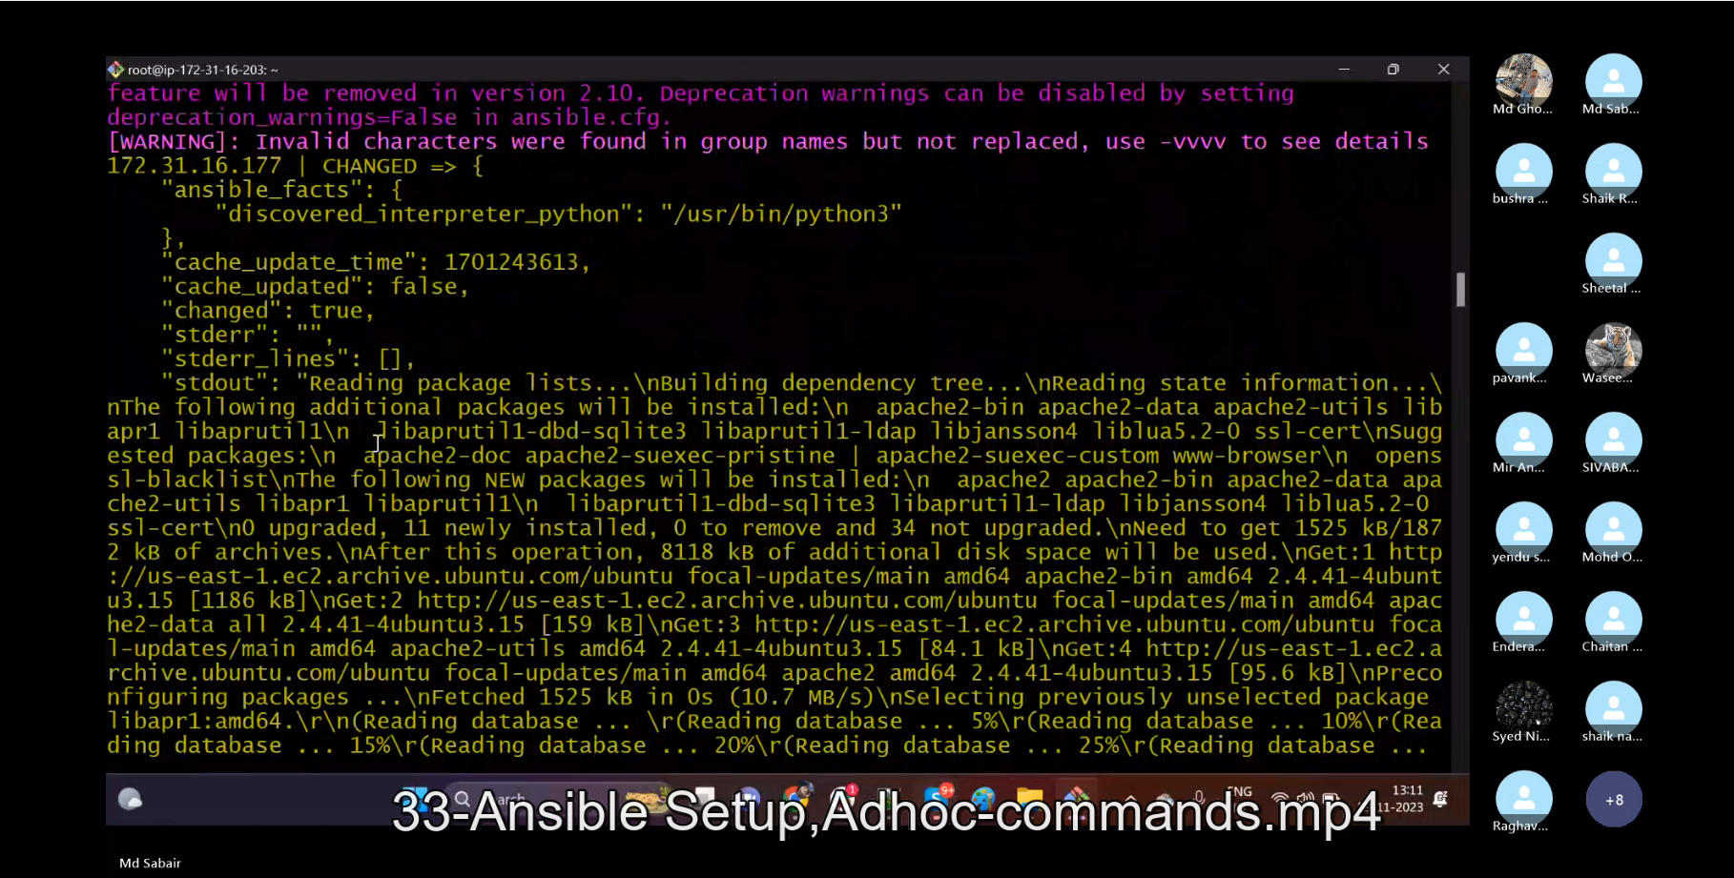

1. **Setup one master and two worker nodes in ansible.**

**>> Create 3 ec2 servers [1 as Ansible-controller and 2 as workers]**

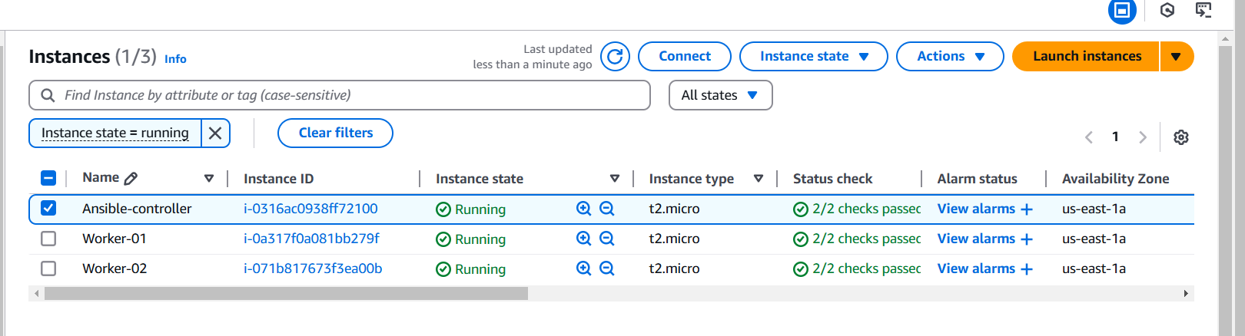

**>> Check if the python is already installed:**

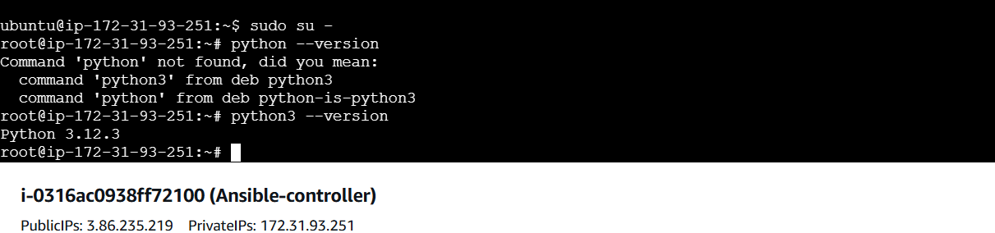

**>> apt update**

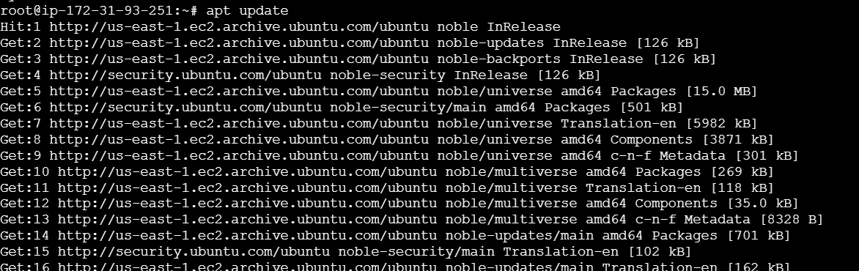

**>> apt install ansible**

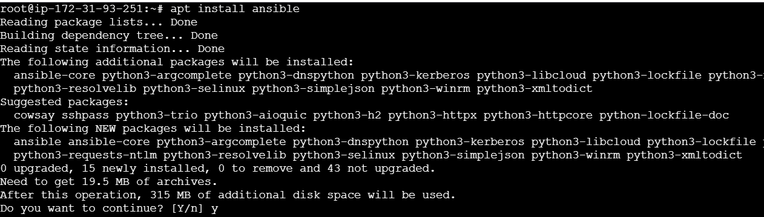

**>> ansible –version**

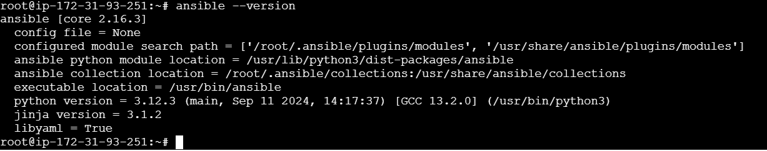

* **Ansible installation:**

***>>Update the system*:**

**sudo apt update**

**sudo apt upgrade -y**

***>>Add the official Ansible PPA (for the latest version):***

**sudo apt install -y software-properties-common**

**sudo add-apt-repository --yes --update ppa:ansible/ansible**

***>>Install Ansible:***

**sudo apt install -y ansible**

***>>ansible --version:  
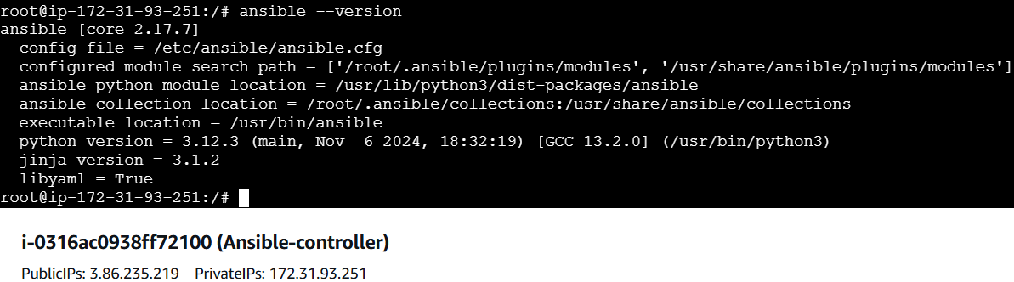***

**>>ansible.cfg file and hosts/Inventory:**

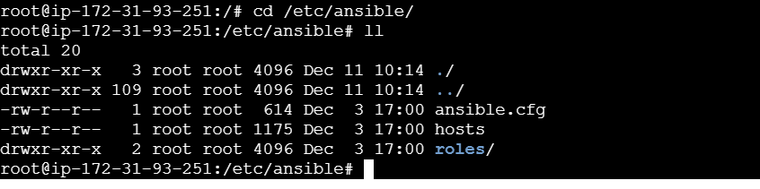

**>> vi hosts (create groups: [all], [worker-01],[worker-02] and paste the private Ips of the worker servers.)**

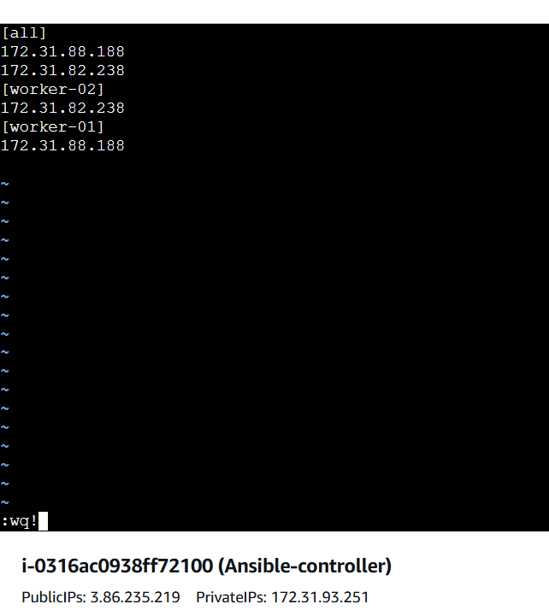



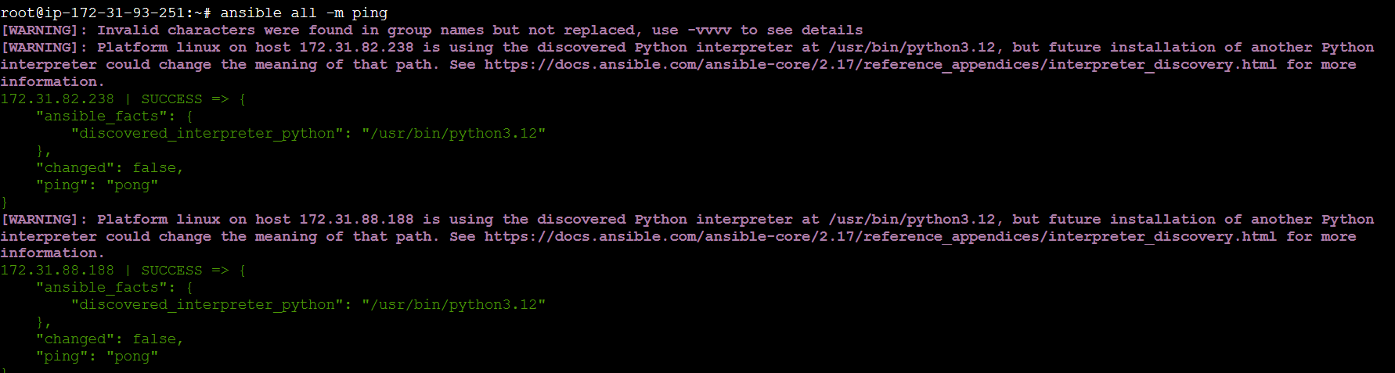

1. **Execute the adhoc command shared in #dvps-cloud-documents Channel.**

**ansible all -m ping**

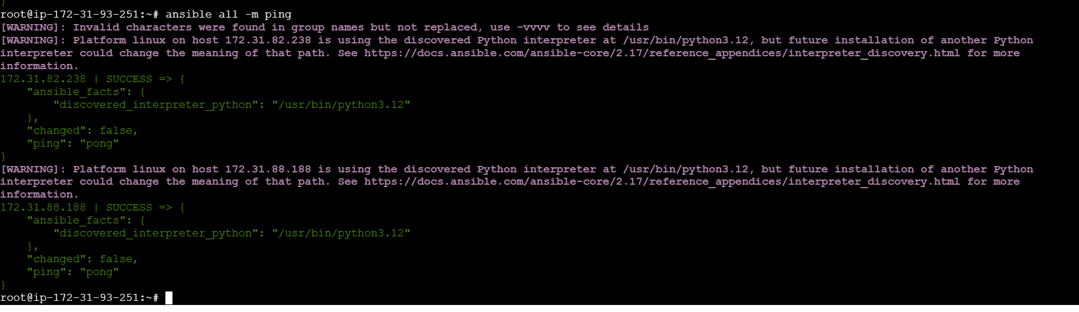

**ansible all -m setup**

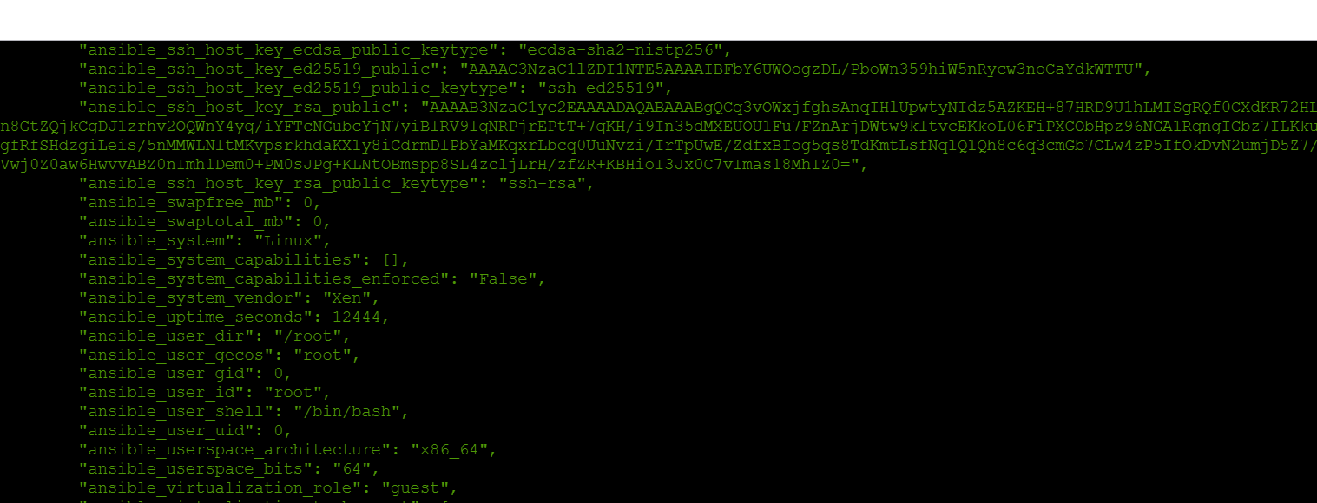

**ansible all -m shell -a uptime**

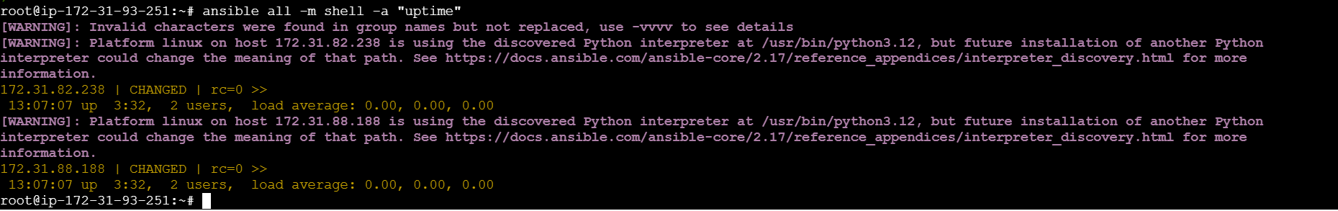

**ansible all -a "free -m"**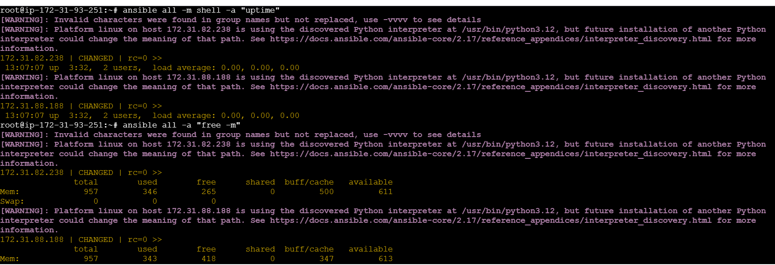

**>>To install the specific service #adhoc commands:**

**Ansible all -m apt -a “name=apache2 state=latest”**

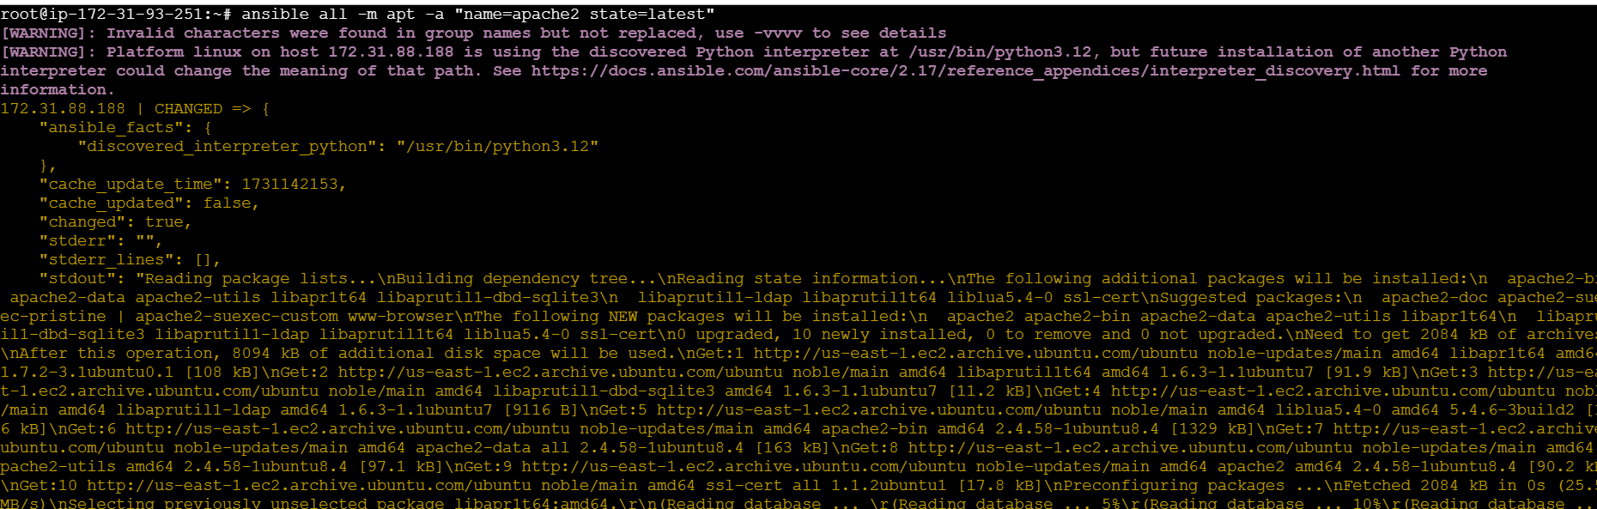

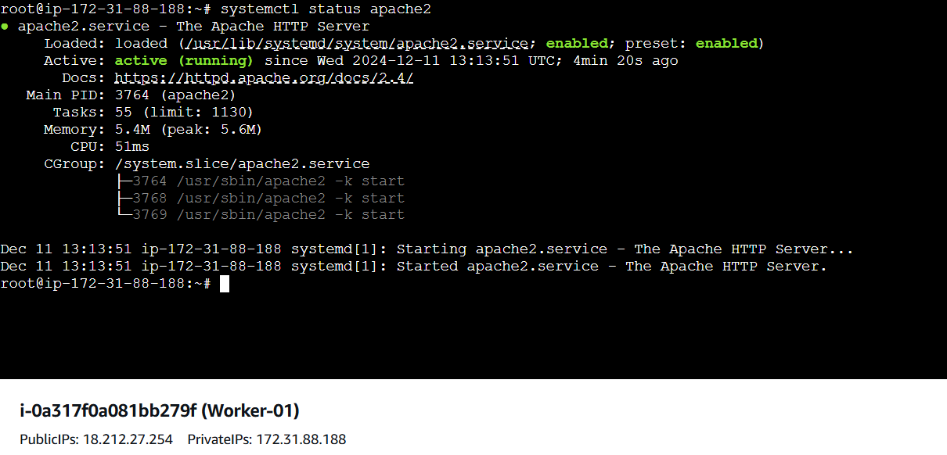

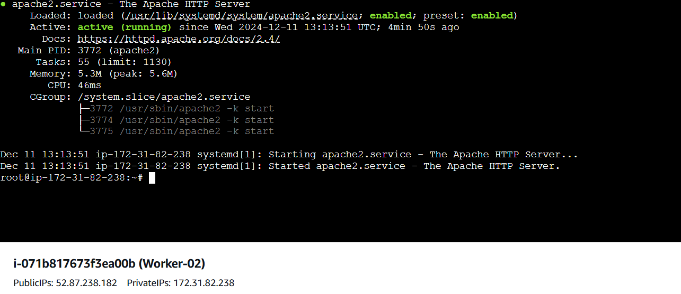

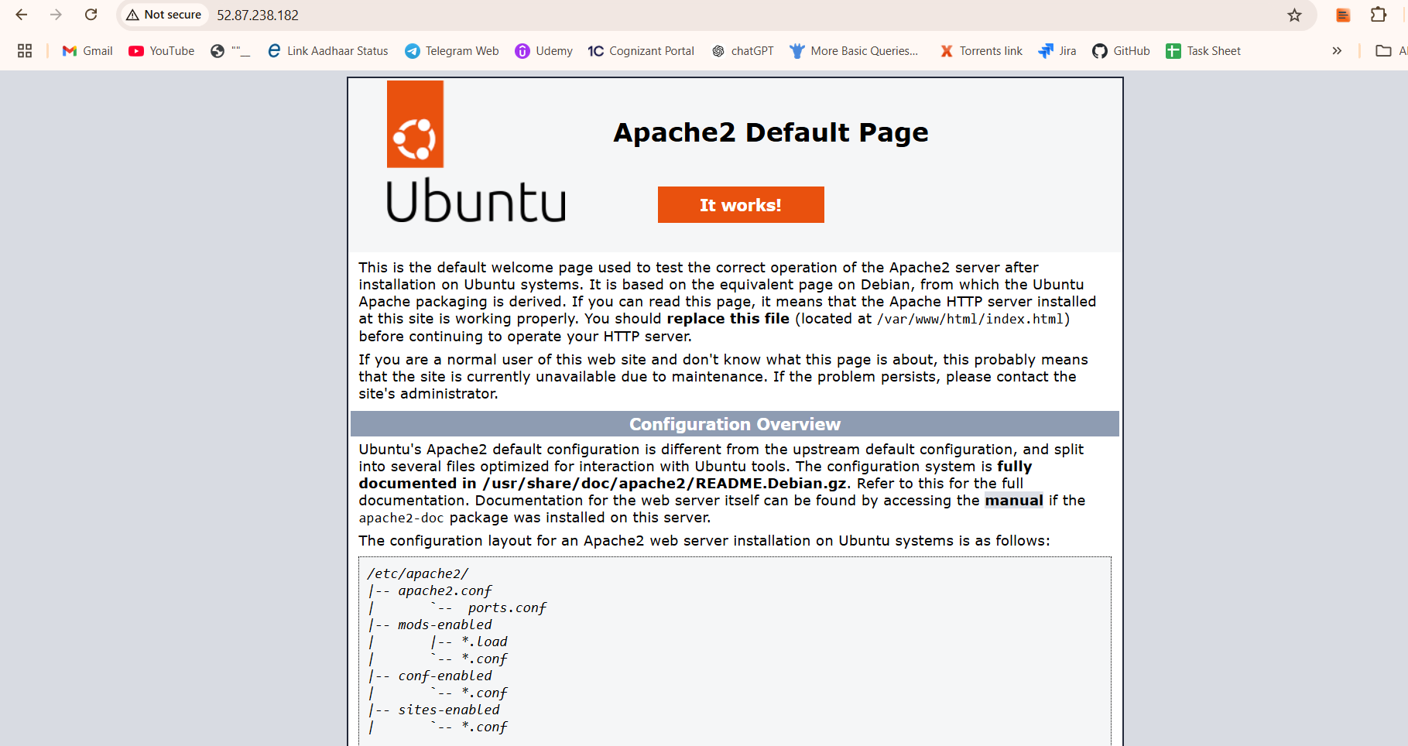

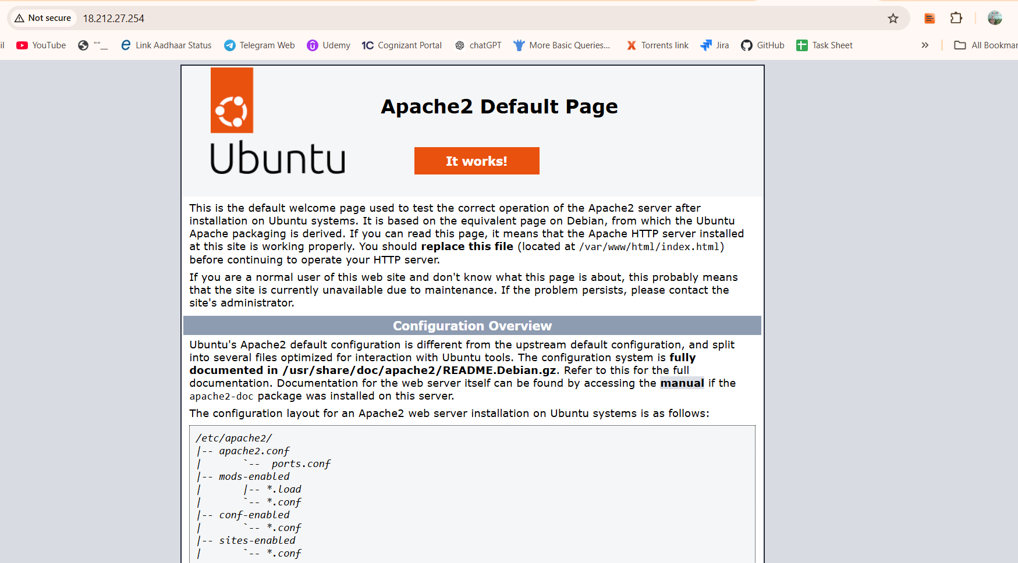

**>>To stop the specific service:**

**Ansible all -m service -a “name=apache2 state=stopped”**

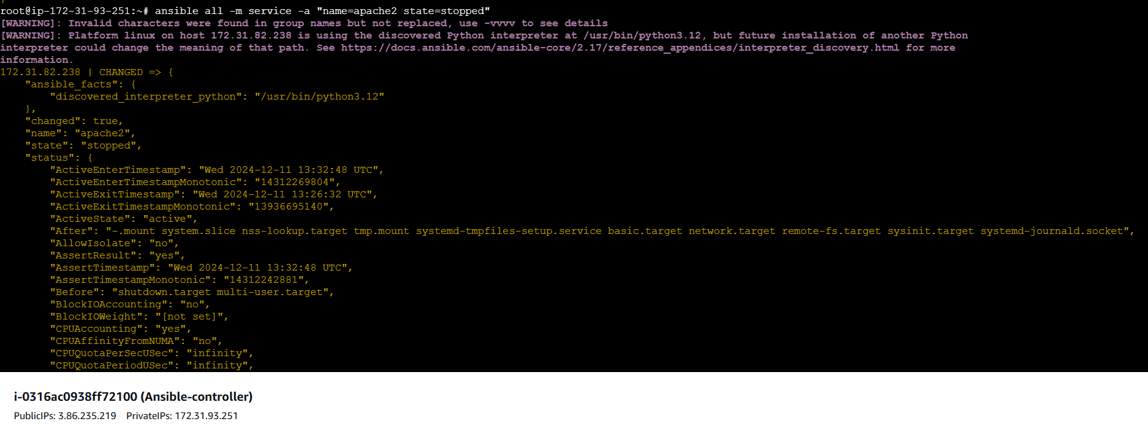

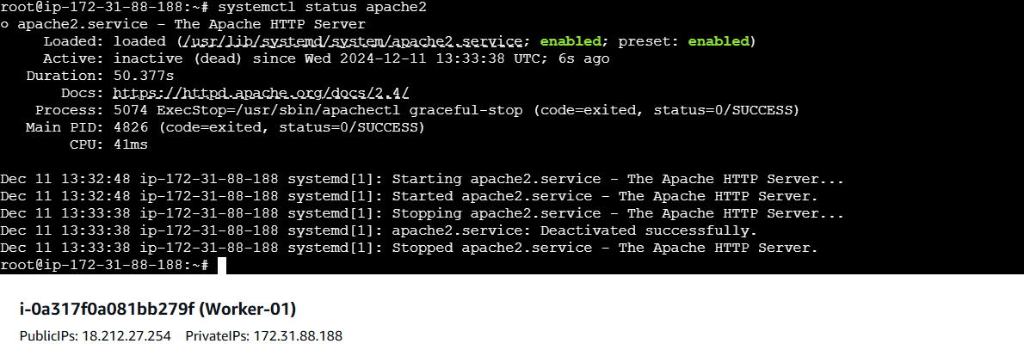

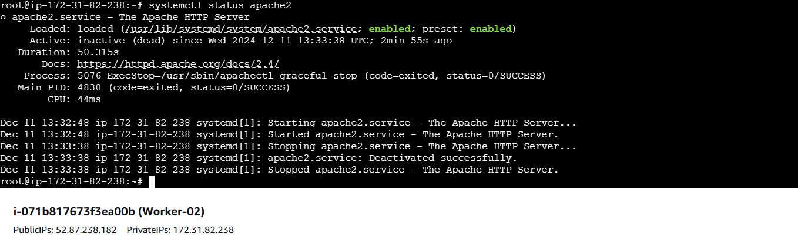

**>>To remove the specific service:**

**Ansible all -m apt -a “name=apache2 state=absent”**

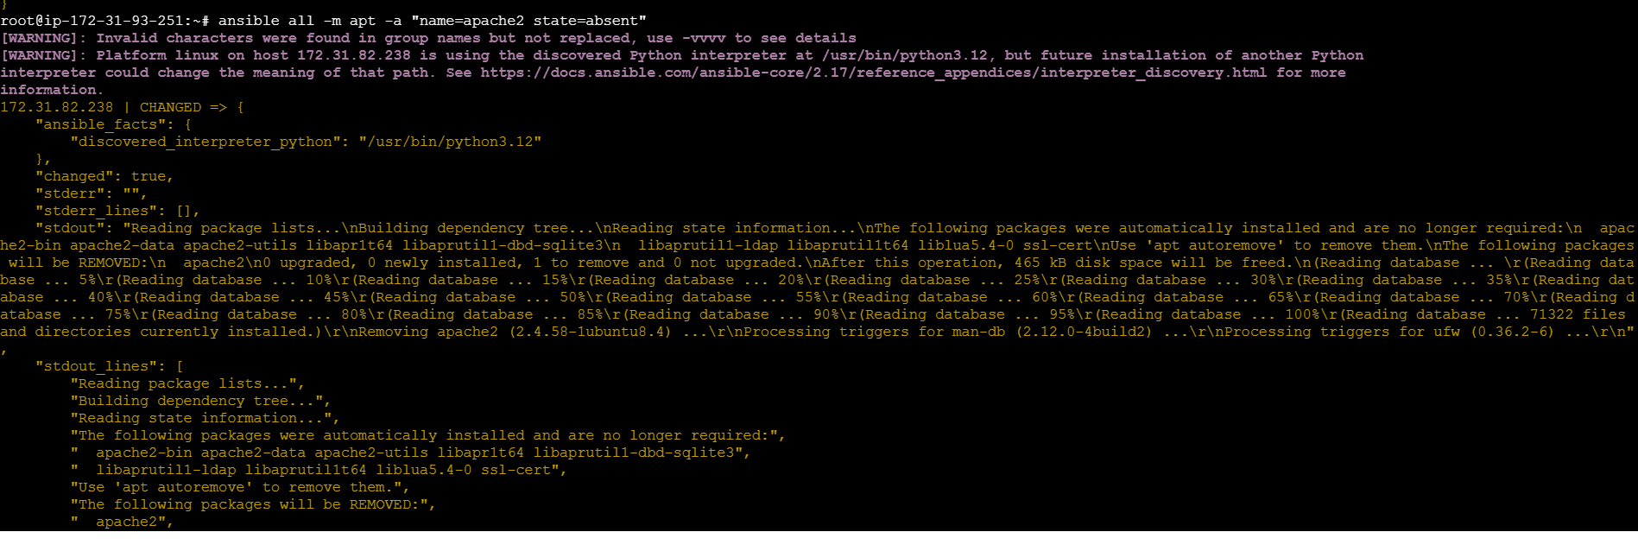

**>>To start the specific service**

**Ansible all -m service -a “name=apache2 state=started”**

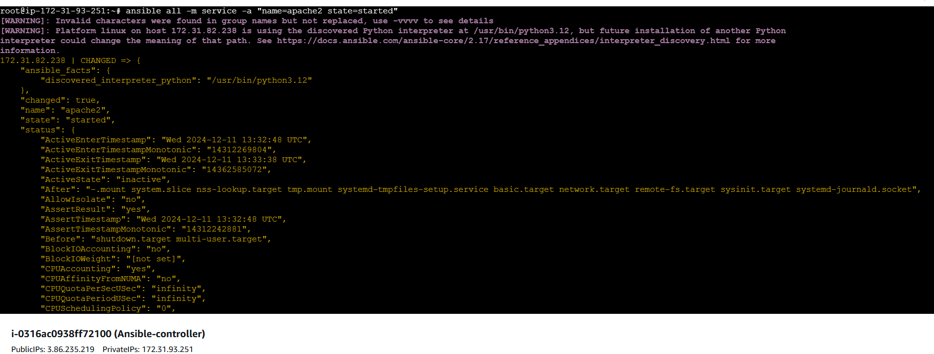

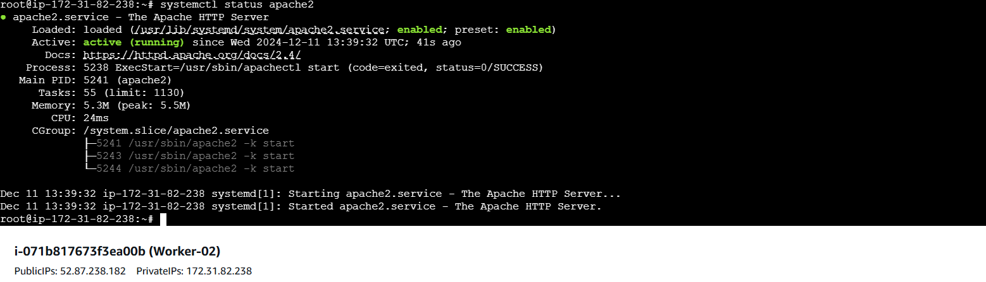

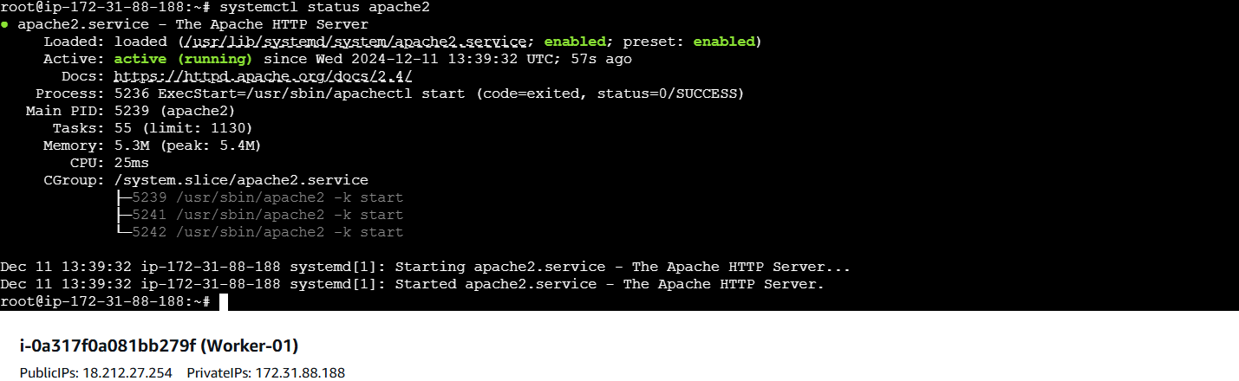

**>>Create a file with 755 permission**

**ansible all -m file -a "path=/home/asnadm/testfile state=touch mode=0755"**

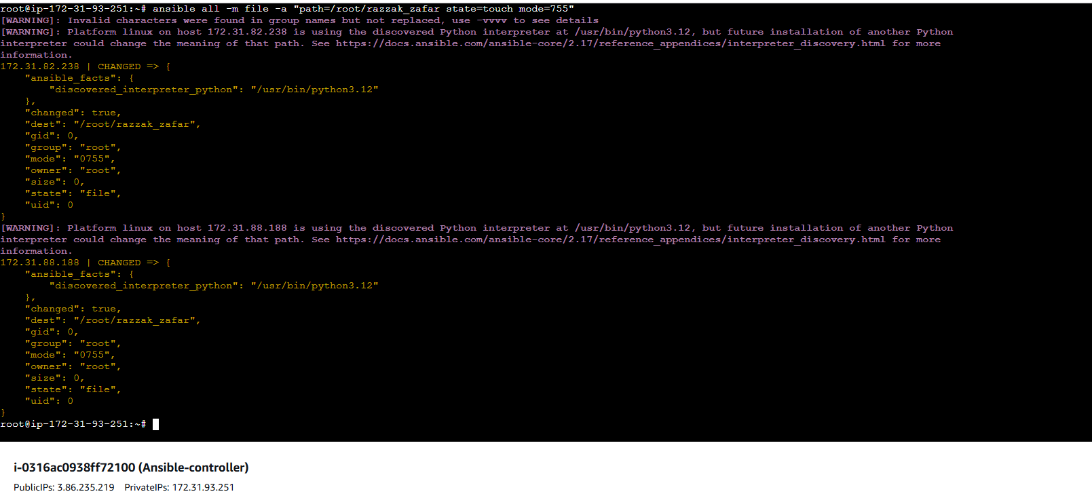

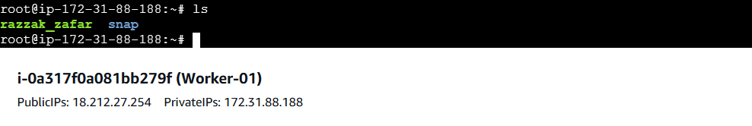

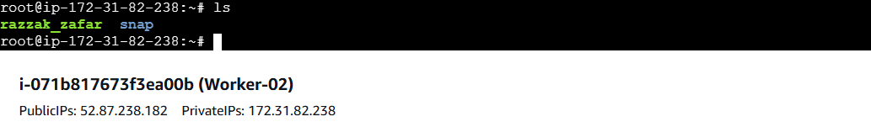

**>>Change the ownership of a file:**

**Ansible all -m file “path=/root/razzak_zafar group=ubuntu owner=ubuntu” -b**

