**Ansible-Tasks-02**

1. **Watch ansible-02 video and write down notes**

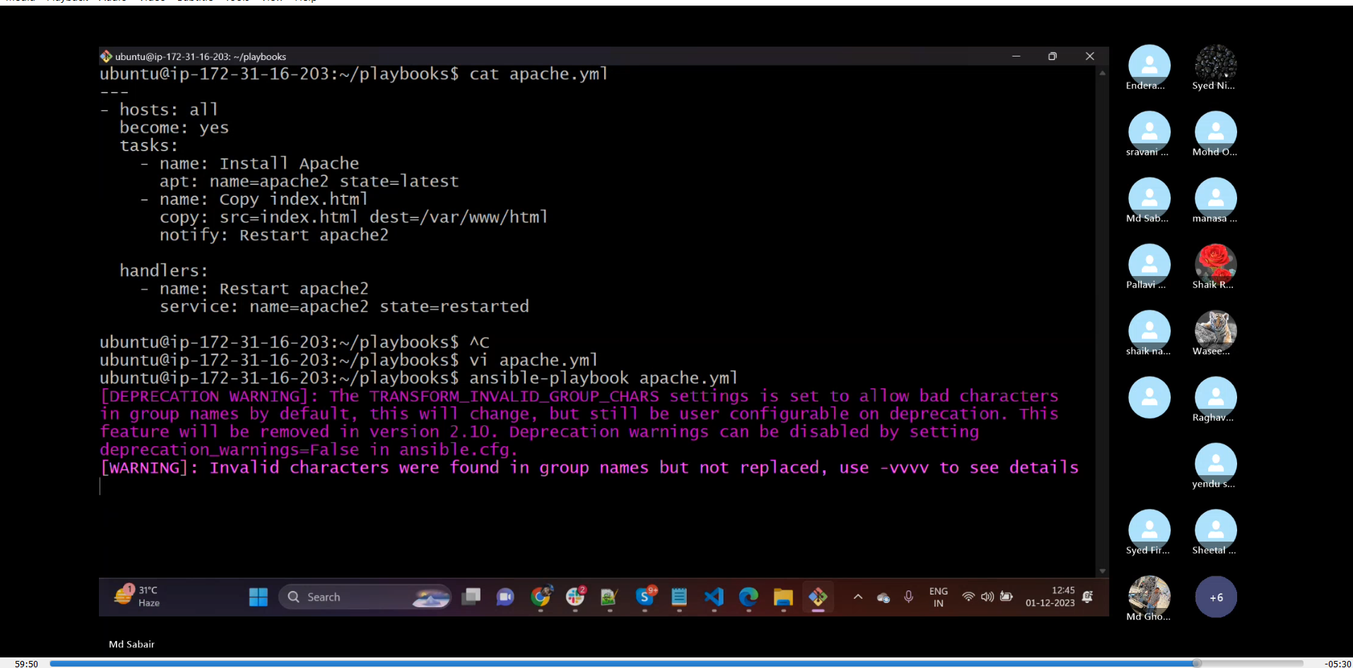

1. **Install httpd using ansible playbook, use handlers, notifiers.**

|  |
| --- |
| ---  - hosts: all  become: yes  tasks:  - name: Install Apache  apt: name=apache2 state=latest  - name: Copy index.html  copy: src=index.html dest=/var/www/html  notify: Restart apache2  handlers:  - name: Restart apache2  service: name=apache2 state=restarted |

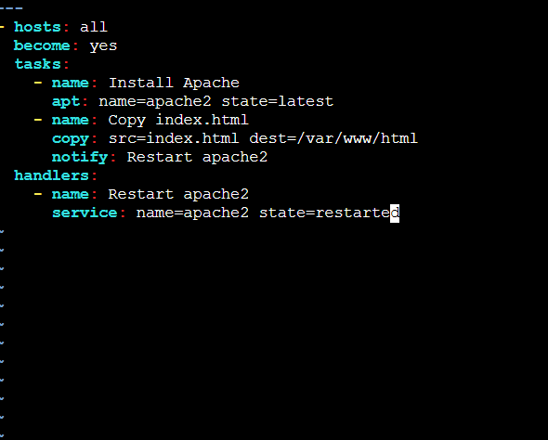

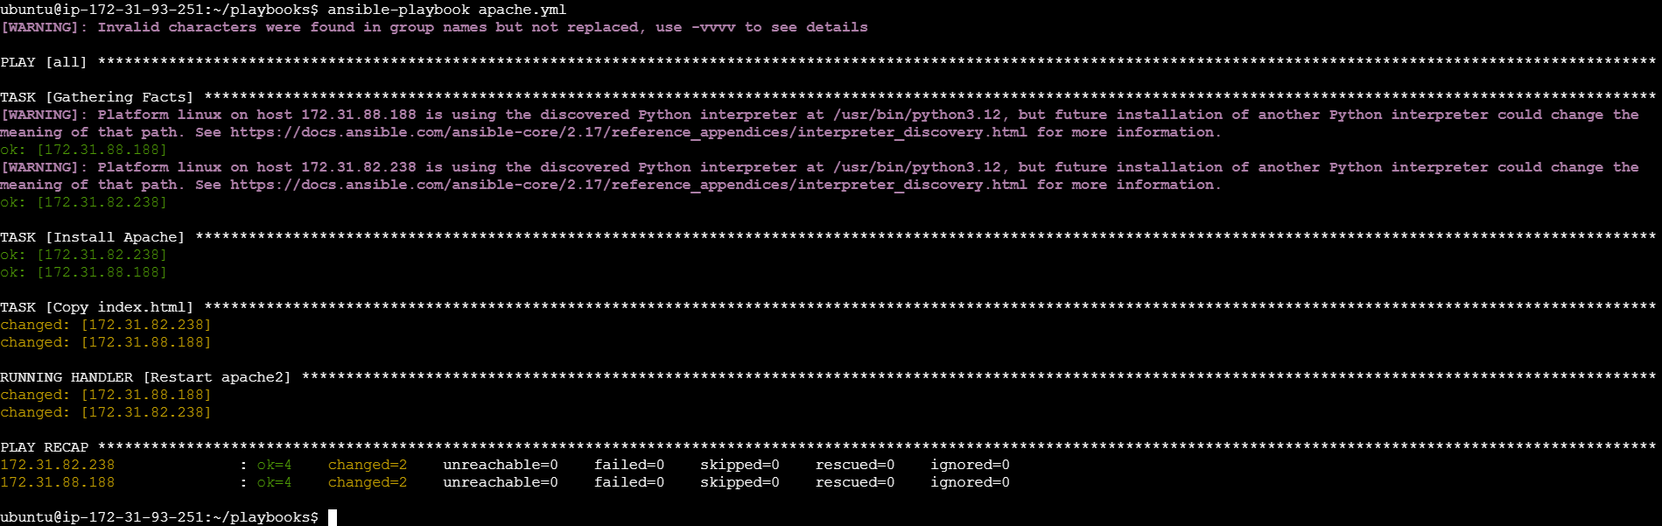

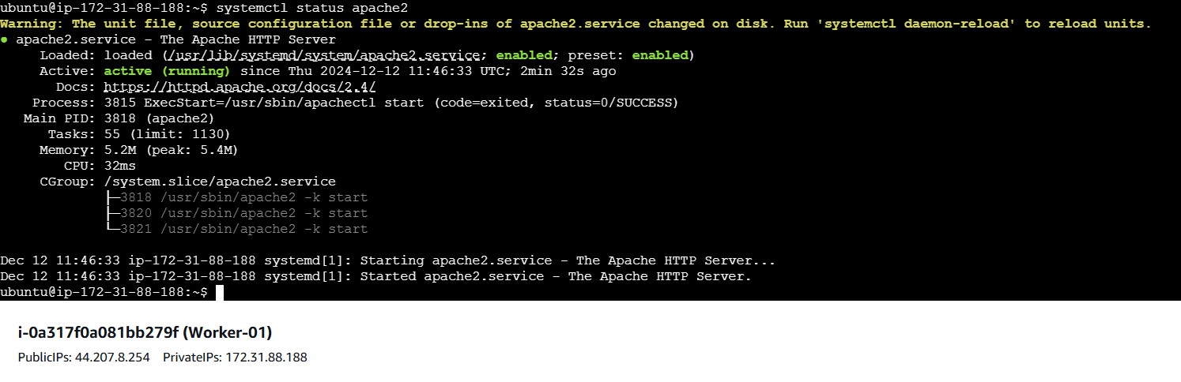

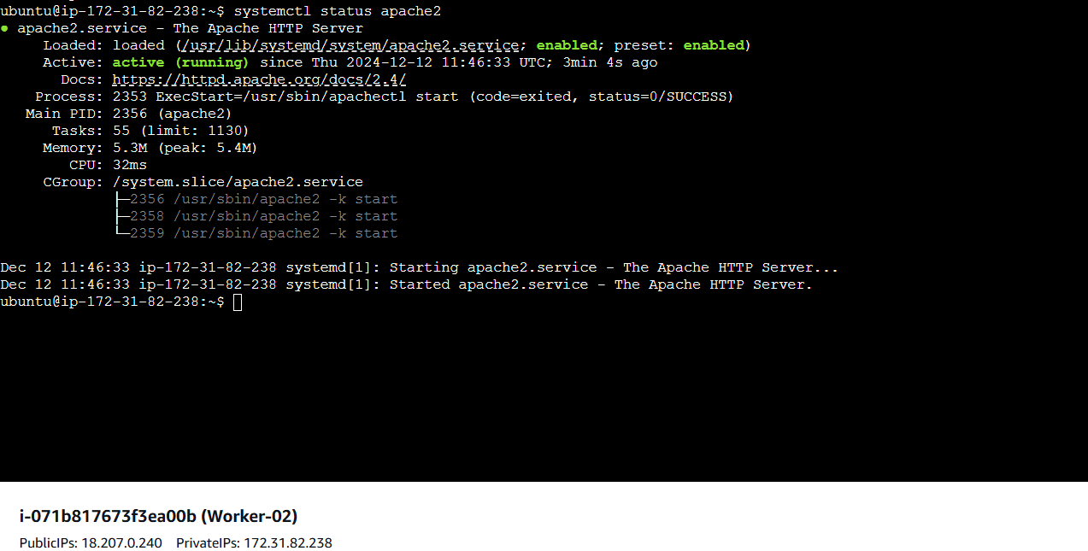

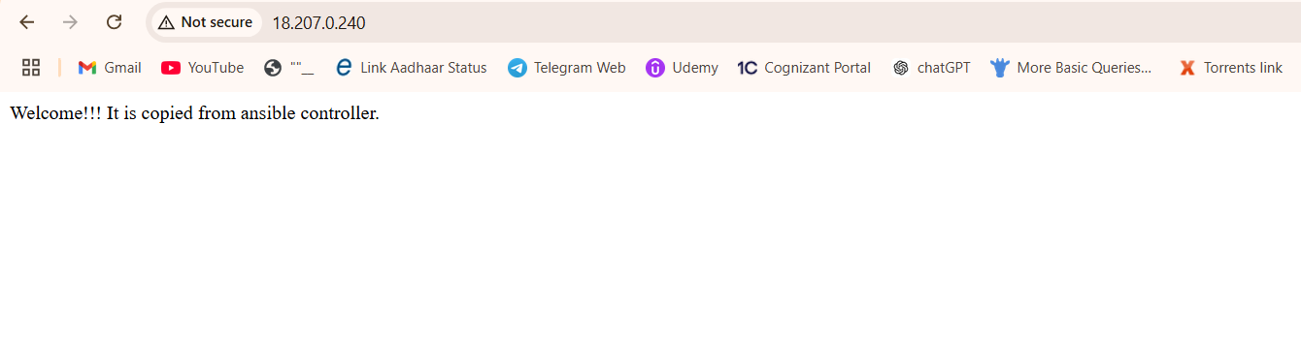

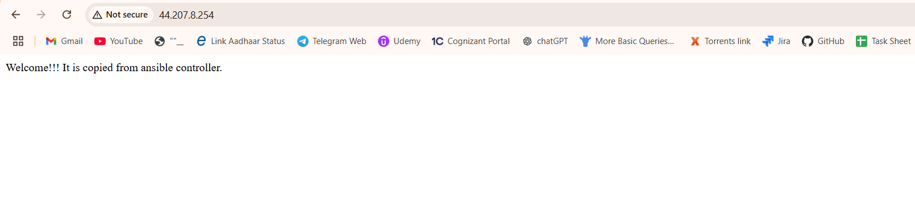

1. **Write an ansible playbook to install apache tomcat.**

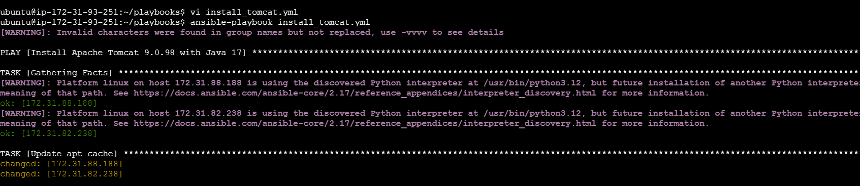

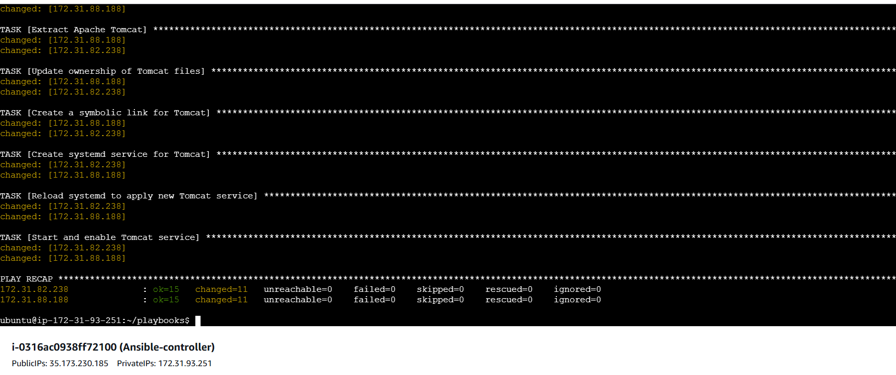

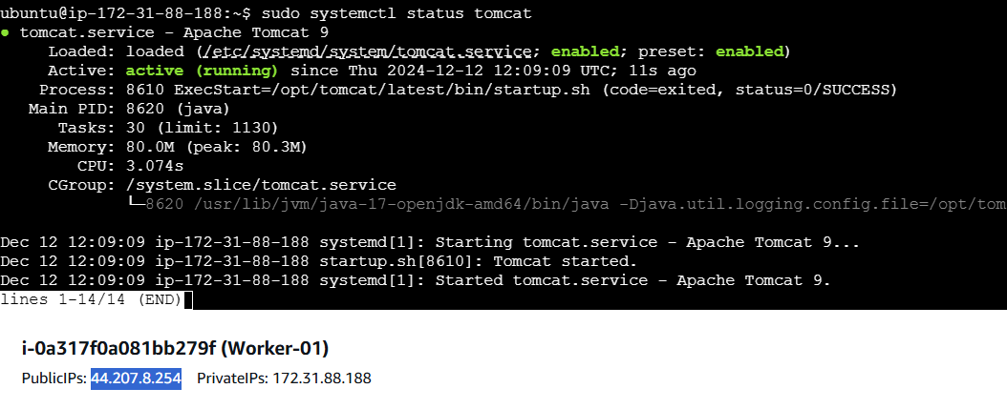

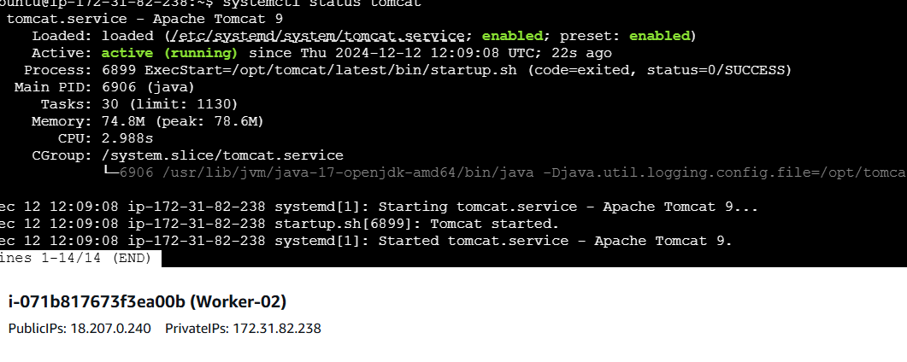

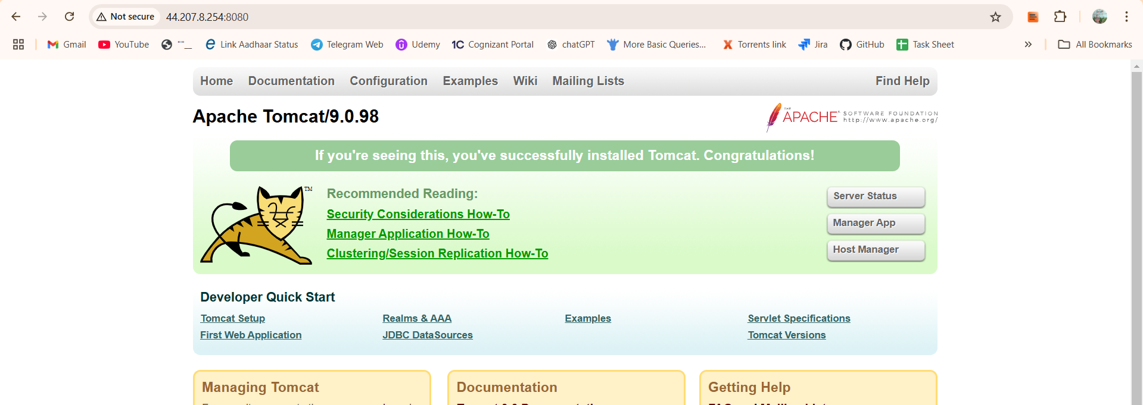

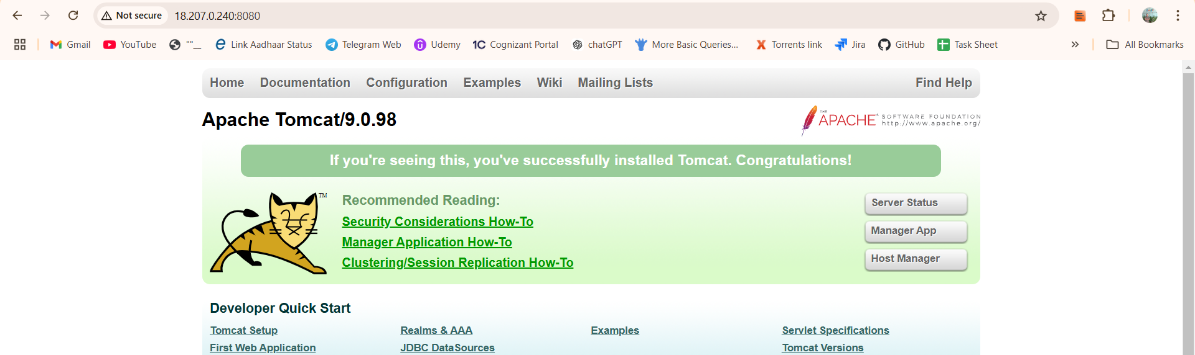

1. **Write an ansible playbook to provision one ec2 on aws**

**>> *First, we need to export access key, secret key and region as environment variables using the following commands in the controller server:***

export AWS_ACCESS_KEY_ID=your_access_key

export AWS_SECRET_ACCESS_KEY=your_secret_key

export AWS_DEFAULT_REGION=your_aws_region

**---**

**- name: Create EC2 instance**

**hosts: localhost**

**connection: local**

**gather_facts: no**

**vars:**

**instance_type: t2.micro**

**ami: ami-0e2c8caa4b6378d8c**

**region: us-east-1**

**key_name: ansible**

**security_group: default**

**tag_name: my-ec2**

**tasks:**

**- name: Launch EC2 Instance**

**community.aws.ec2_instance:**

**key_name: "{{ key_name }}"**

**instance_type: "{{ instance_type }}"**

**image_id: "{{ ami }}"**

**region: "{{ region }}"**

**security_group: "{{ security_group }}"**

**tags:**

**Name: "{{ tag_name }}"**

**wait: yes**

**user_data: ""**

**register: ec2**

**- name: Debug EC2 instance information**

**debug:**

**var: ec2**

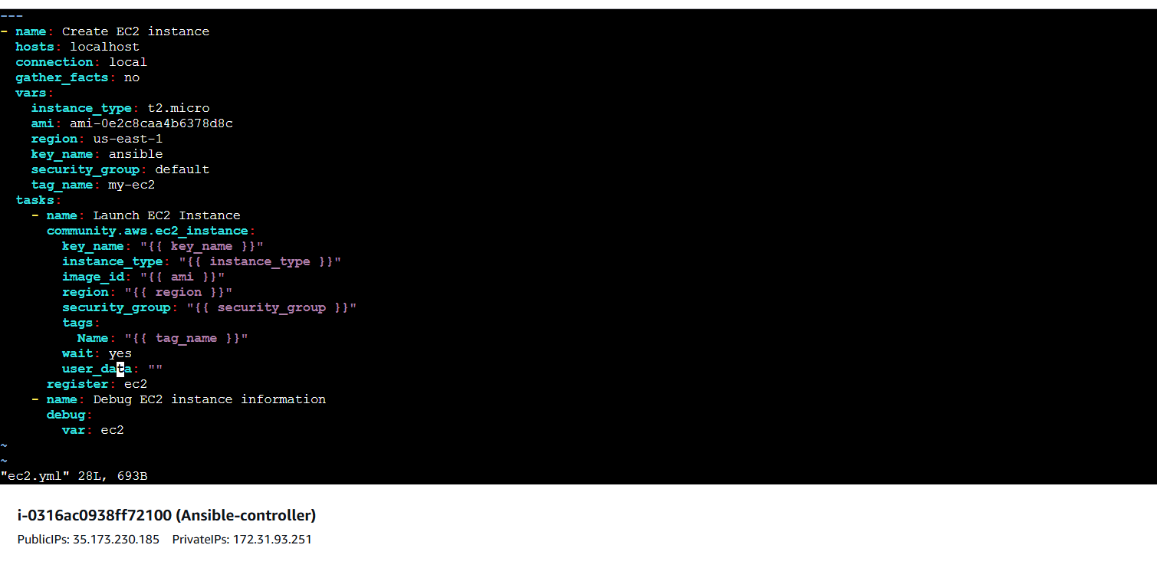

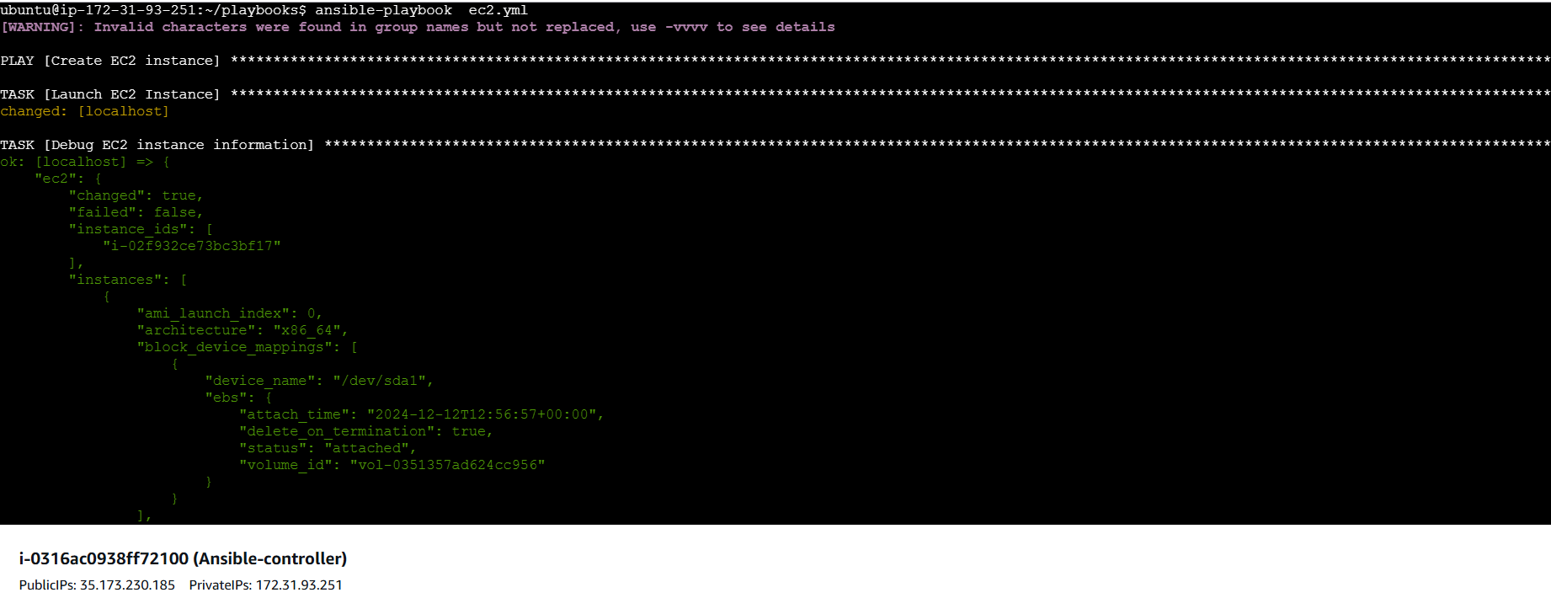

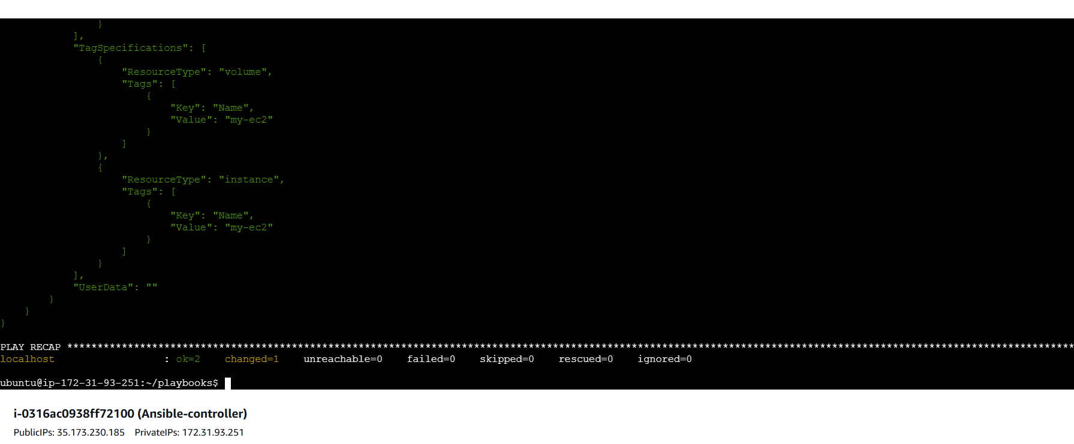

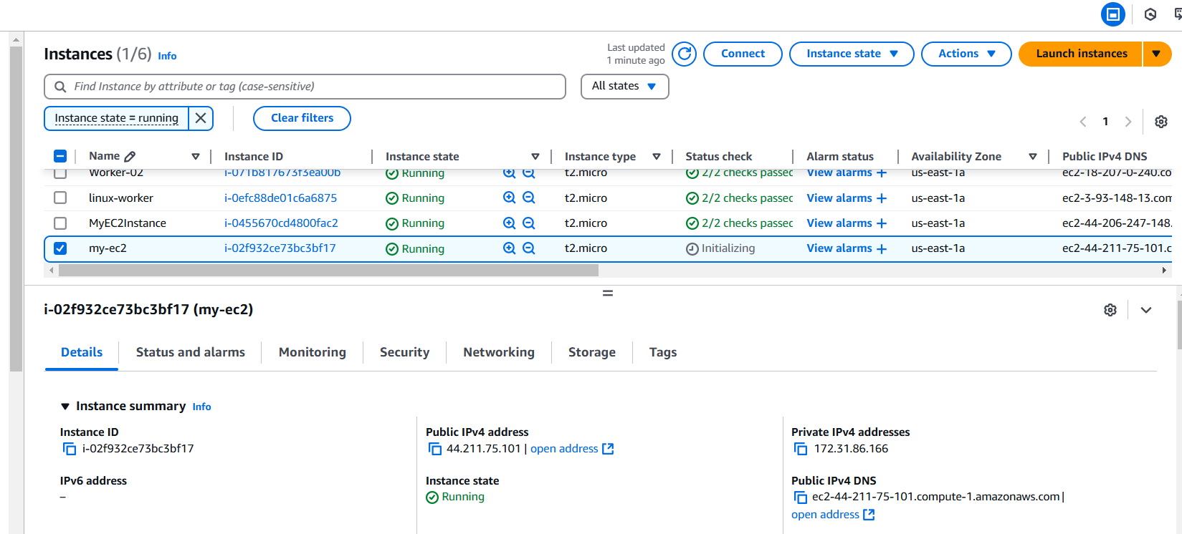

1. **Write a ansible playbook to copy one file from node-1 to node-2.**

|  |
| --- |
| ---  - name: Copy file.txt from worker-01 to worker-02  hosts: localhost  gather_facts: no  vars:  source_node: worker-01  destination_node: worker-02  source_file: /root/file.txt # Full path to the file on worker-01  destination_file: /root/file.txt # Destination path on worker-02  tasks:  - name: Fetch the file from worker-01  ansible.builtin.fetch:  src: "{{ source_file }}"  dest: /tmp/file.txt  flat: yes  delegate_to: "{{ source_node }}"  - name: Copy the file to worker-02  ansible.builtin.copy:  src: /tmp/file.txt  dest: "{{ destination_file }}"  delegate_to: "{{ destination_node }}" |

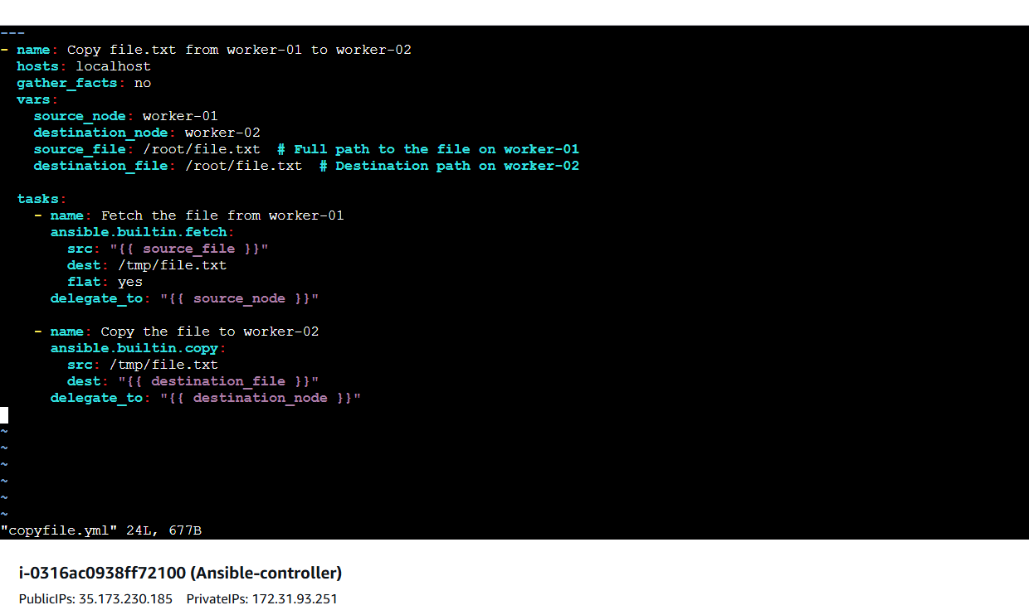

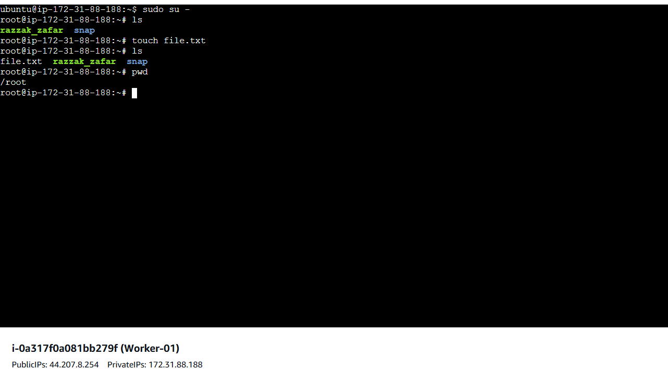

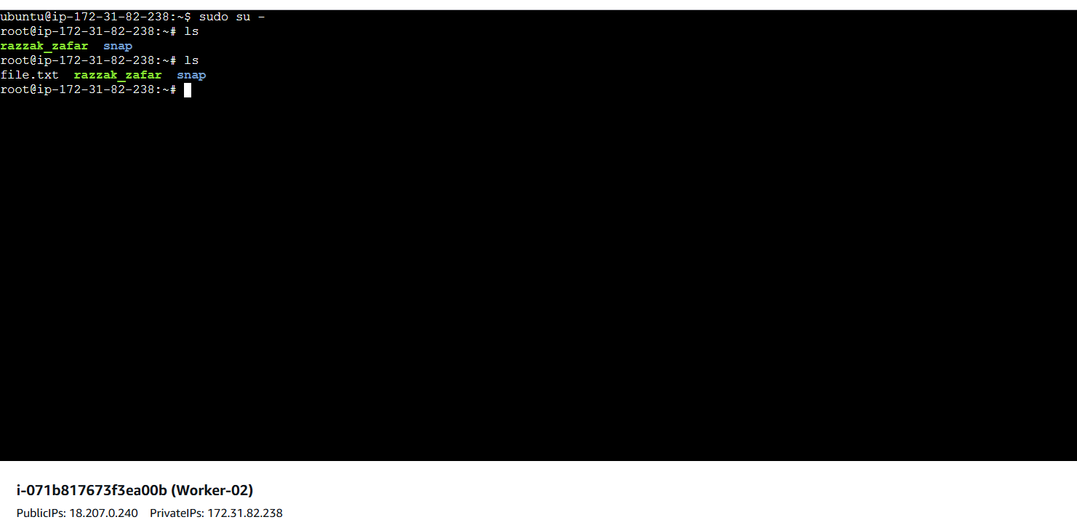

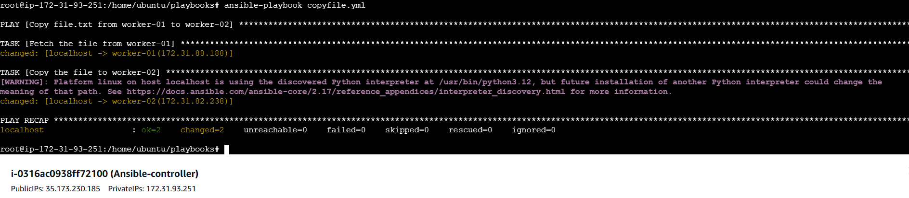

1. **Write a ansible playbook to create different files with different names using single playbook.**

**---**

**- name: Create Files**

**hosts: all**

**gather_facts: false**

**tasks:**

**- name: Create files**

**file:**

**path: "{{ item }}"**

**state: touch**

**with_items:**

**- /root/development.txt**

**- /root/staging.txt**

**- /root/production.txt**

**- /root/integrate.txt**

