**Ansible-Tasks-03**

1. **Write a single ansible playbook which will install apache and nginx. Note: Playbook should not be hardcoded and pass the variables from different file**

**>> Playbook:**

|  |
| --- |
| ---  - name: Install and run specific services on workers  hosts: all  become: yes  vars_files:  - vars1.yml  tasks:  - name: Install Apache2 on worker-01  apt:  name: "{{ service1 }}"  state: present  update_cache: yes  when: "'worker-01' in group_names"  - name: Install Nginx on worker-02  apt:  name: "{{ service2 }}"  state: present  update_cache: yes  when: "'worker-02' in group_names"  - name: Ensure Apache2 is running on worker-01  service:  name: "{{ service1 }}"  state: started  enabled: yes  when: "'worker-01' in group_names"  - name: Ensure Nginx is running on worker-02  service:  name: "{{ service2 }}"  state: started  enabled: yes  when: "'worker-02' in group_names" |

**>> Variable file:**

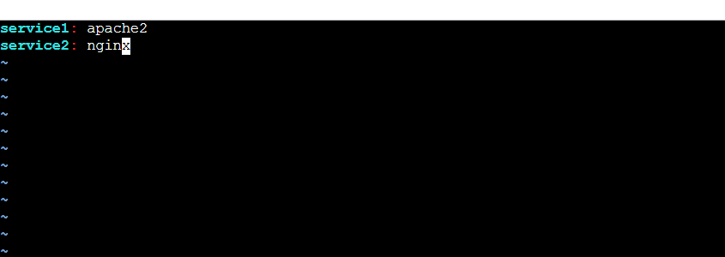

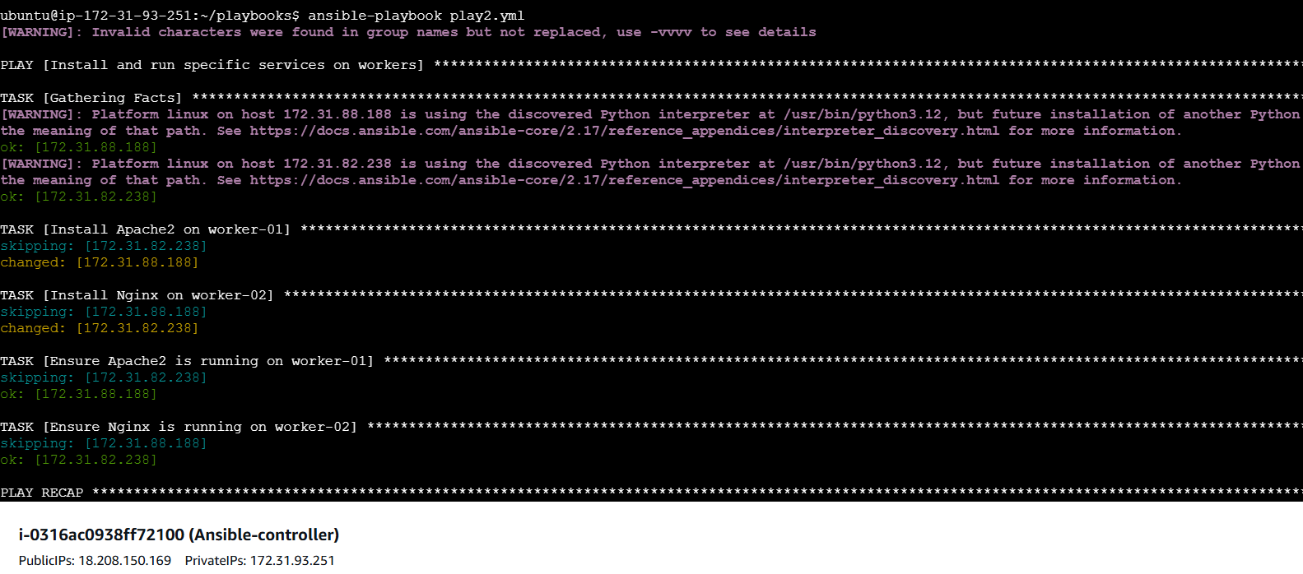

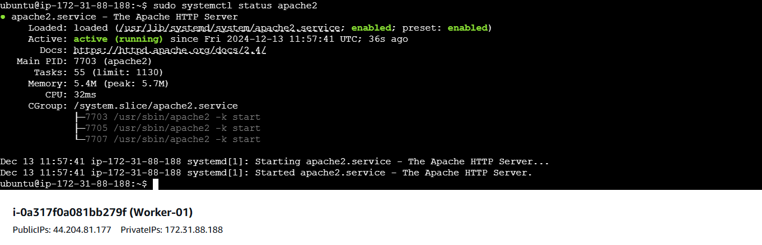

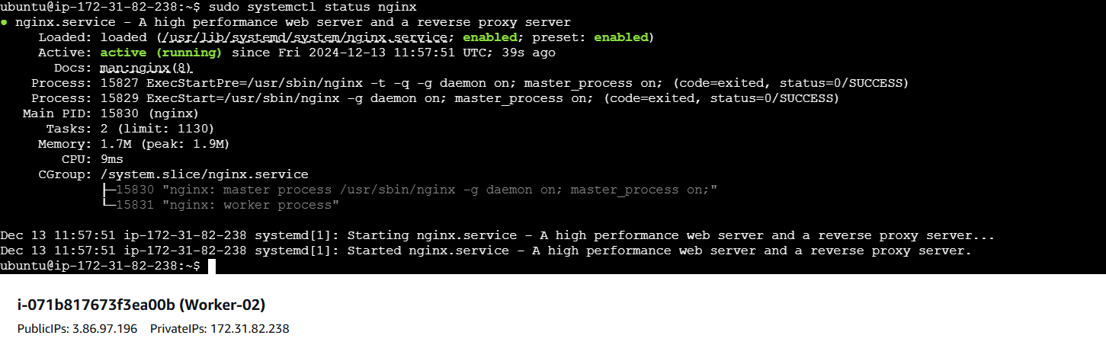

**2) Ansible playbook to create 10 different directories with minimal code and directory names should be passed as variables.**

**>> Playbook:**

|  |
| --- |
| # create_directories.yml  ---  - name: Create multiple directories  hosts: all  become: yes # If needed to create directories as root  vars_files:  - varsd.yml # Load the variables from the varsd.yml file  tasks:  - name: Create directories  file:  path: "{{ item }}"  state: directory  mode: '0755'  loop: "{{ directories }}" |

**>> Variable file:**

|  |
| --- |
| # vars.yml  directories:  - /home/ubuntu/dir1  - /home/ubuntu/dir2  - /home/ubuntu/dir3  - /home/ubuntu/dir4  - /home/ubuntu/dir5  - /home/ubuntu/dir6  - /home/ubuntu/dir7  - /home/ubuntu/dir8  - /home/ubuntu/dir9  - /home/ubuntu/dir10 |

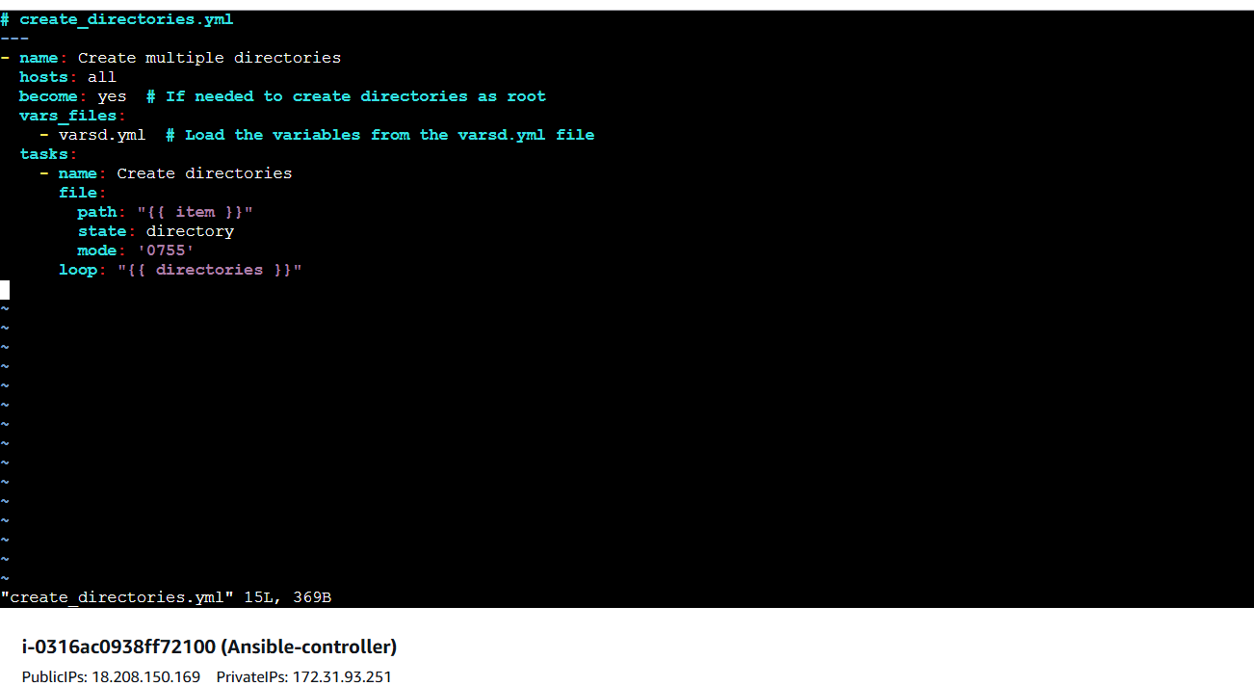

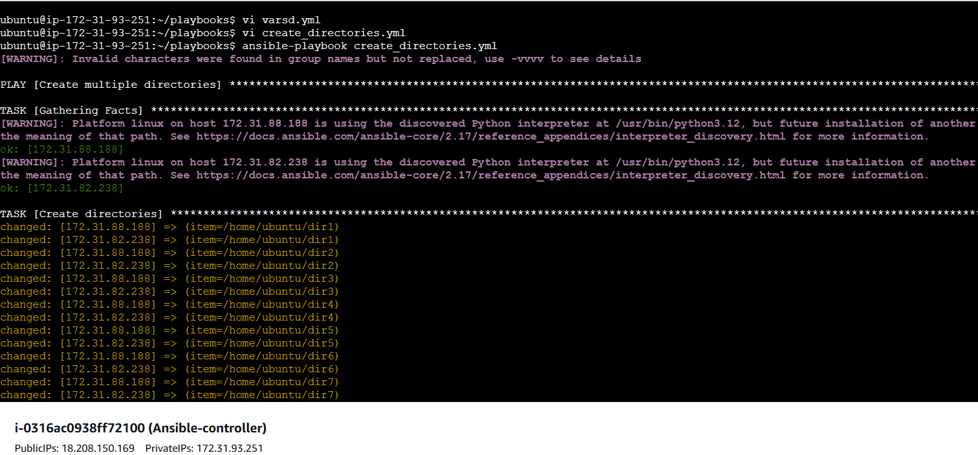

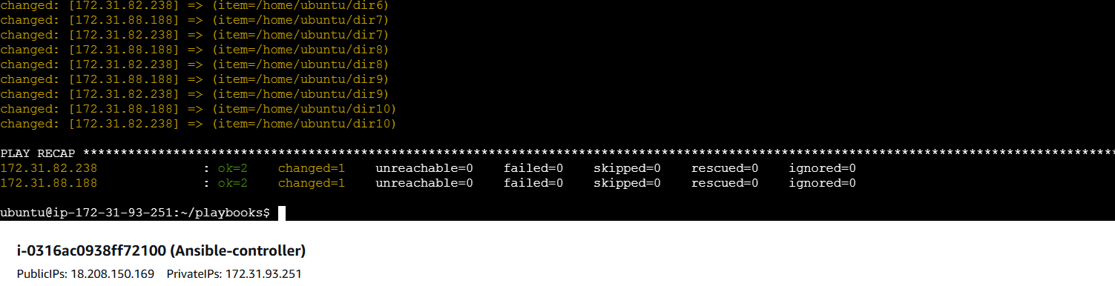

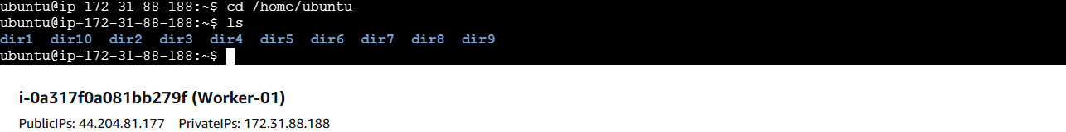

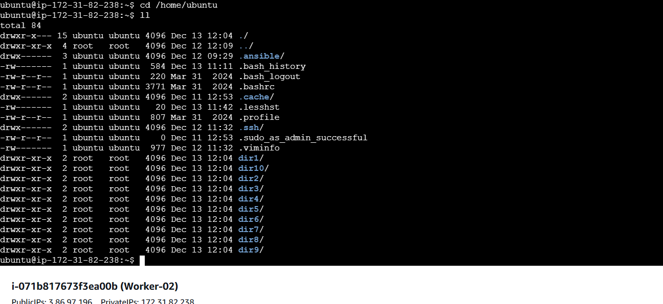

**4) Ansible playbook to inject ansible vault variables.**

* **Create a secrets.yml file and pass secret text in it then encrypt it. Using the command:**

**>>ansible-vault encrypt secrets.yml**

* **Write a playbook call secrets.yml as variable file in the script:**

**>>** **vars_files:**

**- secrets.yml # The encrypted Vault file**

* **Run the playbook using the command:**

**>>ansible-playbook inject_vault_variables --ask-vault-pass**

|  |
| --- |
| ---  - name: Inject Vault variables  hosts: all  become: yes  vars_files:  - secrets.yml # The encrypted Vault file  tasks:  - name: Show DB password  debug:  msg: "The DB password is {{ db_password }}"  - name: Show API key  debug:  msg: "The API key is {{ api_key }}" |

