**Challenge-1:**

*--Create on file with name Techie_horizon.  
--Copy the file "Techie_Horizon" from aws instance to windows machine.  
--Install Jenkins in the server created in step 1.  
--Install httpd,nginx,Apache Tomcat.*

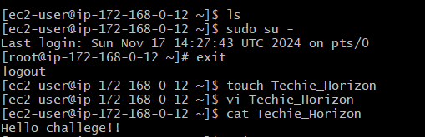

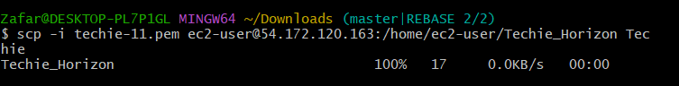

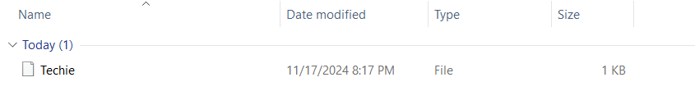

Install Jenkins:

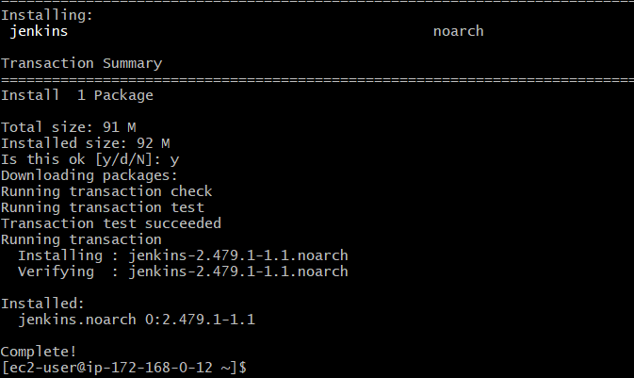

**Install Tomcat**:

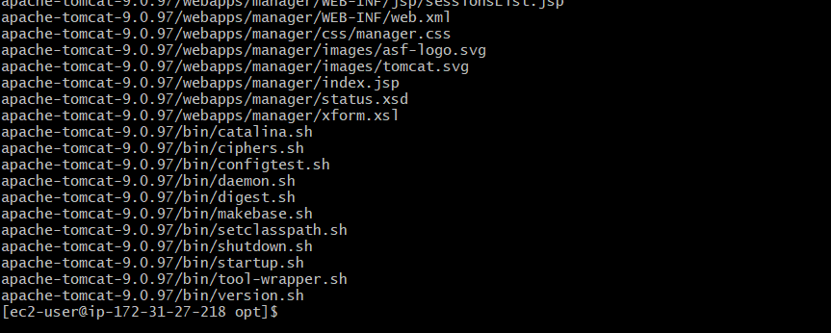

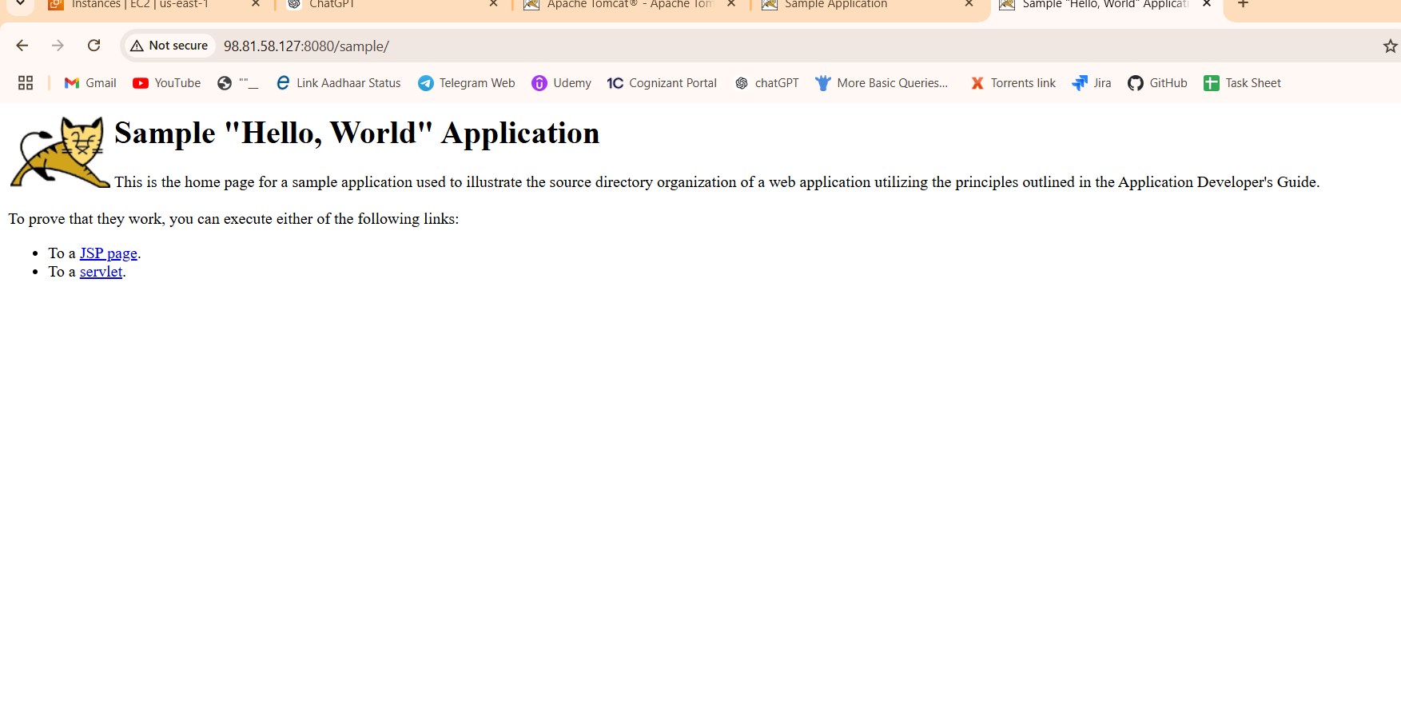

**Installing nginx**:

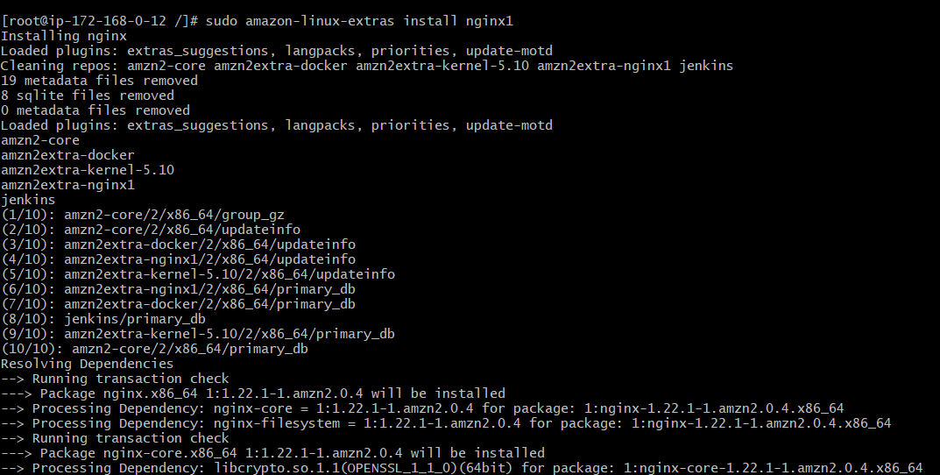

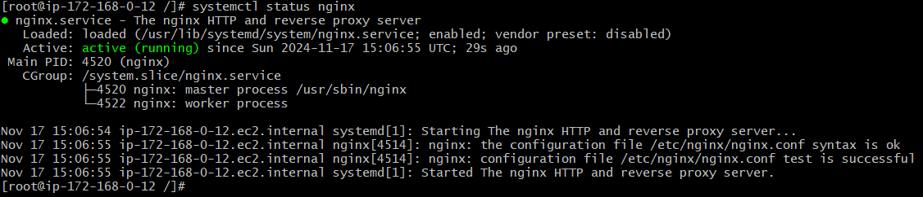

**Install apache httpd:**

