**Docker Tasks-1:**

**1) Setup a virtual machine using Ubuntu image.**

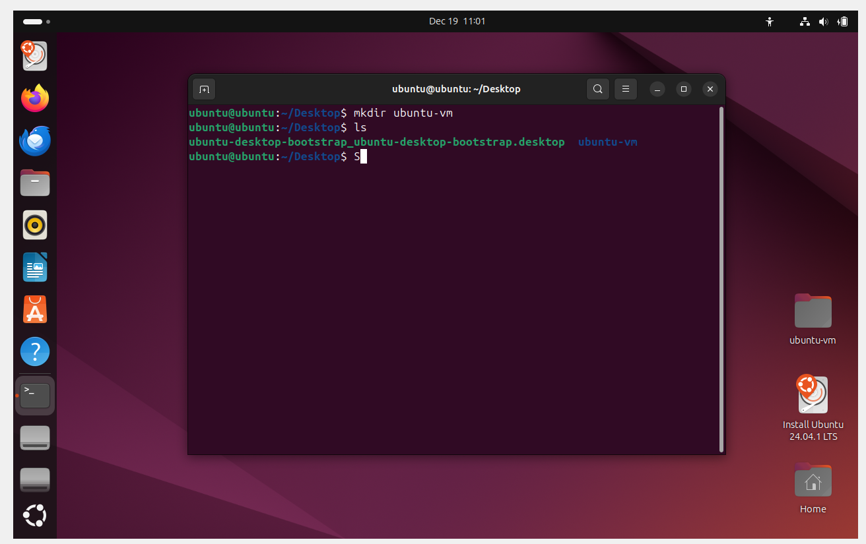

**2) Install docker on ec2.**

|  |
| --- |
| yum -y install docker  systemctl start docker  systemctl enable docker  systemctl status docker |

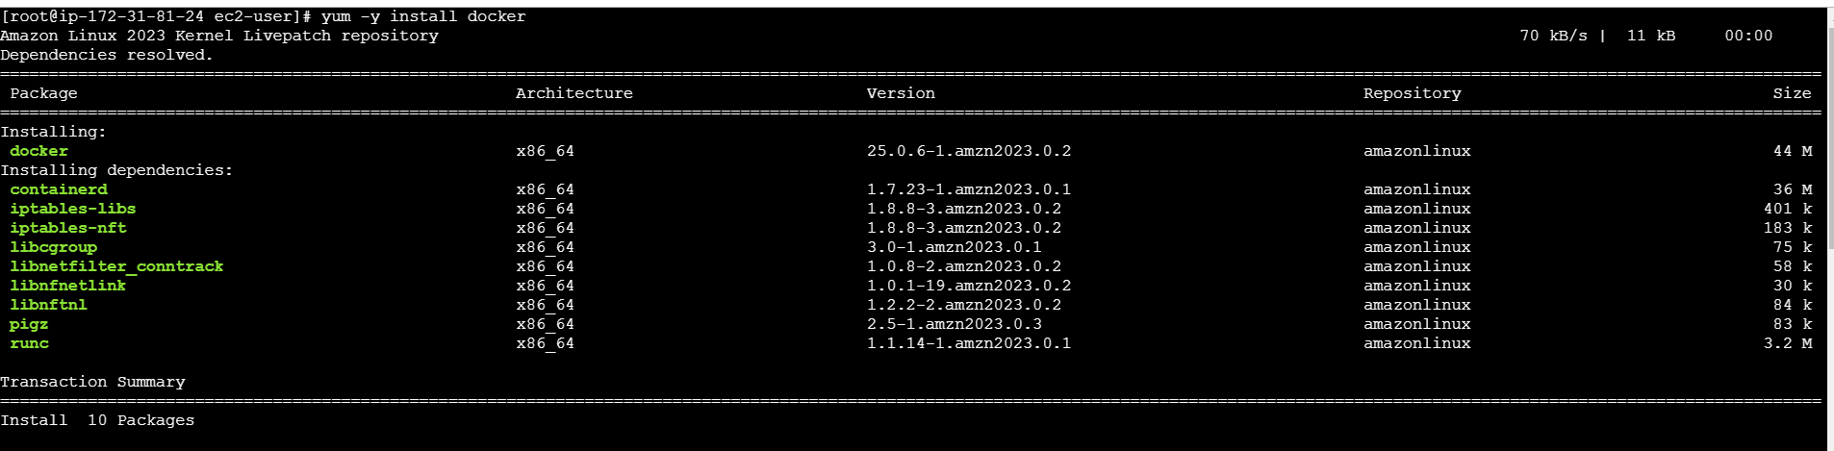

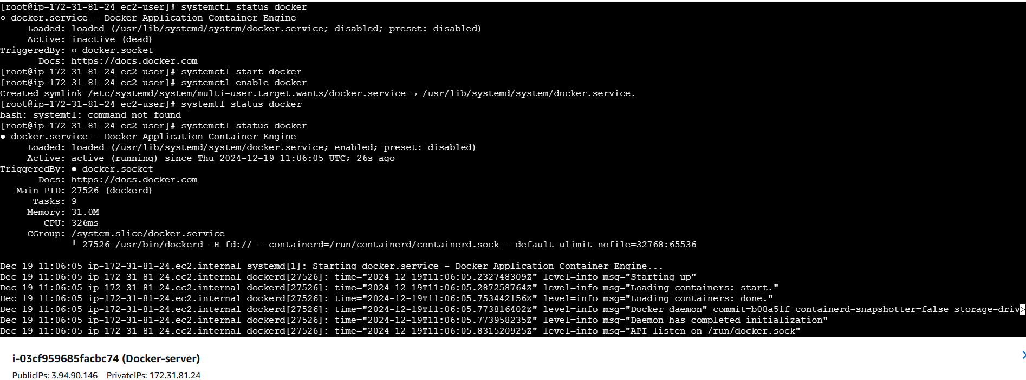

**3) Pull 5 docker images (nginx, apache tomcat, ubuntu, jenkins, sonarqube)**

* **docker pull nginx**

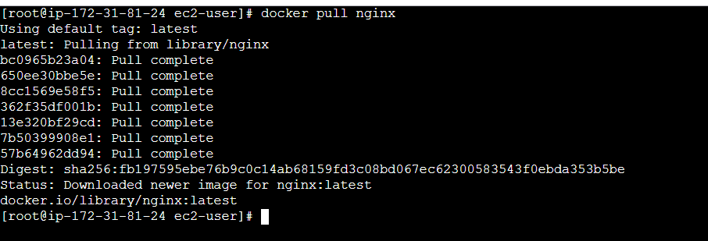

* **docker pull httpd**

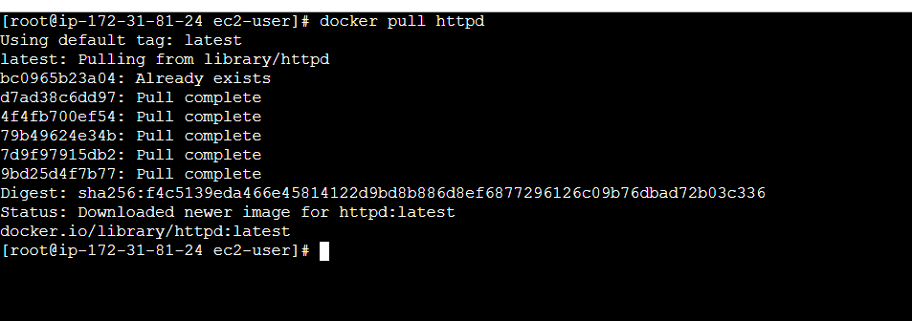

* **docker pull tomcat**

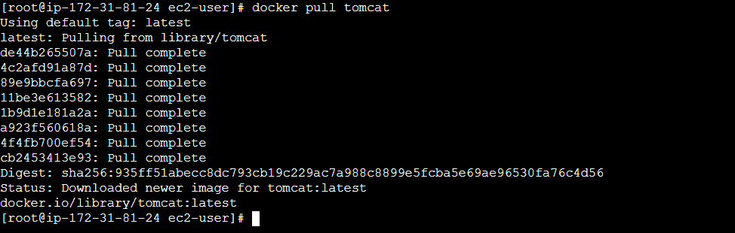

* **docker pull ubuntu**

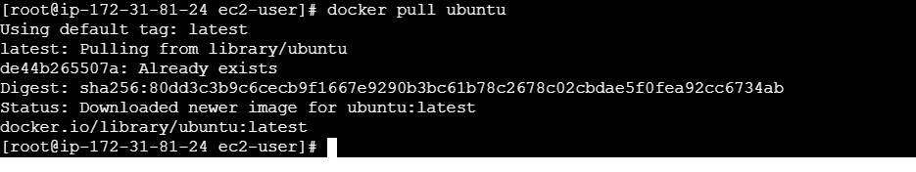

* **docker pull jenkins/jenkins:jdk17**

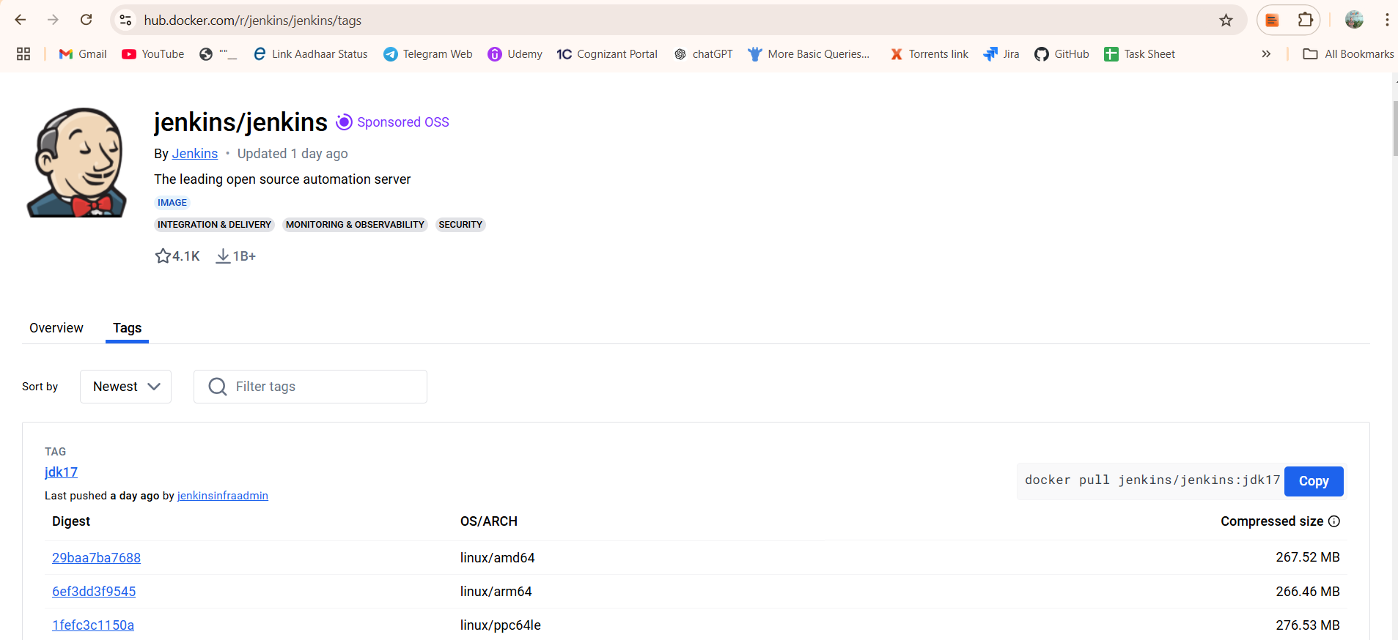

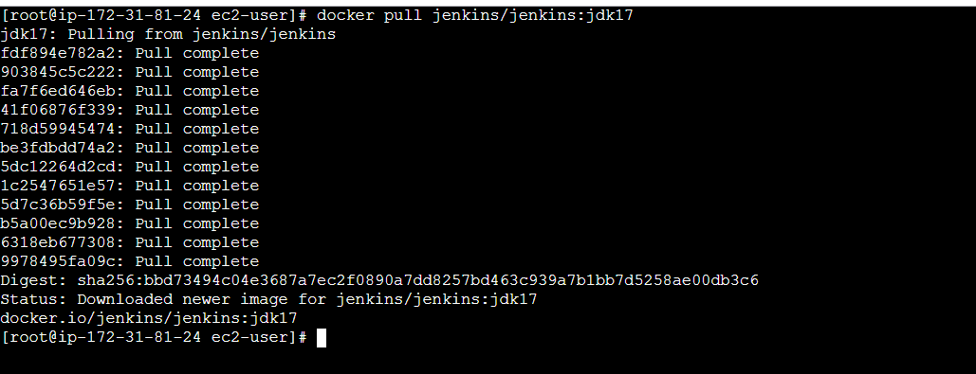

* **docker pull sonarqube**

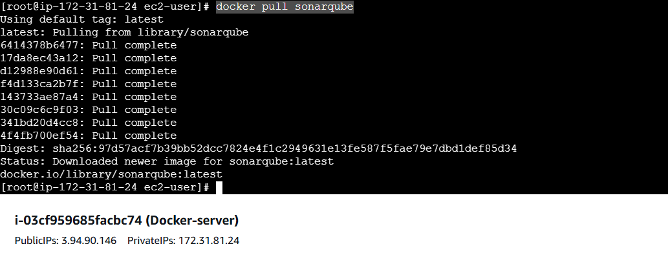

**>>> To check all the images available.**

* **docker images**

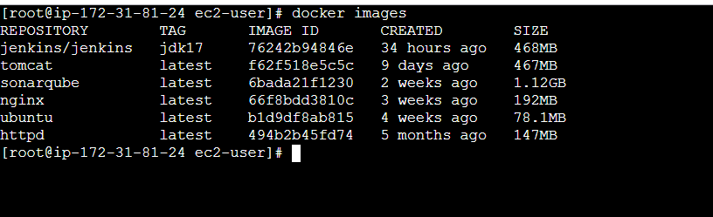

**4) Run nginx container and expose on port 81.**

* docker container run -itd -p 81:80 --name nginx

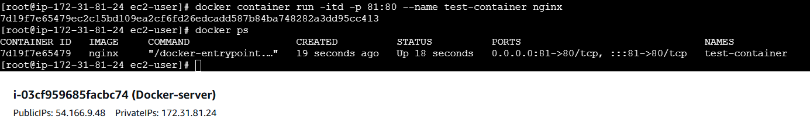

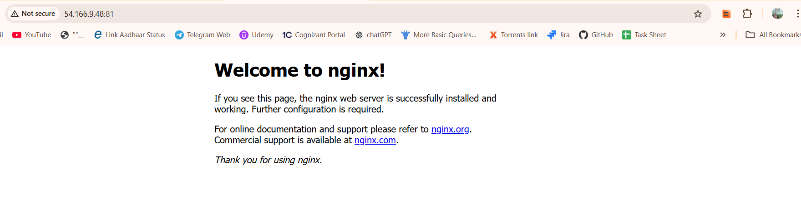

**5) Delete the apache tomcat image from local.**

* docker image rmi f62f518e5c5c

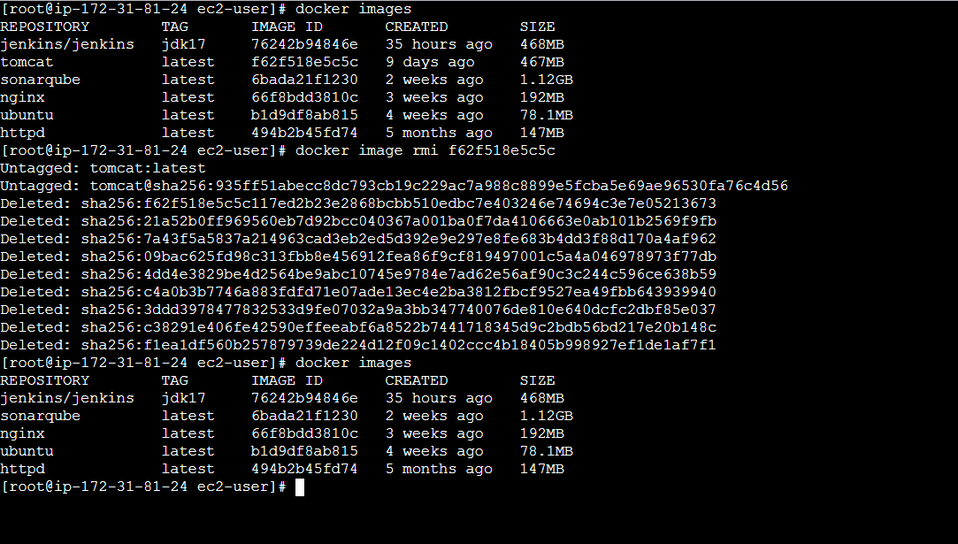

**6) Inspect the jenkins image,sonarqube image.**

* Docker inspect <image Id of jenkins>

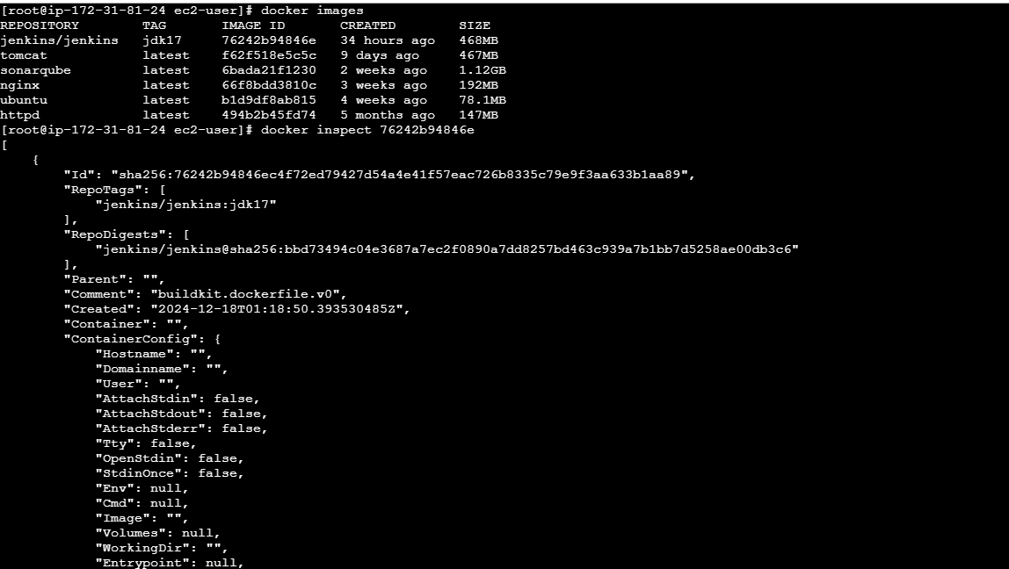

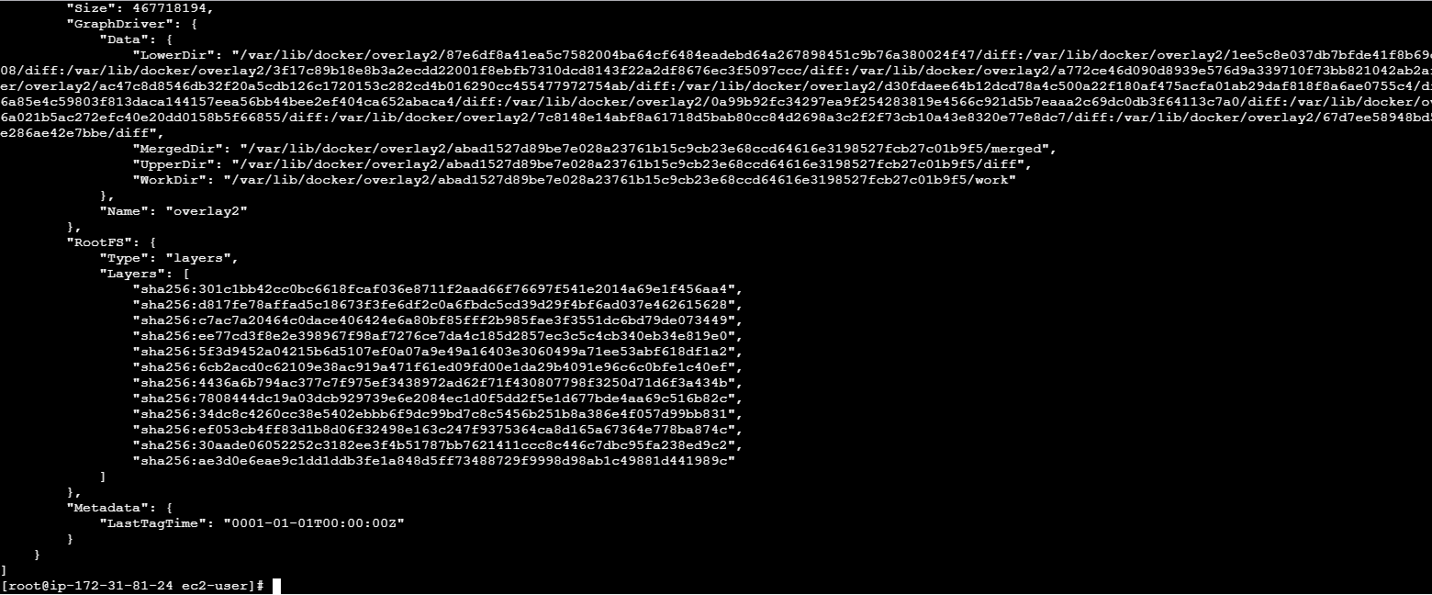

* Docker inspect <image Id of sonarqube>

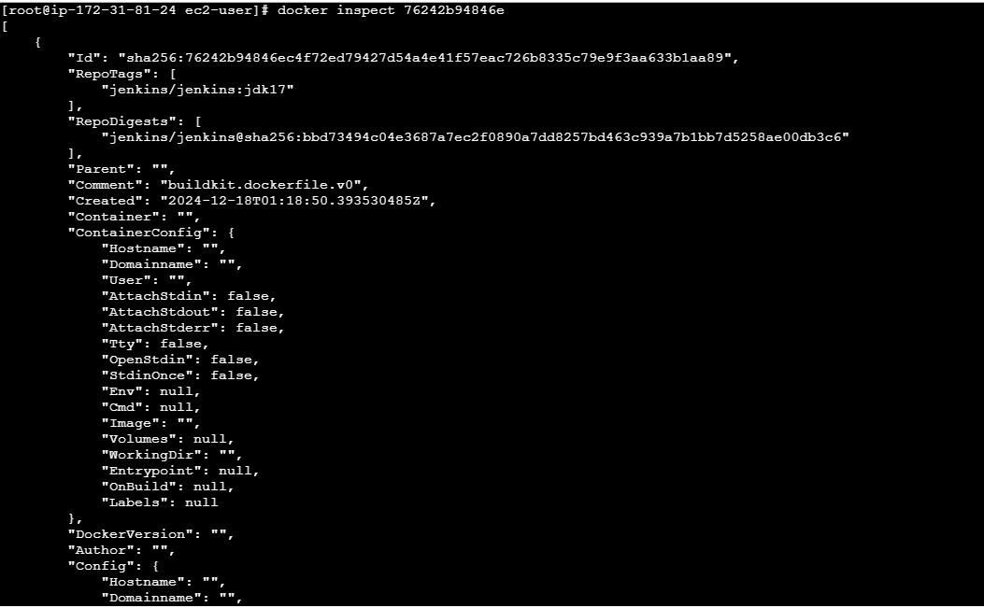

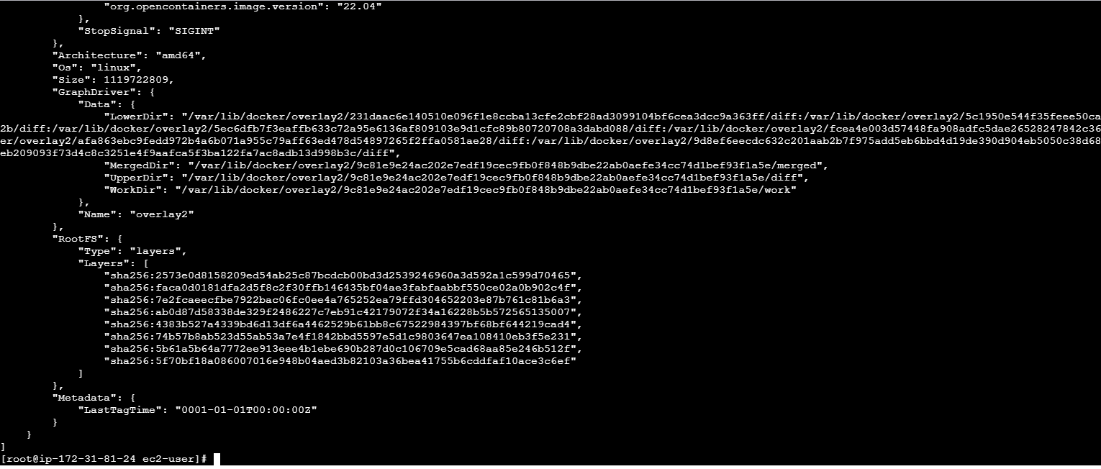

**7) Run jenkins container and run one sample job.**

* docker container run -itd -p 8082:8080 76242b94846e
* docker ps



**>> To find Jenkins password:**

* find / -name initialAdminPassword
* cat <the/path/to/password>

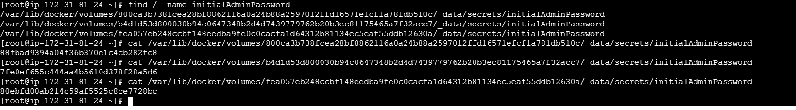

>>Login into Jenkins and build the sample job:

