**Docker Tasks-2**

**1)Create a tomcat container on 8080 and deploy sample application in tomcat.**

>>docker pull tomcat:latest

>>docker run -itd -p 8080:8080 tomcat

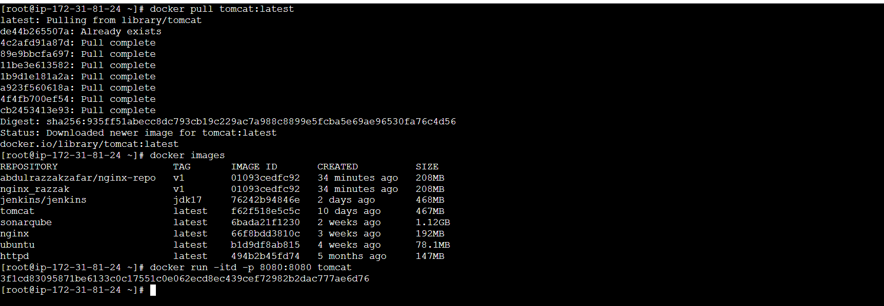

>>docker exec -it 3f1cd /bin/bash

>>cd webapps

>>wget https://tomcat.apache.org/tomcat-6.0-doc/appdev/sample/sample.war

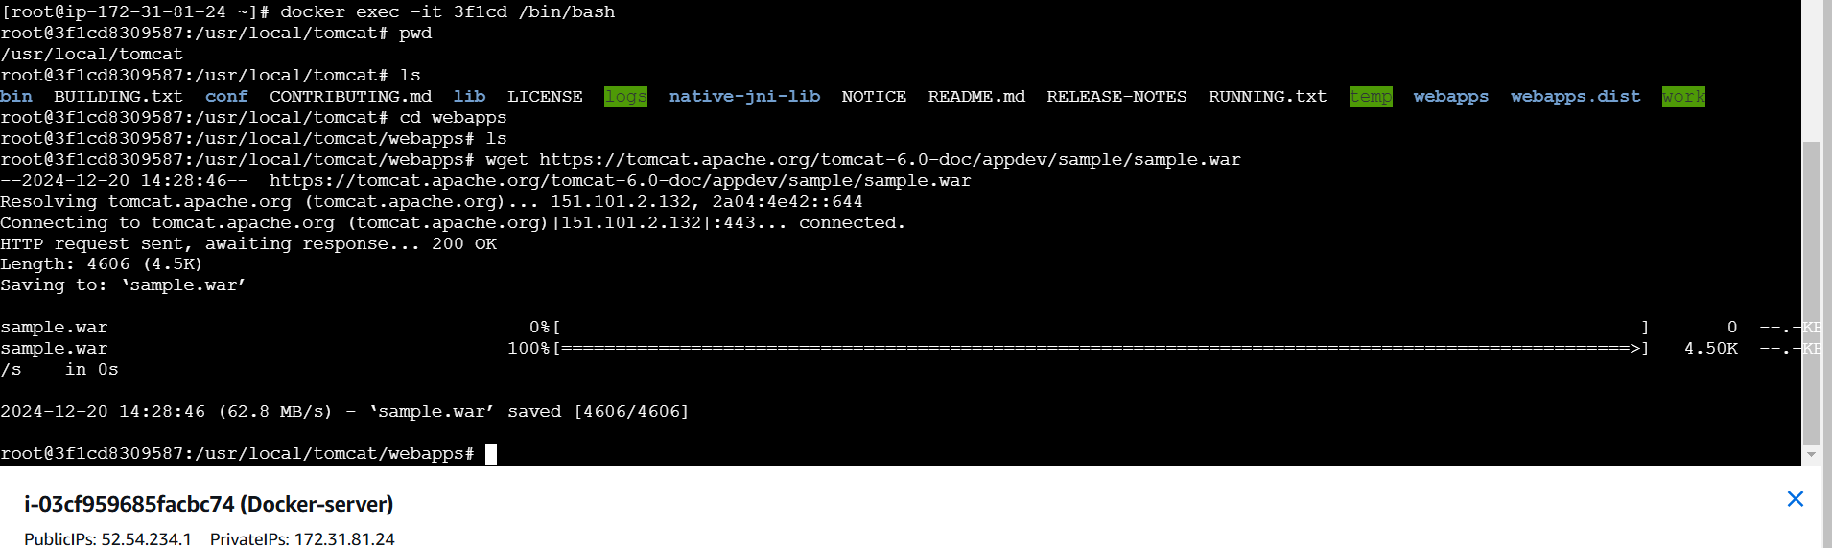

**Go to the browser paste** http://52.54.234.1:8080/**sample**/

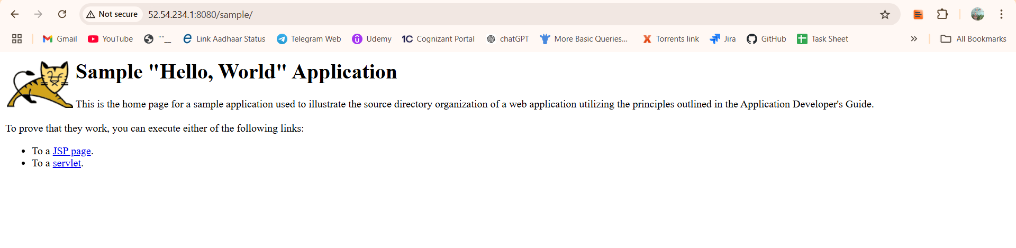

**2) Create volume and deploy tomcat container on port 8081.**

**>>**docker volume create deployment

>>cd /var/lib/docker/volumes

>>cd deployment

>>cd _data

>>wget https://tomcat.apache.org/tomcat-6.0-doc/appdev/sample/sample.war

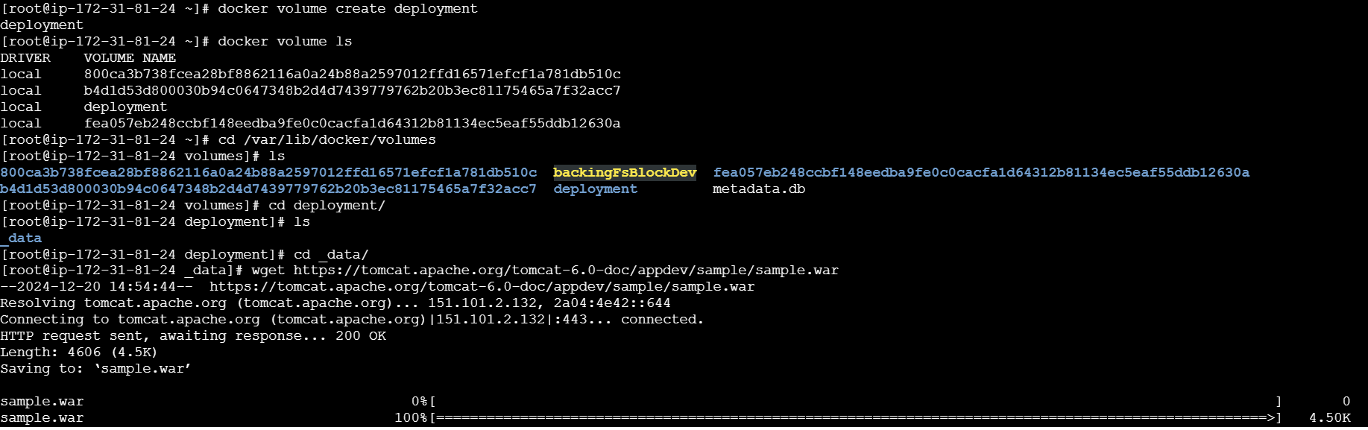

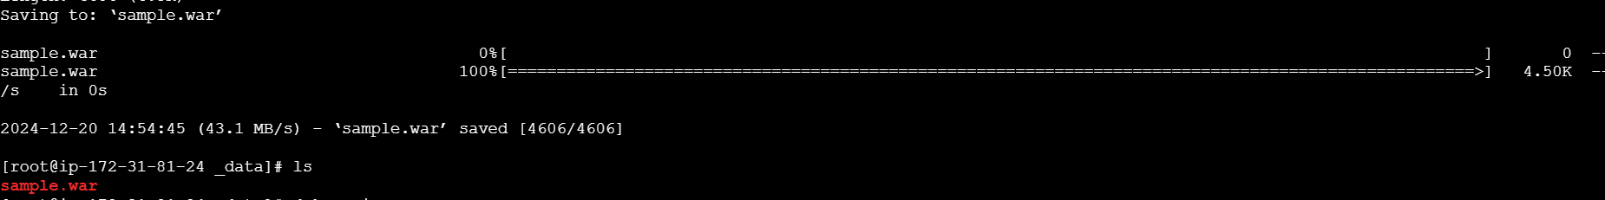

**>>docker run -itd -p 8081:8080 -v /var/lib/docker/volumes/deployment/_data:/usr/local/tomcat/webapps tomcat:latest**



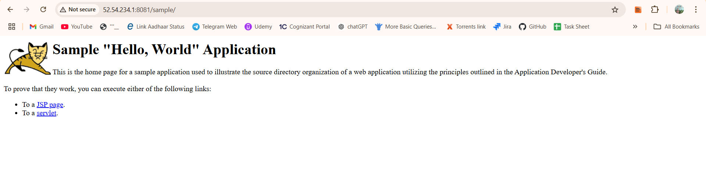

**3) Limit the nginx container to 500 MB**.

>>docker container run -itd --memory=500m nginx

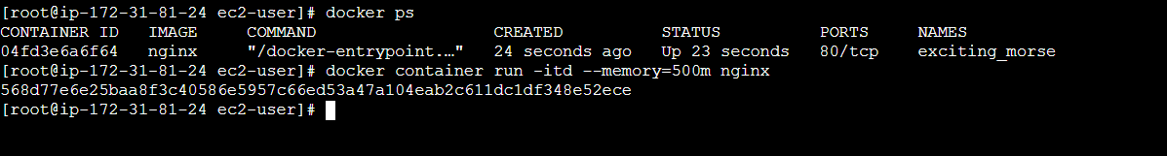

>>docker stats

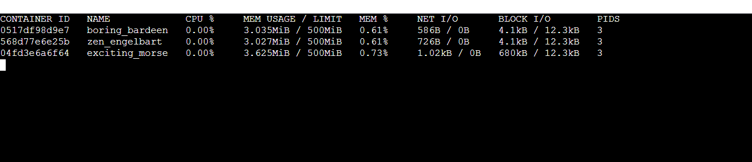

**4) Create a sample docker file using below instructions**.

*1) Base module as amazonlinux:latest*

*2) Maintainer you name*

*3) Install nginx*

*4) COPY one index.html file to image*

*5) EXpose on port 80*

*6) Command to start the nginx container*

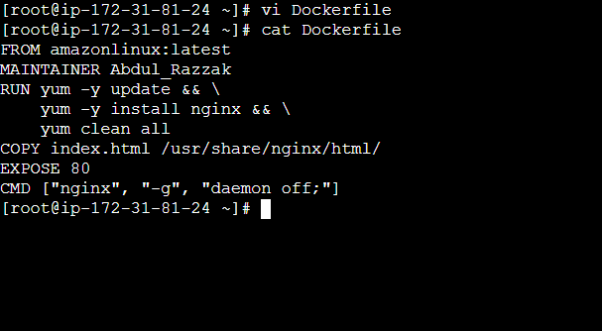

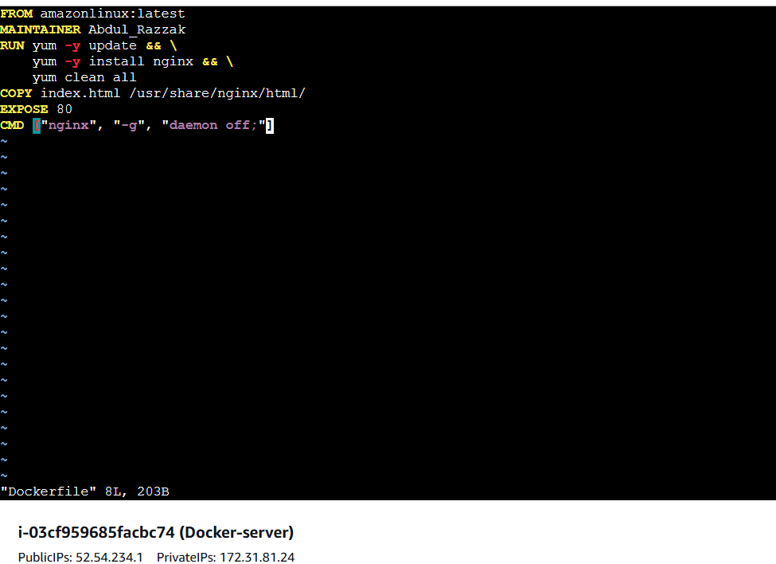

* **Build the docker image using the docker file:**

>> docker build -t nginx_razzak:v1

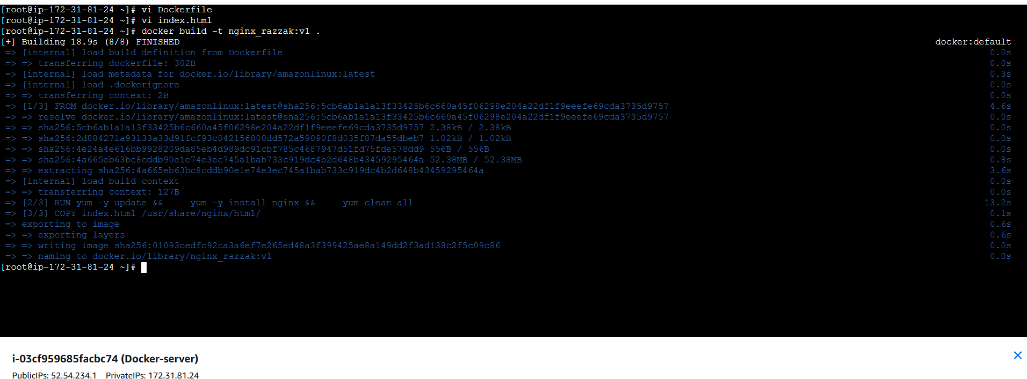

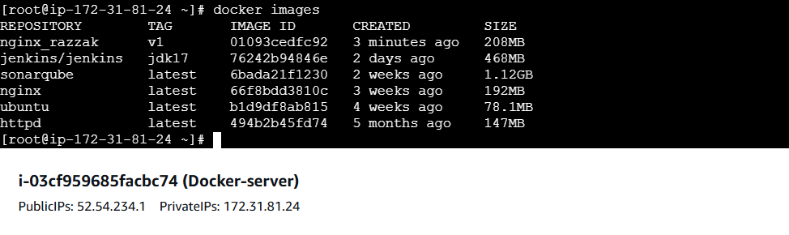

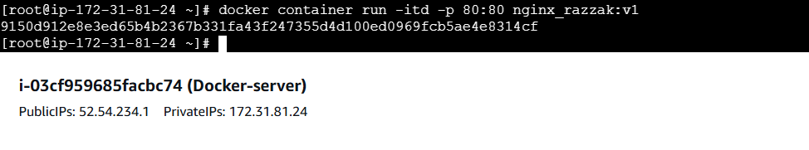

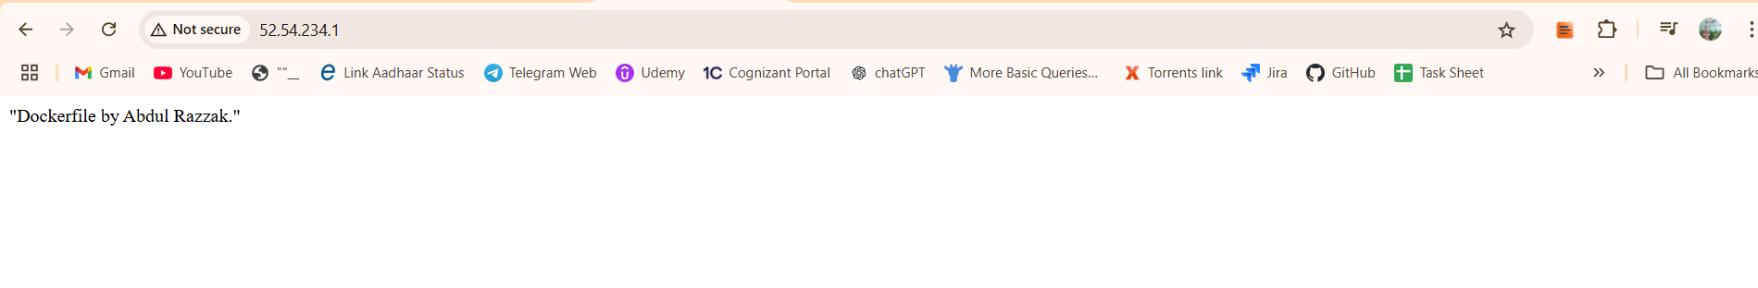

**5) Push image to dockerhub**

>>Docker login

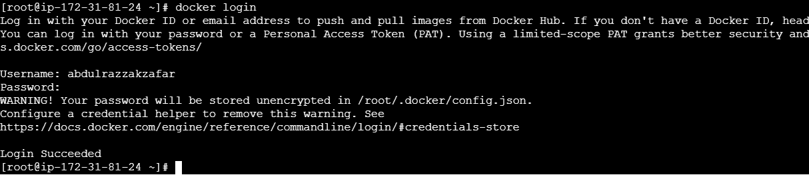

* **Change the tag of our docker image as per our repository name:**

>> docker tag nginx_razzak:v1 abdulrazzakzafar/nginx-repo:v1

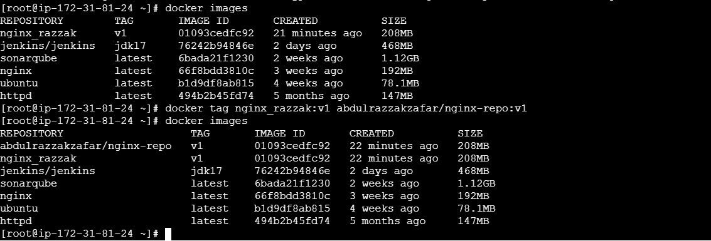

* **Push the image to the DockerHub repo:**

>>docker push abdulrazzakzafar/nginx-repo:v1

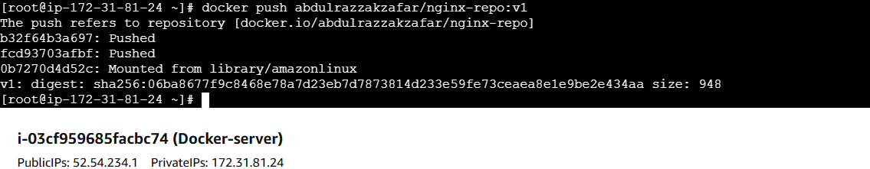

* **Now our image is available in the DockerHub repo:**

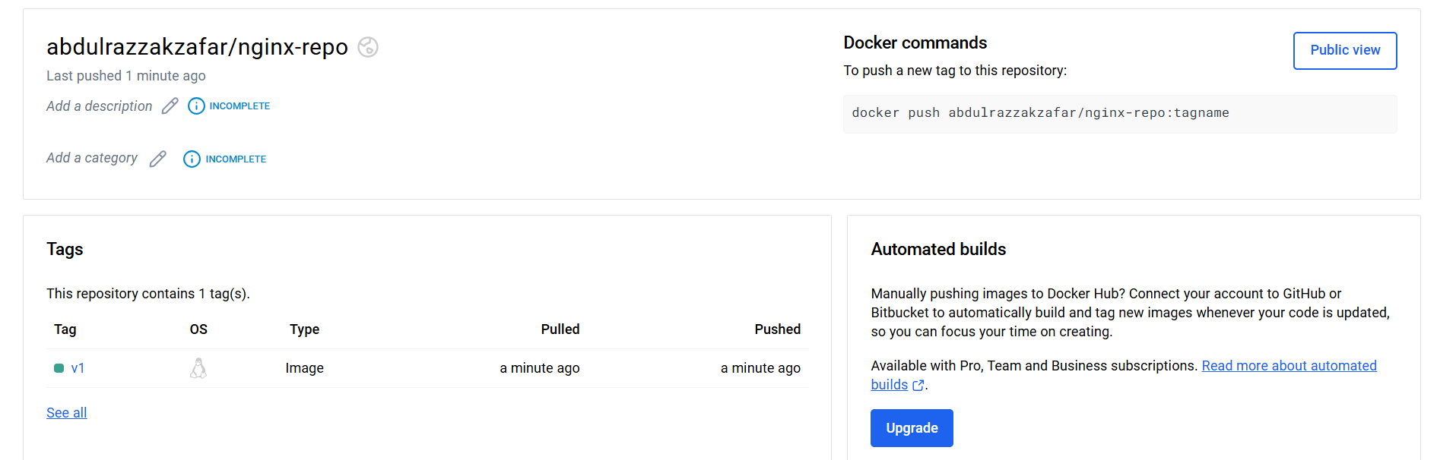

**6) push image to aws ecr**

* Create a repository in aws ecr

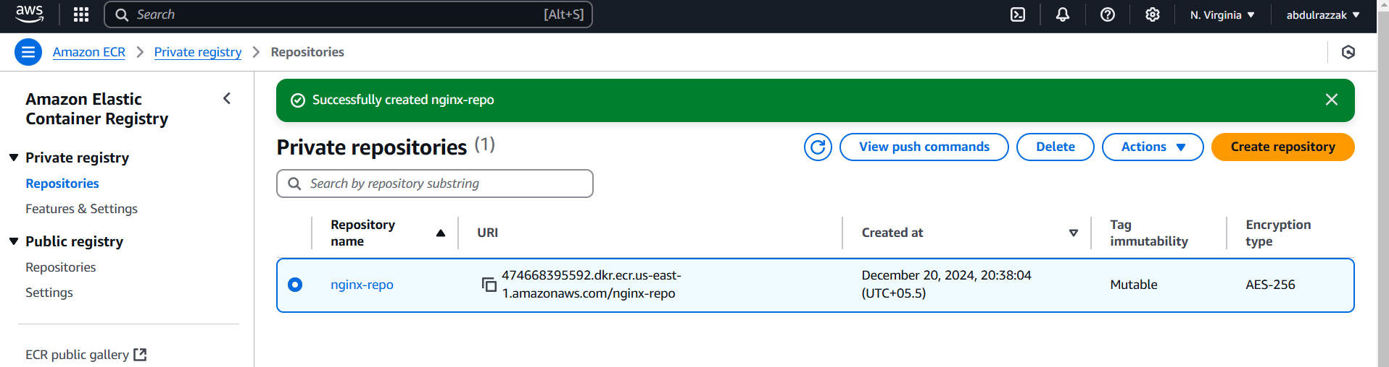

>>aws configure

>> aws ecr get-login-password --region us-east-1 | docker login --username AWS --password-stdin 474668395592.dkr.ecr.us-east-1.amazonaws.com

**Tag your image so you can push the image to this repository**:

>> docker tag nginx-repo:latest 474668395592.dkr.ecr.us-east-1.amazonaws.com/nginx-repo:latest

**Now, Push our image to your newly created AWS repository**:

>> docker push 474668395592.dkr.ecr.us-east-1.amazonaws.com/nginx-repo:latest

