**Jenkins-3 Tasks:**

**1) Create one jenkins job using the below code and create three stages.**

[**https://github.com/betawins/VProfile-1.git**](https://github.com/betawins/VProfile-1.git)

***>> Stage1: Git clone to download the source code.***

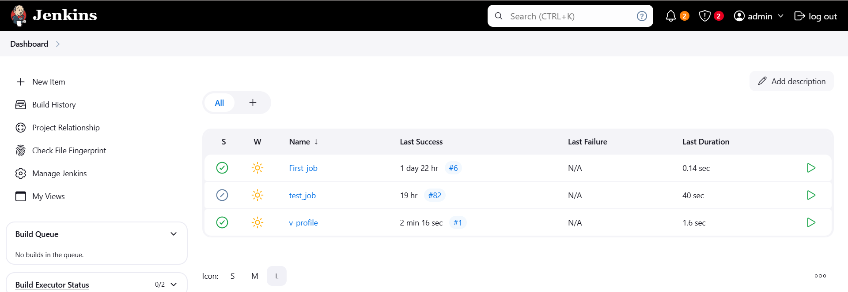

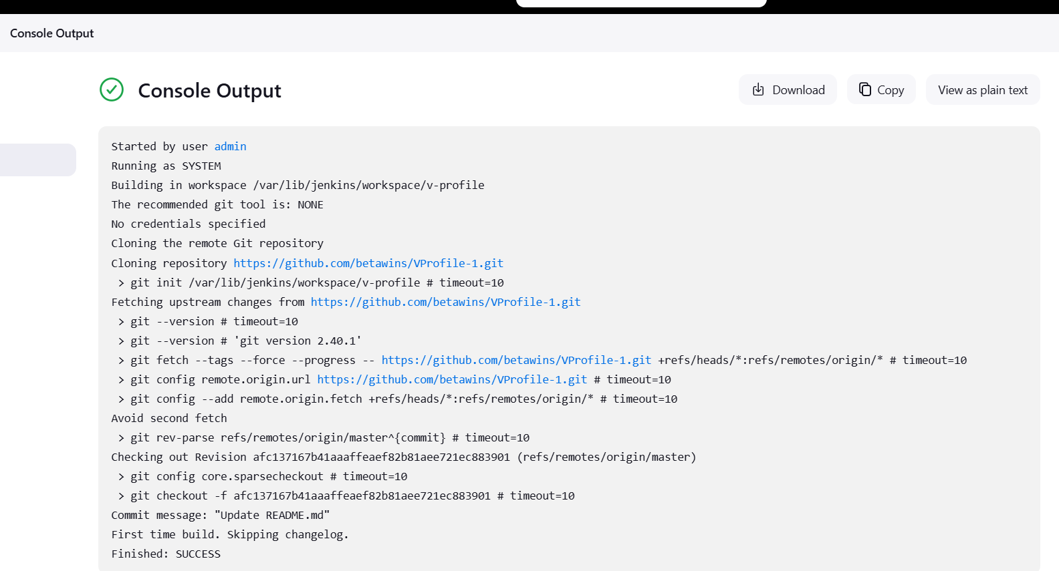

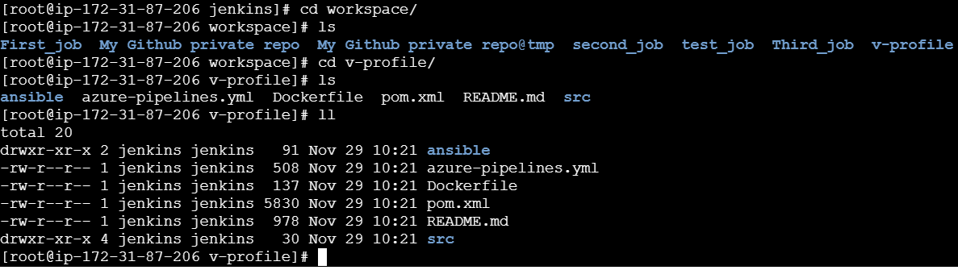

***>> Stage2: Sonarqube Integration to check the quality of code***

* *Installed and started mysql community server:*

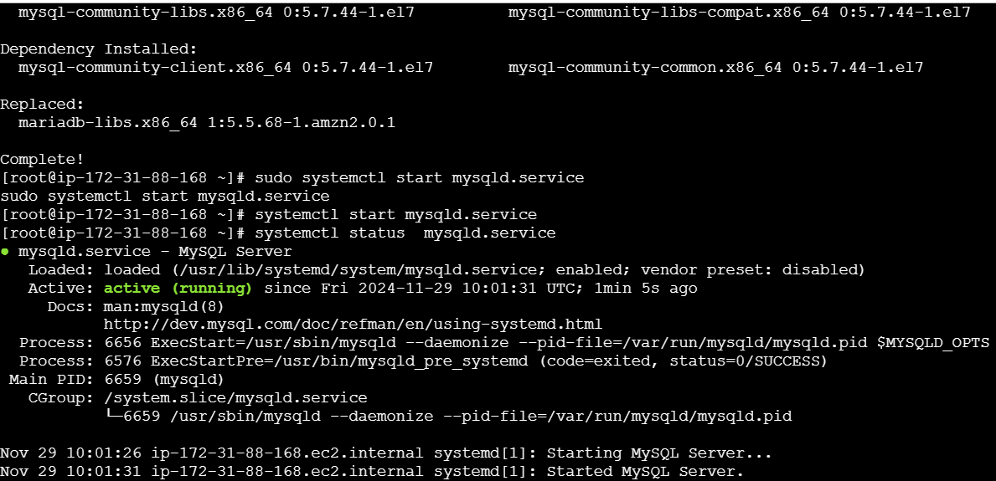

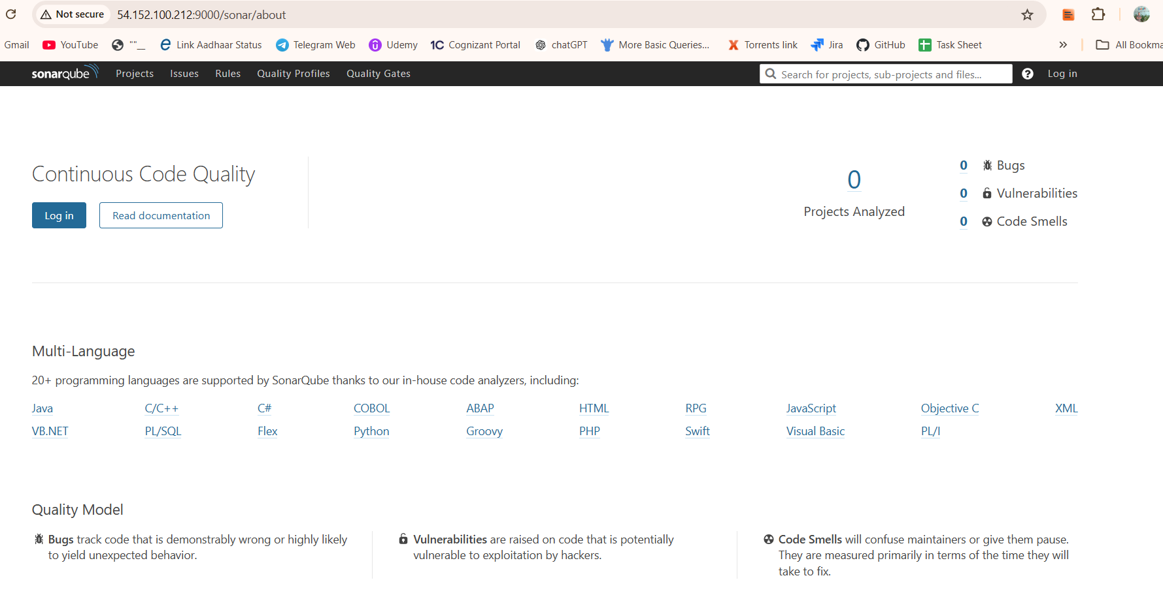

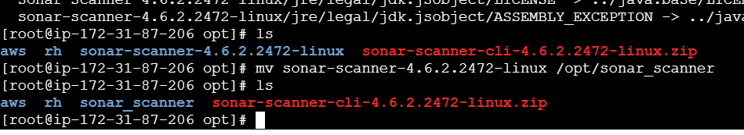

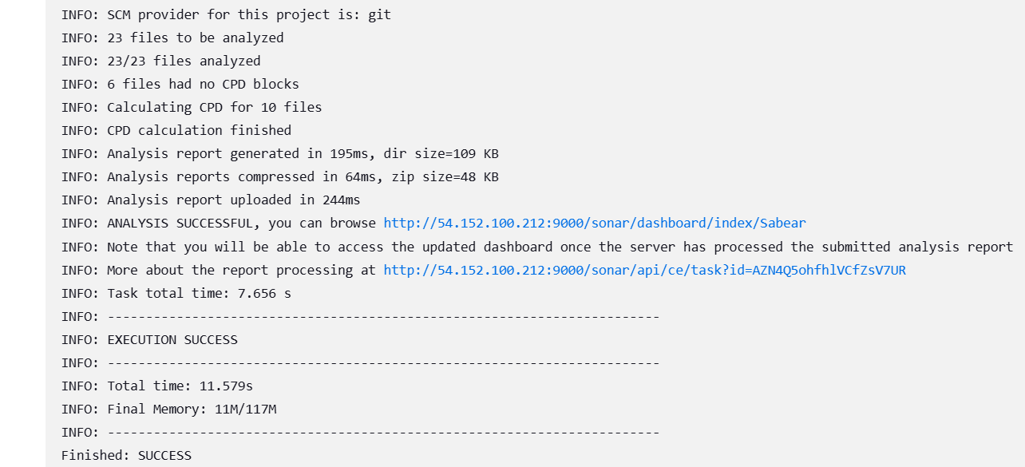

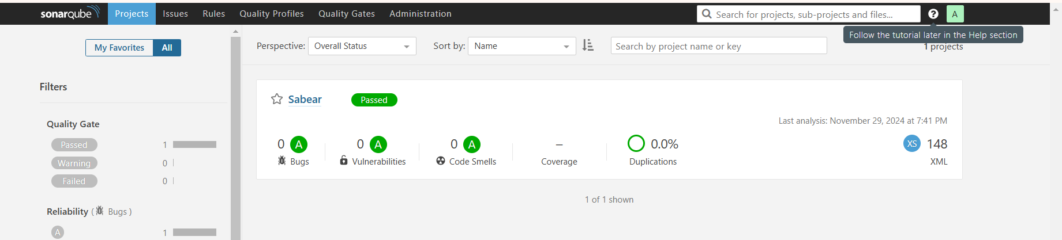

**2) 1) Create one jenkins job using the below code and create three stages.**

[**https://github.com/betawins/hiring-app.git**](https://github.com/betawins/hiring-app.git)

***>> stage1: Git clone to download the source code.***

* Under “Branches to Build” change the branch name from master to main (as our repo has only main branch).
* 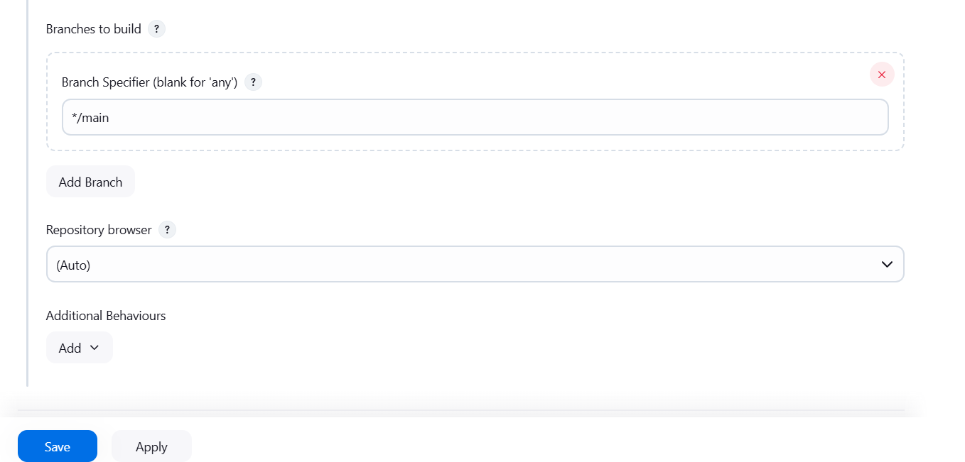

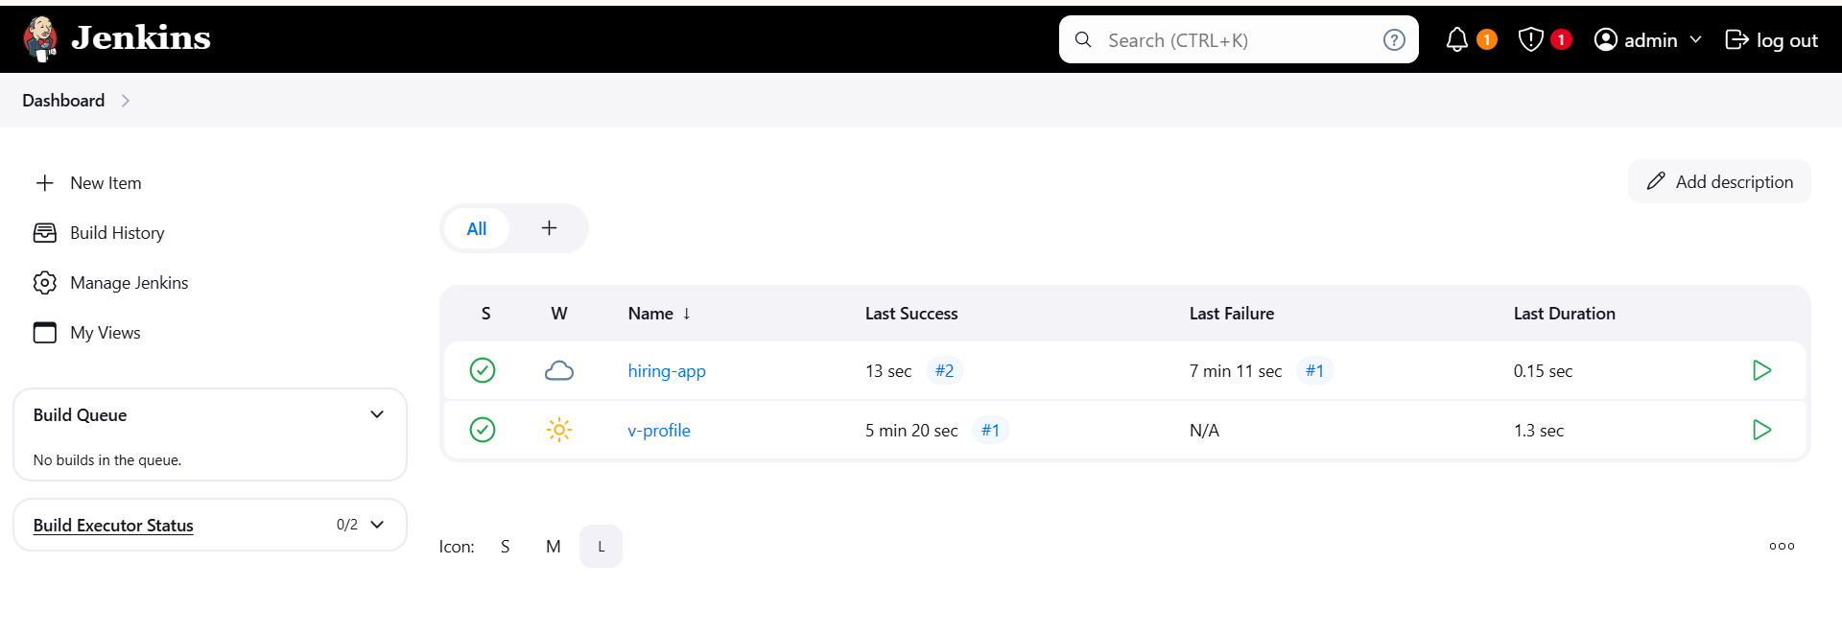

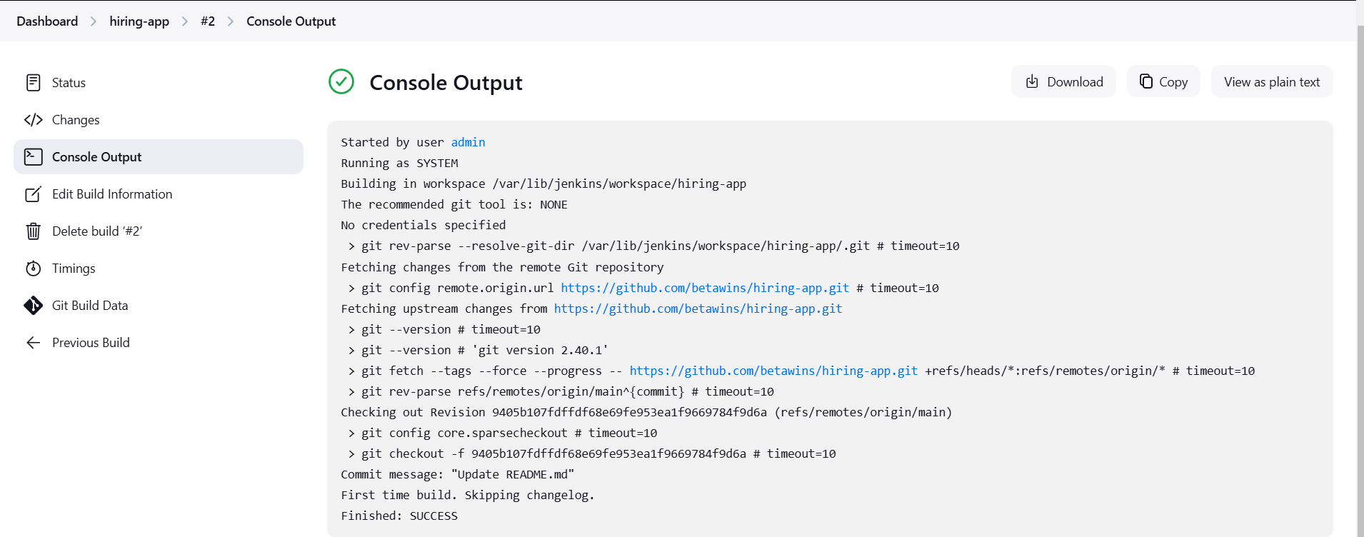

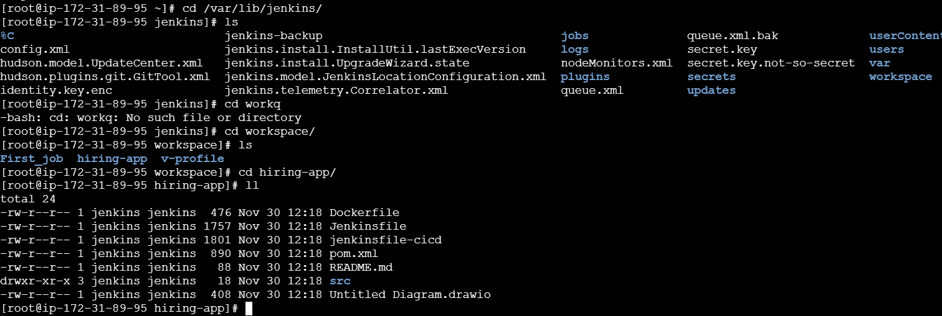

***>> stage2: Sonarqube Integration to check the quality of code***

