**1)Setup jenkins CICD pipeline using freestyle job using Docker containers using below code.** <https://github.com/betawins/hiring-app.git>

**1)Git Clone:**

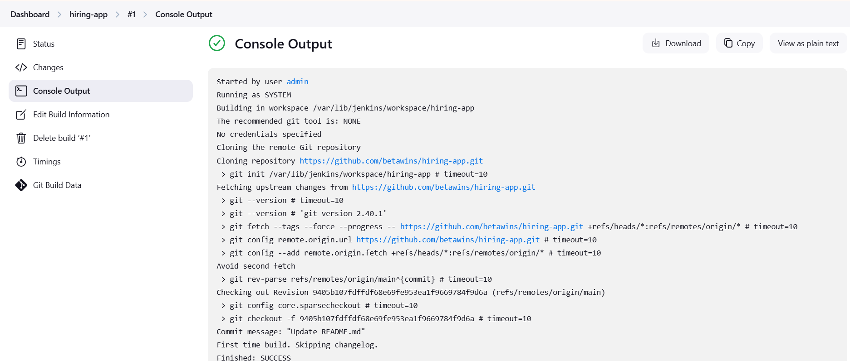

**2) Sonarqube Integration:**

* ***using Docker container Method:***

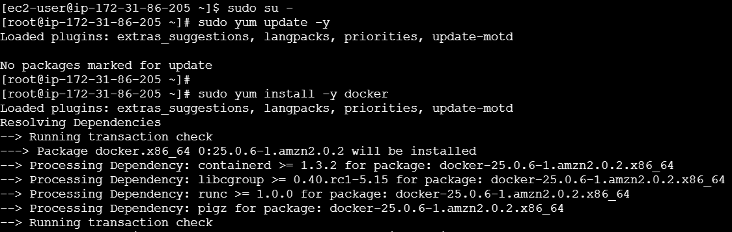

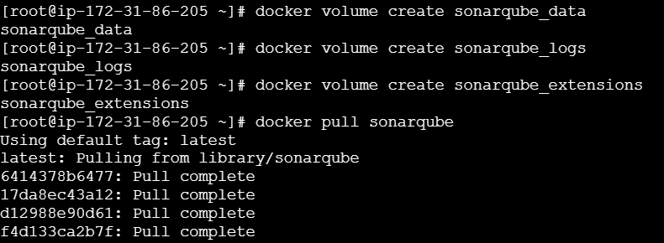



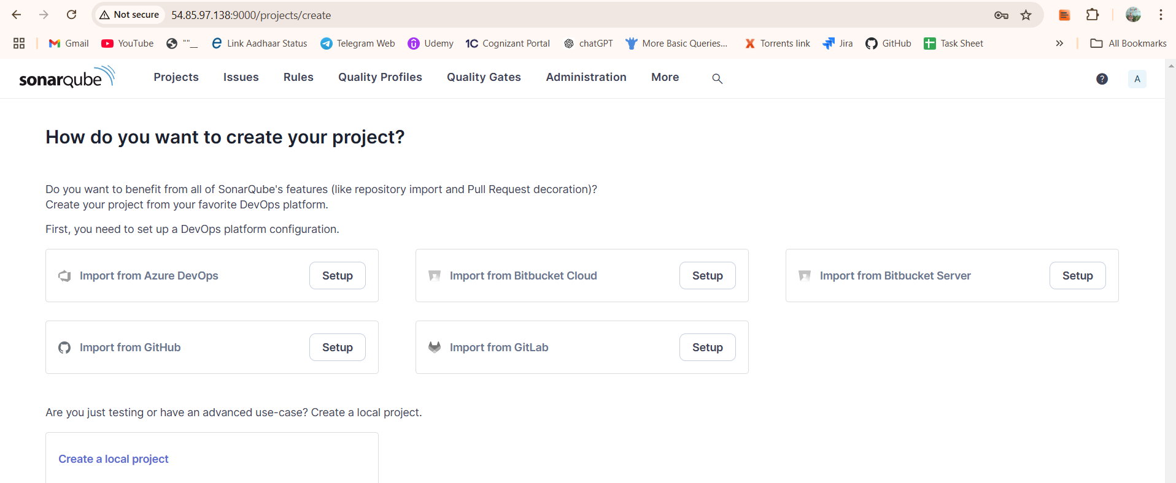

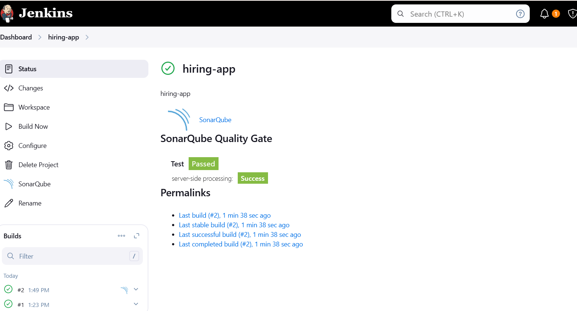

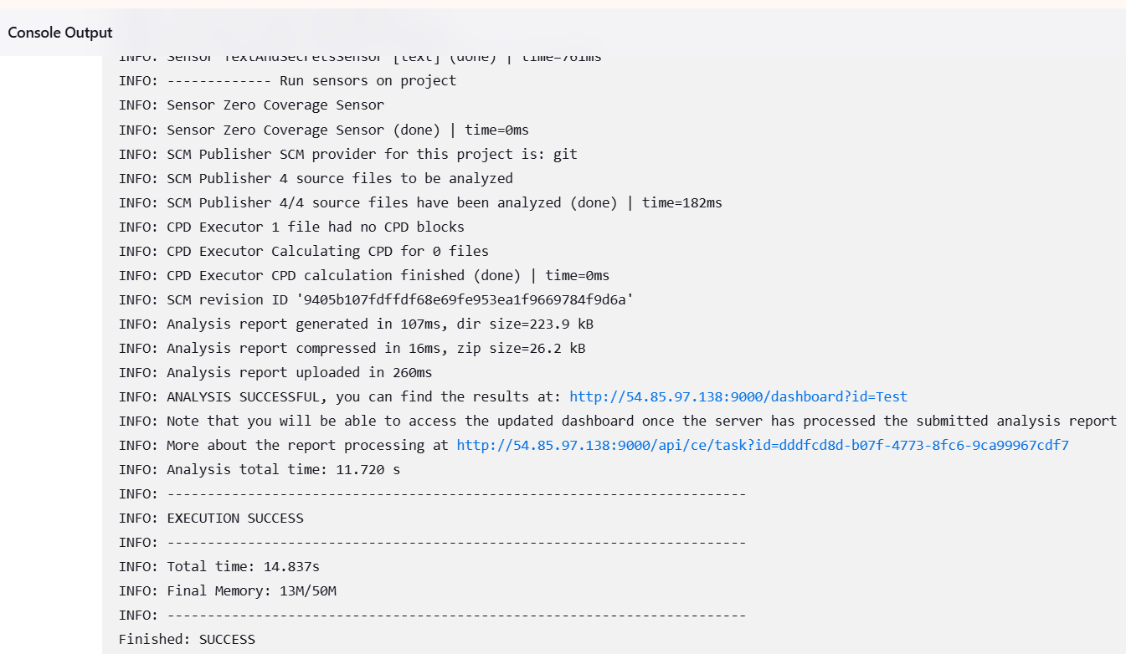

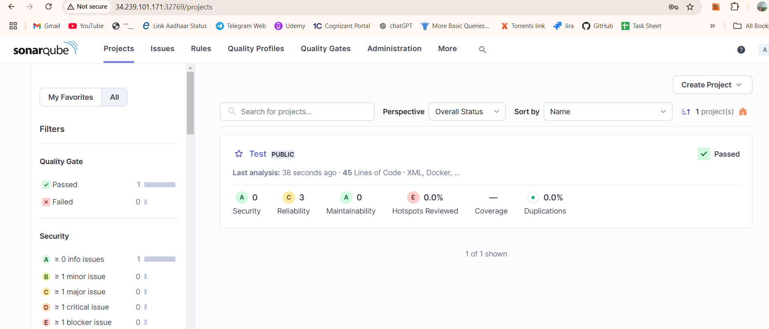

**3) Maven Compilation:**

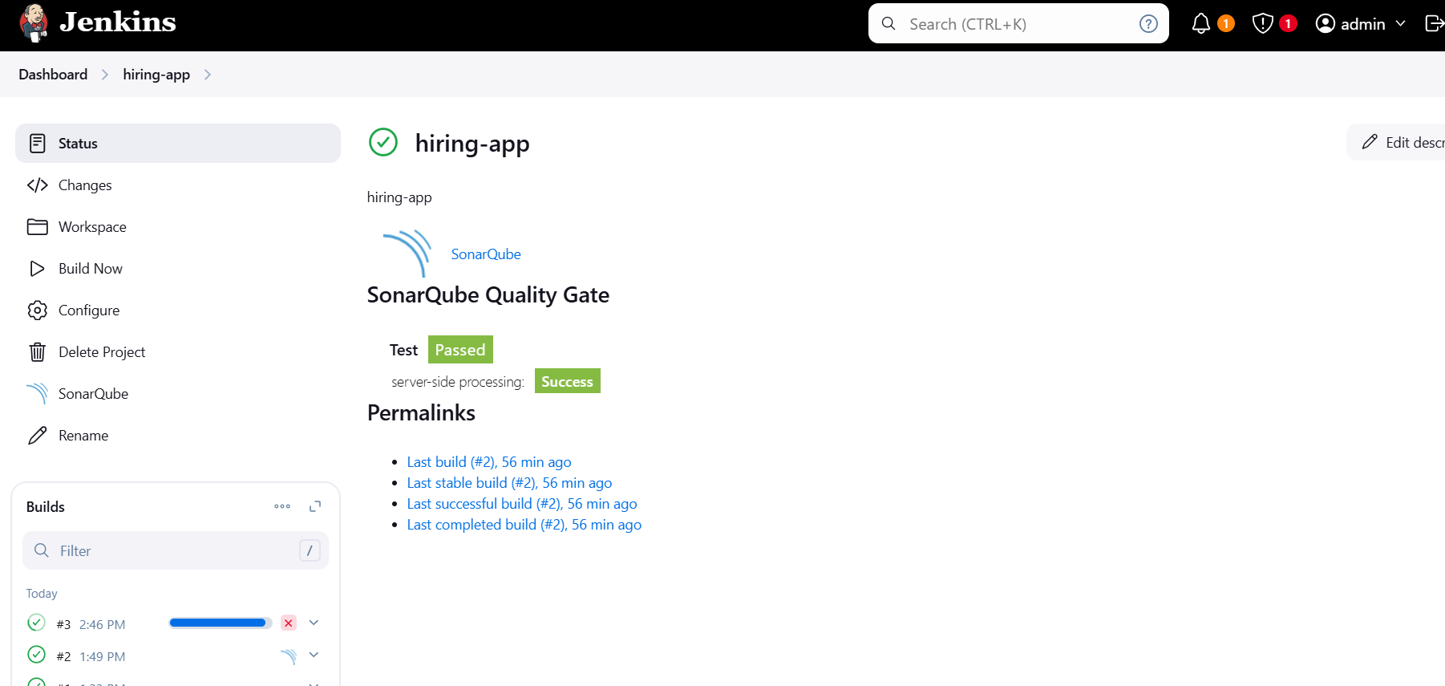 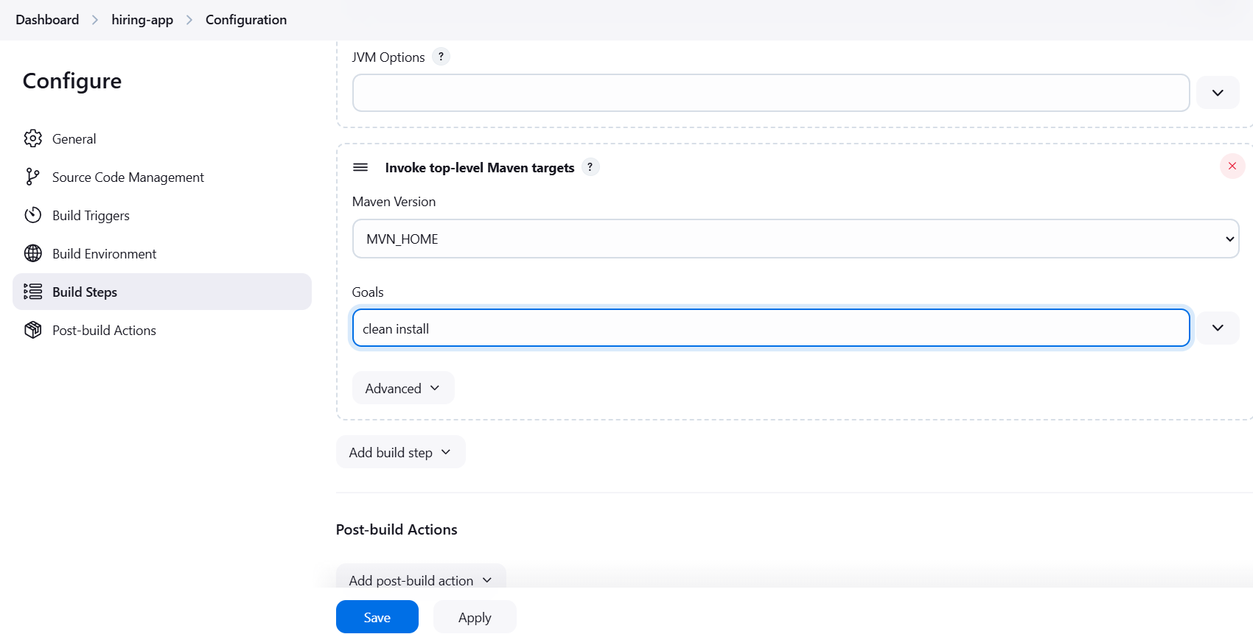

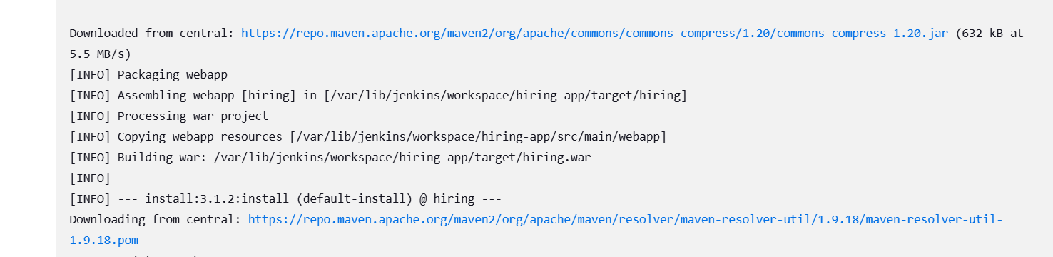

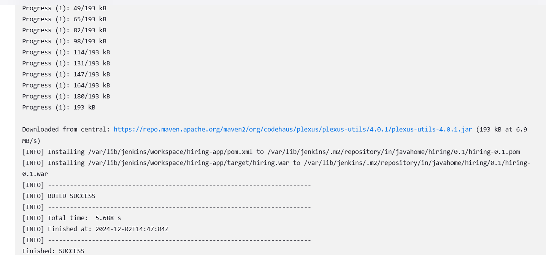

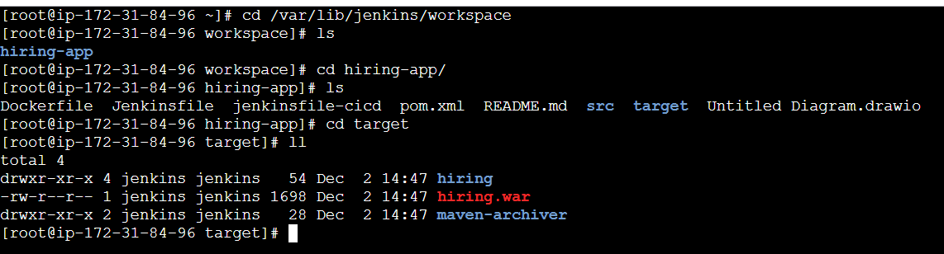

**4) Nexus Artifactory:** 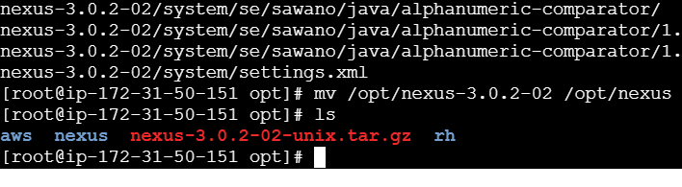

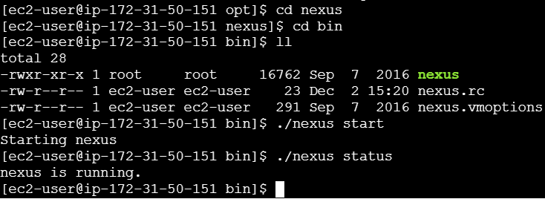

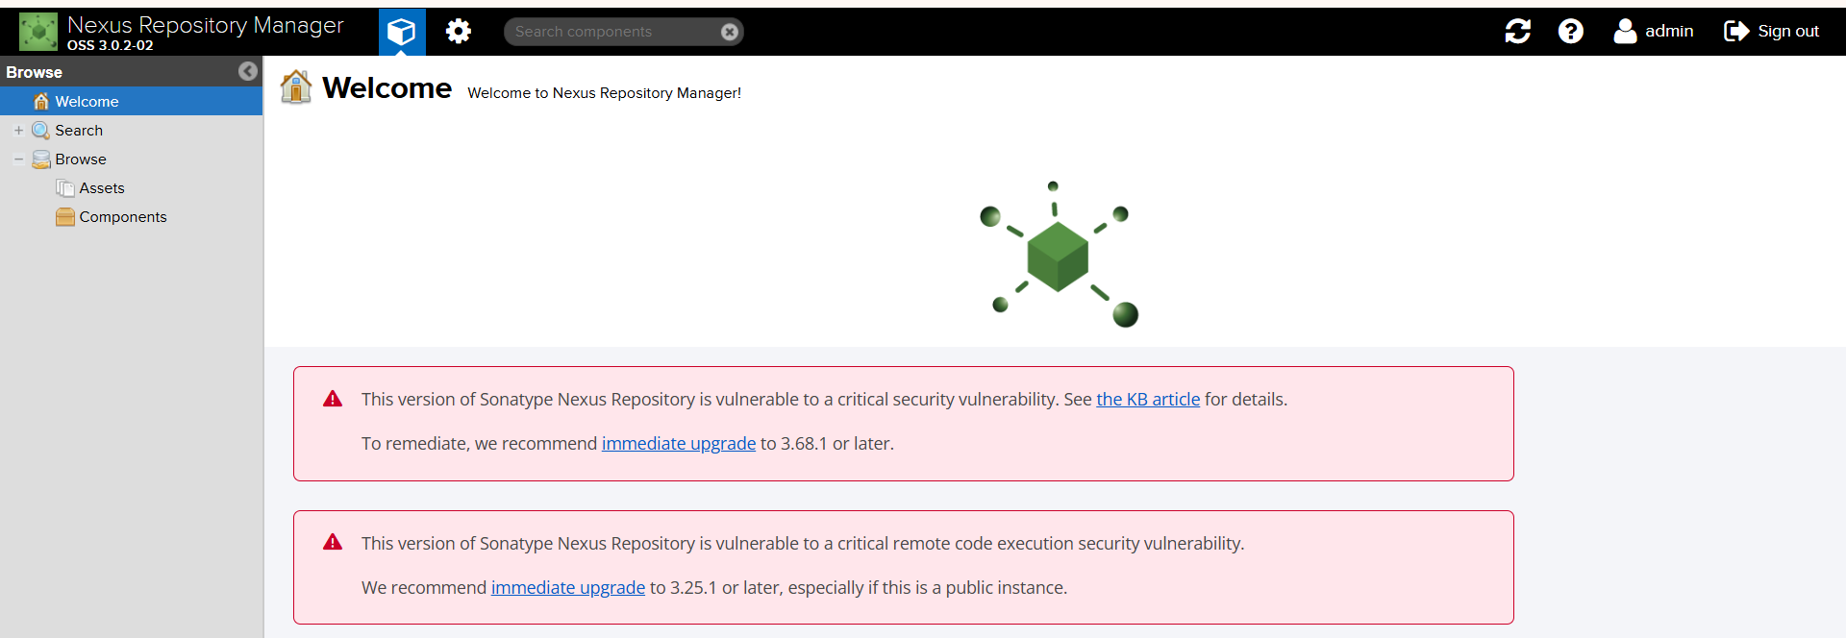

***Installed Nexus Artifact uploader plugin:***

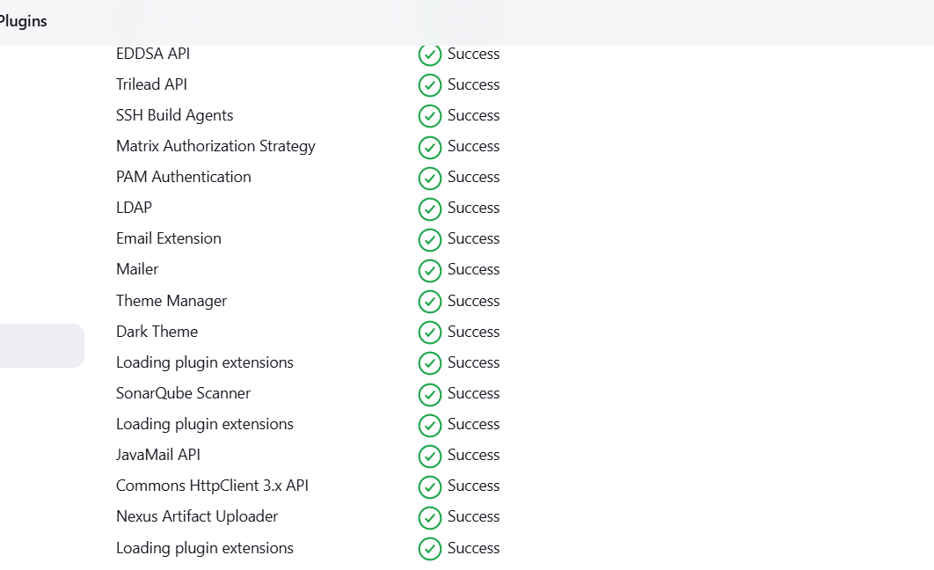

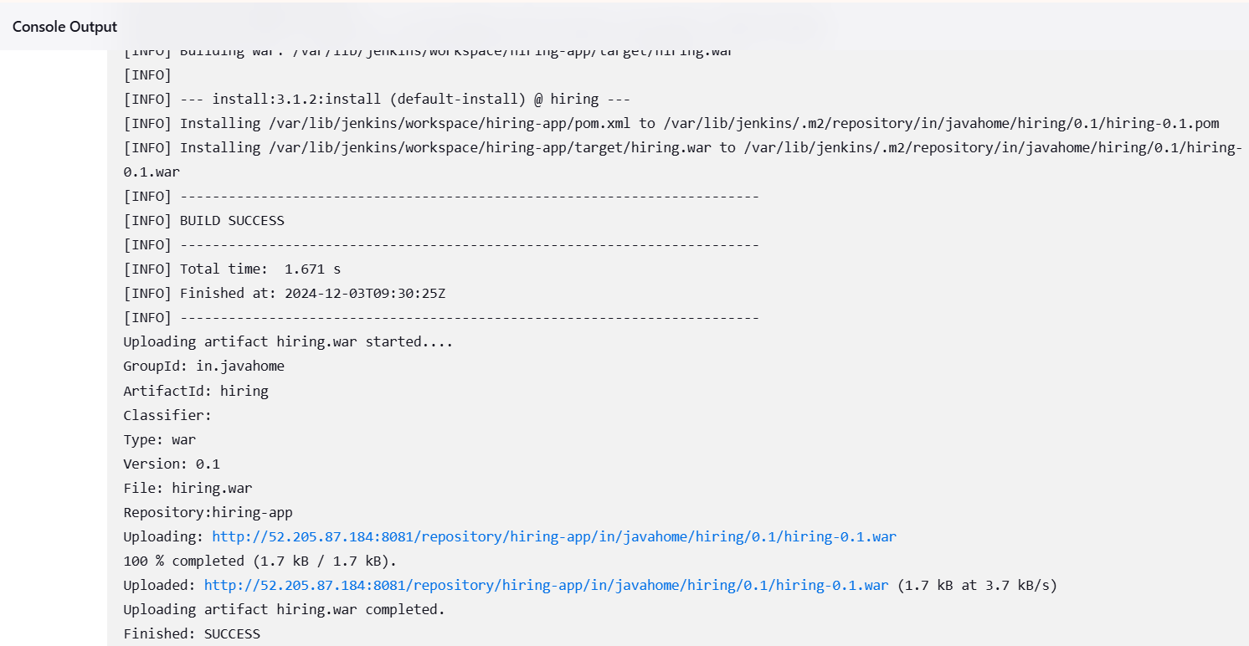

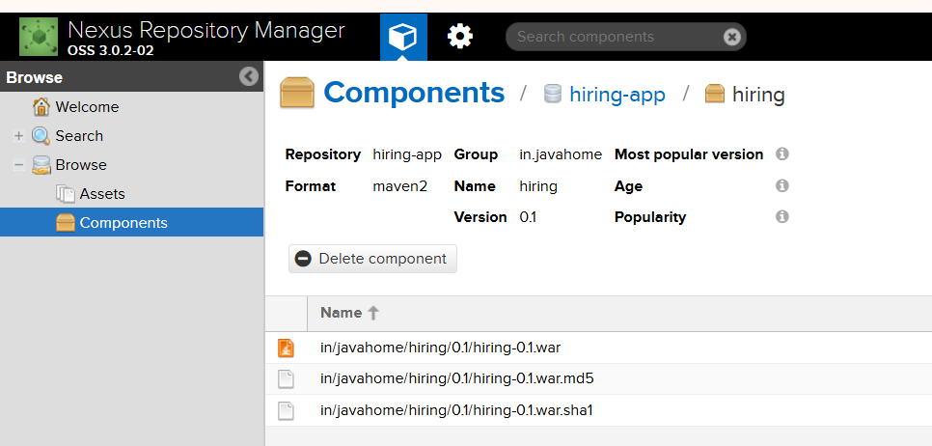

**>>Our Artifact/war package:**

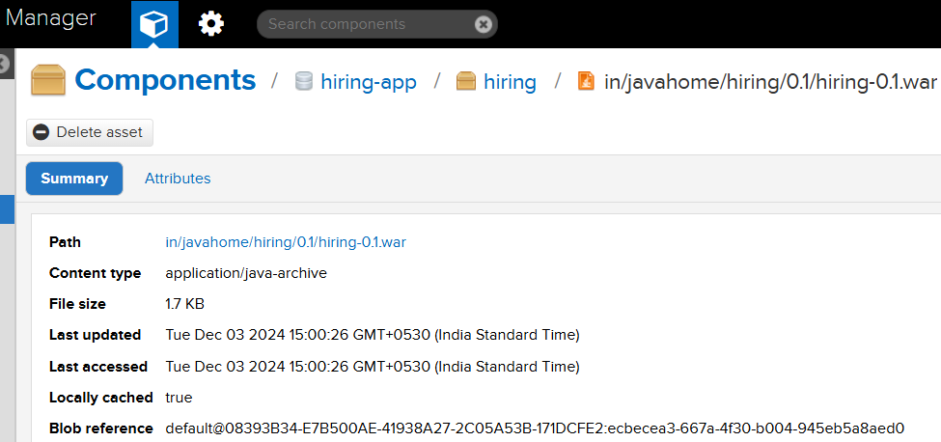

**5) Slack Notification:**

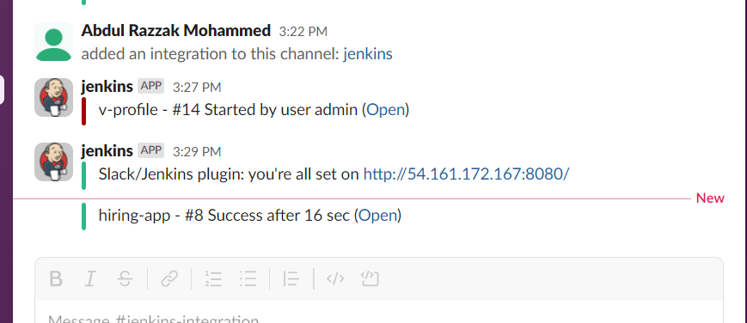

**6) Deploy On tomcat:**

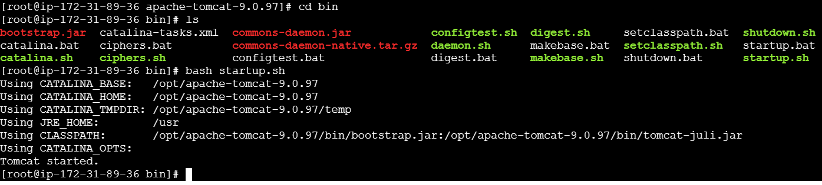

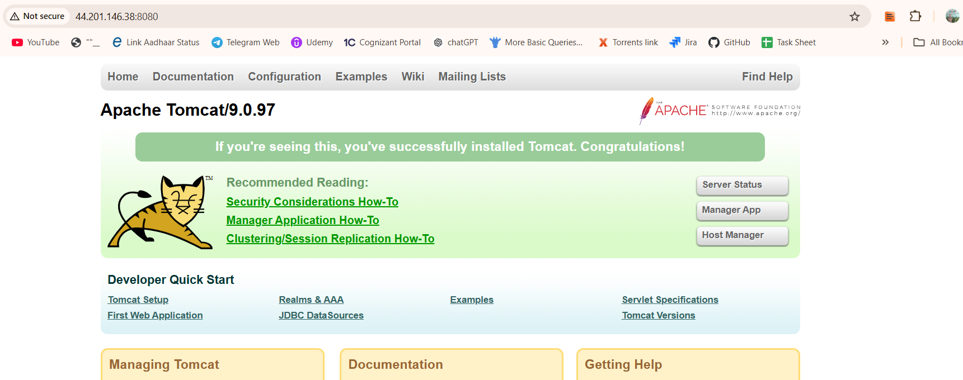

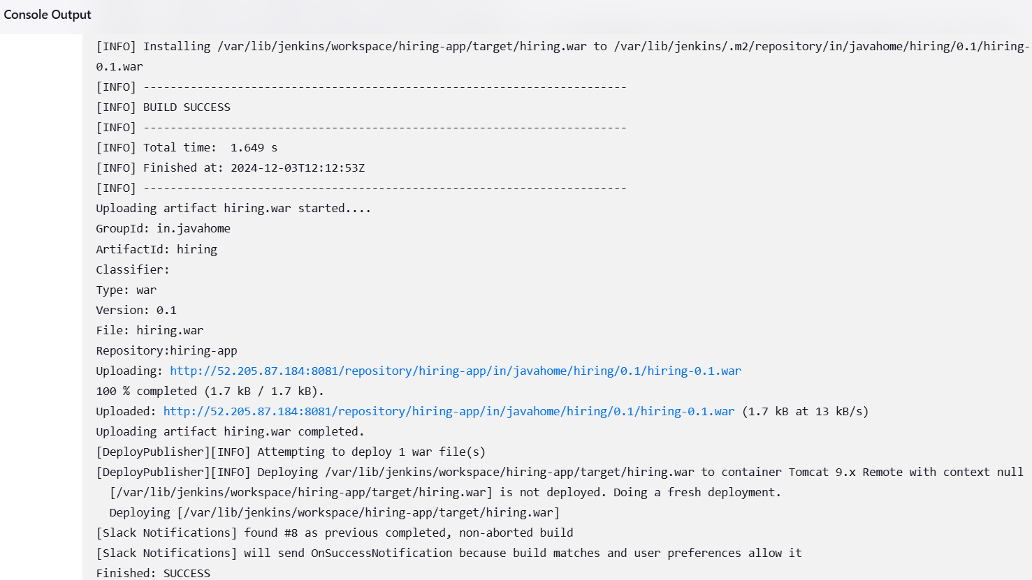

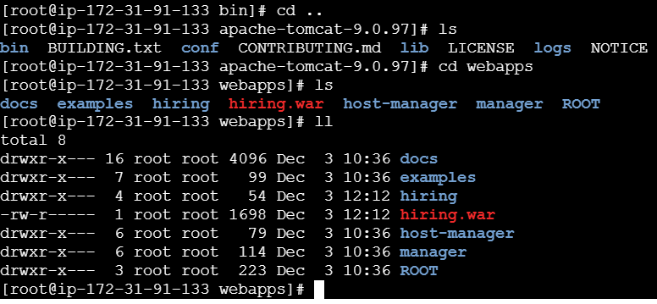



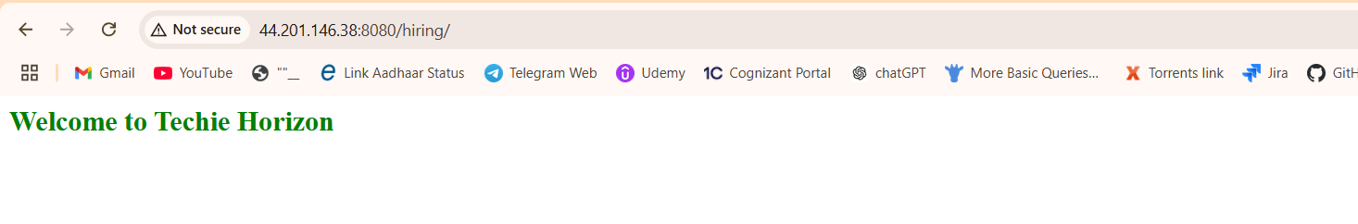

**2) Setup a jenkins CICD pipeline using Declarative pipeline using feature-1.1 branch.** [**https://github.com/betawins/sabear_simplecutomerapp/tree/feature-1.1**](https://github.com/betawins/sabear_simplecutomerapp/tree/feature-1.1)

**1) Git Clone:**

