**Jenkins Set-up Tasks:**

1. **Install jenkins and run jenkins on port number 8081.**

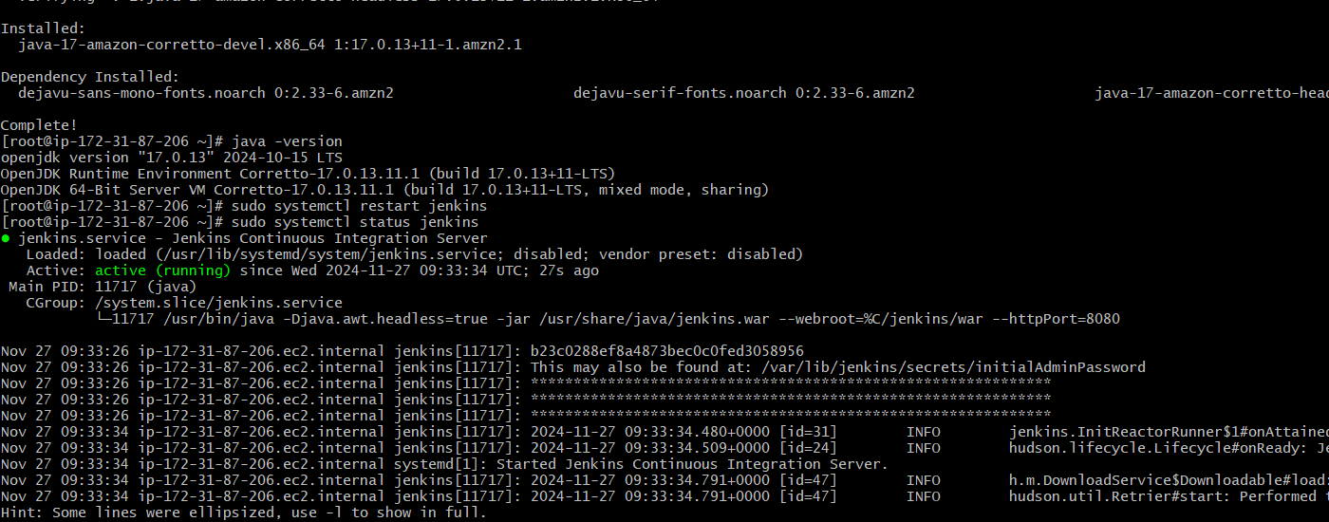

***-Jenkins running on Port number: 8081.***

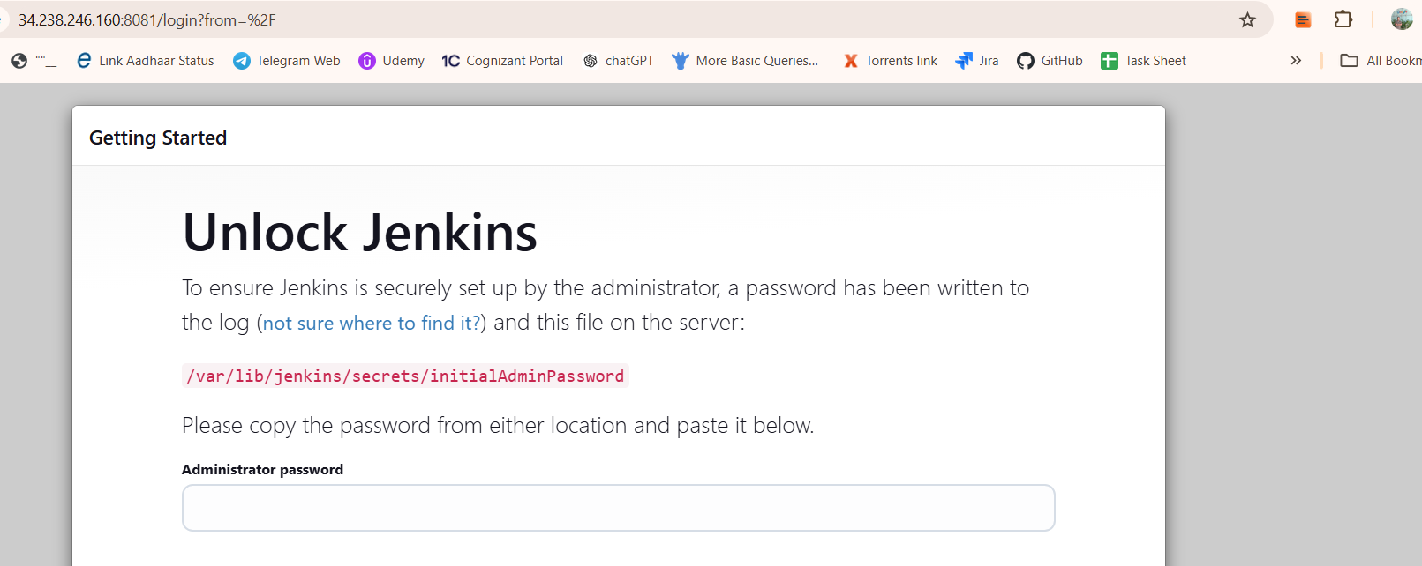

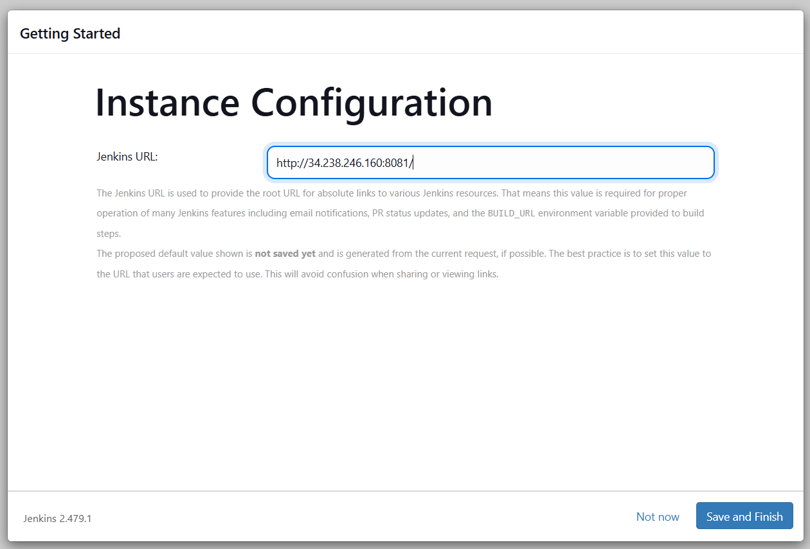

**2) Secure Jenkins server  
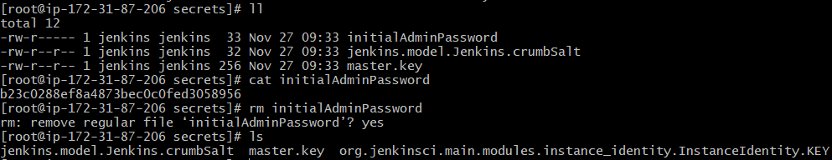**

**3) Create users called Devops, Testing in Jenkins with Limited access.**

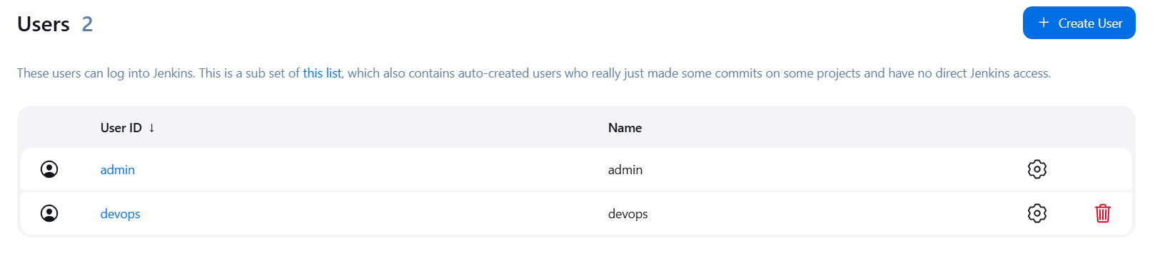

[**http://34.238.246.160:8081/securityRealm/**](http://34.238.246.160:8081/securityRealm/)

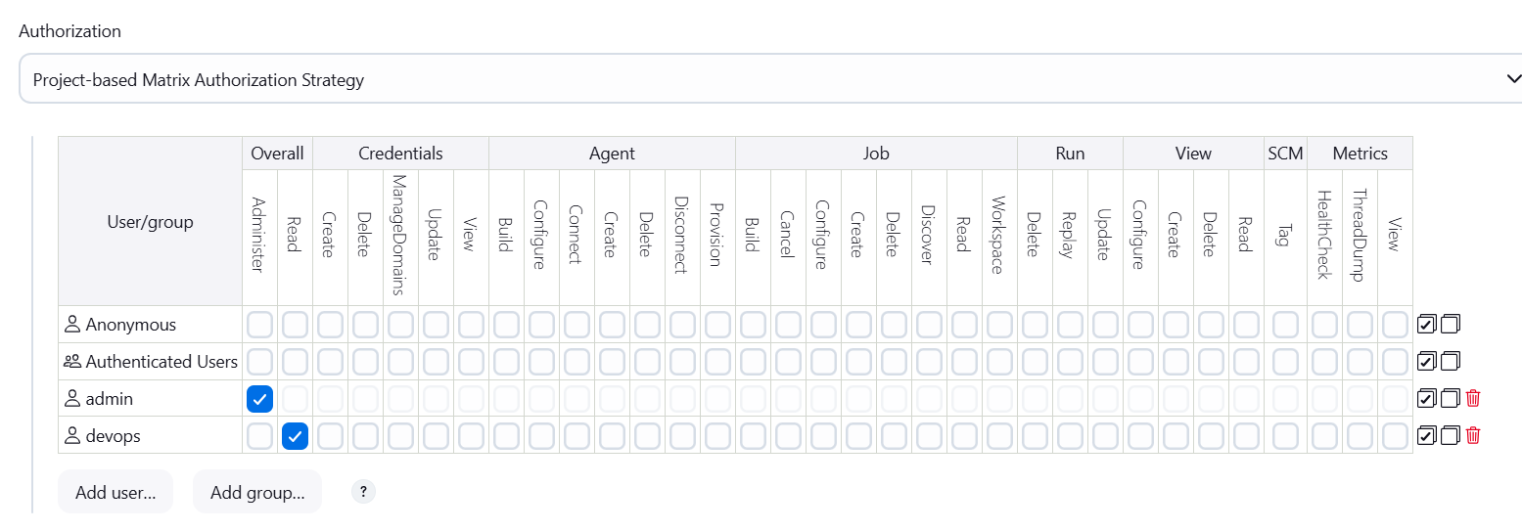

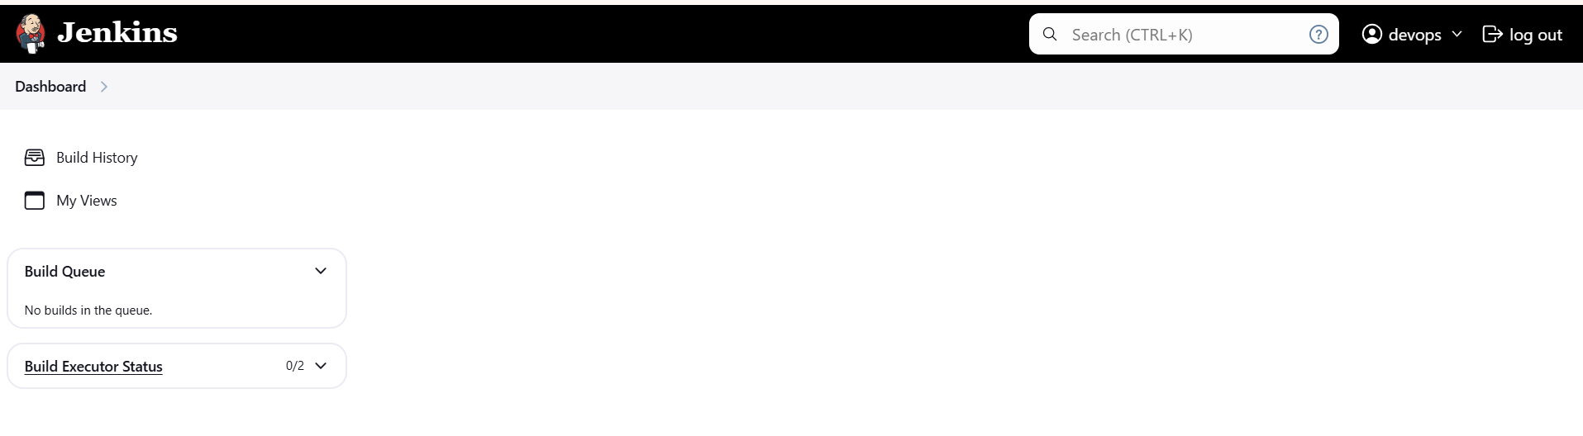

**4) Configure labels and restrict the jobs to execute based on label only.**

***-Downloaded “Node and Label parameter” Plugins:***

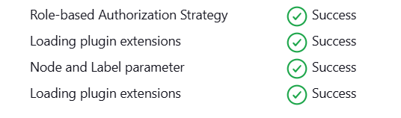

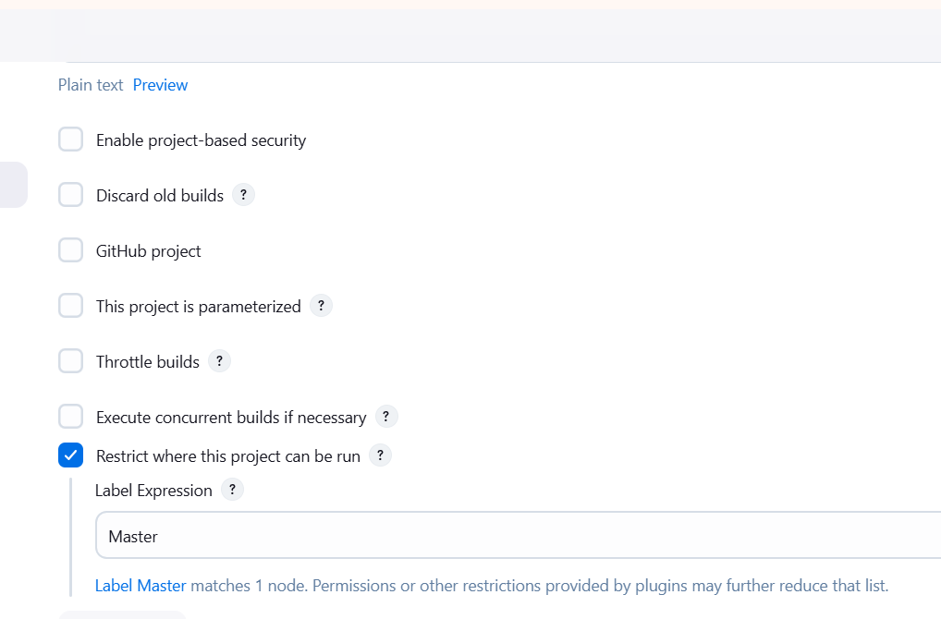

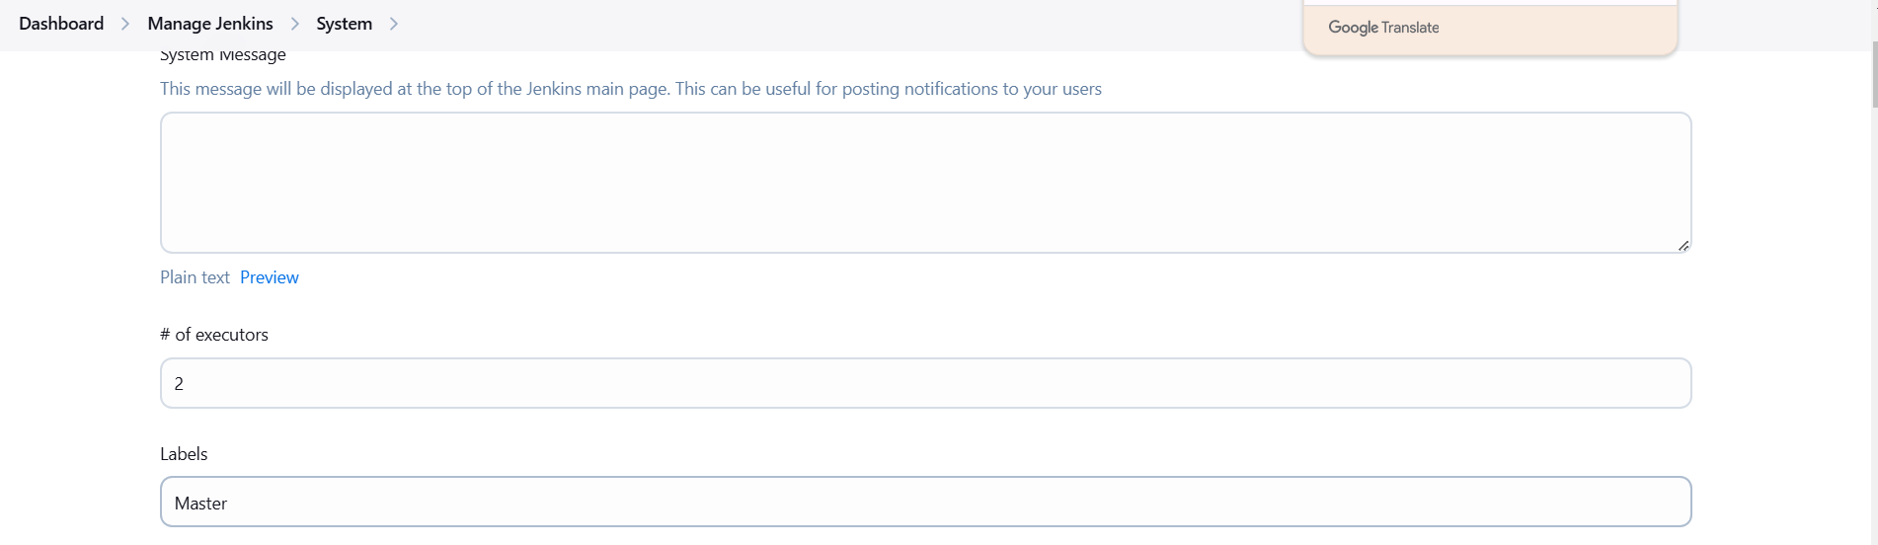

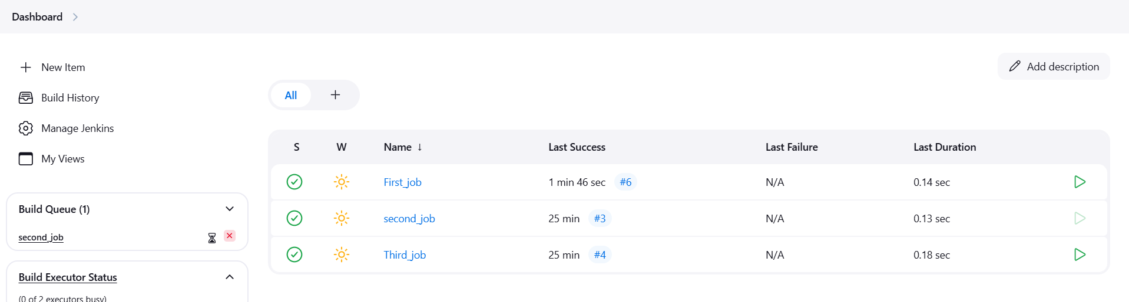

**5) Create Three sample jobs using the below URL.** [**https://github.com/betawins/Techie_horizon_Login_app.git**](https://github.com/betawins/Techie_horizon_Login_app.git)

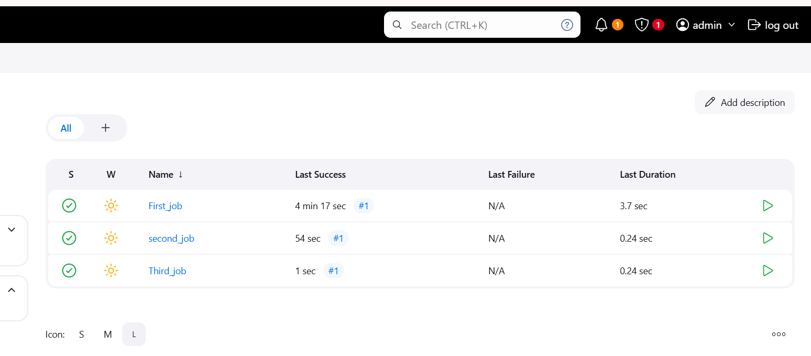

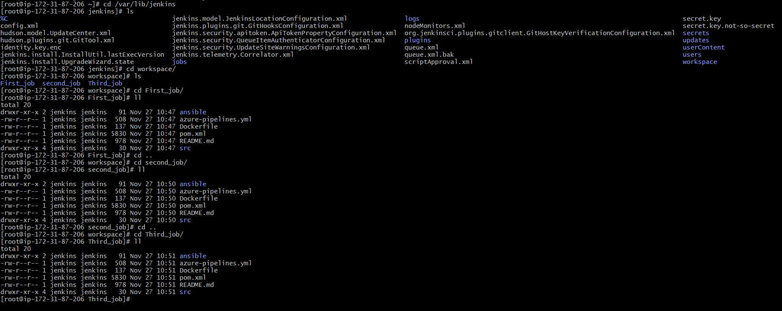

**6) Create one jenkins job using git hub Private repository.**

