**Jenkins-02-Tasks:**

**1) Configure 2 slave machines in jenkins master.**

**Nodes:**

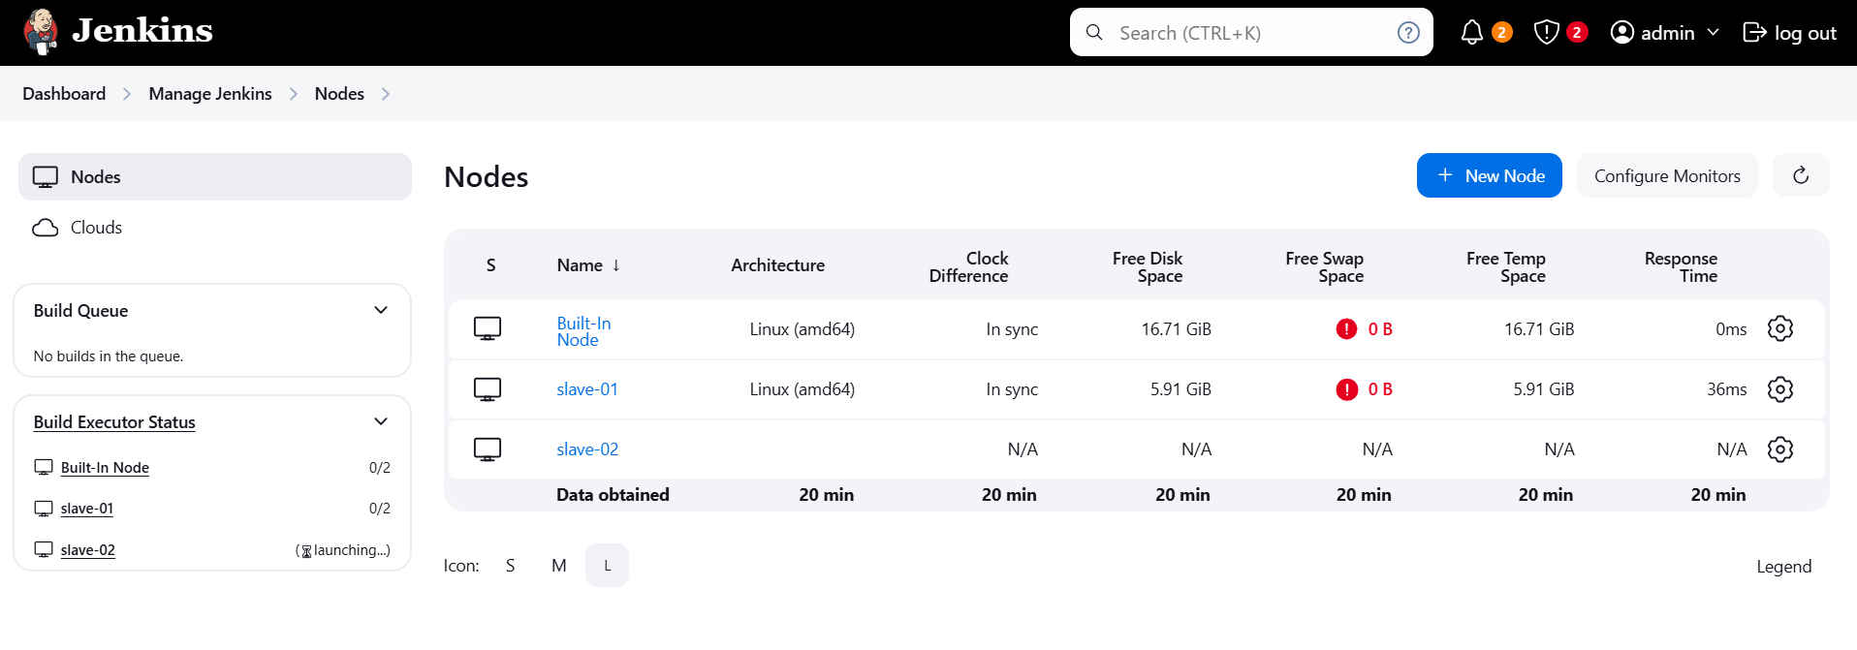

**Dashboard:**

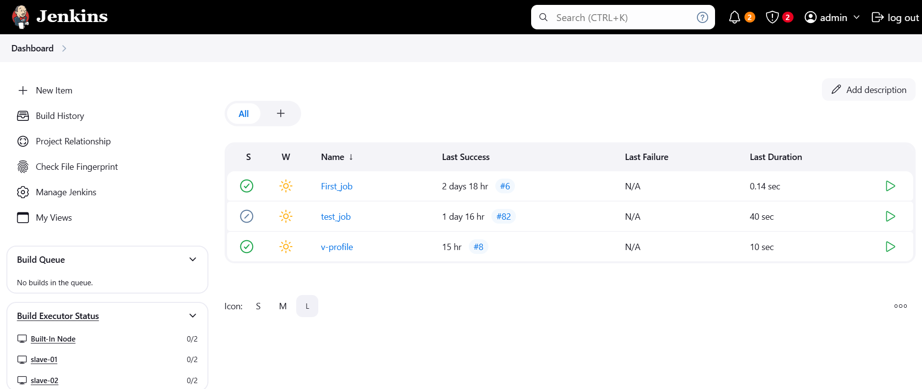

**2) Configure webhooks to jenkins job.**

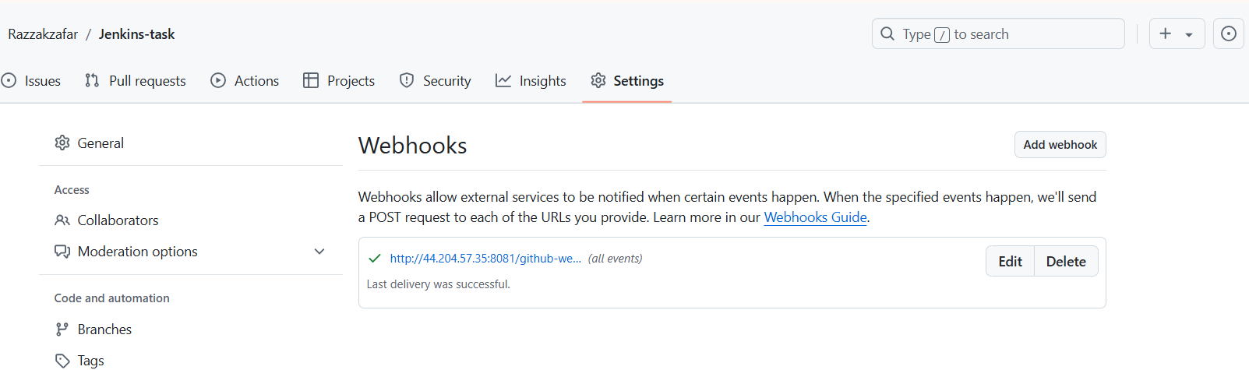

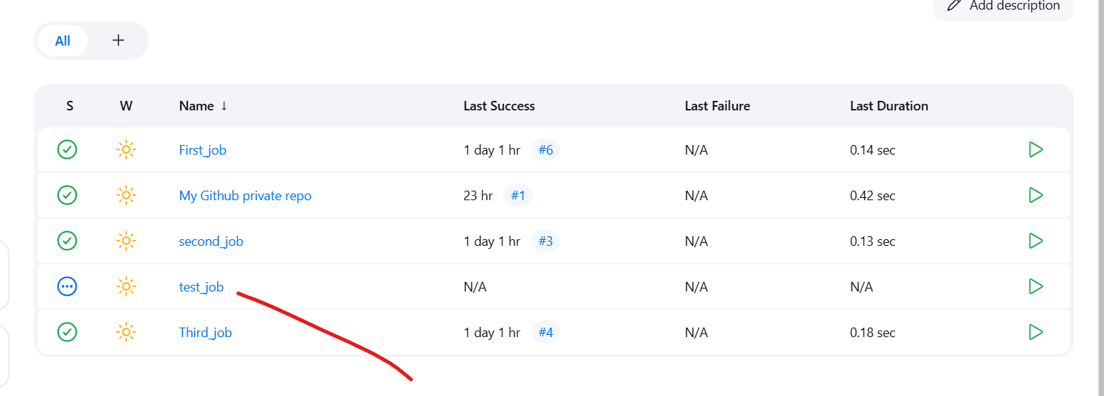

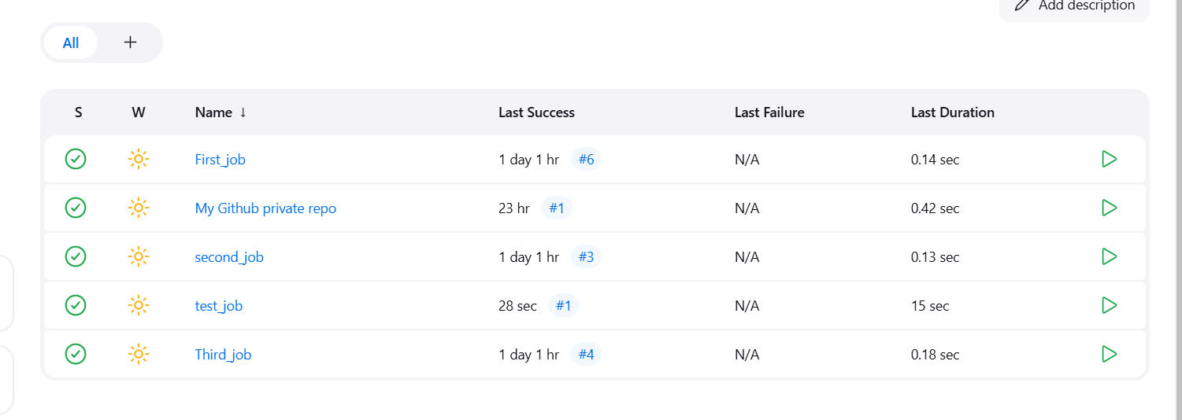

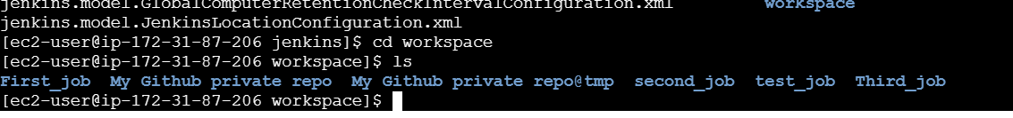

**3) Configure poll scm and build periodical options in jenkins job**.

***--Poll scm:***

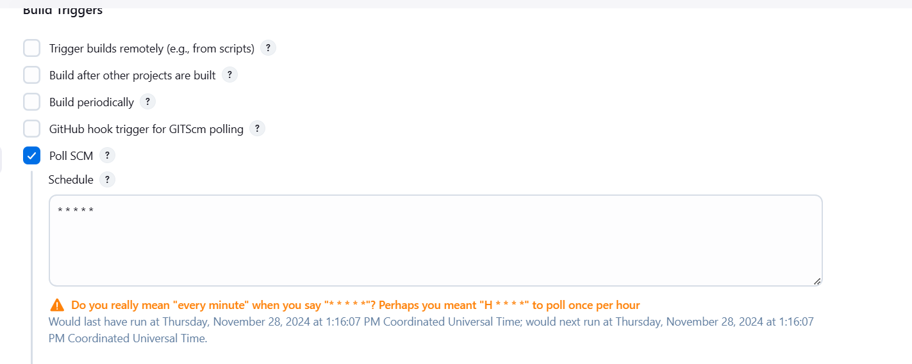

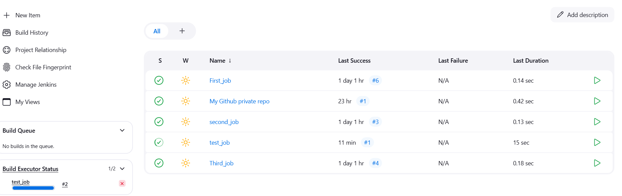

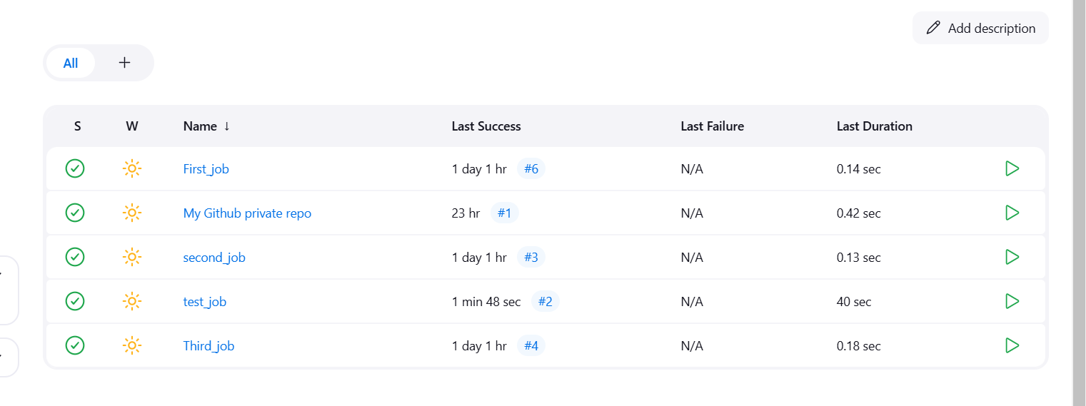

***--Build Periodical:***

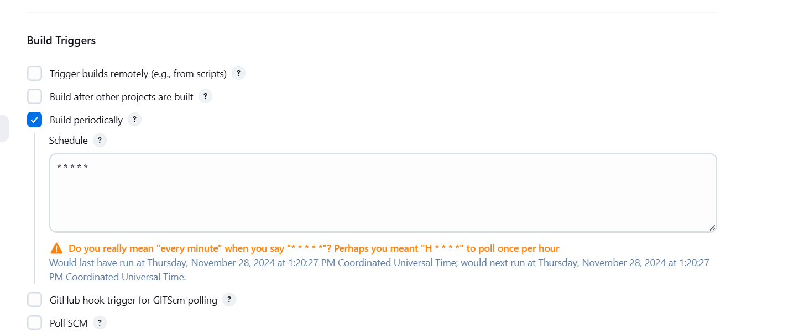

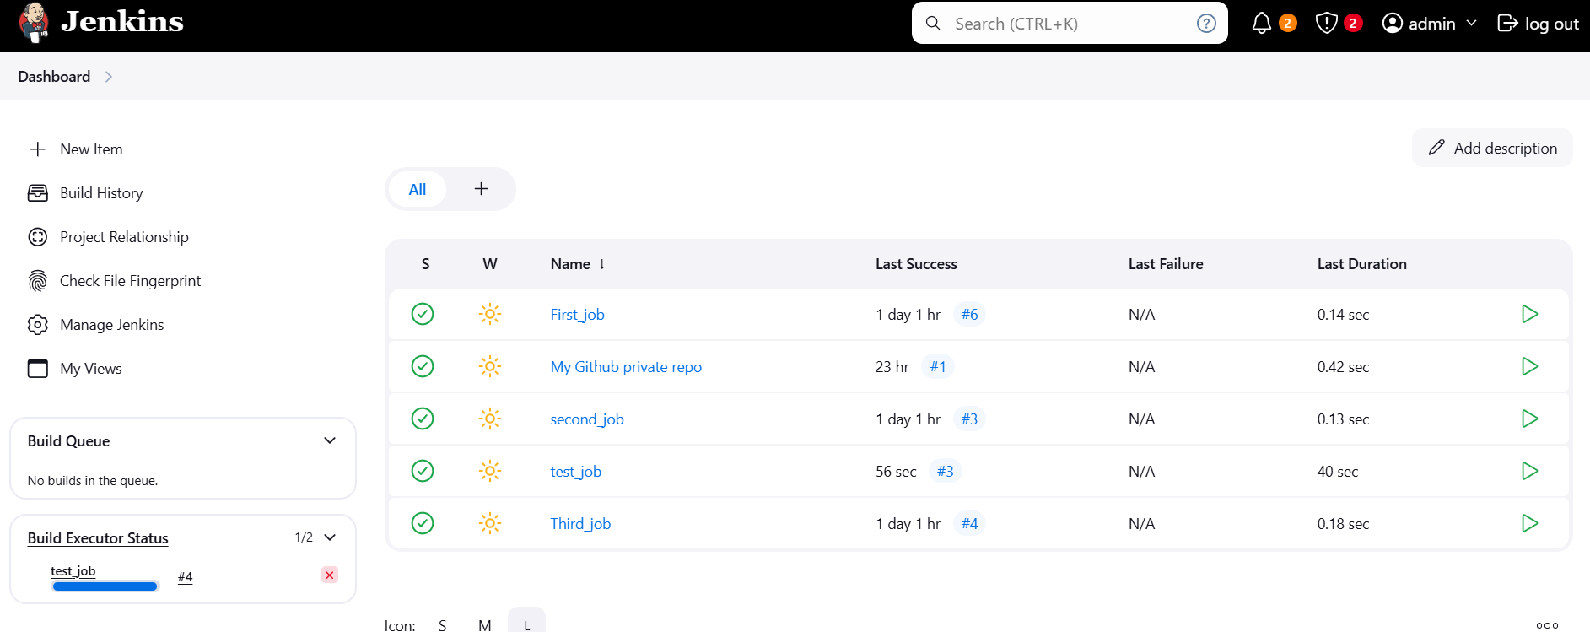

**4) Take backup of jenkins server by using bash script.**

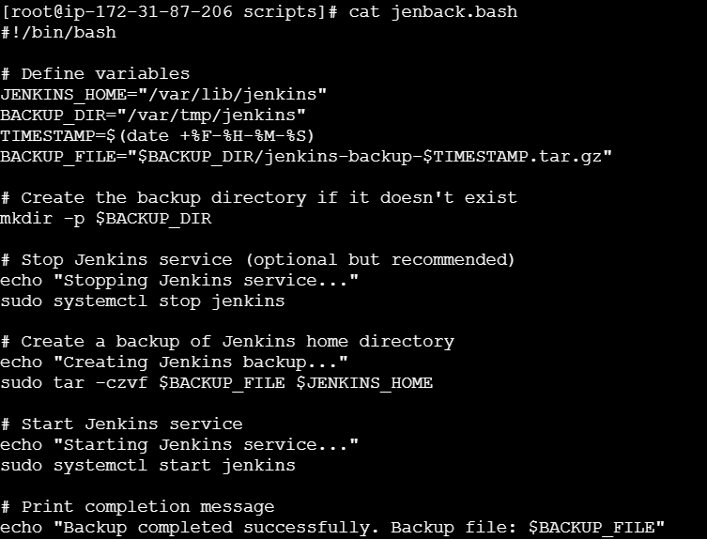

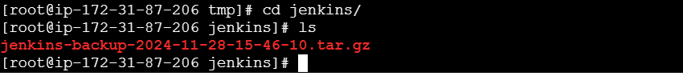

**5) Take backup of jenkins using rethin backup plugin.**

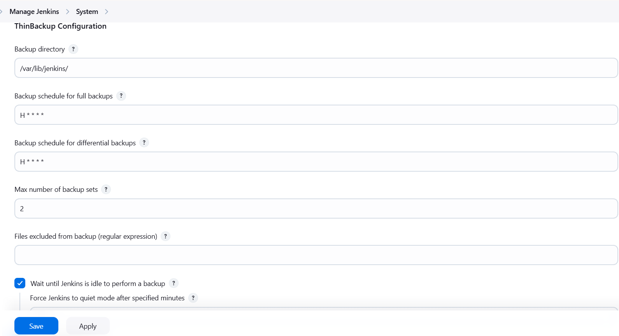

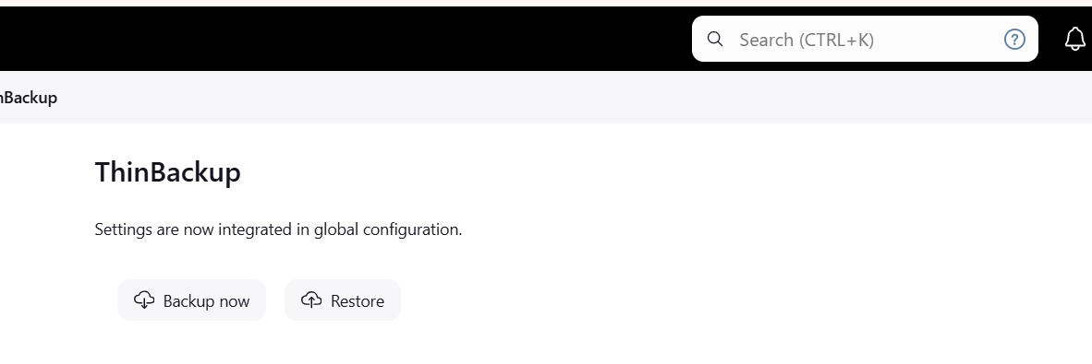

**6) Setup a new jenkins server and dump the backup taken in task4.**

