**Kubernetes Tasks-9:**

**1) Execute all the steps shown in video.**

* **Using service to expose our cluster:**

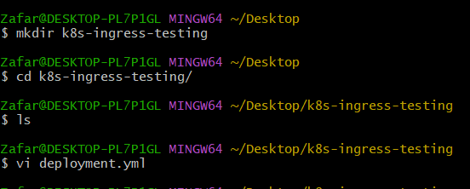

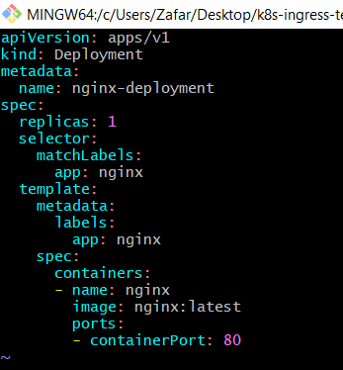

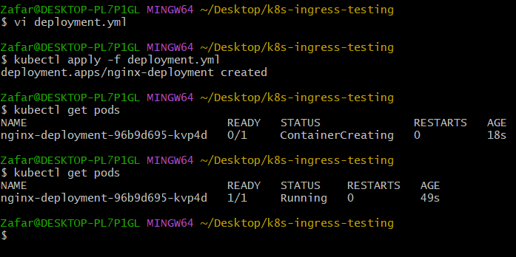

* **Creating a service to expose our container:**

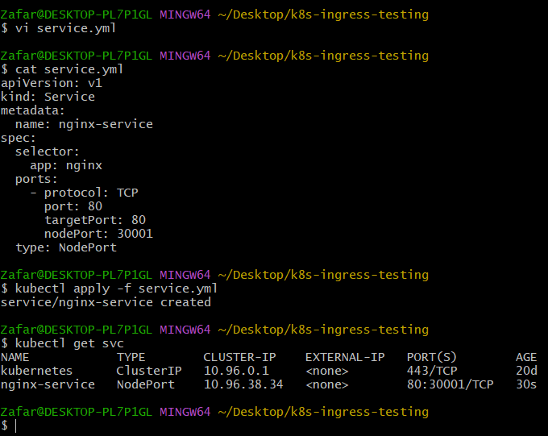

* **Copy the URL and paste it on the browser:**



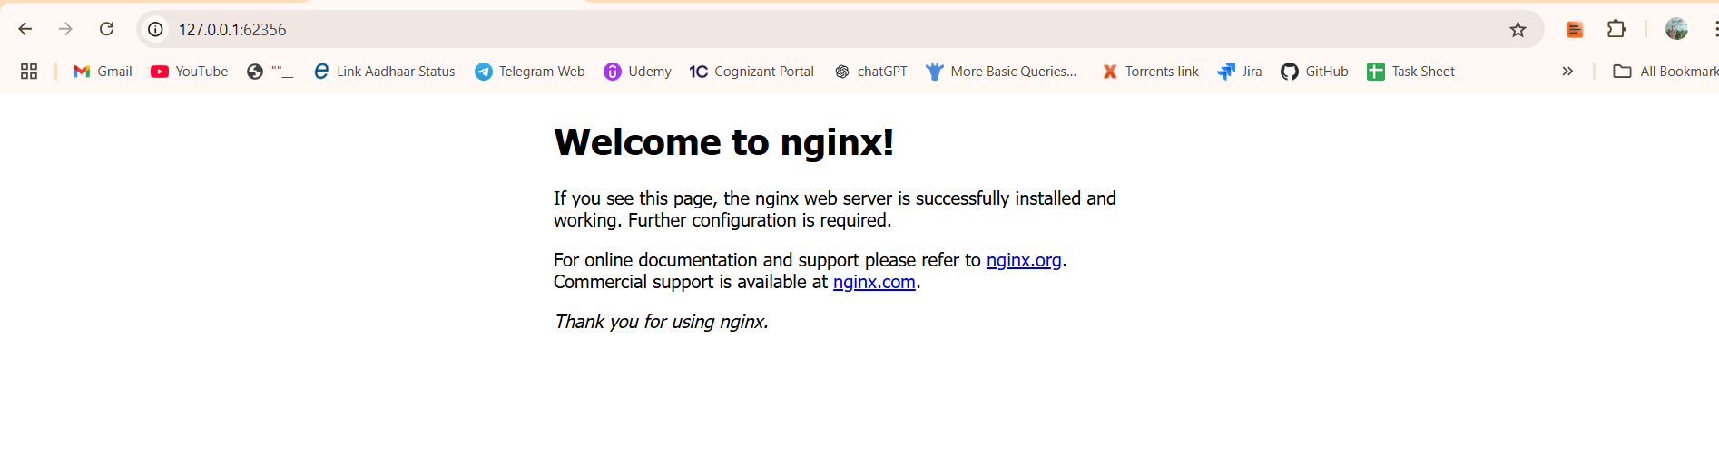

* **Let us setup our nginx ingress controller using this command:**

**>>** minikube addons enable ingress

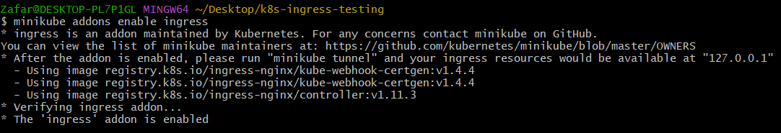

* **If we do**

**>> kubectl get pods -A**

* **We can see 3 ingress-nginx pods are running, these are nothing but our ingress controller:**

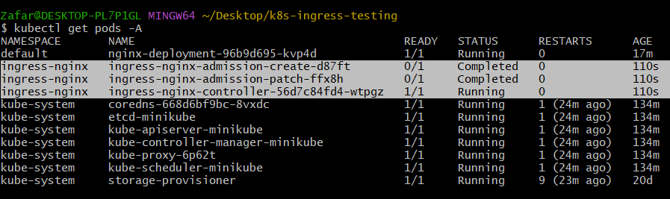

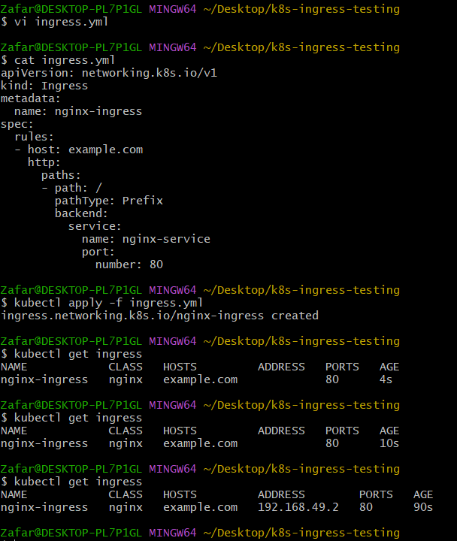

* Editing the hosts file.
* The path to the hosts file 🡪 C:\Windows\System32\drivers\etc

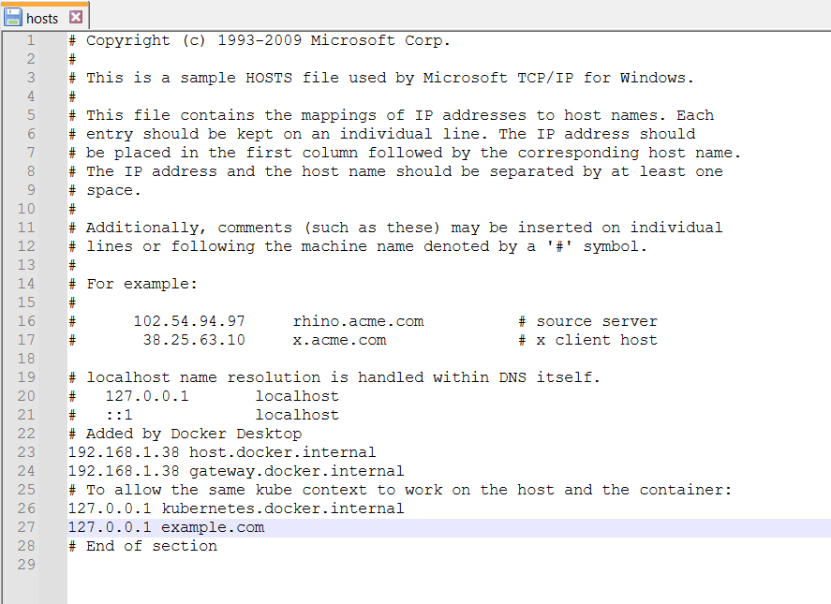

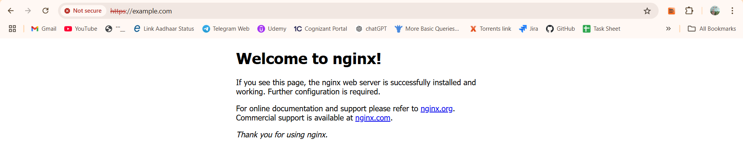

**2) Upgrade k8s cluster from 1.26 to 1.28 Version.**

Document to upgrade cluster.  
<https://devopscube.com/upgrade-kubernetes-cluster-kubeadm/>

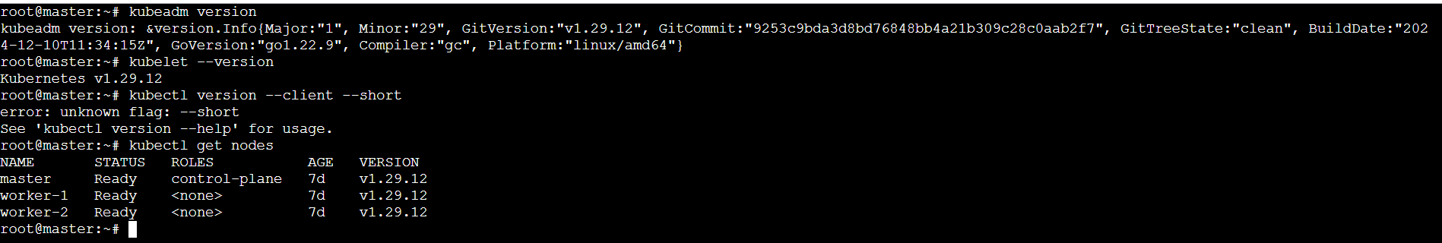

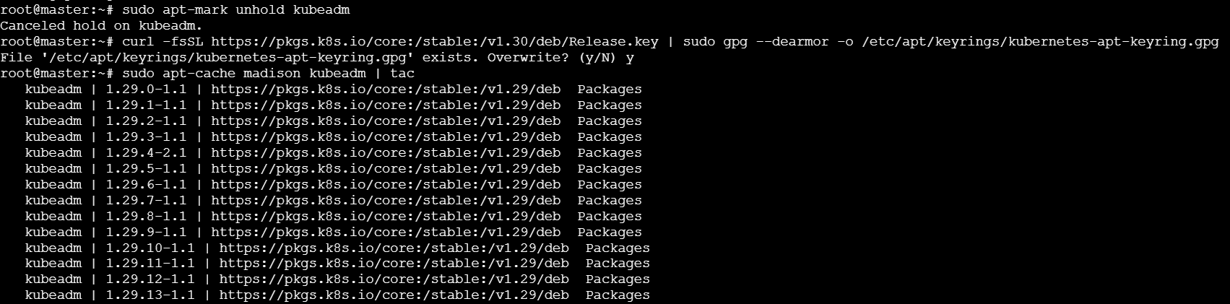

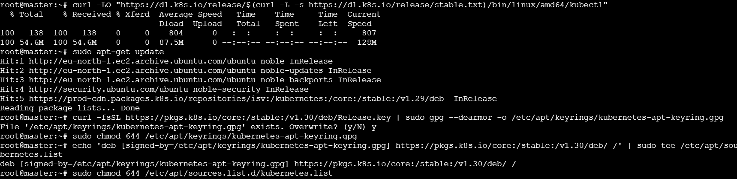

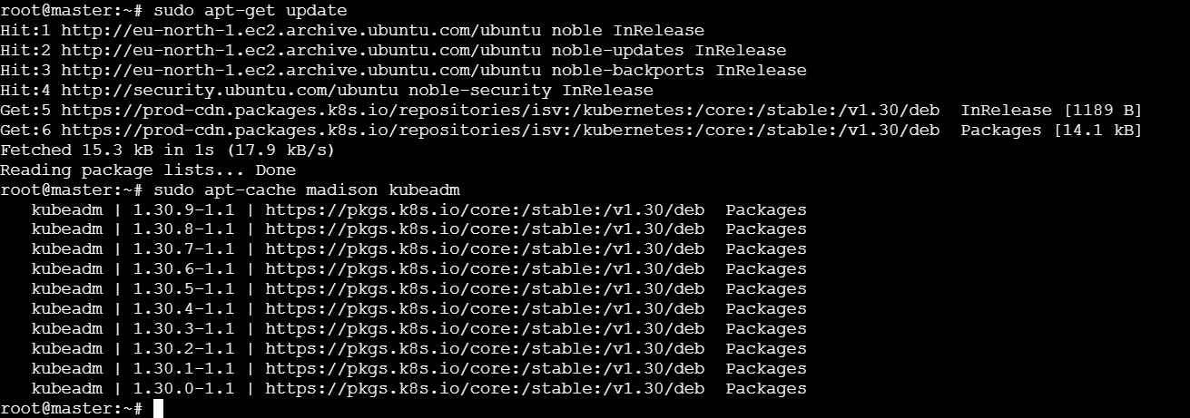

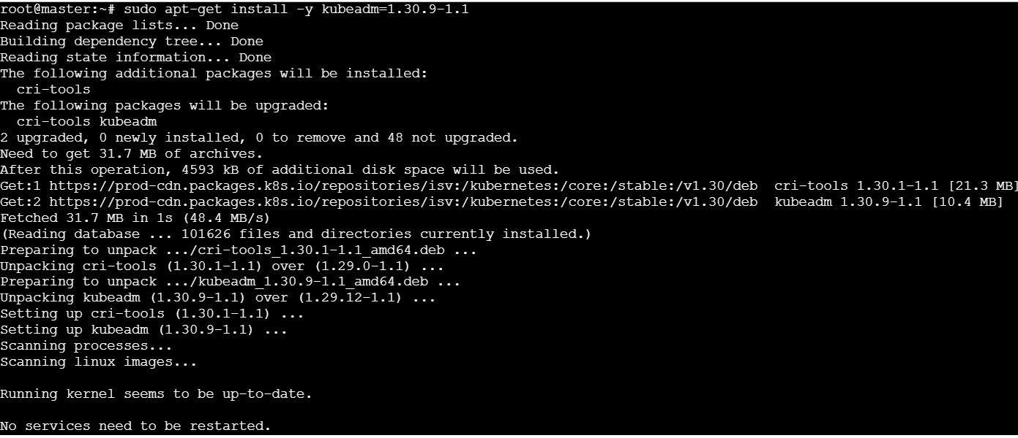

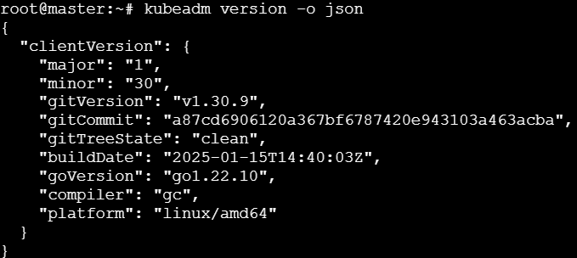

* **Upgrade Kubelet and Kubectl.**

