**Established network connectivity between three VPCs in three different regions using AWS Transit Gateway:**

* **Create VPC in three different regions:**
* **VPC - N. Virginia.**

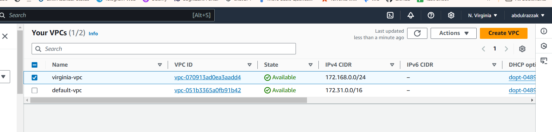

* **VPC – Ohio:**

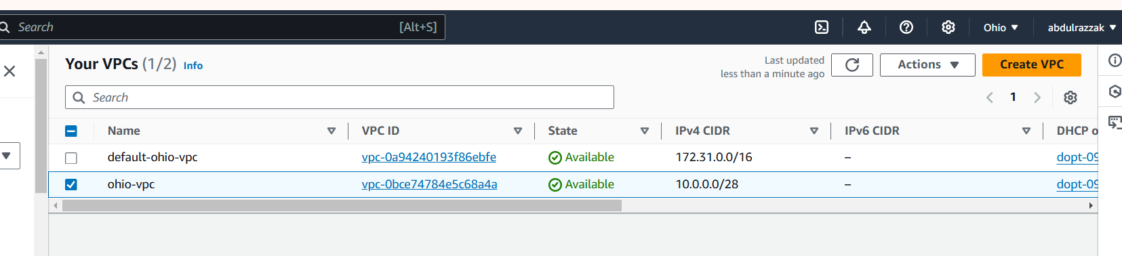

* **VPC – N. California:**

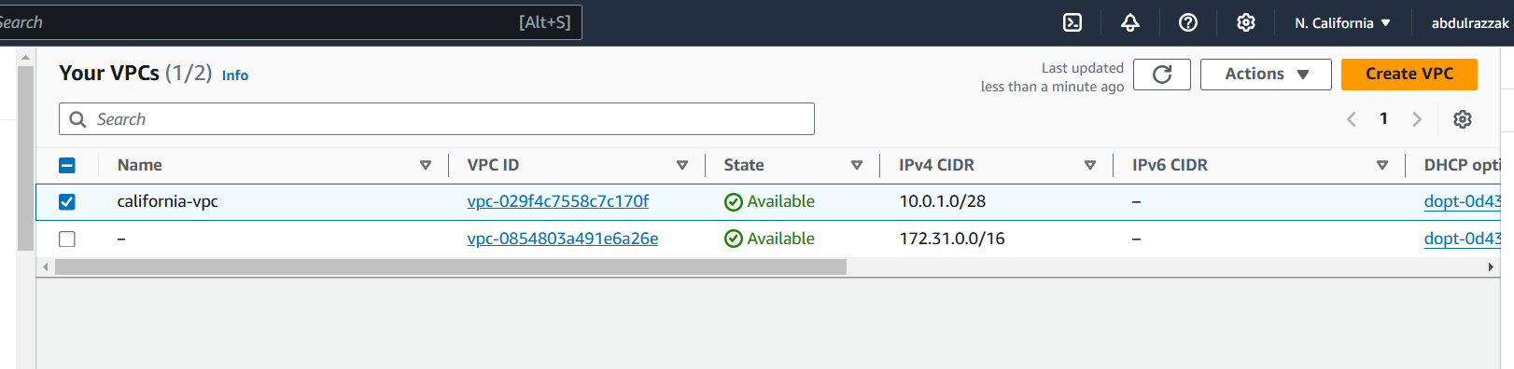

* **Create subnets for each VPC in each region:**

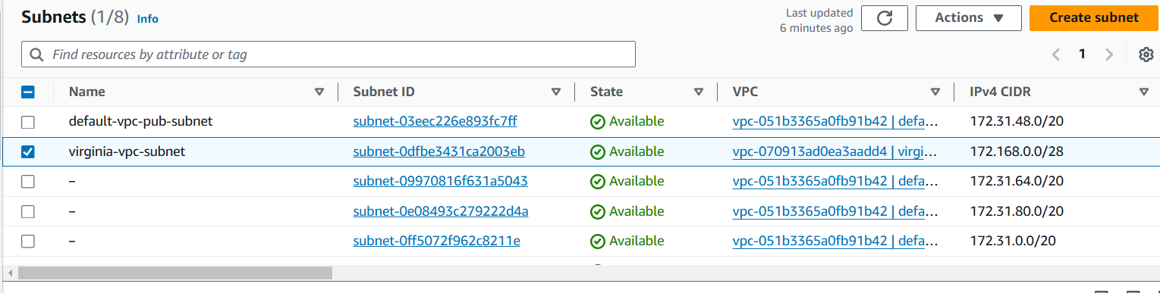

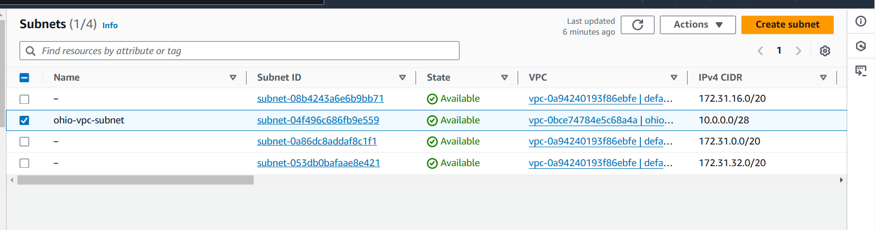

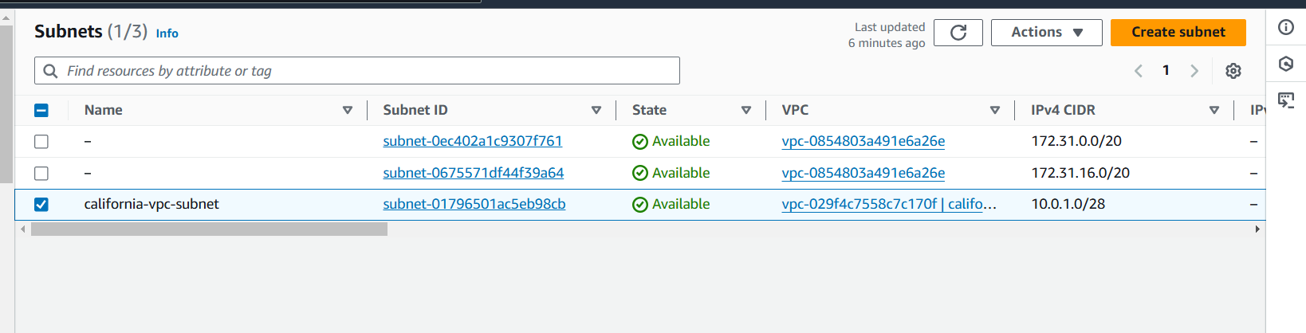

* **Launch an instance for each VPC in each region:**

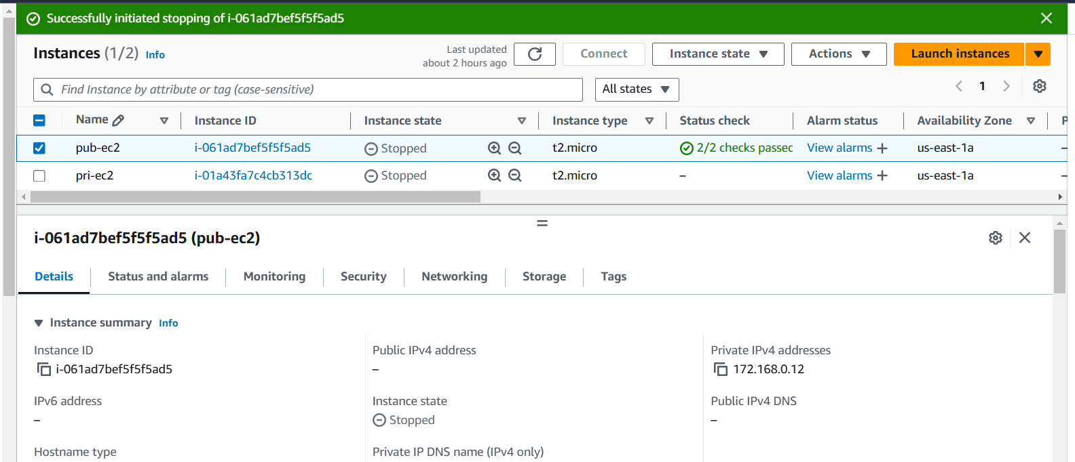

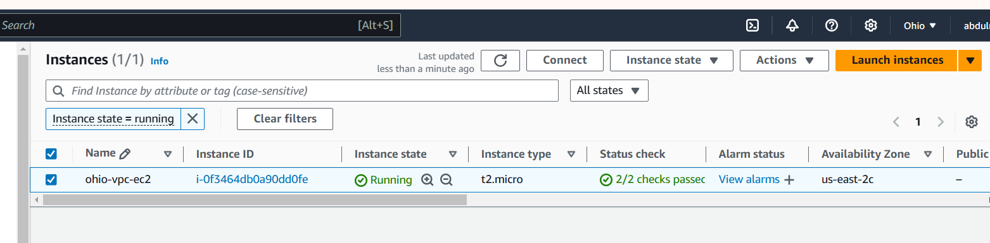

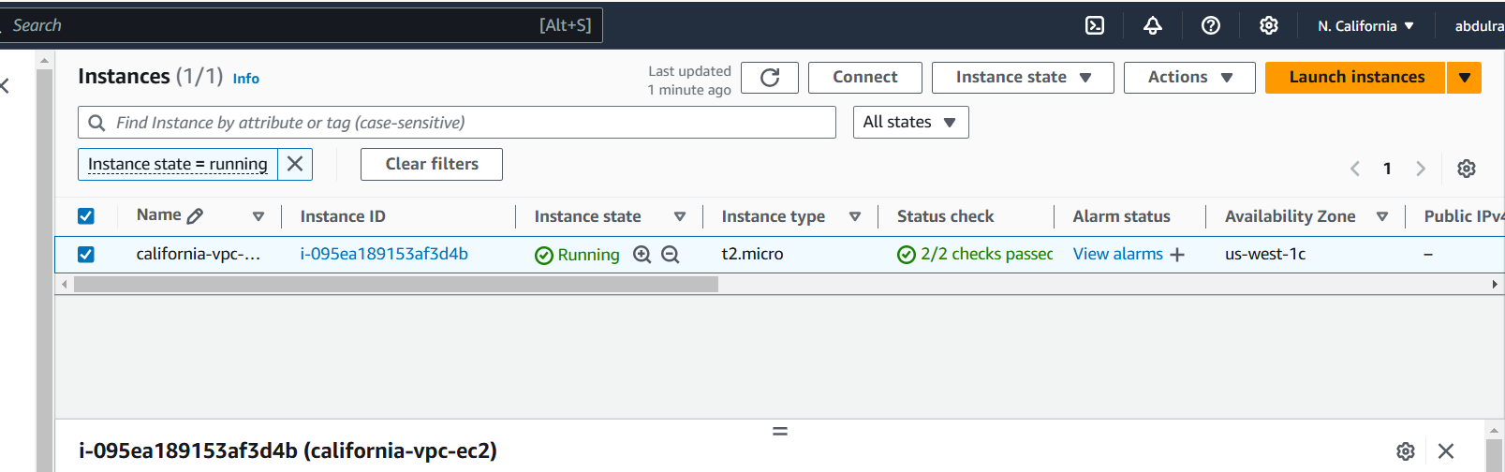

* **Create Internet Gateway and attach it to the respective VPC:**

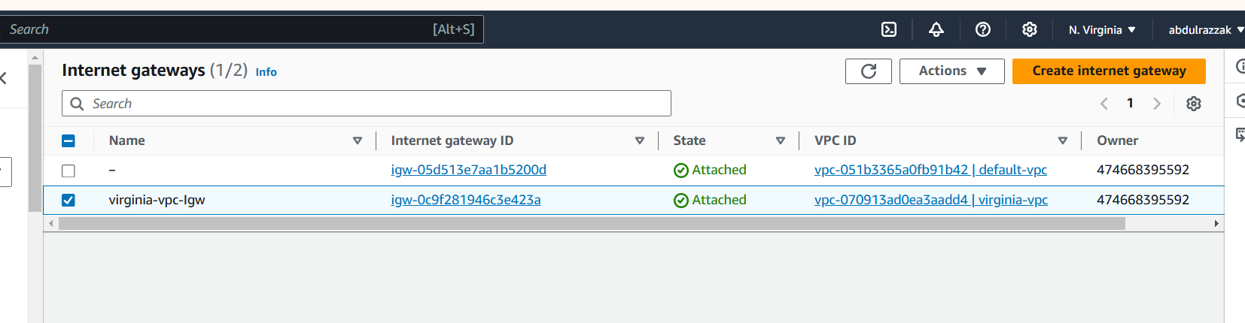

* **Create a Transit Gateway for each region:**
* **Transit gtw for N. Virginia Region:**

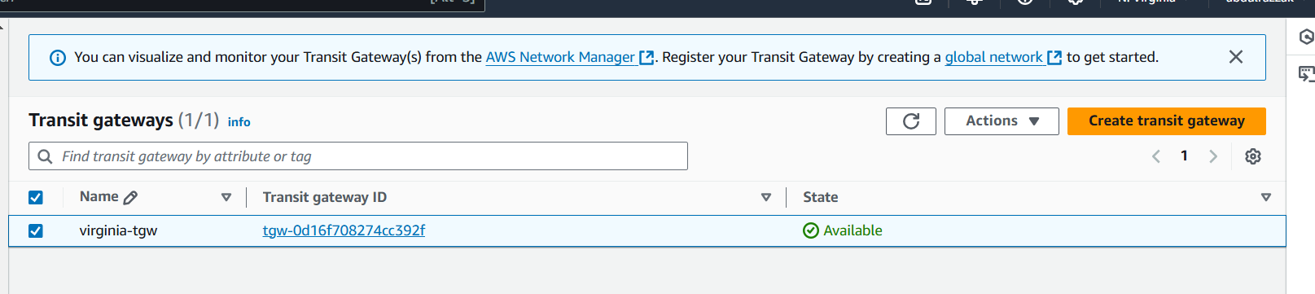

* **Transit gtw for Ohio region:**

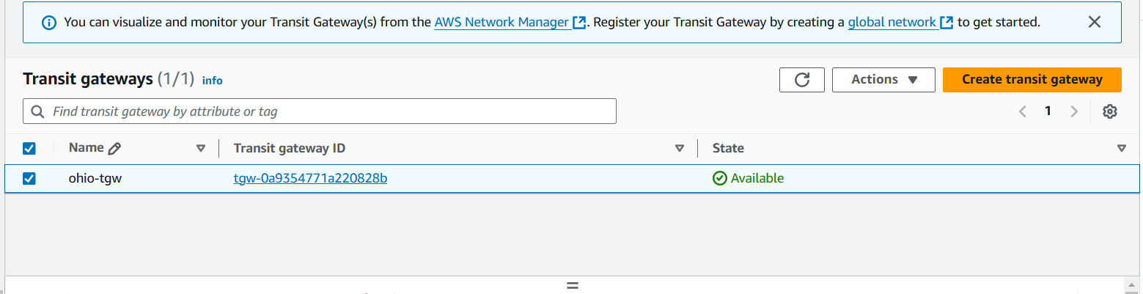

* **Transit Gtw for N. California region:** 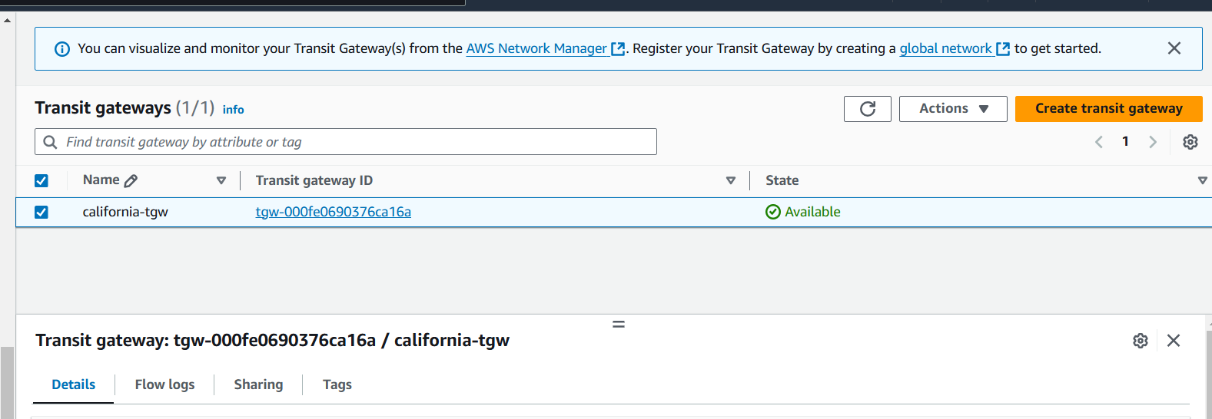
* **Give the Transit gateway attachments for every region:**

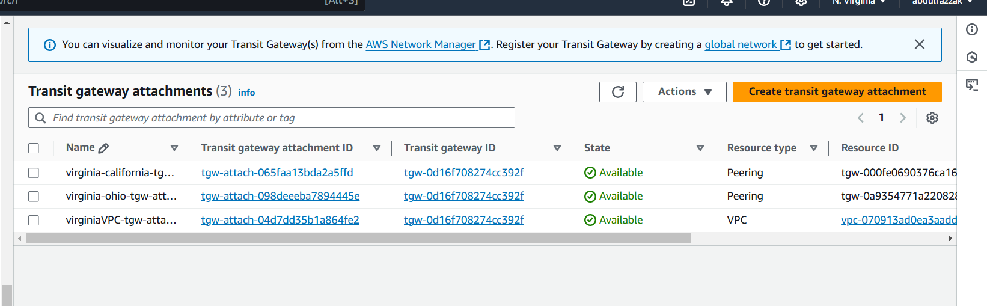

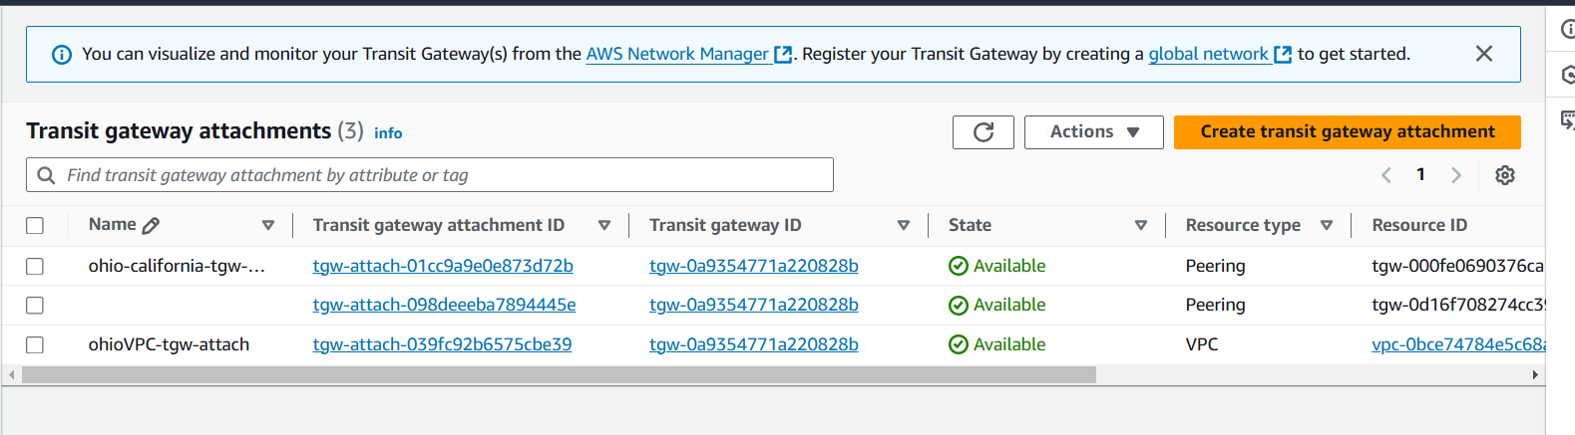

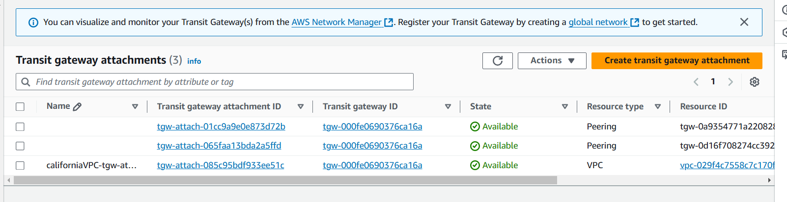

* **In Transit gtw route table, create static route for each connection(attachment) along with the transit gtw attachment for our current VPC:**
* **Creating static route in N. Virginia region:**

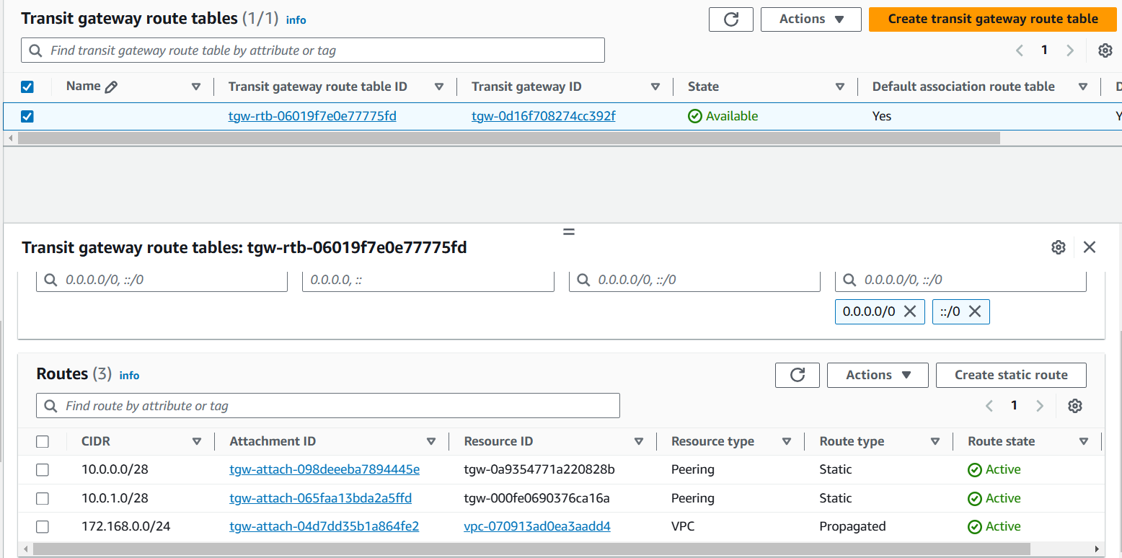

* **Creating static route in Ohio region:**

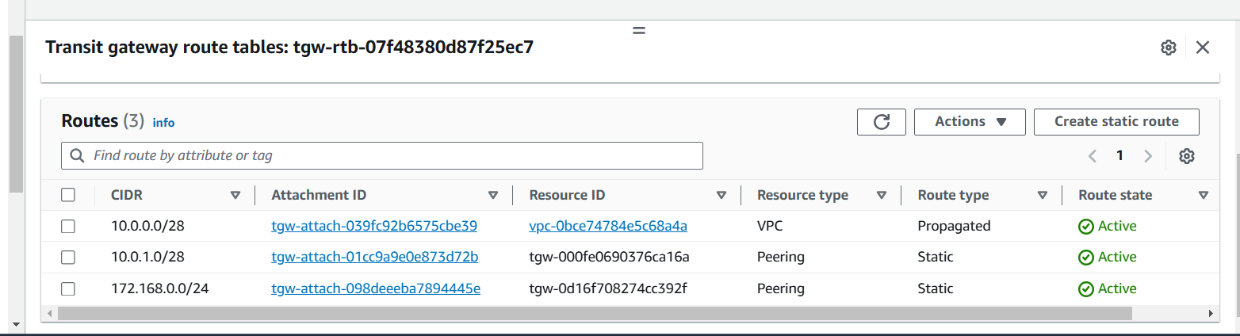

* **Creating static route in N. California region:**

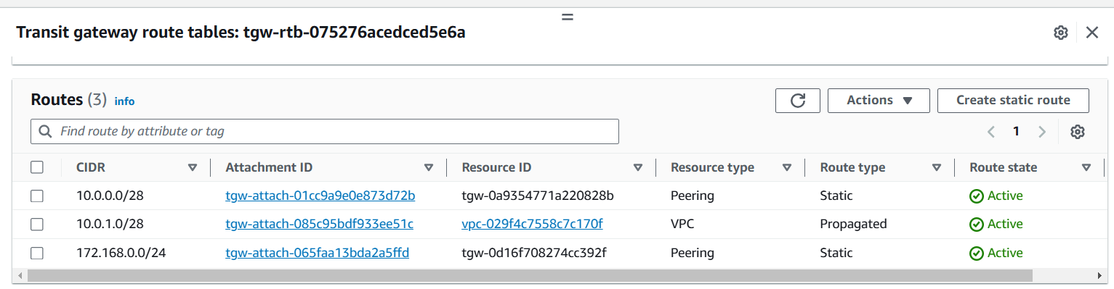

* **Udate the CIDR of each VPC of each region in the route table in the destination column, then select Transit gateway from the Target dropdown and select the transit gtw attachment ID for our current VPC:**
* **N. California Route Table:**

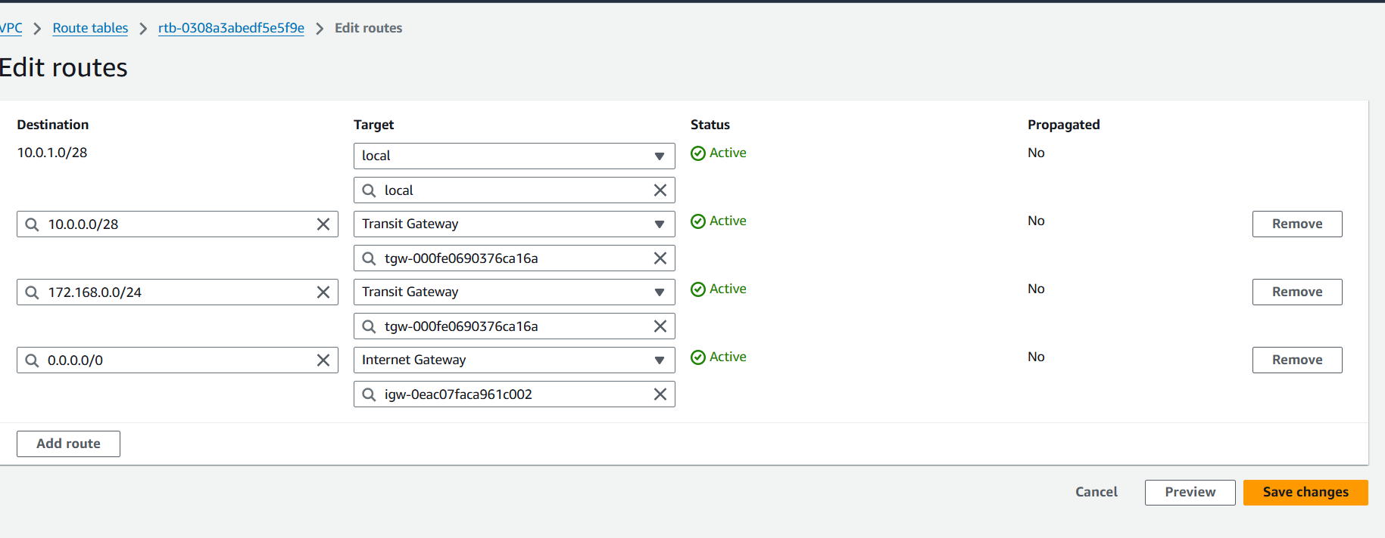

* **Ohio Route Table:**

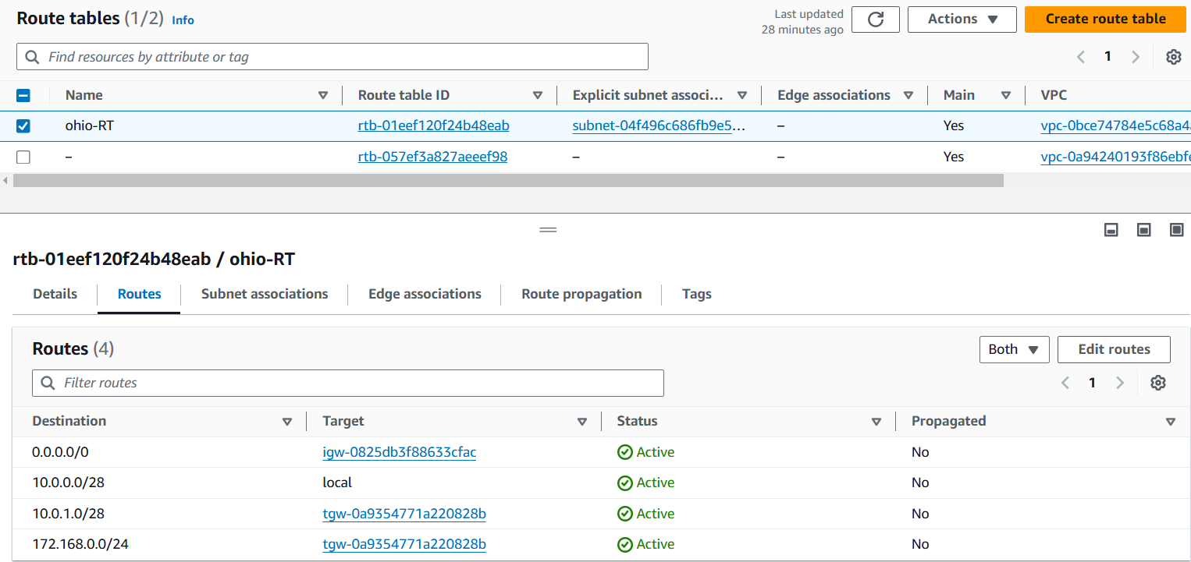

* **N. Virginia Route Table:**

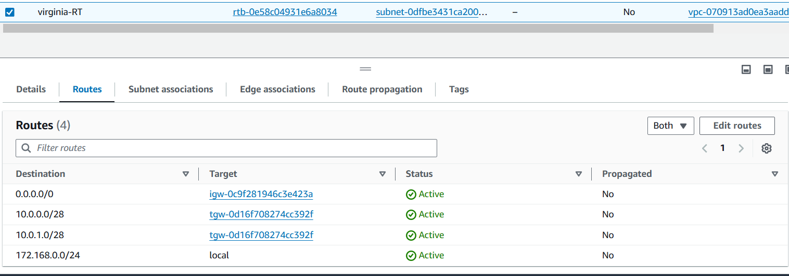

* **Update Security Groups for each Ec2 Instance in each region to accept all traffic:**
* **N. Virginia Region:**

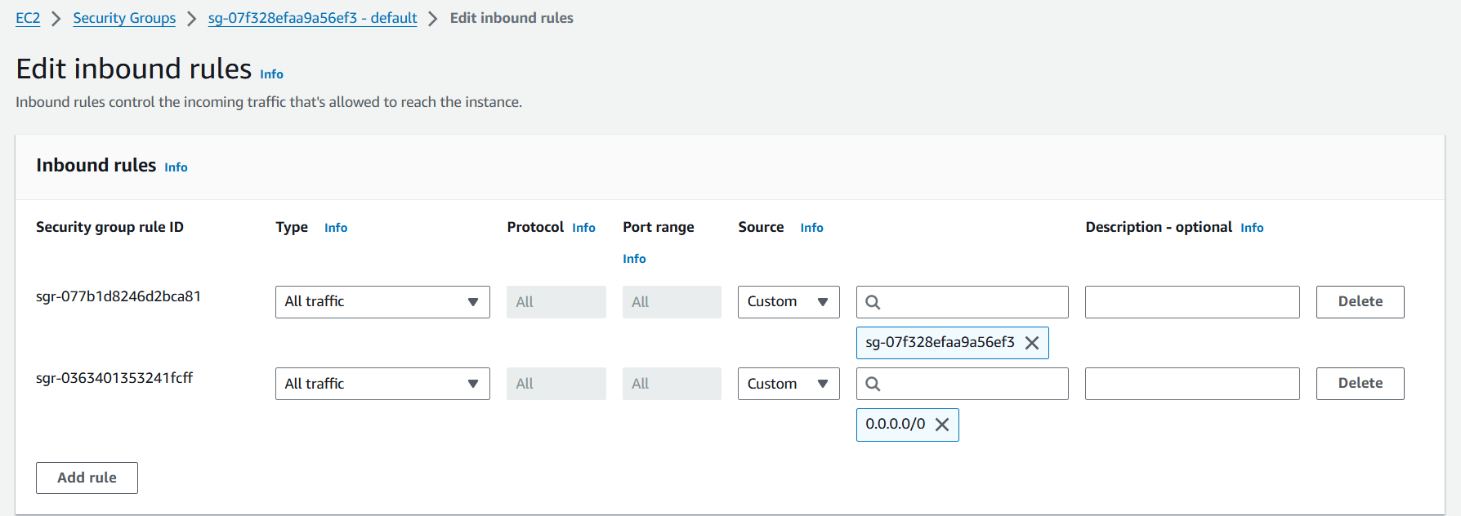

* **Ohio Region:**

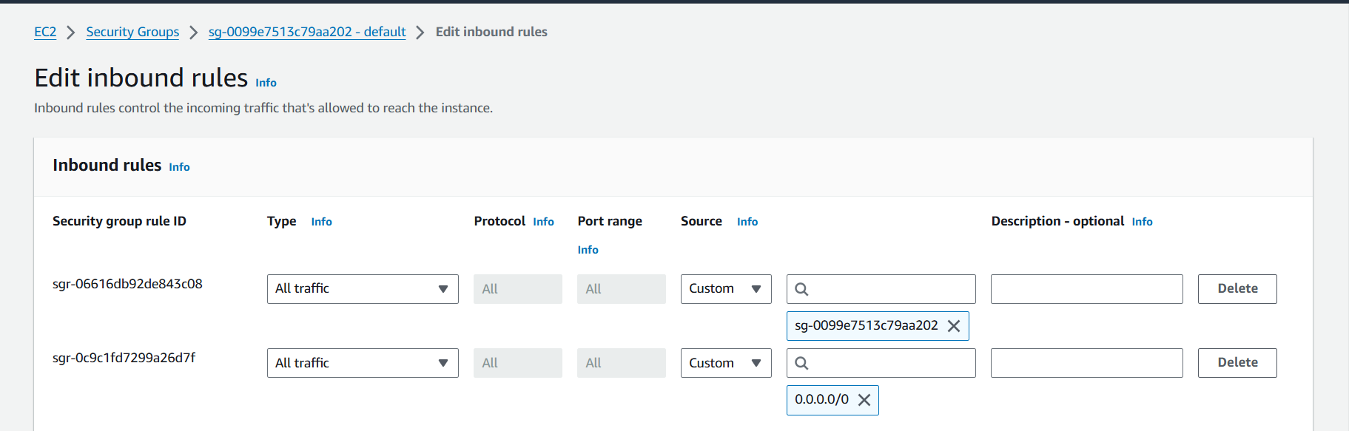

* **N. California Region:**

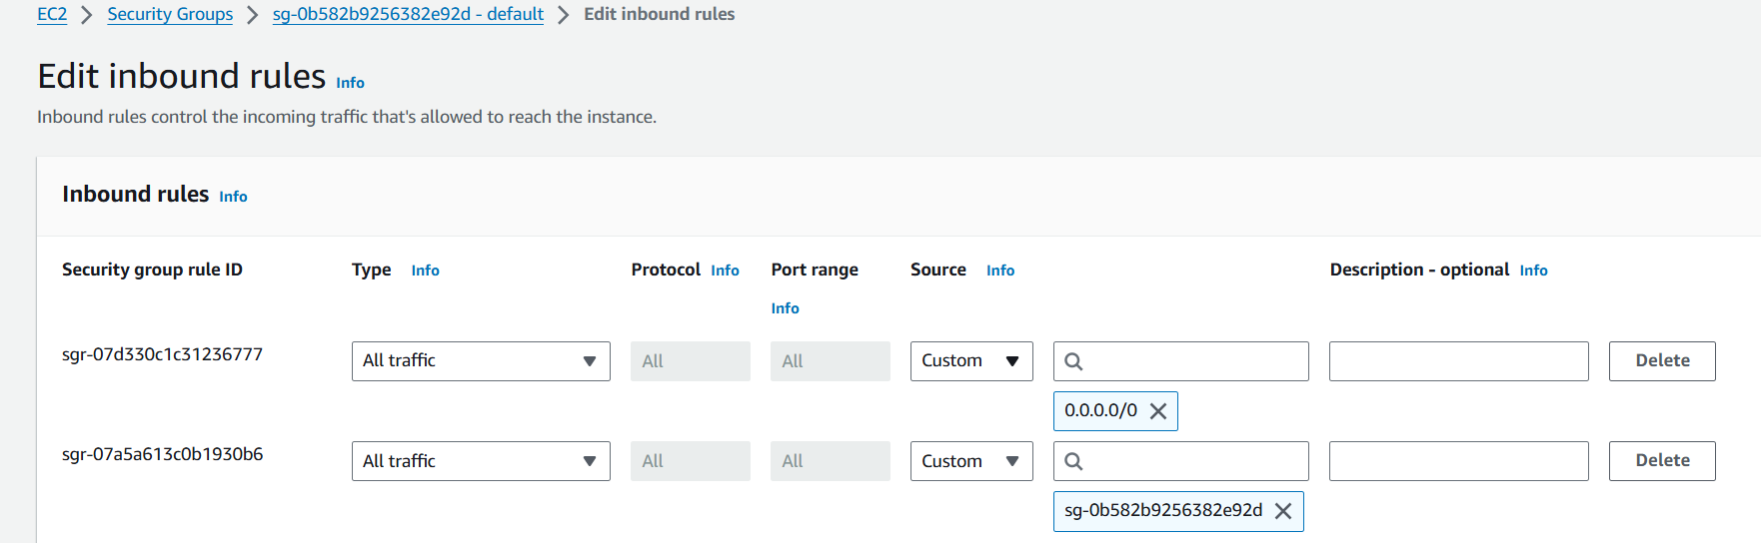

* **Connect to the public ec2 instance in N. Virginia Region using Gitbash as terminal to check the connectivity between each VPC in each Region using the command “ping <private Ip of the Server in different region>”.**
* **Connected to the VPC of Ohio region from the VPC of N. Virginia region.**

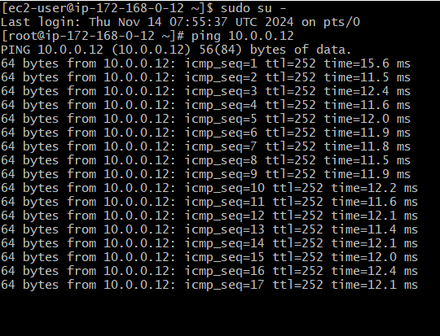

* **Connecting using the private Ip of the same N. Virginia Region:**

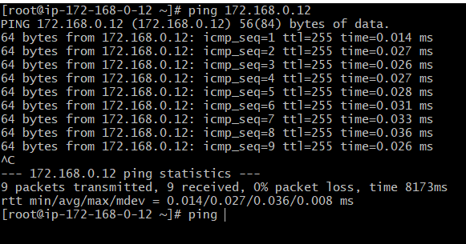

* **Connected to the VPC of N. California region from the VPC of N. Virginia region.**

