**CT & CW Tasks:**

**1) Enable cloudtrail monitoring and store the events in s3 and cloudwatch log events**

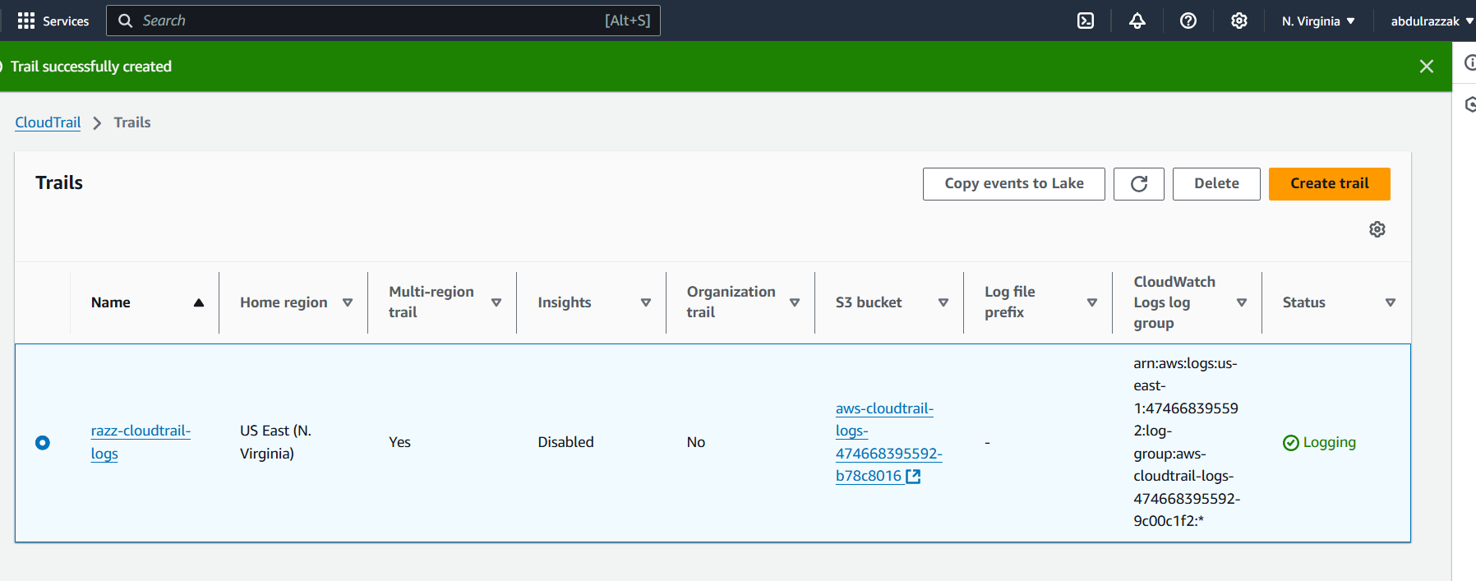

* **Events stored in s3 bucket:**

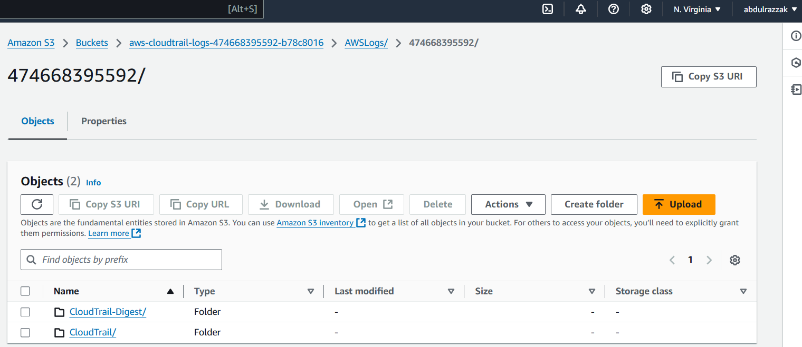

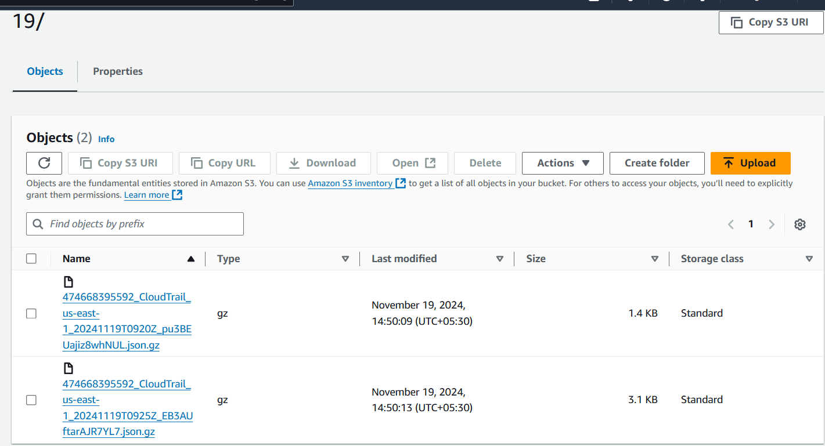

* **Events Stored in CloudWatch Log groups:**

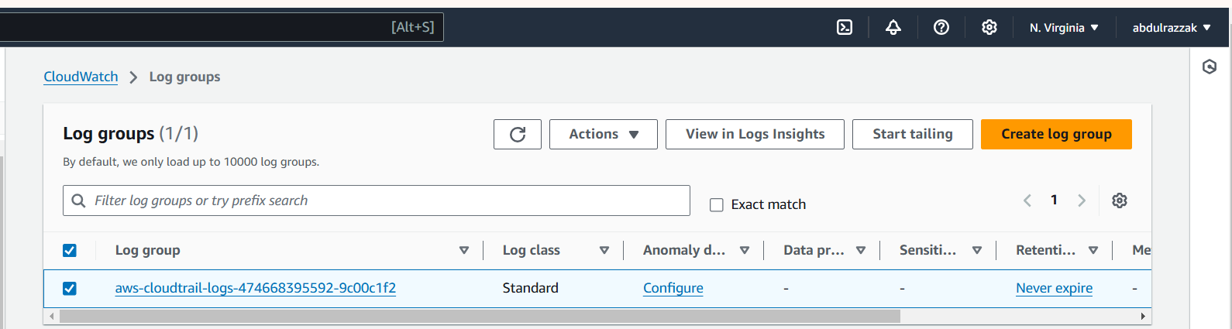

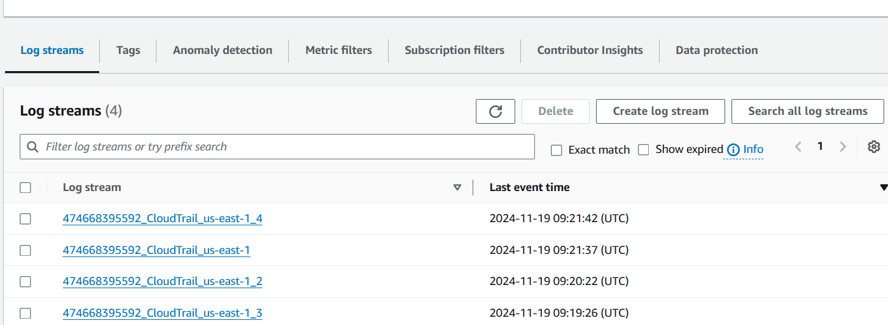

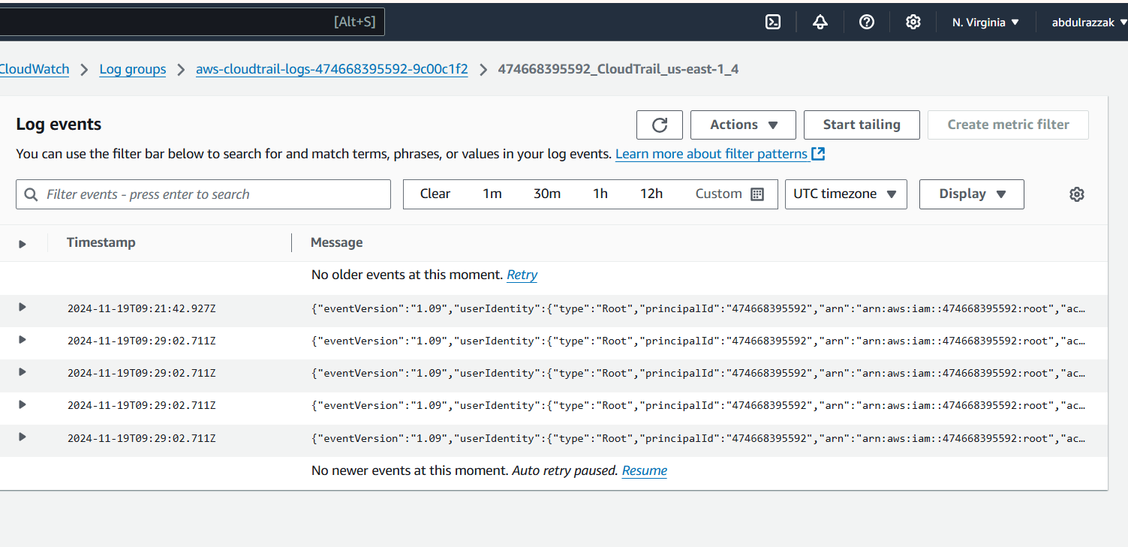

**2) Enable SNS for cloudtrial to send alert on email.**

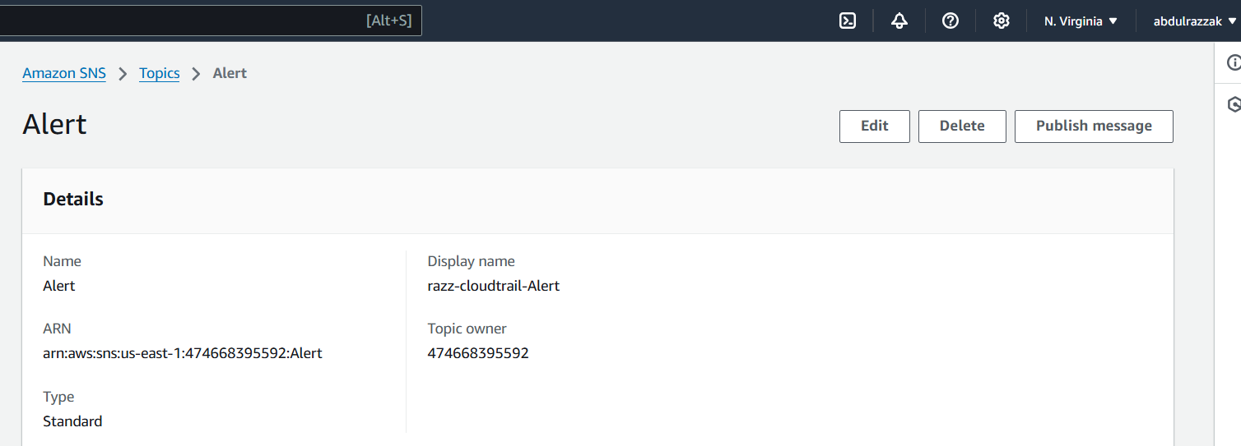

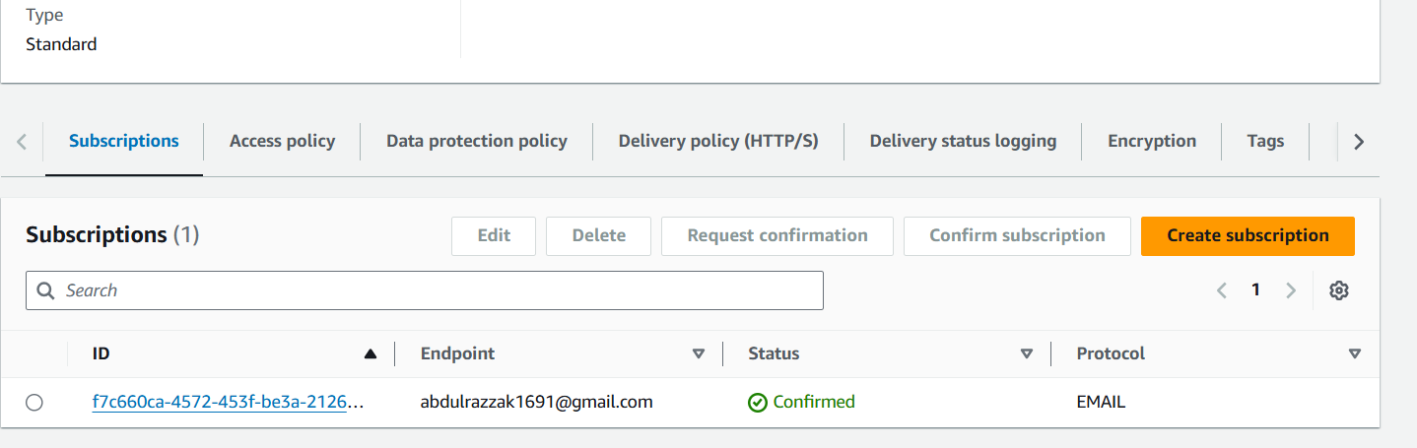

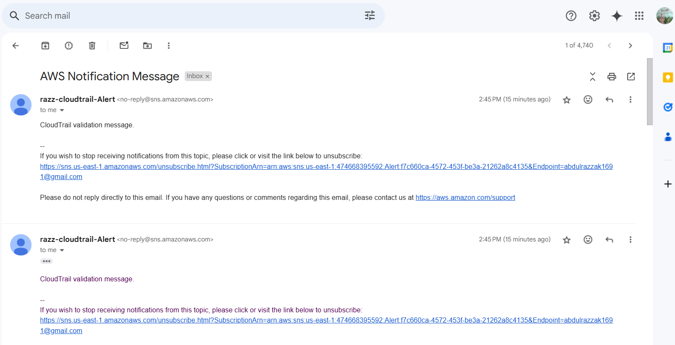

**3) Configure cloud watch monitoring and record the cpu utilization and other metrics of ec2.**

**CPU Utilization:  
Network Packets In:**

**Network Packets out:**

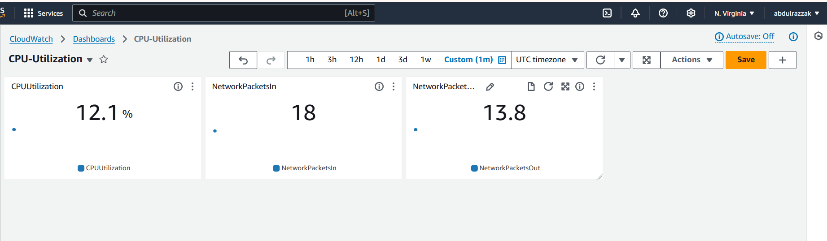

**4) Create one alarm to send alert to email if the cpu utilization is more than 70 percent.**

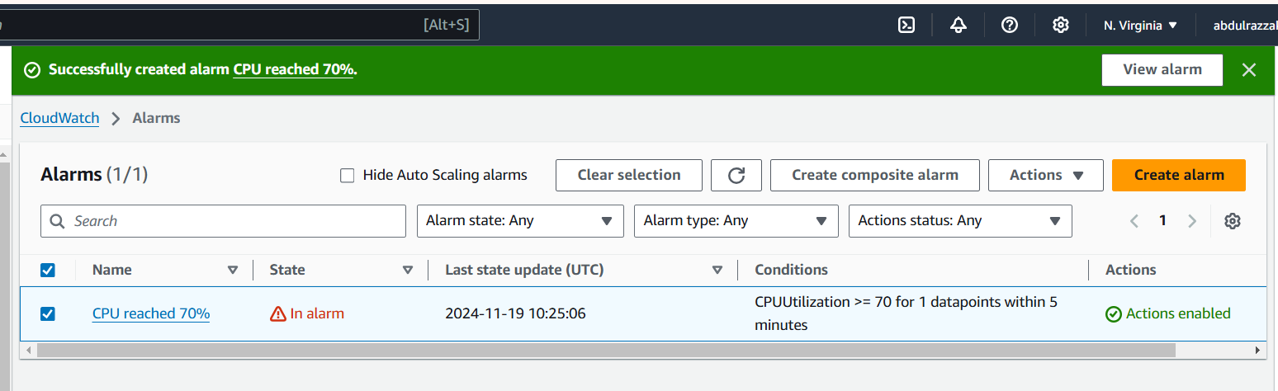

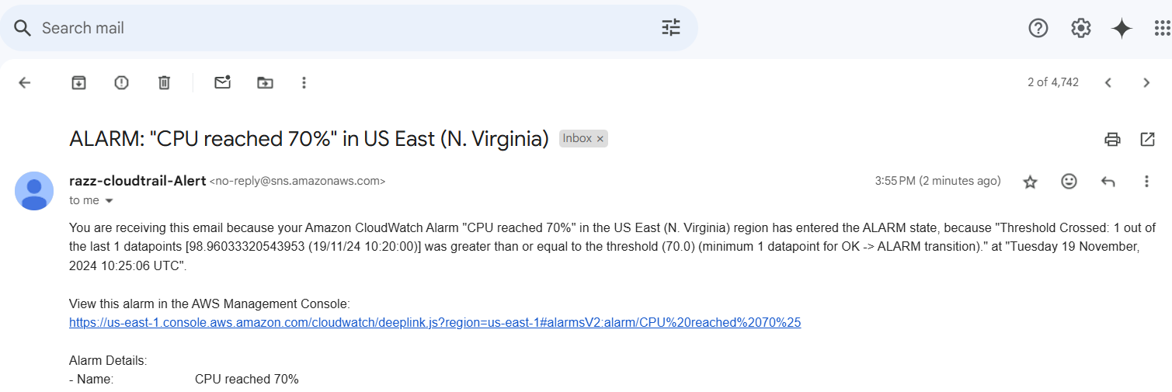

**5) Create Dashboard and monitor tomcat service whether it is running or not and send the alert:**

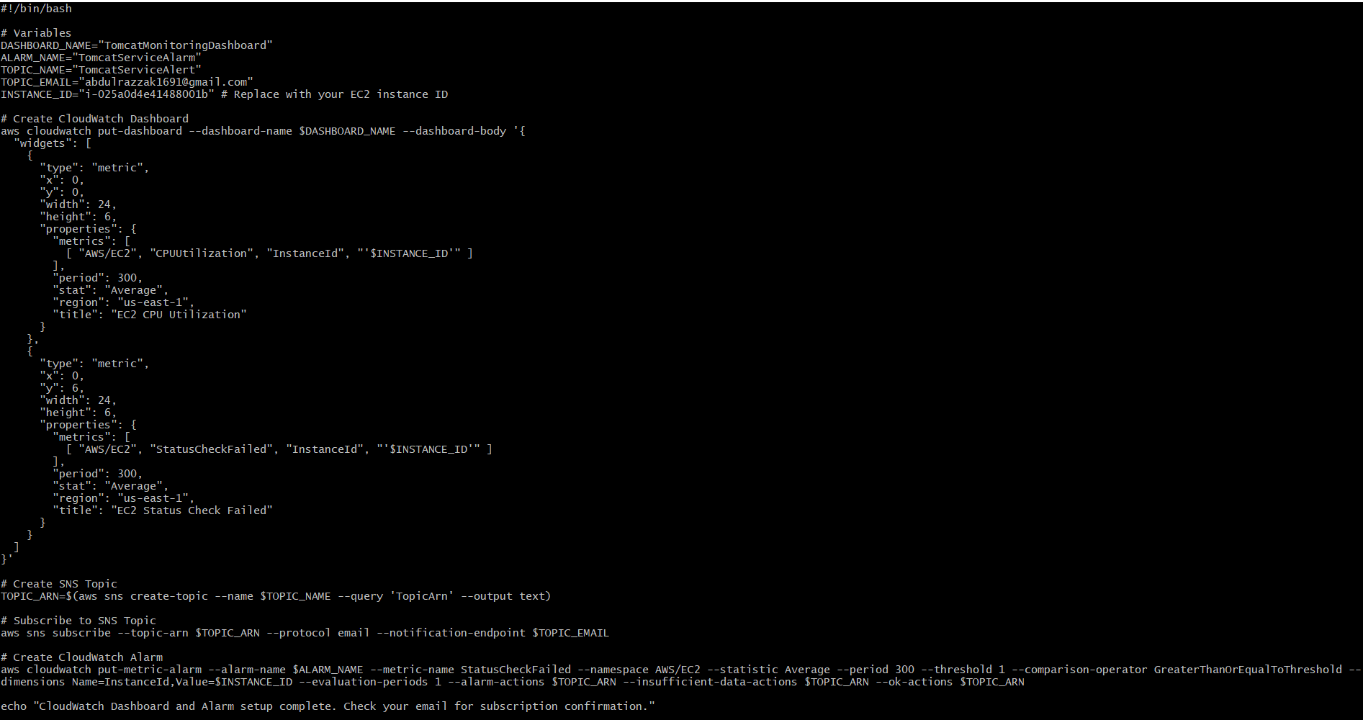

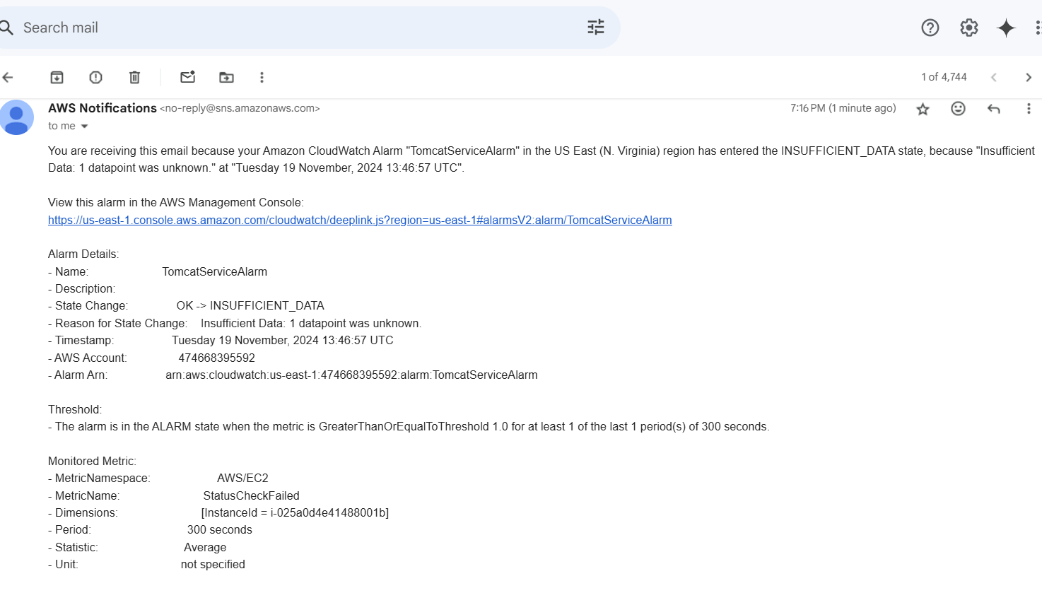

**6) Create Dashboard and monitor nginx service to send the alert if nginx is not running.**

